FACULDADE DE INFORMATICA E ADMINISTRAÇÃO PAULISTA ANÁLISE E DESENVOLVIMENTO DE SISTEMA

PEDRO HENRIQUE DOS SANTOS – RM:559064
THIAGO THOMAZ – RM:557992
VINÍCIUS DE OLIVEIRA COUTINHO - RM556182

MOTTUGRID
DATABASE

SÃO PAULO 2025
Function 1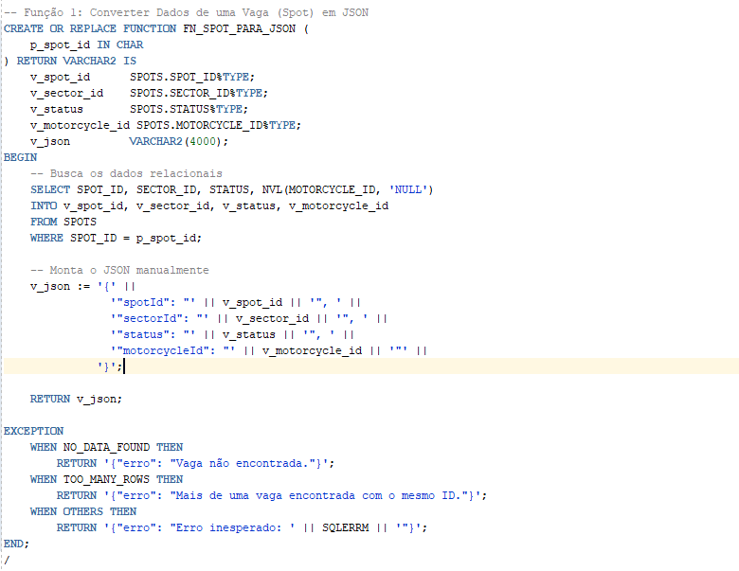
Execução sem retornar exception
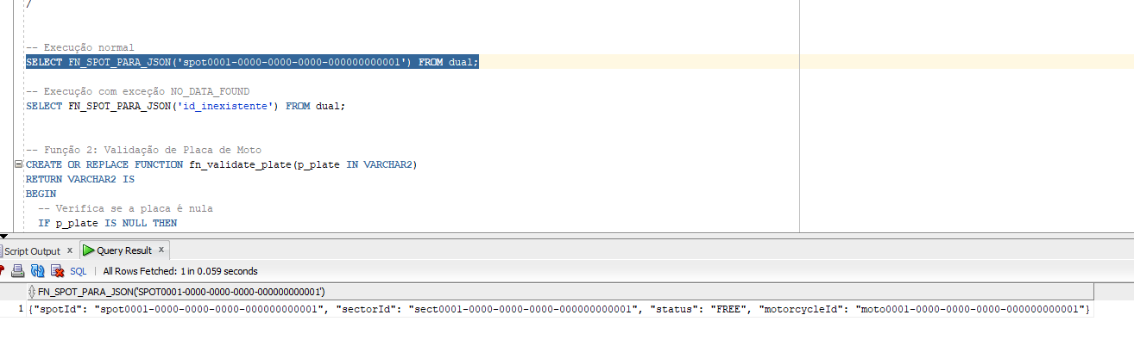

Execução com exception
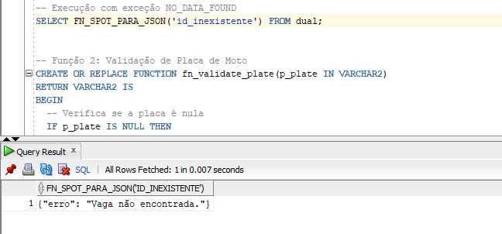

Function 2
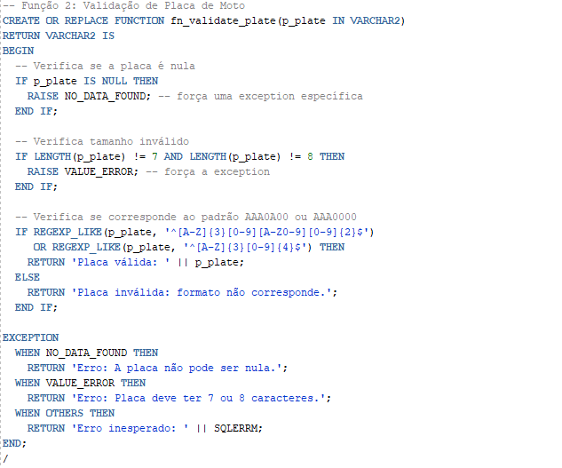
Execução sem retornar exception
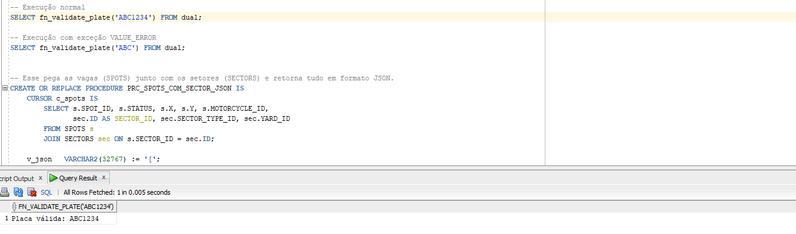

Execução com exception
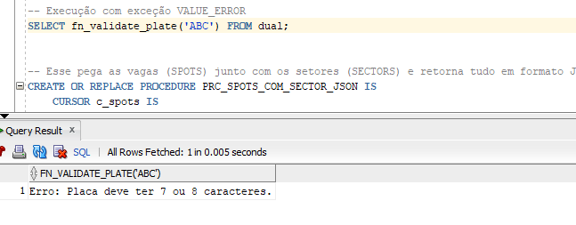

Procedure 1
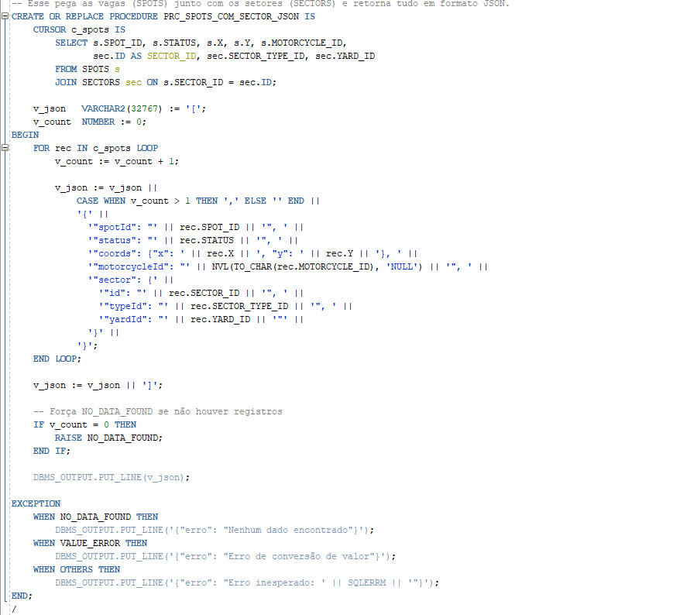
Execução sem retornar exception
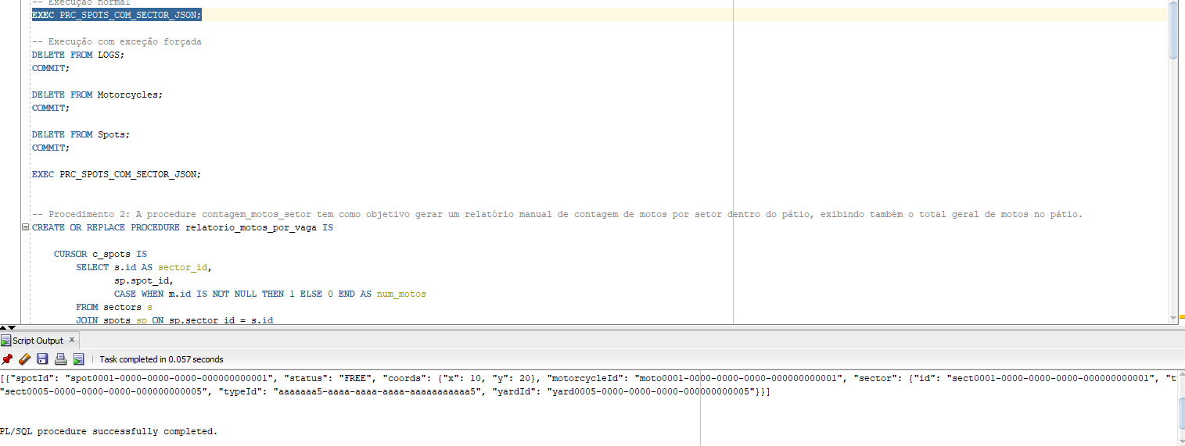

Execução com exception
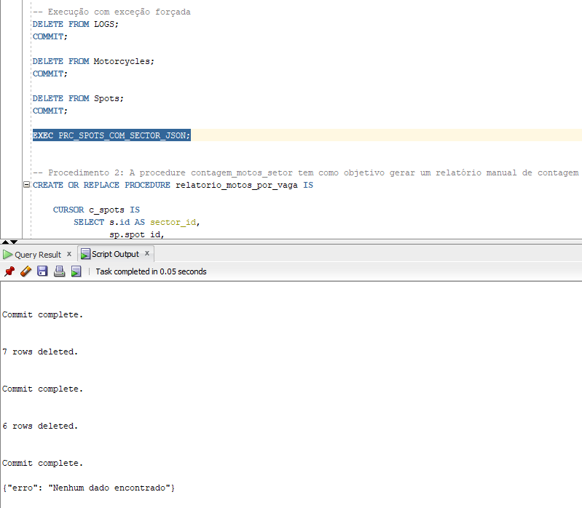

Procedure 2
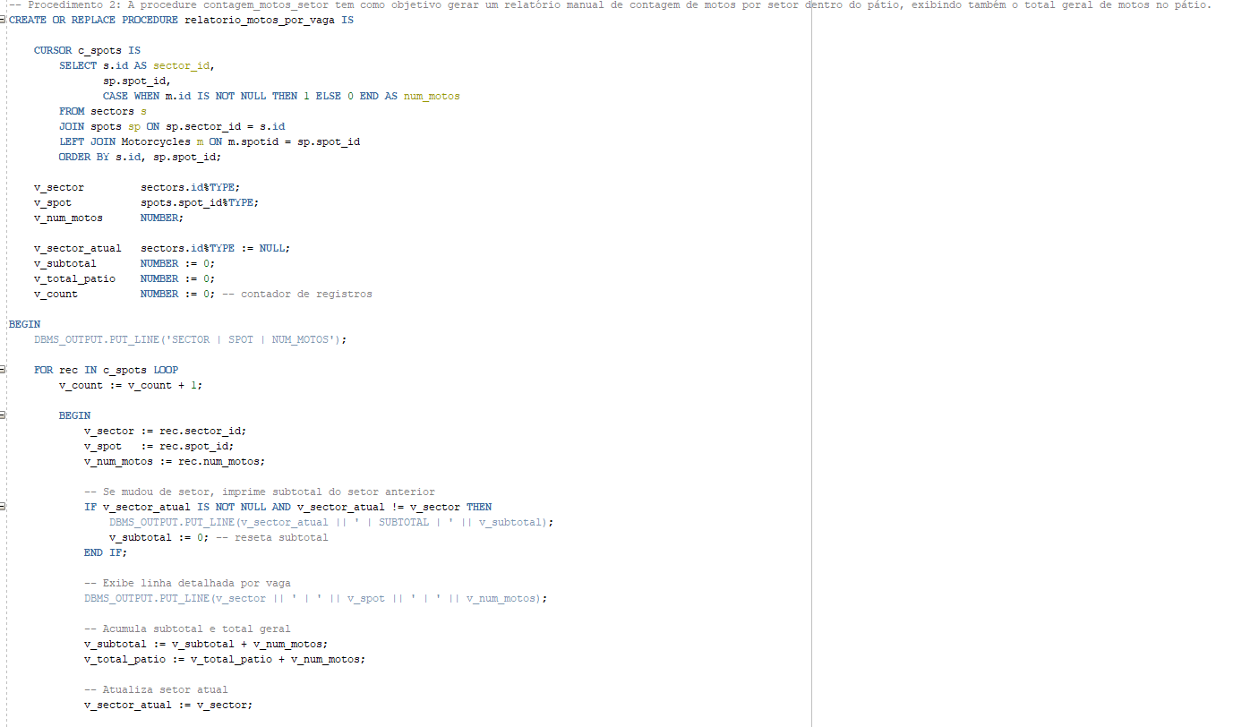
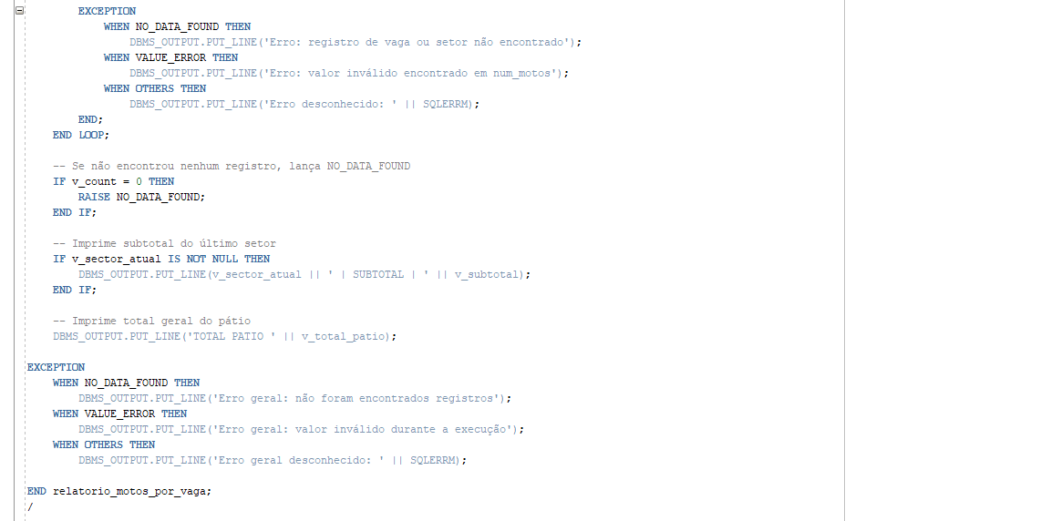

Execução sem retornar exception
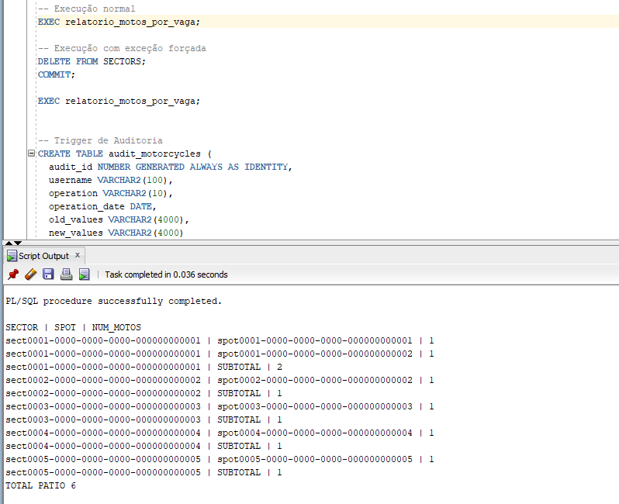

Execução com exception
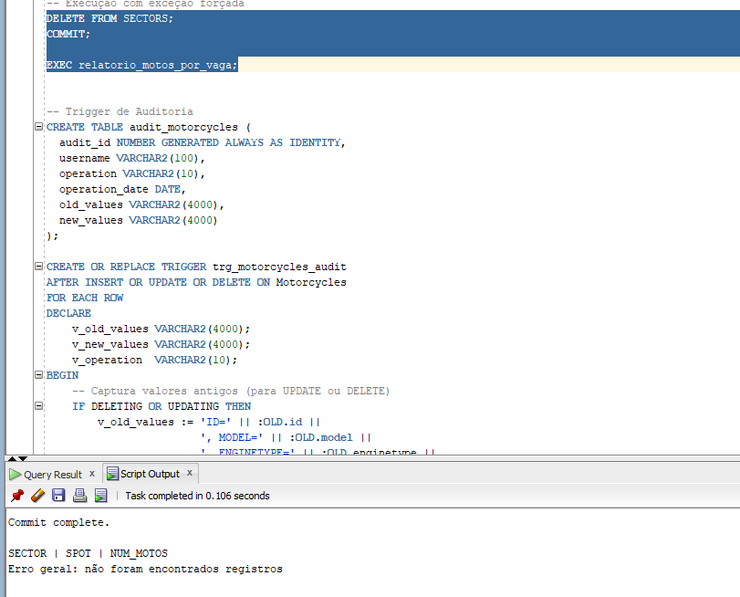

Trigger
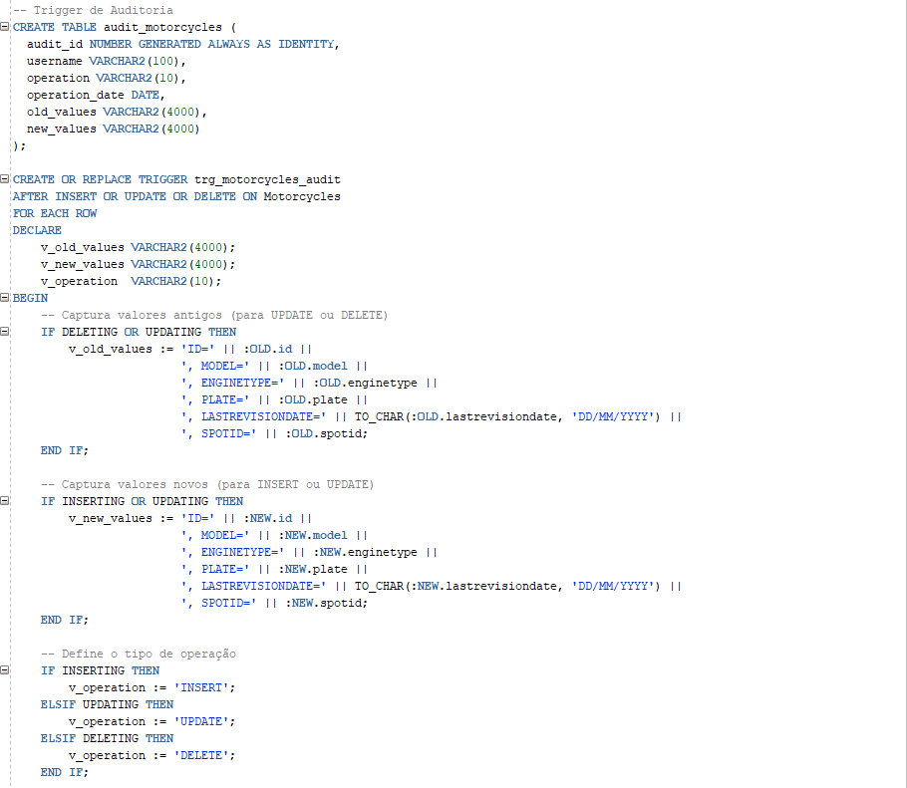
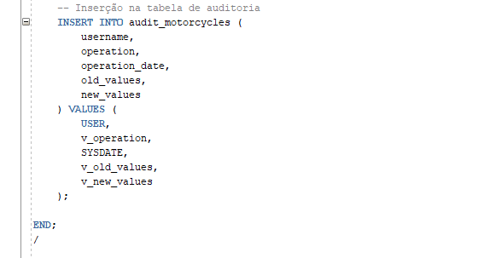
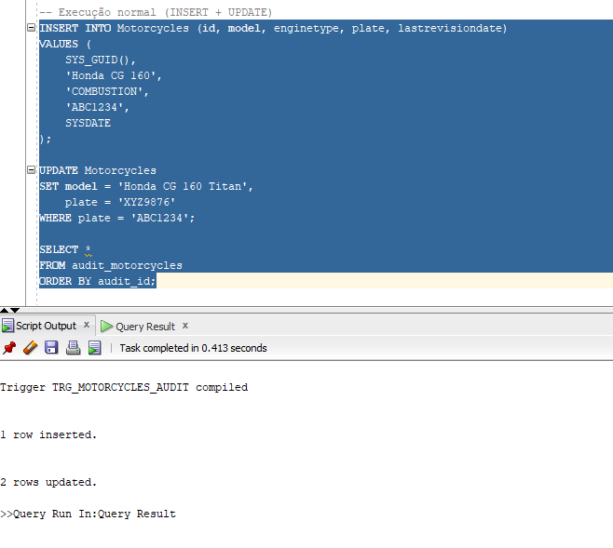

CODIGOS SQL DESSA SPRIN

SET SERVEROUTPUT ON;

-- Função 1: Converter Dados de uma Vaga (Spot) em JSON
CREATE OR REPLACE FUNCTION FN_SPOT_PARA_JSON (
p_spot_id IN CHAR
) RETURN VARCHAR2 IS
v_spot_id SPOTS.SPOT_ID%TYPE;
v_sector_id SPOTS.SECTOR_ID%TYPE;
v_status SPOTS.STATUS%TYPE;
v_motorcycle_id SPOTS.MOTORCYCLE_ID%TYPE;
v_json VARCHAR2(4000);
BEGIN
-- Busca os dados relacionais
SELECT SPOT_ID, SECTOR_ID, STATUS, NVL(MOTORCYCLE_ID, 'NULL')
INTO v_spot_id, v_sector_id, v_status, v_motorcycle_id
FROM SPOTS
WHERE SPOT_ID = p_spot_id;

-- Monta o JSON manualmente
v_json := '{' ||
'"spotId": "' || v_spot_id || '", ' ||
'"sectorId": "' || v_sector_id || '", ' ||
'"status": "' || v_status || '", ' ||
'"motorcycleId": "' || v_motorcycle_id || '"' ||
'}';

RETURN v_json;

EXCEPTION
WHEN NO_DATA_FOUND THEN
RETURN '{"erro": "Vaga n�o encontrada."}';
WHEN TOO_MANY_ROWS THEN
RETURN '{"erro": "Mais de uma vaga encontrada com o mesmo ID."}';
WHEN OTHERS THEN
RETURN '{"erro": "Erro inesperado: ' || SQLERRM || '"}';
END;
/

-- Função 2: Validação de Placa de Moto
CREATE OR REPLACE FUNCTION fn_validate_plate(p_plate IN VARCHAR2)
RETURN VARCHAR2 IS

BEGIN
-- Verifica se a placa é nula
IF p_plate IS NULL THEN
RAISE NO_DATA_FOUND; -- for�a uma exception espec�fica
END IF;

-- Verifica tamanho invalido
IF LENGTH(p_plate) != 7 AND LENGTH(p_plate) != 8 THEN
RAISE VALUE_ERROR; -- for�a a exception
END IF;

-- Verifica se corresponde ao padr�o AAA0A00 ou AAA0000
IF REGEXP_LIKE(p_plate, '^[A-Z]{3}[0-9][A-Z0-9][0-9]{2}$')
OR REGEXP_LIKE(p_plate, '^[A-Z]{3}[0-9]{4}$') THEN
RETURN 'Placa v�lida: ' || p_plate;
ELSE
RETURN 'Placa inv�lida: formato n�o corresponde.';
END IF;

EXCEPTION
WHEN NO_DATA_FOUND THEN
RETURN 'Erro: A placa n�o pode ser nula.';
WHEN VALUE_ERROR THEN
RETURN 'Erro: Placa deve ter 7 ou 8 caracteres.';
WHEN OTHERS THEN
RETURN 'Erro inesperado: ' || SQLERRM;
END;
/

-- Esse pega as vagas (SPOTS) junto com os setores (SECTORS) e retorna tudo em formato JSON.
CREATE OR REPLACE PROCEDURE PRC_SPOTS_COM_SECTOR_JSON IS
CURSOR c_spots IS
SELECT s.SPOT_ID, s.STATUS, s.X, s.Y, s.MOTORCYCLE_ID,
sec.ID AS SECTOR_ID, sec.SECTOR_TYPE_ID, sec.YARD_ID
FROM SPOTS s
JOIN SECTORS sec ON s.SECTOR_ID = sec.ID;

v_json VARCHAR2(32767) := '[';
v_count NUMBER := 0;

BEGIN
FOR rec IN c_spots LOOP
v_count := v_count + 1;

v_json := v_json ||
CASE WHEN v_count > 1 THEN ',' ELSE '' END ||
'{' ||
'"spotId": "' || rec.SPOT_ID || '", ' ||
'"status": "' || rec.STATUS || '", ' ||
'"coords": {"x": ' || rec.X || ', "y": ' || rec.Y || '}, ' ||
'"motorcycleId": "' || NVL(TO_CHAR(rec.MOTORCYCLE_ID), 'NULL') || '", ' ||
'"sector": {' ||
'"id": "' || rec.SECTOR_ID || '", ' ||
'"typeId": "' || rec.SECTOR_TYPE_ID || '", ' ||
'"yardId": "' || rec.YARD_ID || '"' ||
'}' ||
'}';
END LOOP;

v_json := v_json || ']';

-- Força NO_DATA_FOUND se n�o houver registros
IF v_count = 0 THEN
RAISE NO_DATA_FOUND;
END IF;

DBMS_OUTPUT.PUT_LINE(v_json);

EXCEPTION
WHEN NO_DATA_FOUND THEN
DBMS_OUTPUT.PUT_LINE('{"erro": "Nenhum dado encontrado"}');
WHEN VALUE_ERROR THEN
DBMS_OUTPUT.PUT_LINE('{"erro": "Erro de convers�o de valor"}');
WHEN OTHERS THEN
DBMS_OUTPUT.PUT_LINE('{"erro": "Erro inesperado: ' || SQLERRM || '"}');
END;
/

-- Procedimento 2: A procedure contagem_motos_setor tem como objetivo gerar um relat�rio manual de contagem de motos por setor dentro do p�tio, exibindo tamb�m o total geral de motos no p�tio.
CREATE OR REPLACE PROCEDURE relatorio_motos_por_vaga IS

CURSOR c_spots IS
SELECT s.id AS sector_id,
sp.spot_id,
CASE WHEN m.id IS NOT NULL THEN 1 ELSE 0 END AS num_motos
FROM sectors s
JOIN spots sp ON sp.sector_id = s.id
LEFT JOIN Motorcycles m ON m.spotid = sp.spot_id
ORDER BY s.id, sp.spot_id;

v_sector sectors.id%TYPE;
v_spot spots.spot_id%TYPE;
v_num_motos NUMBER;

v_sector_atual sectors.id%TYPE := NULL;
v_subtotal NUMBER := 0;
v_total_patio NUMBER := 0;
v_count NUMBER := 0; -- contador de registros

BEGIN
DBMS_OUTPUT.PUT_LINE('SECTOR | SPOT | NUM_MOTOS');

FOR rec IN c_spots LOOP
v_count := v_count + 1;

BEGIN
v_sector := rec.sector_id;
v_spot := rec.spot_id;
v_num_motos := rec.num_motos;

-- Se mudou de setor, imprime subtotal do setor anterior
IF v_sector_atual IS NOT NULL AND v_sector_atual != v_sector THEN
DBMS_OUTPUT.PUT_LINE(v_sector_atual || ' | SUBTOTAL | ' || v_subtotal);
v_subtotal := 0; -- reseta subtotal
END IF;

-- Exibe linha detalhada por vaga
DBMS_OUTPUT.PUT_LINE(v_sector || ' | ' || v_spot || ' | ' || v_num_motos);

-- Acumula subtotal e total geral
v_subtotal := v_subtotal + v_num_motos;
v_total_patio := v_total_patio + v_num_motos;

-- Atualiza setor atual
v_sector_atual := v_sector;

EXCEPTION
WHEN NO_DATA_FOUND THEN
DBMS_OUTPUT.PUT_LINE('Erro: registro de vaga ou setor n�o encontrado');
WHEN VALUE_ERROR THEN
DBMS_OUTPUT.PUT_LINE('Erro: valor inv�lido encontrado em num_motos');
WHEN OTHERS THEN
DBMS_OUTPUT.PUT_LINE('Erro desconhecido: ' || SQLERRM);
END;
END LOOP;

-- Se n�o encontrou nenhum registro, lan�a NO_DATA_FOUND
IF v_count = 0 THEN
RAISE NO_DATA_FOUND;
END IF;

-- Imprime subtotal do �ltimo setor
IF v_sector_atual IS NOT NULL THEN
DBMS_OUTPUT.PUT_LINE(v_sector_atual || ' | SUBTOTAL | ' || v_subtotal);
END IF;

-- Imprime total geral do p�tio
DBMS_OUTPUT.PUT_LINE('TOTAL PATIO ' || v_total_patio);

EXCEPTION
WHEN NO_DATA_FOUND THEN
DBMS_OUTPUT.PUT_LINE('Erro geral: n�o foram encontrados registros');
WHEN VALUE_ERROR THEN
DBMS_OUTPUT.PUT_LINE('Erro geral: valor inv�lido durante a execu��o');
WHEN OTHERS THEN
DBMS_OUTPUT.PUT_LINE('Erro geral desconhecido: ' || SQLERRM);

END relatorio_motos_por_vaga;
/

-- Trigger de Auditoria
CREATE TABLE audit_motorcycles (
audit_id NUMBER GENERATED ALWAYS AS IDENTITY,
username VARCHAR2(100),
operation VARCHAR2(10),
operation_date DATE,
old_values VARCHAR2(4000),
new_values VARCHAR2(4000)
);

CREATE OR REPLACE TRIGGER trg_motorcycles_audit
AFTER INSERT OR UPDATE OR DELETE ON Motorcycles
FOR EACH ROW
DECLARE
v_old_values VARCHAR2(4000);
v_new_values VARCHAR2(4000);
v_operation VARCHAR2(10);

BEGIN
-- Captura valores antigos (para UPDATE ou DELETE)
IF DELETING OR UPDATING THEN
v_old_values := 'ID=' || :OLD.id ||
', MODEL=' || :OLD.model ||
', ENGINETYPE=' || :OLD.enginetype ||
', PLATE=' || :OLD.plate ||
', LASTREVISIONDATE=' || TO_CHAR(:OLD.lastrevisiondate, 'DD/MM/YYYY') ||
', SPOTID=' || :OLD.spotid;
END IF;

-- Captura valores novos (para INSERT ou UPDATE)
IF INSERTING OR UPDATING THEN
v_new_values := 'ID=' || :NEW.id ||
', MODEL=' || :NEW.model ||
', ENGINETYPE=' || :NEW.enginetype ||
', PLATE=' || :NEW.plate ||
', LASTREVISIONDATE=' || TO_CHAR(:NEW.lastrevisiondate, 'DD/MM/YYYY') ||
', SPOTID=' || :NEW.spotid;
END IF;

-- Define o tipo de opera��o
IF INSERTING THEN
v_operation := 'INSERT';
ELSIF UPDATING THEN
v_operation := 'UPDATE';
ELSIF DELETING THEN
v_operation := 'DELETE';
END IF;

-- Inser��o na tabela de auditoria
INSERT INTO audit_motorcycles (
username,
operation,
operation_date,
old_values,
new_values
) VALUES (
USER,
v_operation,
SYSDATE,
v_old_values,
v_new_values
);

END;
/

CODIGO CORRIGIDO SPRINT PASSADA

SET SERVEROUTPUT ON;
-- 1. Motores por tipo, ano de revisÃ£o, setor e pÃ¡tio (3 JOINs)
BEGIN
FOR rec IN (
SELECT
m.enginetype,
EXTRACT(YEAR FROM m.lastrevisiondate) AS revision_year,
st.name AS sector_type,
y.name AS yard_name,
COUNT(*) AS total_motorcycles
FROM Motorcycles m
JOIN spots s ON m.spotid = s.spot_id
JOIN sectors sec ON s.sector_id = sec.id
JOIN sector_types st ON sec.sector_type_id = st.id
JOIN yards y ON sec.yard_id = y.id
GROUP BY m.enginetype, EXTRACT(YEAR FROM m.lastrevisiondate), st.name, y.name
ORDER BY revision_year DESC, total_motorcycles DESC
) LOOP

DBMS_OUTPUT.PUT_LINE('Engine Type: ' || rec.enginetype ||
', Revision Year: ' || rec.revision_year ||
', Sector Type: ' || rec.sector_type ||
', Yard: ' || rec.yard_name ||
', Total: ' || rec.total_motorcycles);
END LOOP;
END;
/

-- 2. PÃ¡tios, total de setores, Ã¡rea total dos setores, tipo de setor e cidade (3 JOINs)
BEGIN
FOR rec IN (
SELECT
y.name AS yard_name,
COUNT(sec.id) AS total_sectors,
st.name AS sector_type,
a.city AS city,
COUNT(s.spot_id) AS total_spots
FROM yards y
JOIN addresses a ON y.address_id = a.id
JOIN sectors sec ON sec.yard_id = y.id
JOIN sector_types st ON sec.sector_type_id = st.id
JOIN spots s ON s.sector_id = sec.id
GROUP BY y.name, st.name, a.city
ORDER BY total_spots DESC
) LOOP
DBMS_OUTPUT.PUT_LINE('Yard: ' || rec.yard_name ||
', Sectors: ' || rec.total_sectors ||
', Sector Type: ' || rec.sector_type ||
', City: ' || rec.city ||
', Total Spots: ' || rec.total_spots);
END LOOP;
END;
/
-- 3. Cidades, total de pÃ¡tios, total de setores, total de motos (3 JOINs)
BEGIN
FOR rec IN (
SELECT
a.city,
COUNT(DISTINCT y.id) AS total_yards,
COUNT(DISTINCT sec.id) AS total_sectors,
COUNT(DISTINCT m.id) AS total_motorcycles
FROM addresses a
JOIN yards y ON y.address_id = a.id
JOIN sectors sec ON sec.yard_id = y.id
JOIN spots s ON s.sector_id = sec.id
LEFT JOIN Motorcycles m ON m.spotid = s.spot_id
GROUP BY a.city
ORDER BY total_motorcycles DESC
) LOOP
DBMS_OUTPUT.PUT_LINE('City: ' || rec.city ||
', Yards: ' || rec.total_yards ||
', Sectors: ' || rec.total_sectors ||
', Motorcycles: ' || rec.total_motorcycles);
END LOOP;
END;
/

DECLARE
CURSOR c_sectors IS
SELECT
sec.id AS sector_id,
sec.id AS sector_id_repeat -- Alias para a segunda coluna sec.id
FROM sectors sec
ORDER BY sec.id;

TYPE id_table IS TABLE OF sectors.id%TYPE INDEX BY PLS_INTEGER;

ids id_table;
total INTEGER := 0;
v_prev_id sectors.id%TYPE;
v_next_id sectors.id%TYPE;
BEGIN
-- Carrega os dados ordenados no array
FOR rec IN c_sectors LOOP
total := total + 1;
ids(total) := rec.sector_id;
END LOOP;

-- Cabeçalho
DBMS_OUTPUT.PUT_LINE(RPAD('Setor', 38) || RPAD('Anterior', 38) || RPAD('Atual', 38) || RPAD('Próximo', 38));

FOR i IN 1..total LOOP
-- Anterior
IF i = 1 THEN
v_prev_id := NULL;
ELSE
v_prev_id := ids(i - 1);
END IF;

-- Próximo
IF i = total THEN
v_next_id := NULL;
ELSE
v_next_id := ids(i + 1);
END IF;

DBMS_OUTPUT.PUT_LINE(
RPAD(ids(i), 38) ||
RPAD(NVL(v_prev_id, 'Vazio'), 38) ||
RPAD(ids(i), 38) ||
RPAD(NVL(v_next_id, 'Vazio'), 38)
);
END LOOP;
END;
/

