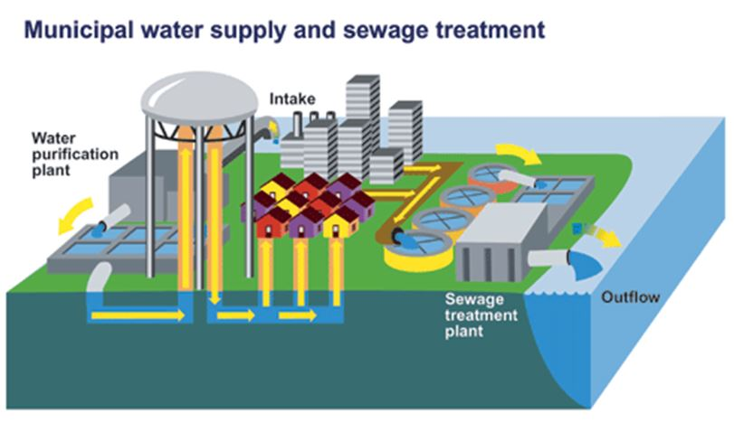

Team Members

Motunrayo Osatohanmen Ibiyo – (Mat No: **297859**)

Mariama Celi Serafim De Oliveira – (Mat No: )

**IoT-Based Water Quality Monitoring System for Urban/Rural Water Distribution**

Department of Information Engineering, Computer Science and Mathematics

University of L’Aquila, Italy

**Professor Davide Di Ruscio**

**Software Engineering for Internet of Things (IoTs)**

Table of Contents

1. Introduction 1

2. Project Description 2

Water Distribution Network (WDN): 3

Project Scope: 3

Objective 3

Project Deliverables: 3

Exclusions 3

3. System Description 3

Components of the System 3

Metrics Description Table 5

Applicable Domain 6

4. Functional Requirements 6

5. Non-Functional Requirements 7

6. System Architecture 7

Architecture Overview 7

Architecture Component 7

# Introduction

Water is a fundamental necessity in daily human activities. The United Nations defines the human right to water as the entitlement of everyone, without discrimination, to sufficient, safe, acceptable, physically accessible, and affordable water for personal and domestic use [*insert reference*].” As part of the 6th Sustainable Development Goal (SDG), the UN aims to improve water availability, promote sustainable water management, and enhance sanitation for the entire population. To achieve this goal, most countries have established water supply network/system to manage resources from various sources—such as rivers, lakes, and underground wells—through treatment plants to the final point of consumption, whether for residential, industrial, commercial, or firefighting use.

The structure of a water supply system typically involves two key phases:

1. **A screenshot of a computer

   Description automatically generatedWater sources – Treatment Plant (Water supply):** In this phase, water is sourced from rivers, lakes, bore wells, etc., and transported to a treatment plant, where it undergoes filtration, aeration, and disinfection to make it suitable for human consumption.

Figure 1: Water supply network

1. **Water Distribution network (WDN)**: Once treated, the water is stored in a Clearwell for distribution. This phase involves the transportation of water from centralized storage to the end users through a network of pipes, valves, pumps, and storage tanks, which is influenced by city topography and demand.

This project focuses on the **second phase: the Water Distribution network (WDN)**

After treatment, water is stored and distributed through a complex system of infrastructure. During distribution, it is crucial to monitor water quality to ensure it meets regulatory standards, such as those outlined in the European Union Water Framework Directive, the U.S. Clean Water Act, and WHO drinking water quality guidelines.

However, water quality monitoring is not the only challenge in WDNs. Issues such as pipe cracks, bursts, and leaks can lead to water contamination or service disruptions. Traditional management techniques struggle to effectively handle these challenges due to the spatial complexity of WDNs. According to [1], WDN management consists of nine distinct components. While this project will not cover leak detection, pressure control, demand prediction, or other aspects of WDN management, it will address one critical component: **Water Quality Monitoring using IoT technology**.

# Project Description

The quality of water distributed for human consumption must meet specific standards defined by governing bodies. These standards typically classify water quality metrics into three categories: physical, chemical, and biological. Physical parameters include colour, temperature, and odour, while chemical metrics focus on substances like pH, hardness, and the presence of metals (iron, aluminium, zinc) or ions (carbonate, sulphates, nitrates). Biological factors might include contaminants like pathogens or microorganisms. These measurements must be conducted at various stages throughout the water distribution network (WDN) to ensure that water quality is maintained.

## Water Distribution Network (WDN):

The WDN comprises two key components involved in transporting treated water from storage to consumers:

1. **Regional Storage Tanks**: After treatment, water is moved from the Clearwell to large-capacity regional storage tanks positioned at elevated altitudes to supply water to different zones.
2. **Distribution Pipes**: These pipes transport water from the storage tanks to the consumers, following various network configurations depending on the city's topography and demand.

## Project Scope:

This project focuses on real-time monitoring of water quality at two critical points in the WDN: regional storage tanks and distribution pipes. The goal is to develop a system that continuously monitors key water quality parameters, provides alerts when thresholds are breached, and activates actuators to mitigate potential issues based on the detected anomalies.

Objective:

* Develop and deploy an IoT-enabled system for real-time monitoring of water quality across the city's water distribution network, ensuring the safety and reliability of water supplied to households.

### Project Deliverables:

* Installation of IoT sensors at key points in the city's water distribution network to monitor parameters such as pH, turbidity, temperature, conductivity, and contamination levels.
* Real-time data collection, storage, and analysis.
* Automated alerts for abnormal water quality readings or contamination risks.
* A user-friendly dashboard for water authorities and households to monitor water quality trends.

Exclusions:

* Maintenance of water distribution infrastructure (e.g., pipelines, tanks).
* Monitoring of non-potable water sources (e.g., industrial effluents or untreated water bodies).

# System Description

The proposed IoT-based **Water Quality Monitoring System (WQMS)** is designed to ensure and maintain the quality of water within a Water Distribution Network (WDN). It comprises six main components, each playing a critical role in monitoring, managing, and responding to water quality parameters. The components interact seamlessly to create a robust and responsive system.

## 

## Components of the System

1. **Sensors**:

The system will employ **seven types of sensors** to measure critical water quality parameters across the WDN. These sensors provide real-time data for analysis and action.

Table 1: Sensors Description

|  |  |  |
| --- | --- | --- |
| **Sensor** | **Function** | **Application Stage** |
| **ORP Sensor** | Measures overall water quality based on voltage between electrodes (oxidative/reductive capacity). | Storage Tanks |
| **pH Sensor** | Monitors hydrogen ion concentration, indicating acidity or alkalinity (ideal range: 6-8.5). | Storage Tanks, Distribution Pipes |
| **Salinity Sensor** | Detects salt levels by measuring water conductivity (acceptable: 0–600 mg/L). | Storage Tanks, Distribution Pipes |
| **Ultrasonic Level Sensor** | Monitors water levels in storage tanks, aiding in distribution planning. | Storage Tanks |
| **Turbidity Sensor** | Detects cloudiness/haziness in water caused by suspended solids (ideal: <1 NTU). | Storage Tanks |
| **Temperature Sensor** | Measures water temperature, which impacts chemical reactions and solubility. | Storage Tanks |
| **Flow Sensor** | Tracks the flow rate of water in pipes and tanks. | Distribution Pipes |

1. **Middleware**

The middleware acts as the central processing hub, receiving sensor data, analyzing it, and initiating appropriate actions.

* **Data Processing**:
  + Receives data from sensors and compares it to predefined acceptable ranges.
  + Analyzes metrics such as pH, turbidity, salinity, and temperature to determine water quality.
  + Detects anomalies or threshold breaches.
* **Control Signals**:
  + Sends commands to actuators (e.g., close valves, activate dosing pumps) when conditions warrant action.
* **Data Forwarding**:
  + Forwards sensor data to the database for historical storage.
  + Provides real-time data to dashboards for visualization.

1. **Database**

The system includes two key types of databases for managing data:

1. **Sensor Data Store**:
   1. A **time-series database** stores real-time sensor data, enabling trend analysis and anomaly detection.
   2. Ensures data is organized for quick retrieval and long-term analysis.
2. **Alerting System**

Alerts are triggered when sensor readings fall outside acceptable ranges, as defined in the **Metrics Description Table**.

**Functions**:

* 1. Notifies system managers about critical conditions, such as contamination or equipment failures.
  2. Send notifications via specified channels (e.g email, SMS, app alerts).

1. **Dashboard and Visualization**

A **user-friendly dashboard** provides visualization of real-time and historical data, enabling quick decision-making and system management.

**Features**:

* + Real-time metrics for each sensor (e.g., pH, turbidity, salinity).
  + Graphical trends and historical data for long-term analysis.
  + Alerts and event logs for system monitoring.

**Users**:

* + Water distribution authorities for operational oversight.
  + Maintenance teams for identifying and resolving system issues.
  + Regulatory bodies for compliance and reporting.

## Metrics Description Table

The table below summarizes the acceptable and unacceptable ranges for key water quality parameters.

Table 2: Metrics' threshold specifications

|  |  |  |  |  |
| --- | --- | --- | --- | --- |
| **S/N** | **Sensor** | **Measurement Range** | **Acceptable Value** | **Stage Needed** |
| 1 | **ORP Sensor** | -100 to 1000 mV | 650–700 mV | Storage Tanks |
| 2 | **pH Sensor** | 0–14 | 6–8.5 | Storage Tanks, Distribution Pipes |
| 3 | **Salinity Sensor** | 0–50,000 mg/L | Ideal: 0- 600  Fair: 600 -900  Poor: 900 – 1000  unacceptable: >1000 | Storage Tanks, Distribution Pipes |
| 4 | **Ultrasonic Level Sensor** | 0–8 meters | >0 | Storage Tanks |
| 5 | **Turbidity Sensor** | 0–50 NTU | 0–5 (<1 best) | Storage Tanks |
| 6 | **Temperature Sensor** | -55°C to 150°C | 25–30°C | Storage Tanks |
| 7 | **Flow Sensor** | >3–10 feet per second | Variable by pipe size | Distribution Pipes |

## Applicable Domain

**Urban Utilities and Smart Cities**: The system is designed for water supply authorities, urban households, and municipal governance, particularly in cities looking to improve the efficiency and safety of their water distribution systems.

# Functional Requirements

Table 3: Systems Functional Requirements

|  |  |  |
| --- | --- | --- |
| Functional Requirements for IoT-Based Water Quality Monitoring system | | |
| Identifier | Name | Description |
| WQMS-FR001 | Data Collection | The system must continuously monitor water quality parameters using sensors from different tanks and distribution pipeline in different areas of the city. |
| WQMS-FR002 | Poor Quality Detection | The system must be able to detect water quality anomalies in realtime based on thresholds defined in the metrics description table. |
| WQMS-FR003 | Data Transmission | The system must transmit sensor data wirelessly to the datastore using IoT communication protocols. |
| WQMS-FR004 | Alerts and Notifications | The system should be able to automatically alerts city authorities if water quality falls below acceptable standards. |
| WQMS-FR005 | Monitoring Interface | The system should be able to provide a monitoring interface for authorities to monitor the current and historical state of all tanks and distribution pipelines |
| WQMS-FR006 | Configurable thresholds and targets | The system should allows user to modify the configuration of custom water quality thresholds and targets for different parameters and areas. |

# Non-Functional Requirements

Table 4: System Non-functional Requirements

|  |  |  |
| --- | --- | --- |
| Non-Functional Requirements for IoT-Based Water Quality Monitoring system | | |
| Identifier | Name | Description |
| WQMS-NFR001 | Performance | The system must provide real-time monitoring with minimal latency (<5 seconds) for critical alerts. |
| WQMS-NFR002 | Scalability | The system should support deployments in cities of various sizes, accommodating hundreds or thousands of sensors. The system must also be deployable in several cities. |
| WQMS-NFR003 | Reliability | The system must ensure 99.9% system uptime with redundancy for data storage and failover mechanisms. |
| WQMS-NFR004 | Security: | The system must have an authorization and access control mechanism to prevent unauthorized access or tampering. |
| WQMS-NFR005 | Compliance | The system should allows user to modify the configuration of custom water quality thresholds and targets for different parameters and areas. |

# System Architecture

## Architecture Overview

The **Water Quality Monitoring System (WQMS)** was built using containerized services (Docker). It leverages MQTT for message brokering, Node-RED for integration, InfluxDB for storage, Grafana for visualization, and Telegram for alerts. Below is an overview of its components and workflow:

Figure 2: An overview of WQMS Architecture

## Architecture Component

1. Sensors Simulation:

The sensor Simulation service is responsible for simulating the values of the sensors in the area tanks and the distribution pipeline. The sensor services uses a configuration file named ‘configuration.json’. to initialize sensors in specified locations for the Area Tank and the distribution network. The sensor simulation service publishes the sensot values to MQTT topics. The MQTT topics are in the pattern:

Tank: ‘water_quality/area/tank_name’

Distribution_pipelin sensors: ‘water_quality/area/tank/distribution_pipeline_name/’

1. MQTT Broker: The Eclipse mosquitto was used as a message broker to receive published messages from the sensor simulation service and also make it available to the subscribers of the topics.
2. **Node-RED** – In our system, NodeRed was responsible for three tasks, which are the flows depicted in Figure 2.

Figure 3: Node-RED flows

* 1. **Save sensor data into DB**: The first flow, located at the top, was responsible for subscribing to the topic water_quality/#, processing the received information, and saving it in the InfluxDB database.
  2. **Load variable thresholds**: The second flow, located in the middle, was designed to establish the variable thresholds as global variables in Node-RED, enabling the triggering of Telegram alerts. Initially, these values were stored in a file named thresholds.json, allowing users to modify them at any time prior to running the containers.
  3. **Sending alerts to Telegram**: The third flow, positioned at the bottom, retrieves the most recently saved data from InfluxDB for each tank and pipeline every minute. It checks whether the data falls outside of the specified thresholds and then sends an alert to a Telegram group. Figure 3 illustrates the messages received in the Telegram groups resulting from threshold breaches. The sent messages indicate the specific location and variable that was breached.

Figure 4: Telegram Alert sent by the system

1. **InfluxDB** – This database is responsible for storing the time series data collected by the water system sensors. A bucket called waterdistribution was created to contain all the data from the sensors. To index each data point in the database, the timestamp, type of measurement (pipeline or tank), zone, tank, and device name were utilized. Additionally, each variable was stored as a field with its corresponding values. Figure 4 illustrates the values that were stored for each datapoint of a variable in the database.

Figure 5: Query results for the Flow datapoint in InfluxDB

1. **Grafana** –In Grafana, we created the application dashboard. The dashboard allows visualization of the tanks' and pipelines' locations, as well as their current values. Additionally, time series data for all measurements is plotted in various line graphs. The dashboard plots enable us to observe when extreme values occur and compare data from different locations. Figure 5 shows the top part of the implemented dashboard.

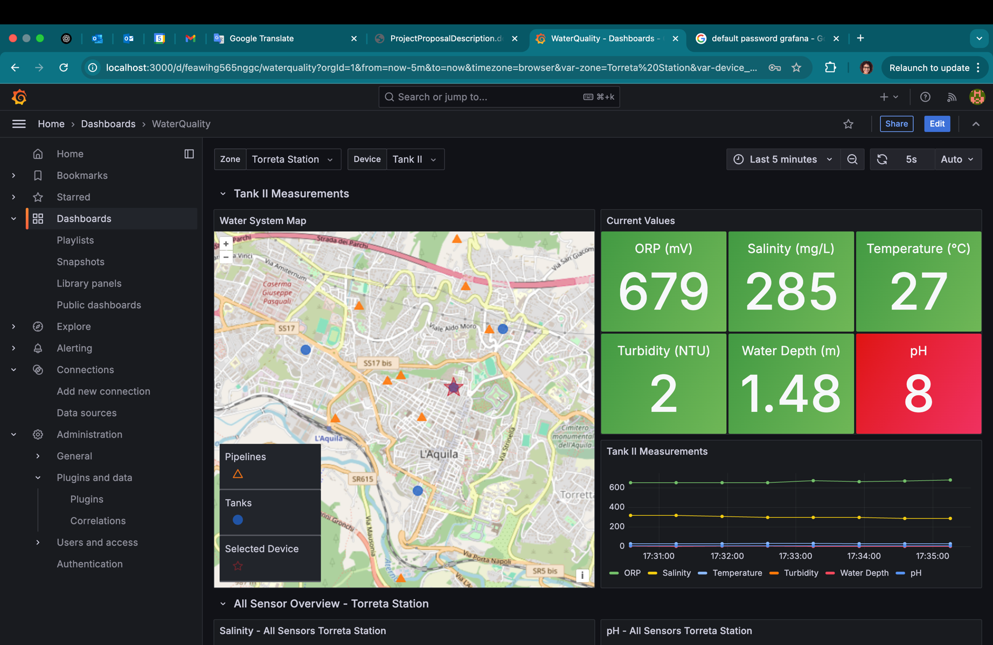

Figure 6: Grafana dashboard

**References**

1. N. K. Velayudhan, P. Pradeep, S. N. Rao, A. R. Devidas and M. V. Ramesh, "IoT-Enabled Water Distribution Systems—A Comparative Technological Review," in IEEE Access, vol. 10, pp. 101042-101070, 2022, doi: 10.1109/ACCESS.2022.3208142.
2. <https://mrccc.org.au/wp-content/uploads/2013/10/Water-Quality-Salinity-Standards.pdf>
3. <https://www.sahealth.sa.gov.au/wps/wcm/connect/public+content/sa+health+internet/public+health/water+quality/salinity+and+drinking+water>
4. <https://cdn.cyfoethnaturiol.cymru/media/694218/information-note-turbidity.pdf>
5. <https://www.dypcn.com/news/how-to-monitor-the-water-level-of-the-pipe-network-what-sensor-is-used-to-monitor-the-water-level-of-the-drainage-pipe-network/>
6. <https://eur-lex.europa.eu/eli/dir/2020/2184/oj>
7. <https://ieeexplore.ieee.org/abstract/document/9895399>
8. <https://ieeexplore.ieee.org/document/7960032>
9. <https://ieeexplore.ieee.org/document/8016224>
10. <https://eur-lex.europa.eu/EN/legal-content/summary/drinking-water-essential-quality-standards.html>
11. To Read
12. <https://evogov.s3.amazonaws.com/media/60/media/17107.pdf>
13. <https://mimoza.marmara.edu.tr/~orhan.gokyay/enve311/ch8.pdf>
14. https://sdgs.un.org/goals/goal6