Project: IoT-Based Water Quality Monitoring System for Urban/Rural Water Distribution

Introduction

Water is an essential necessity in the day-to-day operations of humans. According to the United Nations, “The human right to water entitles everyone without discrimination to sufficient, safe, acceptable, physically accessible and affordable water for personal and domestic use [*insert reference*].” The sixth sustainable development goal (SDG) of UN targets improved water availability, sustainable management of water and sanitation for entire population [5]. To achieve this goal, most countries have a water supply network/system, which comprises of the management of water resources from the source (Rivers, lake, underground sources) to the final destination (where it is consumed) for residential, industrial, commercial and firefighting use.

The generic structure of a water supply system involves two phases.

1. Water sources – Treatment Plant: this phase involves the movement/ intake of water from their sources, river, lakes, bore wells etc to the treatment plant, where the water is filtered, aerated, and disinfected to make it suitable for human use.
2. Water Distribution network (WDN): This second phase involves the distribution of water from the centralized treatment plant to the users.

In this project, we will focus on the second phase of the water supply system.

the distribute water to domestic consumers via a water supply system.

Objective:

* The objective of this project is to develop and deploy an IoT-enabled system for real-time monitoring of water quality parameters across a city’s distribution network, ensuring safe and reliable water supply to households.
* Project Scope:
* Installation of IoT sensors at key points in the city’s water distribution network to monitor parameters such as pH, turbidity, temperature, conductivity, and contamination levels.
* Real-time data collection, storage, and analysis via a cloud-based system.
* Alerts for abnormal water quality readings and potential contamination.
* Development of a user-friendly dashboard for city water authorities and households to monitor water quality trends.
* Integration of predictive analytics for detecting potential contamination risks.
* **Exclusions**:
  + Maintenance of water distribution infrastructure (e.g., pipelines, tanks).
  + Analysis of non-potable water sources (e.g., industrial waste, untreated water bodies).

Applicable Domain

**Urban Utilities and Smart Cities**: Specifically targeting water supply authorities, urban households, and municipal governance.

Functional Requirements

**Functional Requirements**

1. **Data Collection**:
   * IoT sensors deployed to measure water quality parameters (e.g., pH, turbidity, TDS, chlorine levels).
2. **Data Transmission**:
   * Wireless data transmission from sensors to the cloud using IoT communication protocols (e.g., LoRaWAN, NB-IoT).
3. **Data Processing**:
   * Real-time analysis of water quality data using cloud-based services.
   * Detection of anomalies such as contamination or supply disruptions.
4. **Notifications**:
   * Automated alerts to city authorities and affected households when water quality drops below acceptable standards.
5. **Visualization**:
   * Development of a dashboard to display water quality metrics, historical trends, and predictive insights.
6. **Reporting**:
   * Generation of automated water quality reports for city authorities and stakeholders.

Non-Functional Requirements

1. **Performance**:
   * Ensure real-time monitoring with a latency of <5 seconds for critical alerts.
2. **Scalability**:
   * Support deployment in cities of various sizes, accommodating hundreds to thousands of sensors.
3. **Reliability**:

System uptime of 99.9% with redundant data storage and failover mechanisms.

1. **Security**:

Implementation of data encryption and access control to prevent tampering or breaches.

1. **Energy Efficiency**:

Use of low-power IoT devices to ensure long-term deployment without frequent battery replacements.

1. **Compliance**:

Adherence to regional water quality standards and regulations.

In the Deliberation 917/2017/R/idr, ARERA, the six macro indicators concerning the different

aspects of integrated water services are:

• M1 - Containment of water losses in aqueduct networks and systems

• M2 - Maintenance of the continuity of the drinking water service, based on the measurement

of the frequency of service interruptions

• M3 - Adequacy of the quality of the water supplied

• M4 - Minimisation of the environmental impact of the conveyance of waste water, measured on the basis of the degree of adequacy of the sewage system

• M5 - Minimisation of the environmental impact associated with the disposal of sludge deriving from the purification of waste water

• M6 - Minimisation of the environmental impact associated with the disposal of waste water from purification treatments

With the application of those indicators, and others foreseen in the regulation of contractual quality and in the tariff methodology, some of the issues tracked for sanitation and drinking water are listed in the following table:

<https://eur-lex.europa.eu/EN/legal-content/summary/drinking-water-essential-quality-standards.html>

<https://eur-lex.europa.eu/eli/dir/2020/2184/oj>

<https://ieeexplore.ieee.org/abstract/document/9895399>

Hence, entire water distribution system management can be divided in to nine applications such as water quality monitoring, leak detection and monitoring, pressure control and monitoring, parameter estimation and monitoring, state estimation and monitoring, demand prediction and monitoring, pipe health monitoring, pump energy consumption monitoring, and water resource management [68].

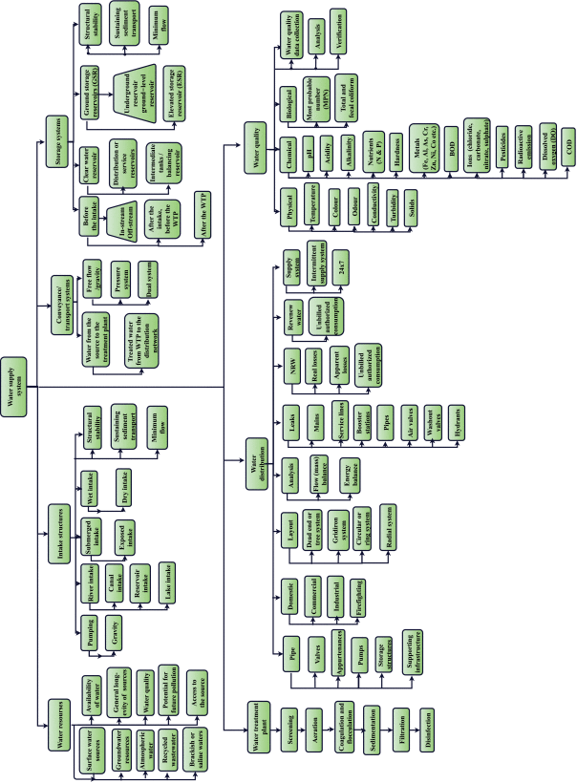

<https://ieeexplore.ieee.org/document/7960032> 1

<https://ieeexplore.ieee.org/document/8016224> 2

Sensors:

1. ORP Sensor - ORP (Oxidation Reduction Potential) is a popular water quality parameter that is normally measured as the voltage between a platinum measuring electrode and a reference electrode [12]. ORP is classically based on a Standard Hydrogen Electrode (SHE) as a reference. This sensor indicates the quality of the water.
2. PH Sensor- A pH Meter is a scientific instrument that measures the hydrogen-ion concentration (or pH) in a solution. This sensor defines the acidity and alkalinity level of the water [2].
3. Salinity Sensor - This sensor measures the level of salt present in the water. Pure water has a high resistance to the flow of electricity whereas salt water has a high electrical conductivity and a salinity sensor works with this principle [13].
4. Ultrasonic/Level Sensor - Level sensors are ultrasonic sensors which have an acoustic transducer which vibrates at ultrasonic frequencies [14]. The pulses are emitted in a cone-shaped beam aimed at a target object which returns after hitting the target object. The time taken for this beam to return gives us the distance, which is the level of the water in the canal or tank.

 According to its datasheet, the ultrasonic sensor detects objects from 0-inches to 254-inches (6.45-meters) and provides sonar range information from 6-inches out to 254-inches with l-Inch resolution. -1

1. Turbidity Sensor- Turbidity sensors measure the amount of light that is scattered by the suspended solids in both tank and canal water [15]. As the amount of total suspended solids (TSS) in water increases, the water's turbidity level (and cloudiness or haziness) also increases.
2. Temperature Sensor- A temperature sensor measures the hotness or coolness of an object. The sensor's working base is the voltage that's read across the diode [16]. The temperature rises whenever the voltage increases. This gives the temperature measurement of the water in the canal and tank.
3. Flow sensor - This measures liquid flowing through a pipe or a container by counting the pulses from the output of the sensor. We can easily calculate the flow rate (in liters/hour) using a suitable conversion formula [17].

|  |  |  |  |  |  |
| --- | --- | --- | --- | --- | --- |
| S/N | Sensor | Measurement Range | Acceptable value for the human body | Influence | Stage needed |
| 1 | Oxidation Reduction Potential |  |  |  |  |
| 2 | PH sensor | 0-14 | 6-8.5 |  | Flow and storage sensor |
| 3 | Salinity Sensor |  |  |  |  |
| 4 | Water level | 0 - 6.45-meters | Depending on the storage capacity (0-max) |  | storage sensor |
| 5 | Turbidity |  | 0-5 |  | Flow and storage sensor |
| 6 | Temperature Sensor (digital thermometer) | -55 – 150 oC | 25 to 30 |  | Flow sensor |
| 7 | Flow sensor |  |  |  |  |

Actuators

Solenoid Water Valve: The Solenoid water valve is used to control the water flow in order to change the water flow to the filters or not, according to the received command from the controller. (<https://www.sciencedirect.com/science/article/pii/S2212827120308532> )