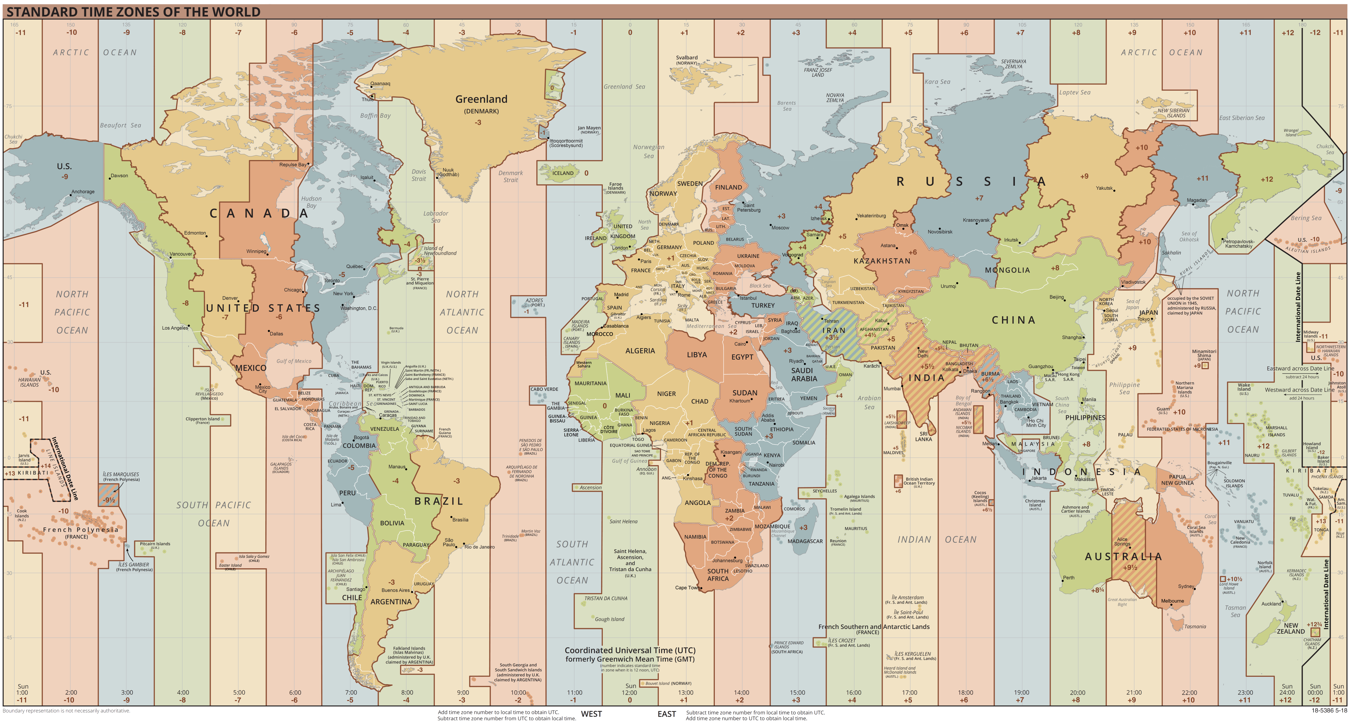
Les Time Zones

Standard Time /= Daylight Time (heure d’été = +1h)

America Time Zones :
HST : Hawaii Time → UTC-10
AK(D/S)T : Alaska Time → UTC-9 (standard)
P(D/S)T : Pacific Time → UTC-8 (standard)
Los Angeles, San Francisco, Las Vegas
M(D/S)T : Mountain Time → UTC-7 (standard)
Phoenix, Albuquerque, Denver
C(D/S)T : Central Time → UTC-6 (standard)
Chicago, Nouvelle Orléans, Mexique
E(D/S)T : Eastern Time → UTC-5 (standard)
New York, Washington DC, Miami, Canada
A(D/S)T : Atlantic Time → UTC-4 (standard)
Puerto Rico
BR[S]T : Brazil Time → UTC-3 (standard)

Europe Time Zones :
(GMT : Greenwich Mean Time → UTC+0)
WE[S]T : Western European Time → UTC+0
Irlande, Îles Brittaniques
CE[S]T : Central European Time → UTC+1
France, Allemagne, Espagne
EE[S]T : Eastern European Time → UTC+2
Finlande, Ukraine, Afrique du Sud

Formats de date

MDY : mm/dd/yyyy → États-Unis
YMD : yyyy-mm-dd → Canada
DMY : dd/mm/yyyy → France

Formats d’heure

24-hour clock | 12-hour clock
00:00 | 12:00 am
01:00 | 1:00 am
12:00 | 12:00 pm
13:00 | 1:00 pm

24-hour clock → Canada, France
12-hour clock → États-Unis

Devises et format prix et nombre

(22 janvier 2020)
EUR (€) : Euro
USD ($) : US Dollar ; 1000€ <=> $1,108.24
CAD ($ ou C$) : Canadian Dollar ; 1000€ <=> $1,450.20

$1 = 100¢

Numéros de téléphone

North American Numbering Plan (NANP) :
NPA-NXX-XXXX
→ NPA (Numberting plan area code) : three digit area code. [2–9] for the first digit,
and [0- 9] for the second and third digits.
→ NXX : Central office (exchange) code. [2–9] for the first digit, and [0–9] for both the second and third digits.
→ XXXX : Line number or subscriber number. [0–9] for each of the four digits.

The country calling code for all countries participating in the NANP is 1.
In international format, an NANP number should be listed as +1 NPA NXX XXXX.

Internation call prefix for NANP countries : 011 (example : 011 64 3 477 4000)
Internation call prefix for France : 00 (example : 00 64 3 477 4000)

NANP → États-Unis, Canada

Metrication

Imperial units :
Length :
→ 1 mile (mi) <=> 1.61 kilometres
→ 1 yard (yd) <=> 0.91 metres
→ 1 inch (in or ″) <=> 2.54 centimetres
→ 1 yard (yd) = 3 feet
→ 1 foot (ft or ′) = 12 inches
→ 180 centimetres <=> 5.91 feet (ft or ′)
Mass and weight :
→ 1 pound (lb) <=> 0.45 kilogrammes
→ 1 pound (lb) = 16 ounces (oz)
→ 1 ounce <=> 28.35 grammes
→ 100 kilogrammes <~> 220 pounds (lb) <~> 3530 ounces (oz)

Imperial units → États-Unis, Canada
Metric system → Europe

Temperature scales

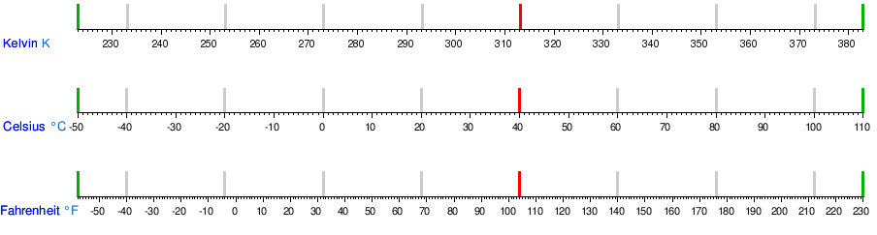
25 °C <=> 77 °F
Freezing water : 0 °C <=> 32 °F
Boiling water : 100 °C <=> 212 °F

Celsius to Fahrenheit :
(T°F) = (T°C) * (9/5) + 32

Fahrenheit to Celsius :
(T°C) = ( (T°F) – 32 ) * (5/9)

