

**KHULNA UNIVERSITY OF ENGINEERING & TECHNOLOGY**

**Department of Computer Science and Engineering**

**PROJECT REPORT ON HOSPITAL MANAGEMENT SYSTEM (PHP)**

**CSE 3100: Web Programming Laboratory**

**Project Name: Hospital Management System in PHP**

**Submitted By:**

**Name: Sanjida Akter Mou**

**Roll No: 1807118**

**Year: 3rd Semester: 1st**

**Department of Computer Science and Engineering (CSE)**

**Khulna University of Engineering & Technology (KUET)**

**Date of submission:21-07-2022**

**Objectives:**

1. Creating a hospital webpage named “Healthcare” for people to make doctor’s appointment through online.
2. Design a system for better patient care.
3. Provide top management a single point of control.
4. Reduce hospital operating costs.
5. Scheduling the appointments of patients with doctors to make it convenient for both.
6. To promote awareness of health care among all sections of people.
7. To promote awareness among functionaries involved in Health and Hospital Management.
8. To promote the development of high quality hospital services and community health care.

**Introduction:**

The “Hospital Management System” project has been developed to reduce the problems prevailing in the practicing manual system. I have named this project as “Healthcare”. This project is supported to eliminate the hardships faced by this existing manual system. This website is very easy to use. It is designed in a very simple way so that the users can save their time and make appointment to the hospital quickly. No formal knowledge is needed for the users to use this website. So, it is proved that the website is very user-friendly. It will take only 2 minutes to make appointment of doctors from this website. The aim is to automate its existing manual system by the help of computer software. Basically, the project describes how to manage for good performance and better services for the users.

In this project, I have used HTML, CSS as frontend, PHP as backend and to add some functionality, JavaScript has been used. Moreover, I have user Visual Studio Code text editor to code. It is mainly database-oriented. I have used PHP MyAdmin , MySQL for this purpose. PhpMyAdmin is a free and open source administration tool for MySQL and MariaDB. As a portable web application written primarily in PHP, it has become one of the most popular MySQL administration tools, especially for web hosting services. The project includes SQL insert, select, delete operations. It has two different functionalities for admin and users. I have used session to maintain the security of the users’ information and logged them in for the time being.

**Detailed Description:**

My project has both user and admin panel and some features which are described in details below:

1. **User Panel:**

* When a user will open the website, a home page will appear before him/her.
* In this page, user can see the about, service, reviews and some sections of the hospital.
* If user has already an account, he/she can click into the login page directly and make appointment. But if he/she doesn’t have an account, he/she has to register at first to make appointment.
* If the user doesn’t want to login or register, he/she can’t make appointment but still can send message to the admin.
* User can log out anytime.

1. **Admin Panel:**

* In the admin panel section, the admin will see the list of all users and admins and also can delete them from the admin dashboard.
* Admin can add doctors by proving some details of the doctors and can see the list of doctors which are added and also can delete the data.
* Admin can check the appointments made by the users and can cancel them.
* Admin can also see the messages sent by the users.
* Admin can log out anytime.

**Detailed visualization:**

* **Home page:** This page is visible for both admin and users.



* **About section:** This page is about the information of the hospital.

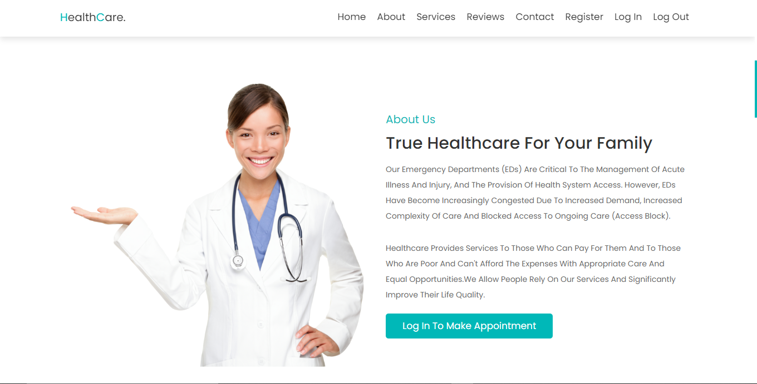

* **Services section:** This section is about the services the hospital authority provides.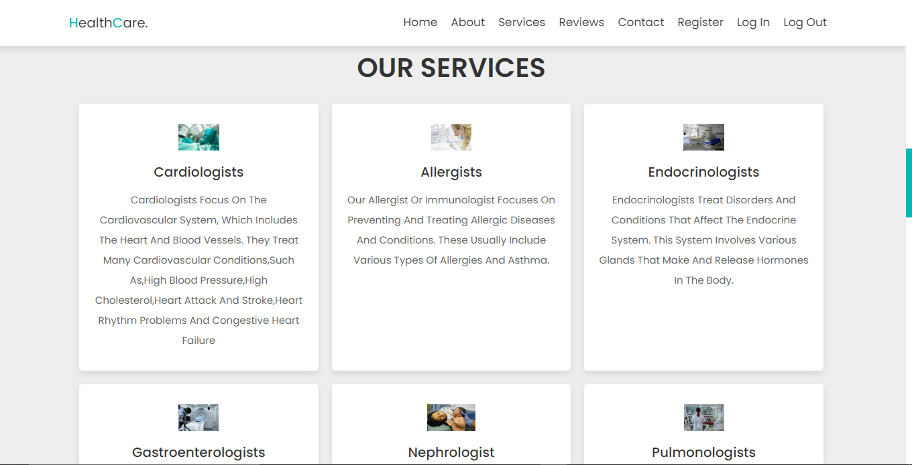 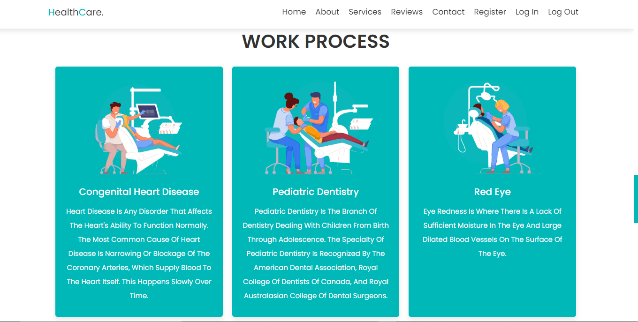
* **Reviews section:** This page is about the reviews of the users.

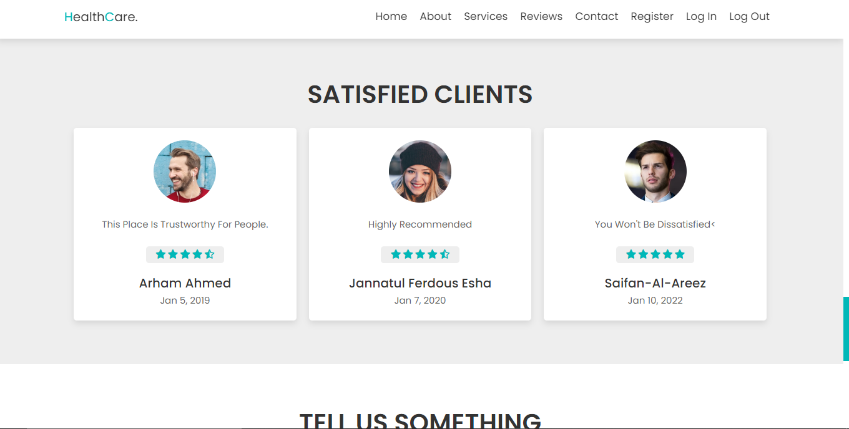

* **Contact section:** This page is about the contact section. From this section, user can send message to the admin.

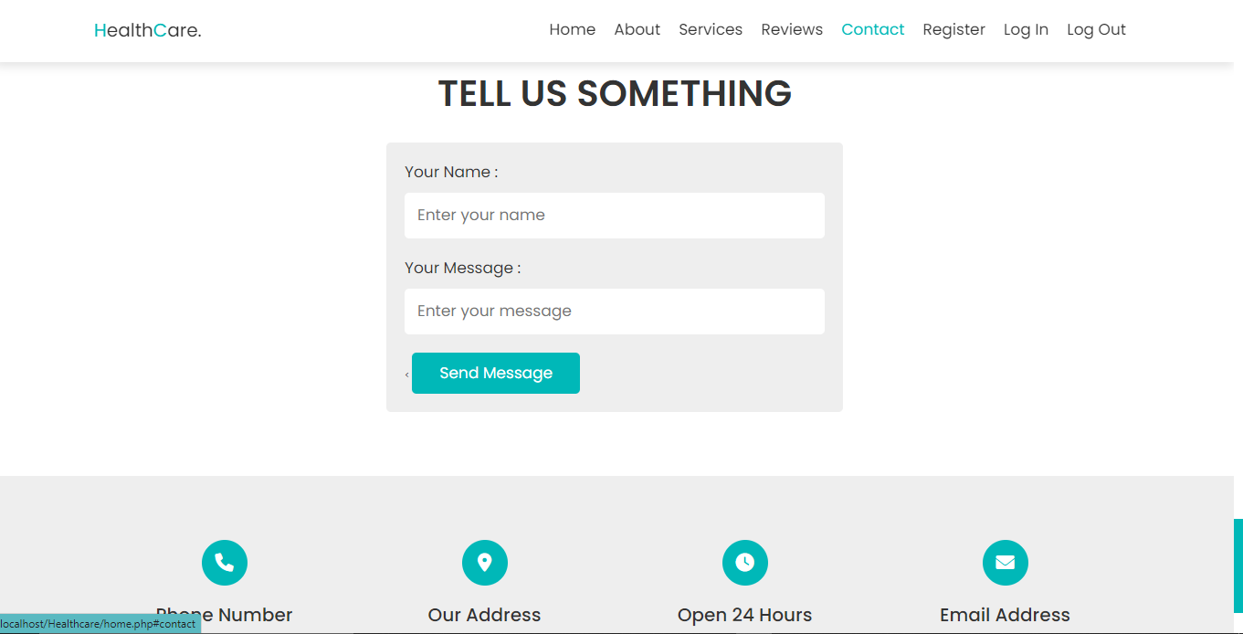

* **Register page:** This is the register page. Here, one can register as a admin or a user.

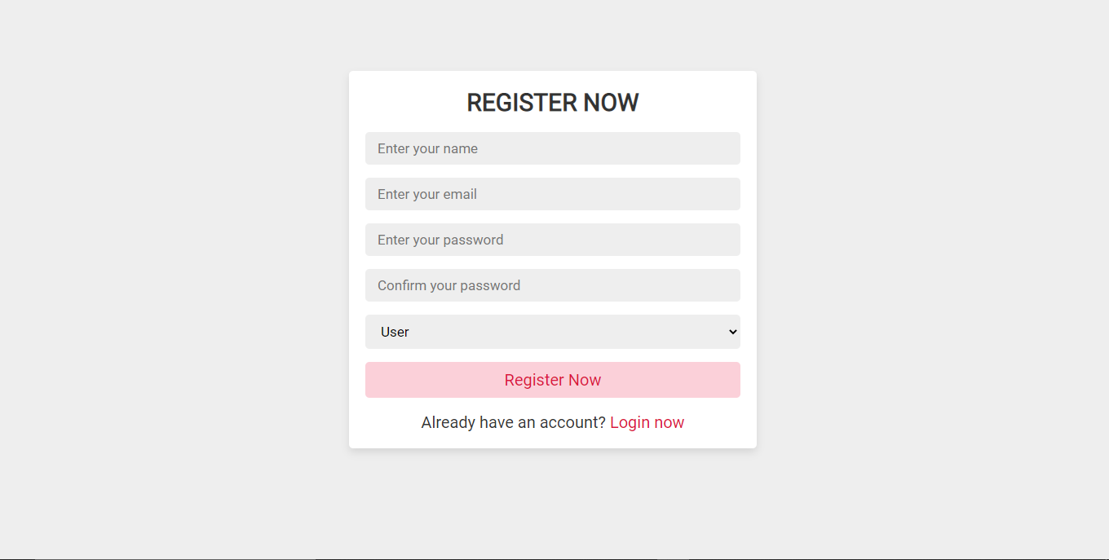

* **Login page:** This is the login page.

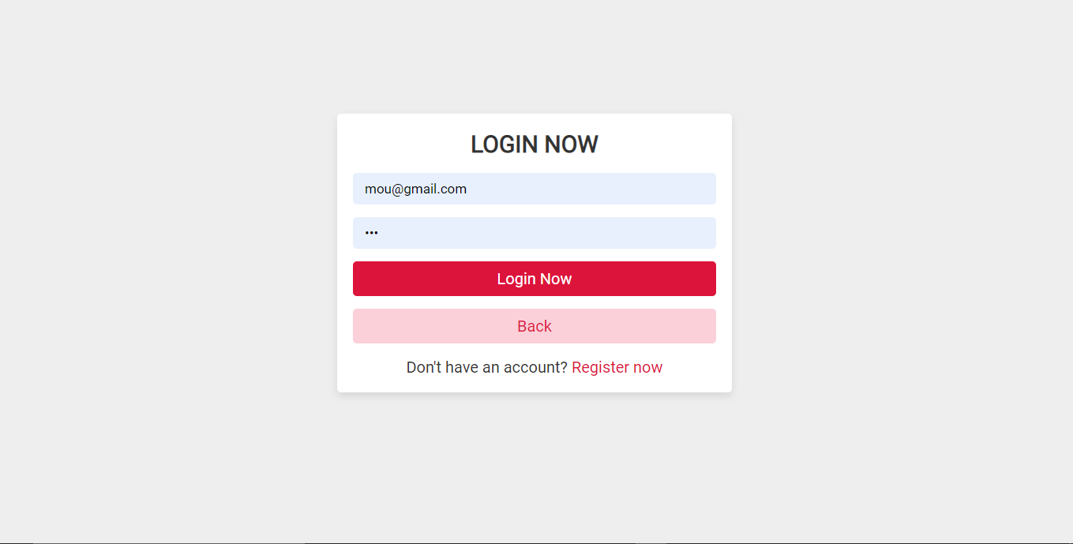

* **Make appointment section :** If user is logged in, this page will appear. It is same as the home page. But in here, user can make appointments by clicking on contact or Make appointment.

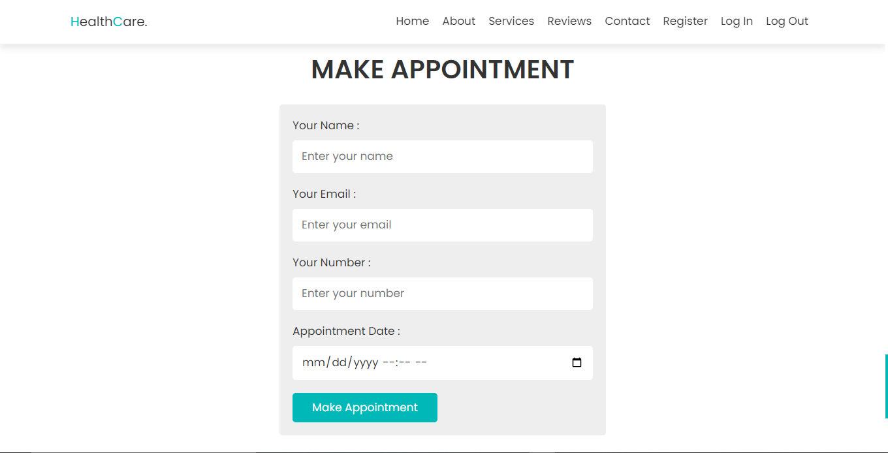

* **Admin-Dashboard:** If admin email, password is provided it will bring to this page named admin dashboard.

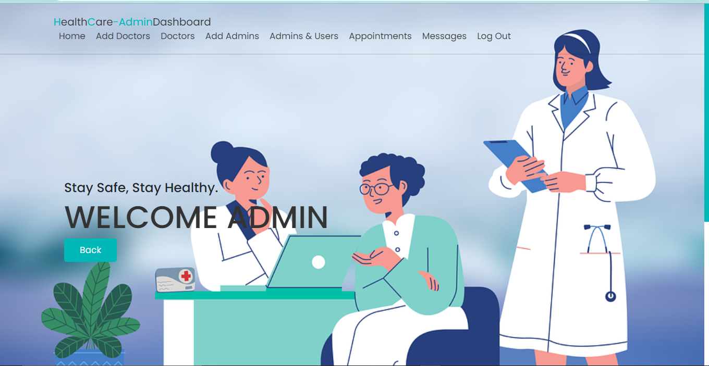

* **Add doctors section:** Here, admin can add doctors.

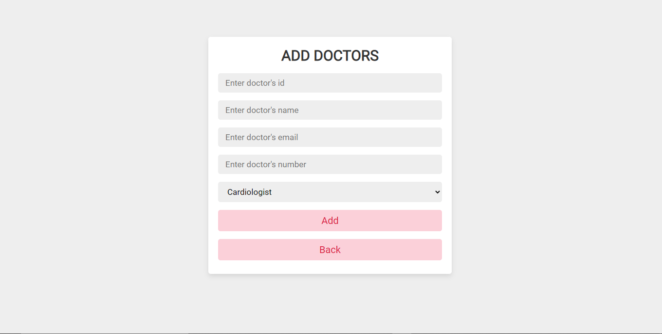

* **Doctor’s list section:** Admin can see the list of doctors.

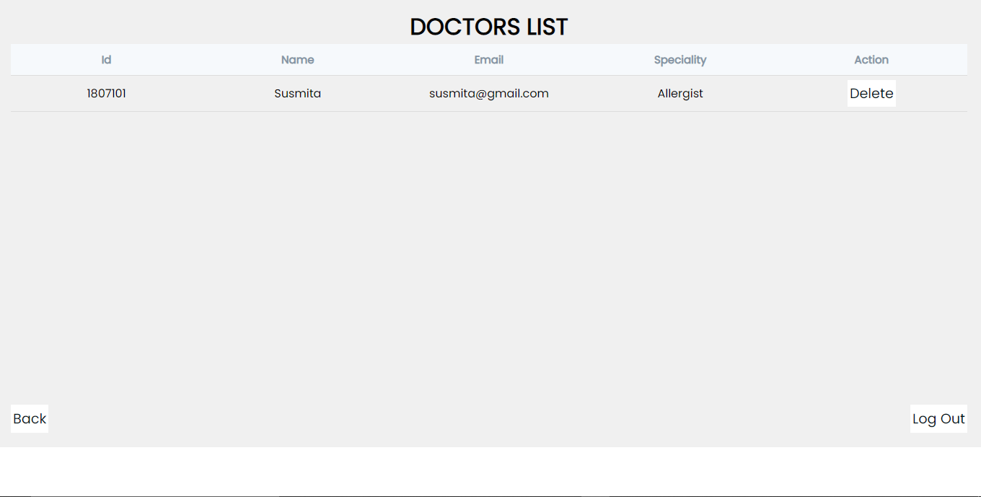

* **Add admins section:** Admin can add other admins.

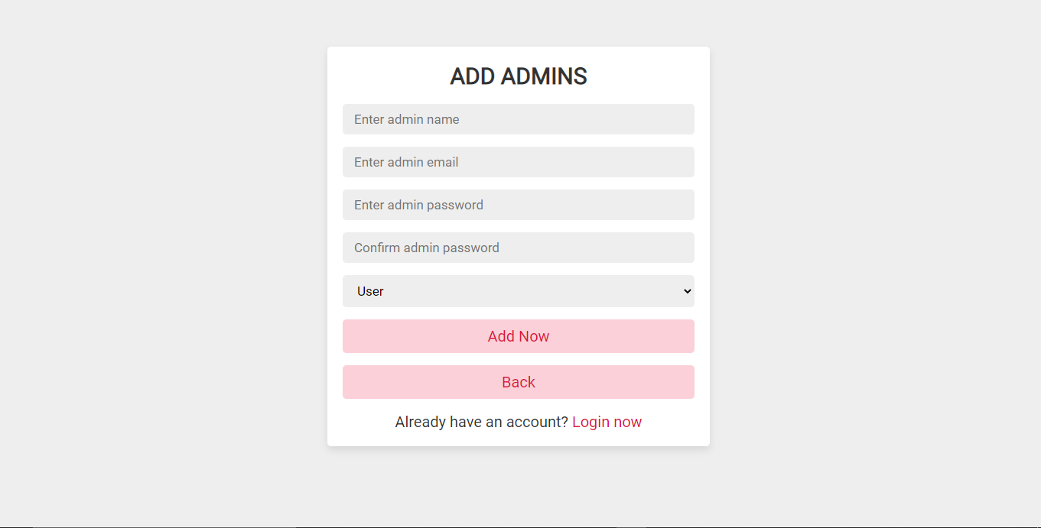

* **Admins and users section:** Admin can see the list of users and doctors.

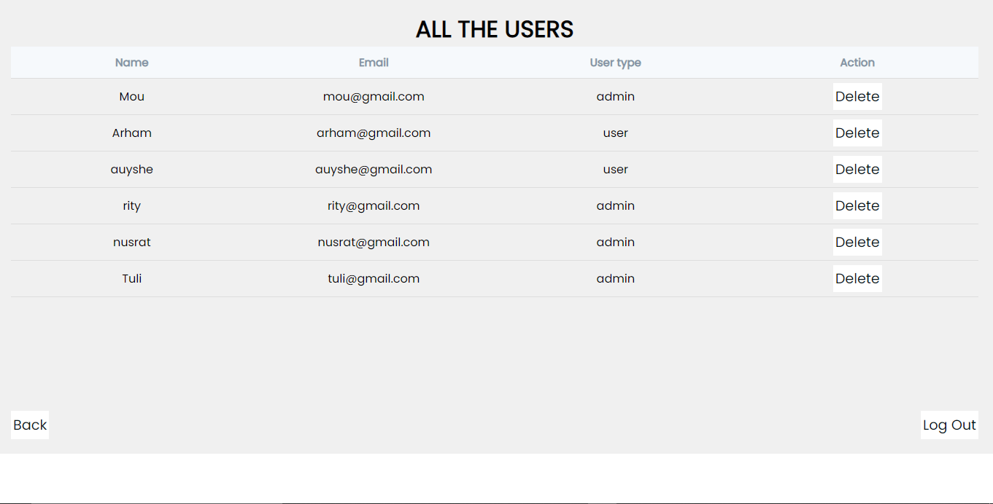

* **Appointments section:** Admin can see the appointments and also can cancel them if it is necessary.

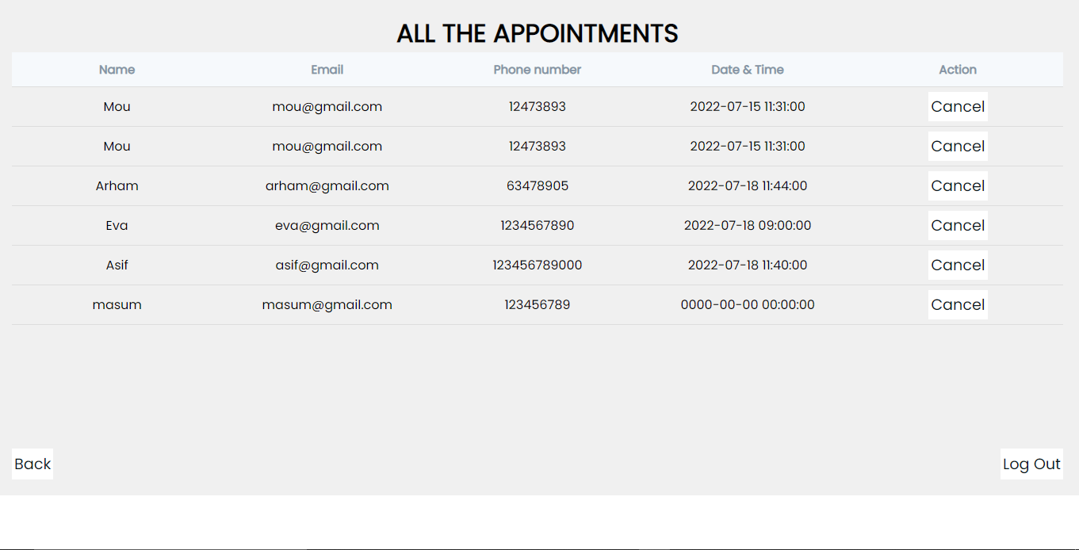

* **Messages section:** Admin can see the messages.

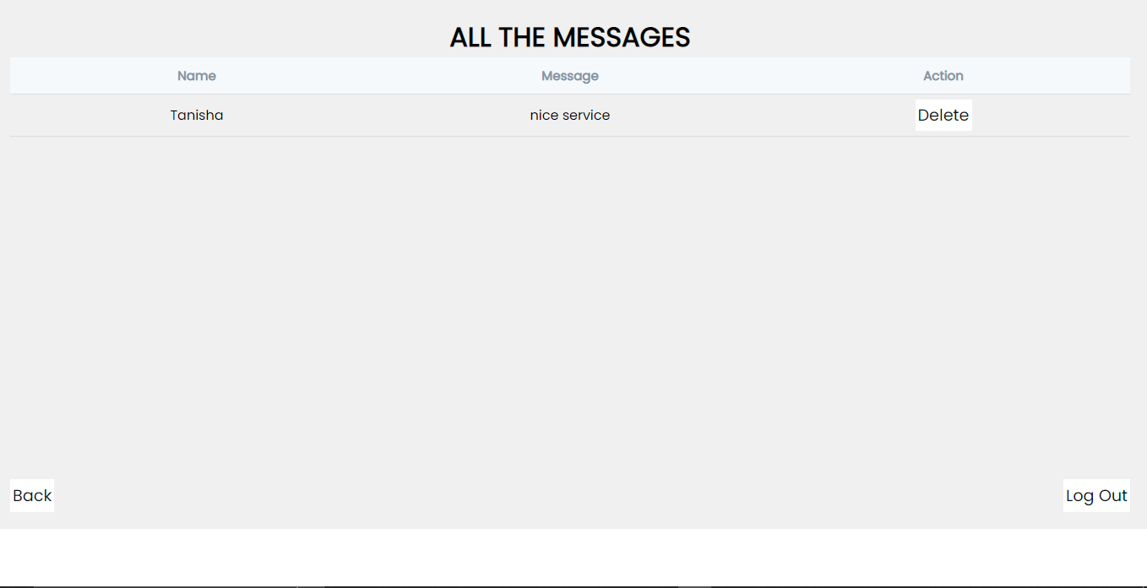

* If admin or user log out from the website, they will return to the home page.

**Flow chart:**

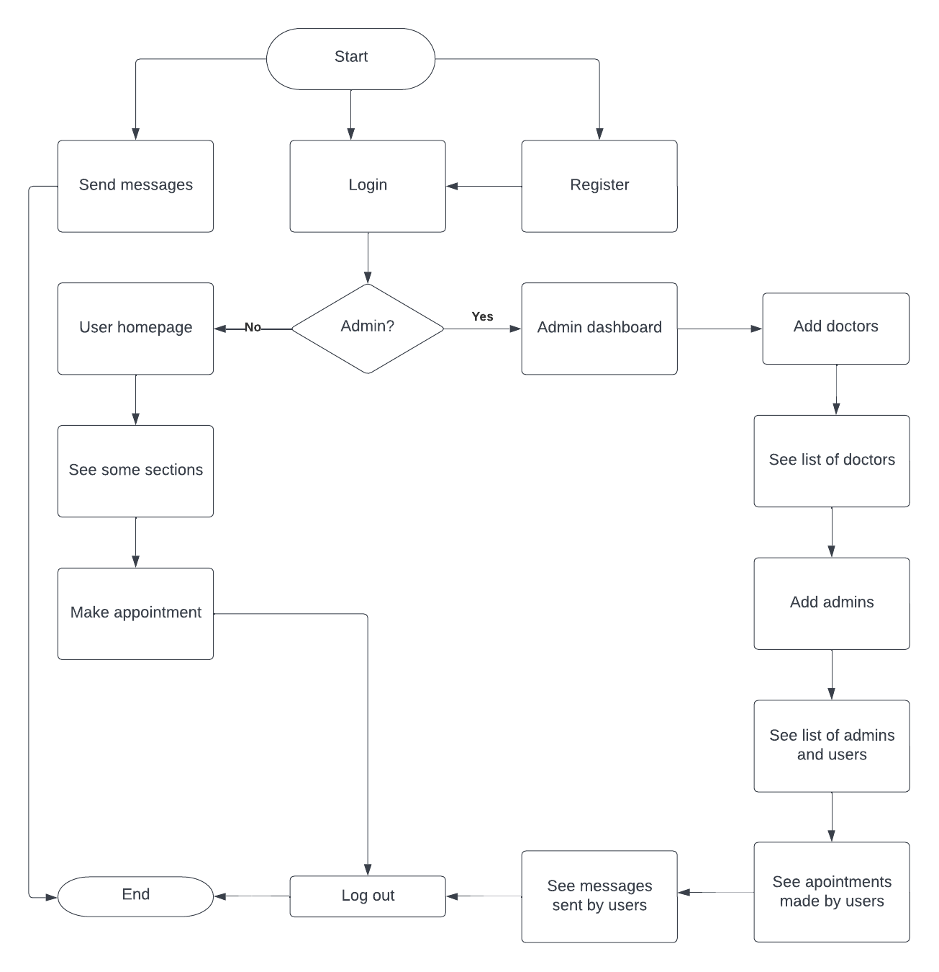

**Schema Diagram:**

In total I have used four tables to store my data.

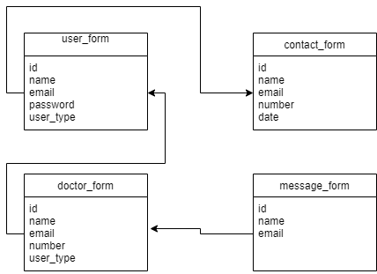

**Target and accomplishment:**

I tend to make a better user-page for users. I wanted to let the users know if their appointment is confirmed or not. But the process includes so much paperwork. So I couldn’t make this feature. Moreover I intended to make a chat system, but due to time inefficiency, I couldn’t do that. Otherwise, everything went fine.

**Discussion and conclusion:**

The project is basically for building a user-friendly hospital management system. I used PHP mysql database management system, Visual Studio code for text editor, DRAW SQL for designing the database and lucid chart for making the flow chart of the website. The xampp control panel denied its access for once. That’s the one issue I faced while making the project into reality. Otherwise I worked fine