**🔭 10. Future Scope – TrafficTelligence**

The **TrafficTelligence** system lays a strong foundation for intelligent traffic prediction, and it can be further expanded in multiple ways to enhance accuracy, usability, and impact:

**🚀 1. Real-Time Data Integration**

* Connect with **live weather APIs** (e.g., OpenWeather) and **traffic data APIs** to automate inputs and improve relevance.
* 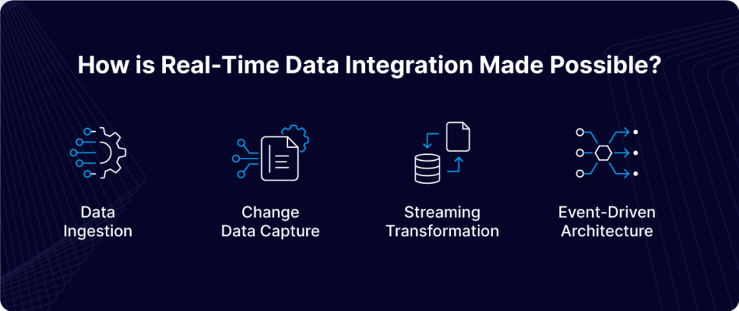

**🔐 2. User Authentication & Profiles**

* Implement login systems to allow users to **save prediction history**, track usage, or access advanced features.

**🧠 3. Advanced Machine Learning Models**

* Upgrade to models like **XGBoost**, **LSTM**, or **Neural Networks** to improve prediction performance, especially for time-series data.
* 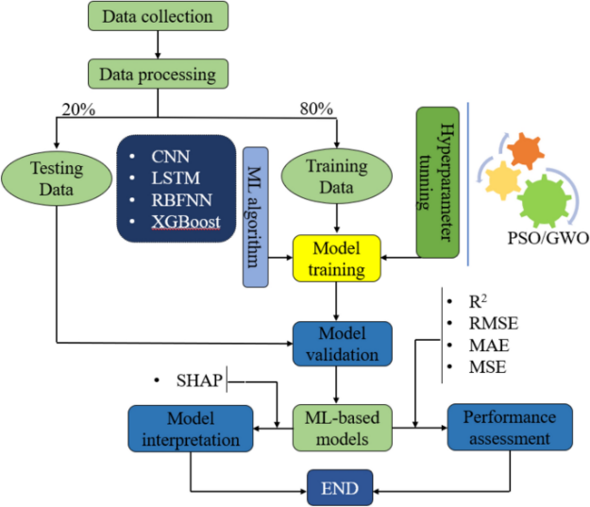

**📦 4. Database Integration**

* Use **MongoDB** or **MySQL** to store user inputs, results, and analytics for later visualization or reporting.

**📱 5. Mobile and Responsive Design**

* Enhance frontend using **React** or **Tailwind CSS** for mobile-friendly access and improved user experience.

**🌐 6. Cloud Deployment**

* Deploy the full application on platforms like **Render**, **Heroku**, or **AWS** to make it publicly accessible.
* 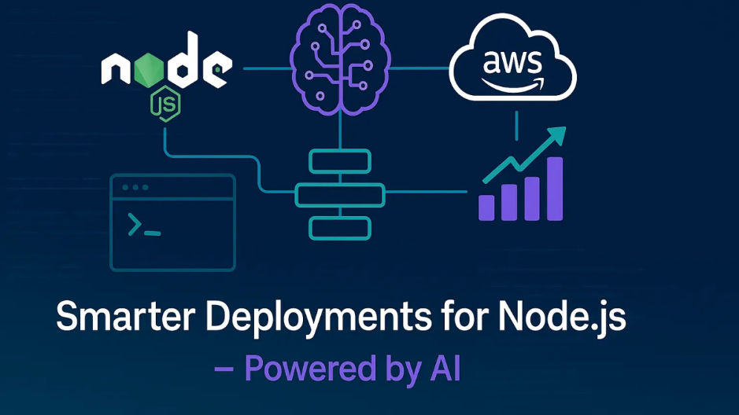

**📊 7. Analytics Dashboard**

* Create an admin dashboard to show traffic trends, weather correlations, and prediction statistics over time.

