MOUNIKA.R

**COLLEGE NAME: SARANATHAN COLLEGE OF ENGINEERING BRANCH:ARTIFICIAL INTELLIGENCE AND DATA SCIENCE YEAR:THIRD YEAR**

**NM ID: au813821243035 REGISTER NUMBER:813821243035**

**EMAIL ID:** [**mounika02042004@gmail.com**](mailto:pxaviertrc1972@gmail.com) **Final Project: FACIAL RECOGNITION USING CONVOLUATIONAL NEURAL NETWORK**

3/21/2024 **Annual Review**

1

## FACIAL RECOGNITION USING CONVOLUTIONAL NEURAL NETWORK

2

# AGENDA



* **Problem statement**
* **Proposed system/solution**
* **System Development Approach**
* **Algorithms And Deployment**
* **Result**
* **Conclusion**
* **References**

3

## PROBLEM STATEMENT



**Develop a deep learning CNN model for real-time facial recognition that achieves high accuracy, robustness to environmental variations, and scalability while minimizing computational overhead for deployment across diverse platforms and applications.**

## PROJECT OVERVIEW



* **Load the dataset**
* **Preprocessing**
* **Train Test Split**
* **Build And Train CNN**
* **Evaluation**
* **Deployment**

**WHO ARE THE END USERS**

* **Security and Surveillance Companies**
* **Law Enforcement Agencies**
* **Government Organizations**
* ​
* ​

**Human Resources Departments**

**Commercial Enterprises**

* ​

**Healthcare Industry**

* ​

**Educational Institutions**

* ​

**Smart Device Manufacturers**

* ​

**Transportation and Aviation Industry**

* **Social Media Platforms**

**6**

3/21/2024 **Annual Review**

**YOUR SOLUTION AND ITS VALUE PROPOSITION**

**One solution is robust facial recognition system utilizing deep learning convolutional neural network(CNNs) to accurately identify individuals from images or video frames in real time.The system is designed to be highly accurate,scalable and adaptable to diverse environments and applications.**

* **Enhanced Security**
* **Operational Efficiency**
* **Improved User Experience**
* **Cost Savings**
* **Compliance and Accountability**

## THE WOW IN YOUR SOLUTION



•

**Accuracy**

* **Robustness to Variability**
* ​

**Feature Learning**

* ​

**End-to-End Learning**

* ​

**Scalability**

* ​

**Privacy Preservation**

* ​

**Real-Time Processing**

* ​

**Adaptability**

* ​

**Continuous Improvement**

# MODELLING

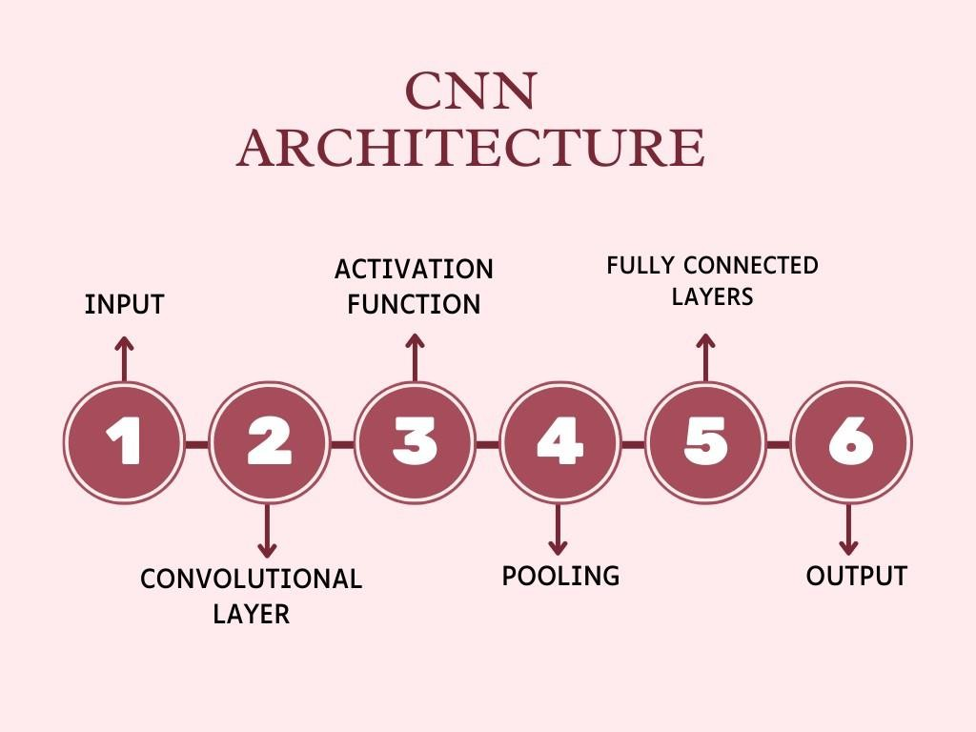

1. 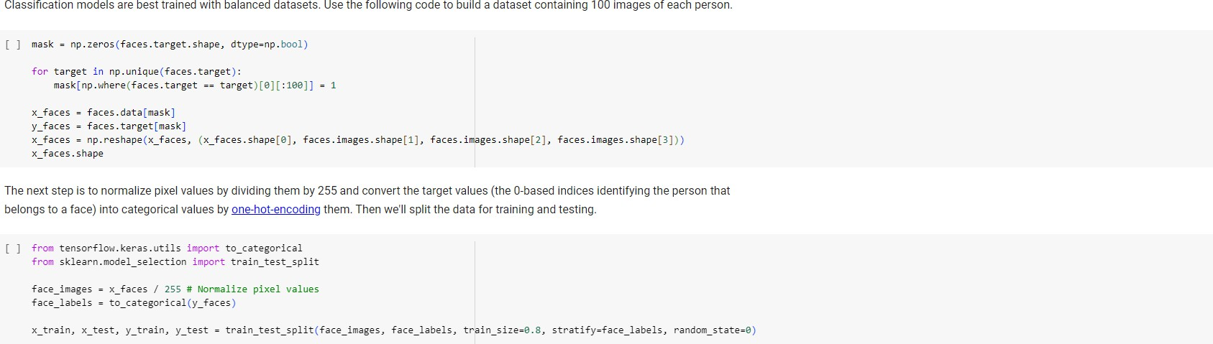**Importing required modules and loading the dataset**

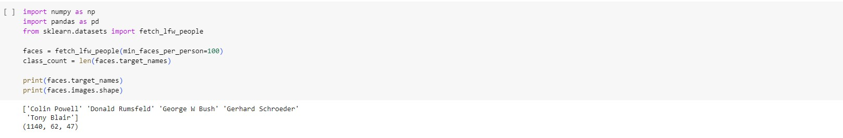

1. **Preprocessing**
2. **Building the model**

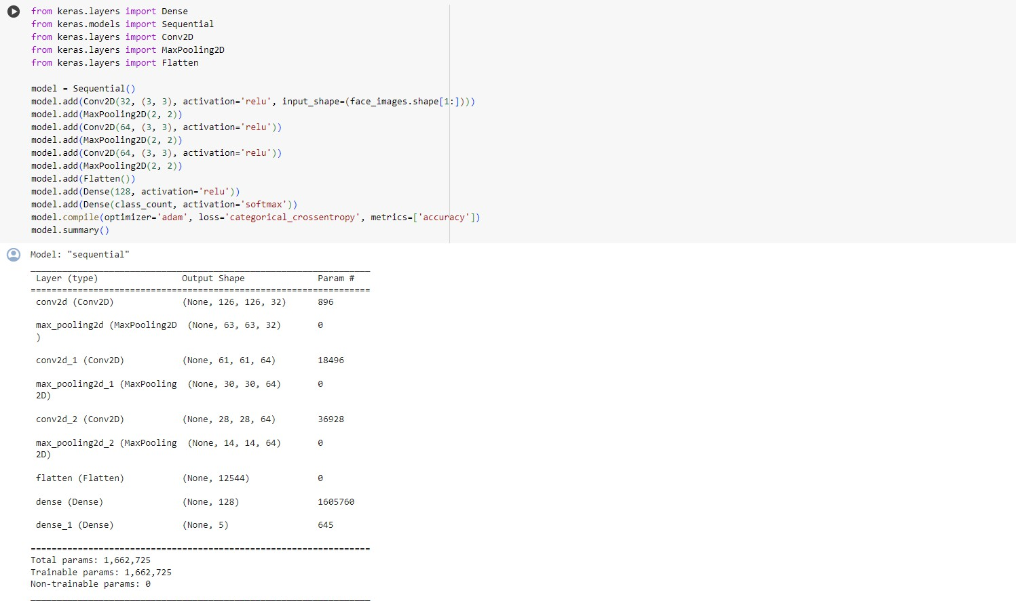

# RESULTS

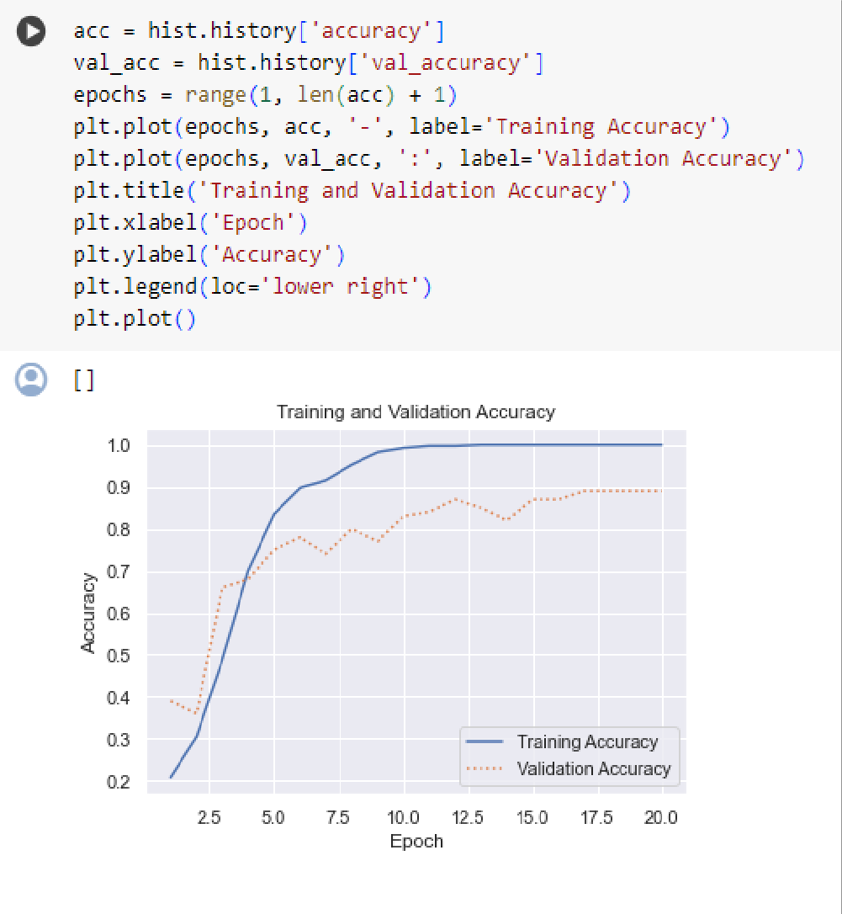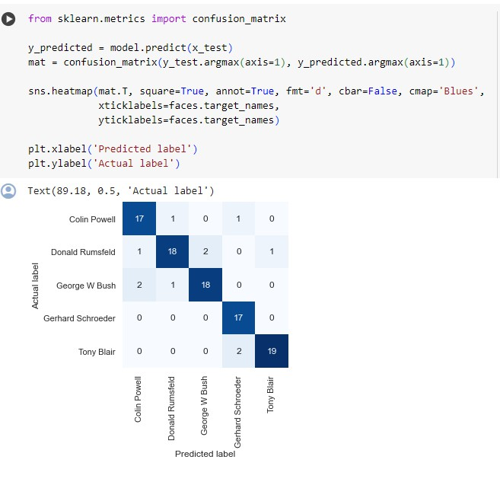

1. **Training And validation Accuracy 2.Confusion Matrix**

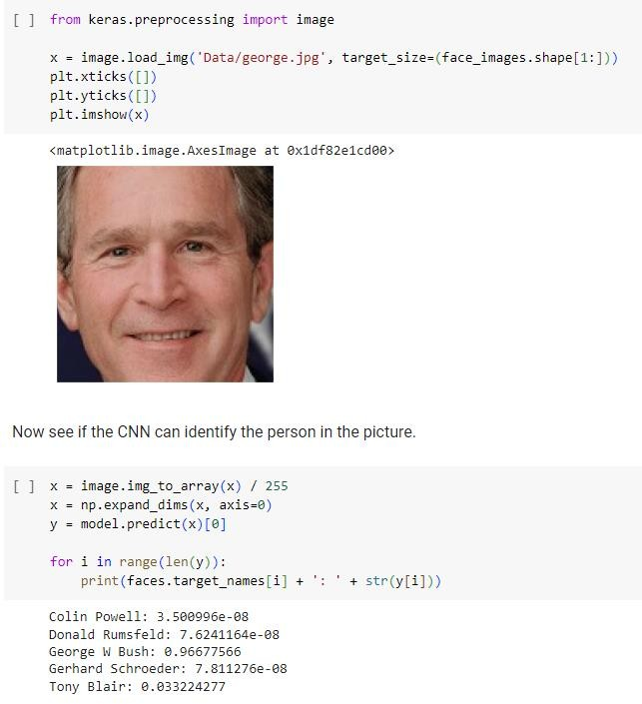**3.Prediction**

CONCLUSION

Facial recognition employing deep learning CNNs presents promising accuracy for face detection and identification across various applications. However, ethical and privacy concerns, including bias and data misuse, necessitate stringent regulations. Continued research is vital to enhancing system accuracy, fairness, and accountability. While facial recognition holds potential benefits, cautious and responsible deployment is imperative to mitigate potential societal harms.