Exercice1 :
- Productuvity is 100 lines per day. Firefox is 10 million of lines of code so it will take me 274 years to implement Firefox. Google is 2000 million of lines of code so it will take me 54 795 years to implement Google.
- These companies succeeded by sharing the tasks between large teams working simultaneously over the years.
- I cannot tell which one is more productive just by the number of lines, it depends on the produced code.
- If AI generates most of the implementation, humans developers can contribute to the communication with users and customers.

Exercice2:
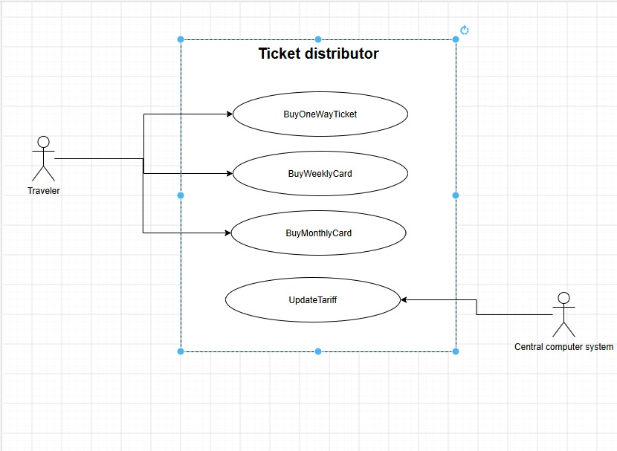

Exercice3:
- Functional requirements:
  - The system shall allow job applicants to create their CVs.
  - The system shall allow the career expert to add the CVs to a shortlist.
  - The system shall allow the client manager to create automated tests.
  - The system shall allow the client manager to send the list of candidates who passed the tests to the recruiter.
  - The system shall send job announcements to users for positions that match their preferences.
- 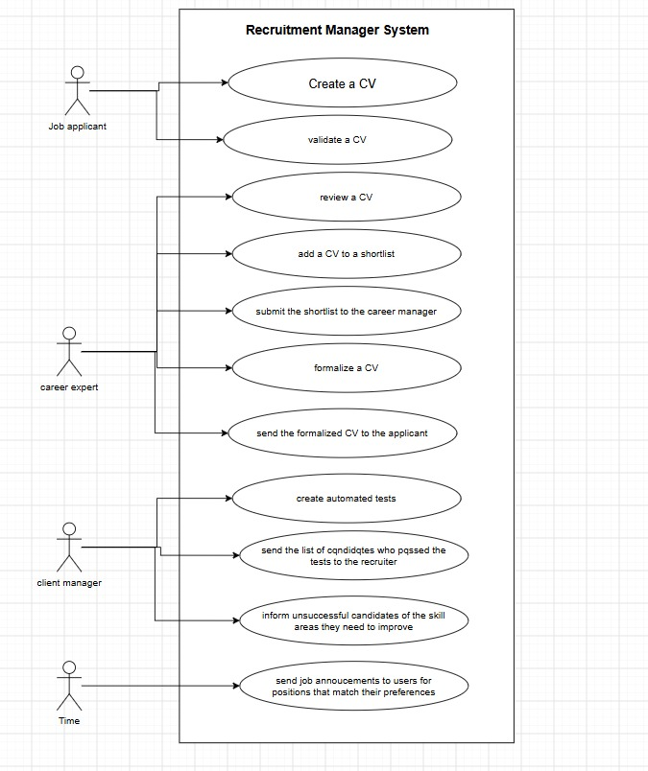

Exercice 4:
- The actors of the system are:
  - Hotel client
  - Bank server
  - The receptionist
  - Cashiers
  - Cleaning staff
  - The floor manager
- Actions that occur outside the system:
  - make a reservation by phone
  - clean all rooms with the status “dirty available”
  - verifies that the room is properly cleaned
  - maintenance intervention
- Modules of the system:
  - Reception
  - Billing
  - Cleaning
- Use case diagram:
