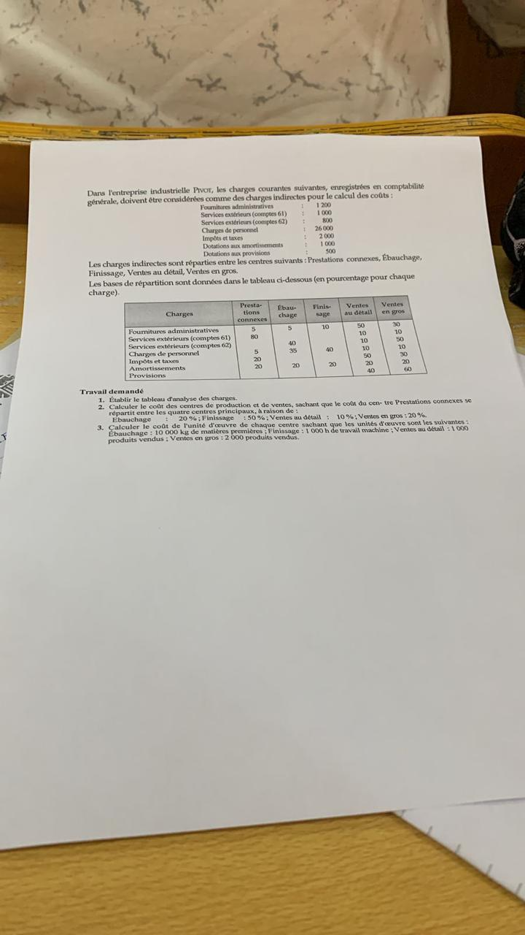
{d.name}    Cooking Time  On2Cook Normal Cooking  7:25 Minutes 35 Minutes  Ingredients | INDUCTION  MICROWAVE  Total Quantity:  {d.Ingredients[].weight:aggSum} g
  {d.Ingredients[i].weight}  {d.Ingredients[i+1].weight} | {d.Ingredients[i].title}  {d.Ingredients[].text}  {d.Ingredients[i+1].title}
  {d.Instruction[i].backgroundColor:color(cell, background)} | {d.Instruction[i].severityBackground:color(cell, background)} | {d.Instruction[i].backgroundColor:color(cell, background)}
  {d.Instruction[i+1].backgroundColor:color(cell, background)} | {d.Instruction[i+1].severityBackground:color(cell, background)} | {d.Instruction[i+1].backgroundColor:color(cell, background)}

