Low Level Design (add program module)

Project Code | Group 6
Project Name | University Admission System

Prepared/Modified by | Role | Date of Preparation
Arshjeet, Jenil, Shreyansh | Software Engineer | 01/12/2017
Reviewed by | Role | Date of Review
Chitransh | Software Engineer | 02/12/2017
Approved by | Role | Date of Approval
Yogini Naik | Mentor | 05/12/2017
Circulation List | arshjeet.singh@capgemini.com  gaurav.puniyani@capgemini.com  sai-satya-kireeti.godavari@capgemini.com  shreyansh.jain@capgemini.com  jenil.mehta@capgemini.com  chitransh.sharma@capgemini.com | Version Number of the template:1.0
Version Number | 1.1

Table of Contents

1. Description Of The Unit 3
2. References 4
3. Dependencies / Assumptions 5
4. Class Diagrams 6
5. Sequence Diagrams 7
6. Design Components 8
6.1 List Of UI Components 8
6.2 List Of Design Classes 8
7. Re-Usable Routines/Components 9
8. Messages 10
9. Configuration Files 11
10. Crud Matrix Table 12
11. Data Mapping Matrix 13
12. Action Flow Matrix 14
13. Stored Procedures 15
14. Program Specification / Pseudo Code 16
REVISION HISTORY OF THE WORK PRODUCT 17

Description Of The Unit

The add program module allows the admin of the university management application to add new programs into the database. This module can be used only by the admin of the university management application.

On clicking the add program button under program tab in the admin home page, the admin is redirected to a add page. The admin enters all the details of the program like program name, program description, applicant’s eligibility, duration and degree certificate offered by university. If the entered program details are invalid, appropriate error messages are displayed.

After entering all the program details, the details are inserted into the database on clicking the add button.

References

Reference | Description
Class Diagram | /Project Documents/Design Documents/HLD/Class Diagrams
URS | /Project Documents/Requirements/Case Study/Group-4-University Admission System.doc
UTP | /Testing/UTP/Test Case/  AddProgram/UTP_AddProgramModule.xls
DB Design | /Project Documents/Design Documents/HLD/  Db Design/Uas_DbDesign.xls

Dependencies / Assumptions

Dependencies:
The admin should be logged in.

Assumptions:
The admin details are stored in the database.

Class Diagrams

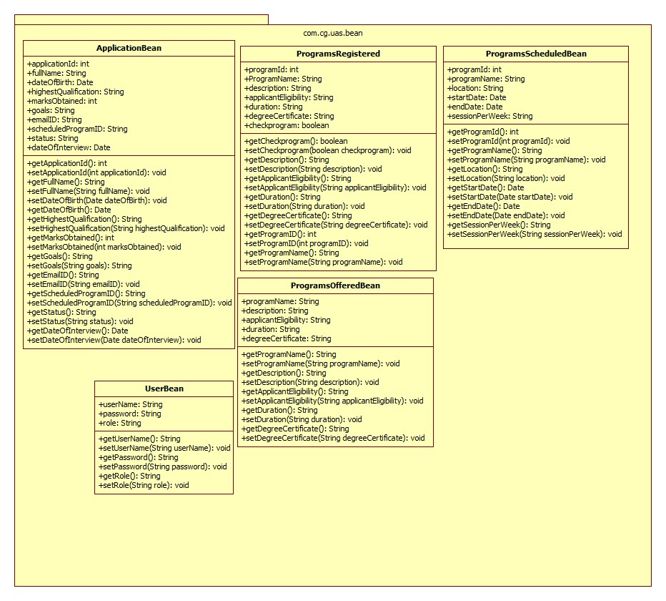

Sequence Diagrams

Design Components

List Of UI Components

6.2 List Of Design Classes
Sr. No. | LLD Name | Class Name | Method Name | Method Description
1 | Add Program Module | ProgramOfferedBean | Appropriate getters and setters methods | Getters retrieve the property values and setters set the property values
2 | Add Program  Module | UasController | addProgram(@ModelAttribute(“program”) ProgramsOfferedBean program, BindingResult result)ModelAndView | Sets the model attribute.  Calls addProgram(ProgramsOffered program) of AdminServiceImpl class. If it returns true then it redirects to success page else it redirects to error page with appropriate error message.
3 | Add Program Module | AdminServiceImpl | addProgram(ProgramsOfferedBean program):boolean | Calls addProgram(ProgramsOfferedBean program) of AdminDaoImpl class and returns the result to controller.
4 | Add Program Module | AdminDaoImpl | addProgram(ProgramsOfferedBean program):boolean | Inserts the program details into the database and returns the result to AdminServiceImpl .

Re-Usable Routines/Components

Re-Usable Routines/Components

- JSP & CSS files
- Log4j properties files

Messages

#. | Type | Message Text
M1 | Error | Program Name should not be empty.
M2 | Error | Description should not be empty.
M3 | Error | Applicant eligibility is mandatory.
M4 | Error | Duration cannot be empty.
M5 | Error | Degree certificate offered is mandatory.

Configuration Files

File Name | Path | Description
jpaContext.xml | \UAS\WebContent\WEB-INF\jpaContext.xml | To configure database connection.
web.xml | \UAS\WebContent\WEB-INF\web.xml | To configure the bean properties.
dispatcher-servlet.xml | \UAS\WebContent\WEB-INF\dispatcher-web.xml | To configure the request mapping and view resolver.
Log4j.properties | \UAS\src\log4j.properties | To implement logger

Crud Matrix Table

# | Table Name | Create | Read | Update | Delete
1. | program_offered | Y | Y | Y | Y

11.Data Mapping Matrix

Sr. No. | Screen Label | Field Source | Field Type | Data Type | Max Length | Data Flow | Mandatory
1 | Program Name | NA | Label | NA | NA | UI | NA
2 | programName | ProgramOfferedBean.  programName | TextBox | Varchar2(5) | 10 | UI→D | Yes
3 | Description | NA | Label | NA | NA | UI | NA
4 | description | ProgramOfferedBean.  description | TextBox | Varchar2(20) | 10 | UI→D | Yes
5 | Applicant Eligibility | NA | Label | NA | NA | D→UI | NA
6 | applicantEligibility | ProgramOfferedBean.  applicantEligibility | TextBox | Varchar2(40) | 10 | UI→D | Yes
7 | Duration | NA | Label | NA | NA | UI | NA
8 | duration | ProgramOfferedBean.  duration | TextBox | Number | 10 | UI→D | Yes
9 | Degree Certificate | NA | Label | NA | NA | UI | NA
10 | degreeCertificate | ProgramOfferedBean.  degreeCertificate | TextBox | Varchar2(10) | 10 | UI→D | Yes
11 | Add program | NA | Button | NA | NA | UI | NA

Legend
D → UI (Database to User Interface)
UI → D (User Interface to Database)
UI (User Interface Only)

12. Action Flow Matrix

Sr. No. | Action | Description | Process
1 | On click of Add Program button under Program tab in Admin Homepage | Redirected to the programsOffered page | The admin clicks on the Add Program button in the admin homepage and gets redirected to the programsOffered page.
2 | On click of Add Program button in programsOffered page | The program details are inserted into the database. | Data is entered in the fields by the admin which gets inserted into the database when add button is pressed.

Stored Procedures

# | Stored Procedure Name  (with Description) | Input/Out Parameters | Type | Size
1. | NA | NA | NA | NA

Program Specification / Pseudo Code

14.1<ACTION :ADDPROGRAM_CLICK >

Pseudo Code:
- Client Side Scripting:
None

- Server Side Scripting:
BEGIN
Call addProgram() in Controller class
Navigate to programsOffered page
END

14. 2 <ACTION: ADDPROGRAM_CALL>

Pseudo Code:

- Client Side Scripting:

None

- Server Side Scripting:
BEGIN
Call addProgram(@ModelAttribute("program") ProgramsOfferedBean program, BindingResult result) in UasController class in Dispacher Servlet
BEGIN
Call addProgram(ProgramsOfferedBean program) in AdminServiceImpl class in Service Layer
BEGIN
Calll addProgram(ProgramsOfferedBean program) in AdminDaoImpl class in Data Access Layer
BEGIN
Persisting the object for insert records into ProgramsOffered table
Return boolean value.
END
Return ProgramsOffered to Service Layer
END
Return ProgramsOffered to UasController
END
IF successful navigate to success page
Else navigate to error page and show error.
END

REVISION HISTORY OF THE WORK PRODUCT

# | Date | Version # | Section Changed | Details of changes made | Approved By
1 | 27/11/2017 | 1.0 | LLD prepared | N/A | Yogini Naik
2 | 29/11/2017 | 1.1 | Pseudo code | The pseudo code is modified as per the specified flow. | Yogini Naik
3 | 30/11/2017 | 1.1 | List of Design Class | Method Description of Uas Controller | Yogini Naik

