**1**

50%

Aeltec

Economise

**Périphéries**

**Moniteurs**

Le matériel

informatique:

OUIM1996@ccsq.ca

www.aeltec.com

Rabais

Super

19-Av Burg, QC, W1F R0L

Service à la clientele:

+1 444-555-0000

**Moniteurs : 50% rabais**

**2**

HD dreamer

12,6 kg

Noir

22’’

Non

42 W

$150

Iiyama pro lite

5,5 kg

Noir

22 pouce

221 W

$150

Nom:

Philips 220p4

3,38 kg

22’’

Non

12,6 W

$150

Asus VK248H

5 kg

Nor

24’’

42 W

$150

Samsung Ns190

4,42 kg

Noir

19’’

35 W

$150

Poids:

Couleur :

Taille d’écran:

Energie:

Prix :

NEC AE2224

5,6 kg

Blanc

21,5’’

15W

$100

Philips 22

3 kg

Noir

21,5’’

19.5 W

$150

Benq Gl955A

2.8 kg

Noir

18,5’’

11 W

$150

MSI Optic

4 kg

Noir

24

35 W

$ 249.99

Asus TUF

6 kg

Noir

24’’

20,89 W

$249.99

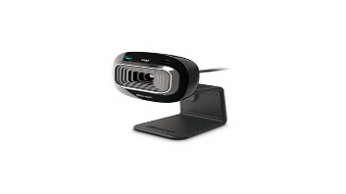Périphériques : 50% rabais

Logitech z160

**$15**

Clavier Compact Cherry type USB

$96

sans fil M 35000

$50

Souris HP avec fil

$11

Microsoft life chat

$100

Logitech H110

$120

Logitech MK710

Type sans fil

$109

Microsoft HD 3000

**$169**

Logitech B525 HD

**$120**

Baffle Logitech Z506

**$45**