Exercise 4 Report

Name: Đoàn Nam Sơn

MSV: DE180896

Exercise 1.1:

Exercise 1.2:

Code:

Result: 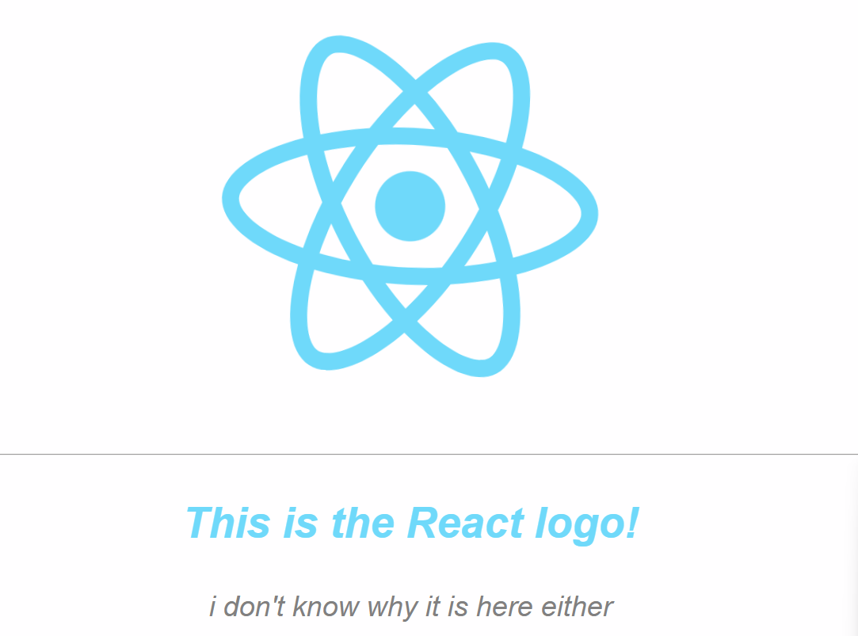

Exercise 1.3:

Code:

Exercise 1.4:

Exercise 1.5:

Result:

Exercise 2.1

Result:

Exercise 2.2:

Result:

Exercise 2.3:

2.3.1

2.3.2

2.3.3

2.3.4

2.3.5

2.3.6

2.3.7

2.3.8

Result: 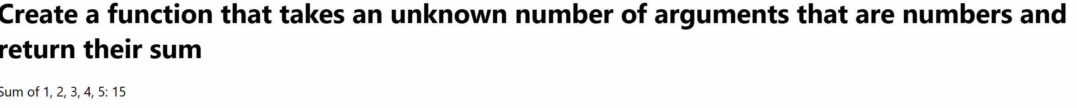

2.3.9

2.3.10

2.3.11

Code:

Result:

2.3.12

Code:

