<https://docs.spring.io/spring-framework/docs/3.1.x/spring-framework-reference/html/transaction.html>



Beug:



Resolution :

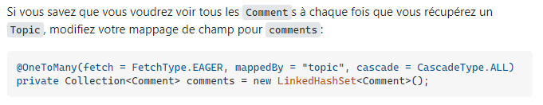

<https://stackoverflow.com/questions/11746499/how-to-solve-the-failed-to-lazily-initialize-a-collection-of-role-hibernate-ex>

<https://stackoverflow.com/questions/2990799/difference-between-fetchtype-lazy-and-eager-in-java-persistence-api>