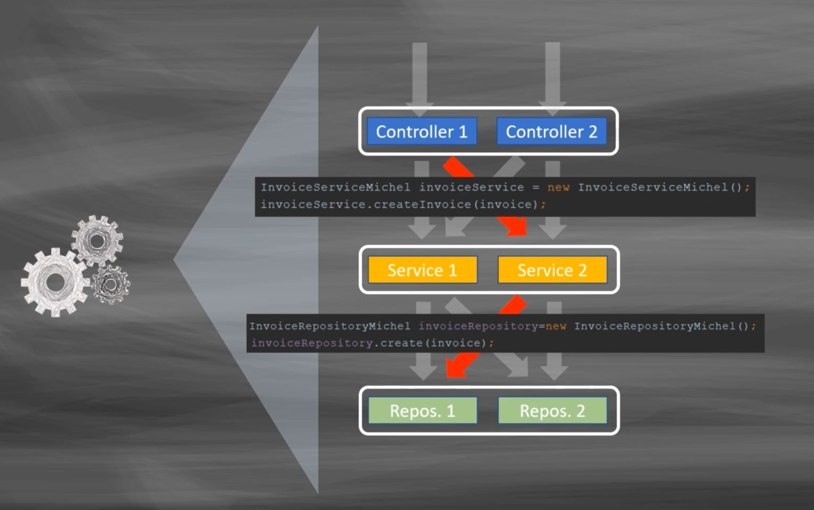

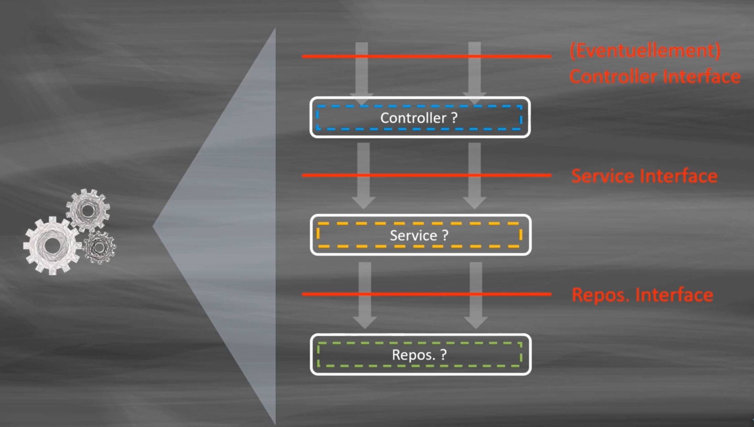

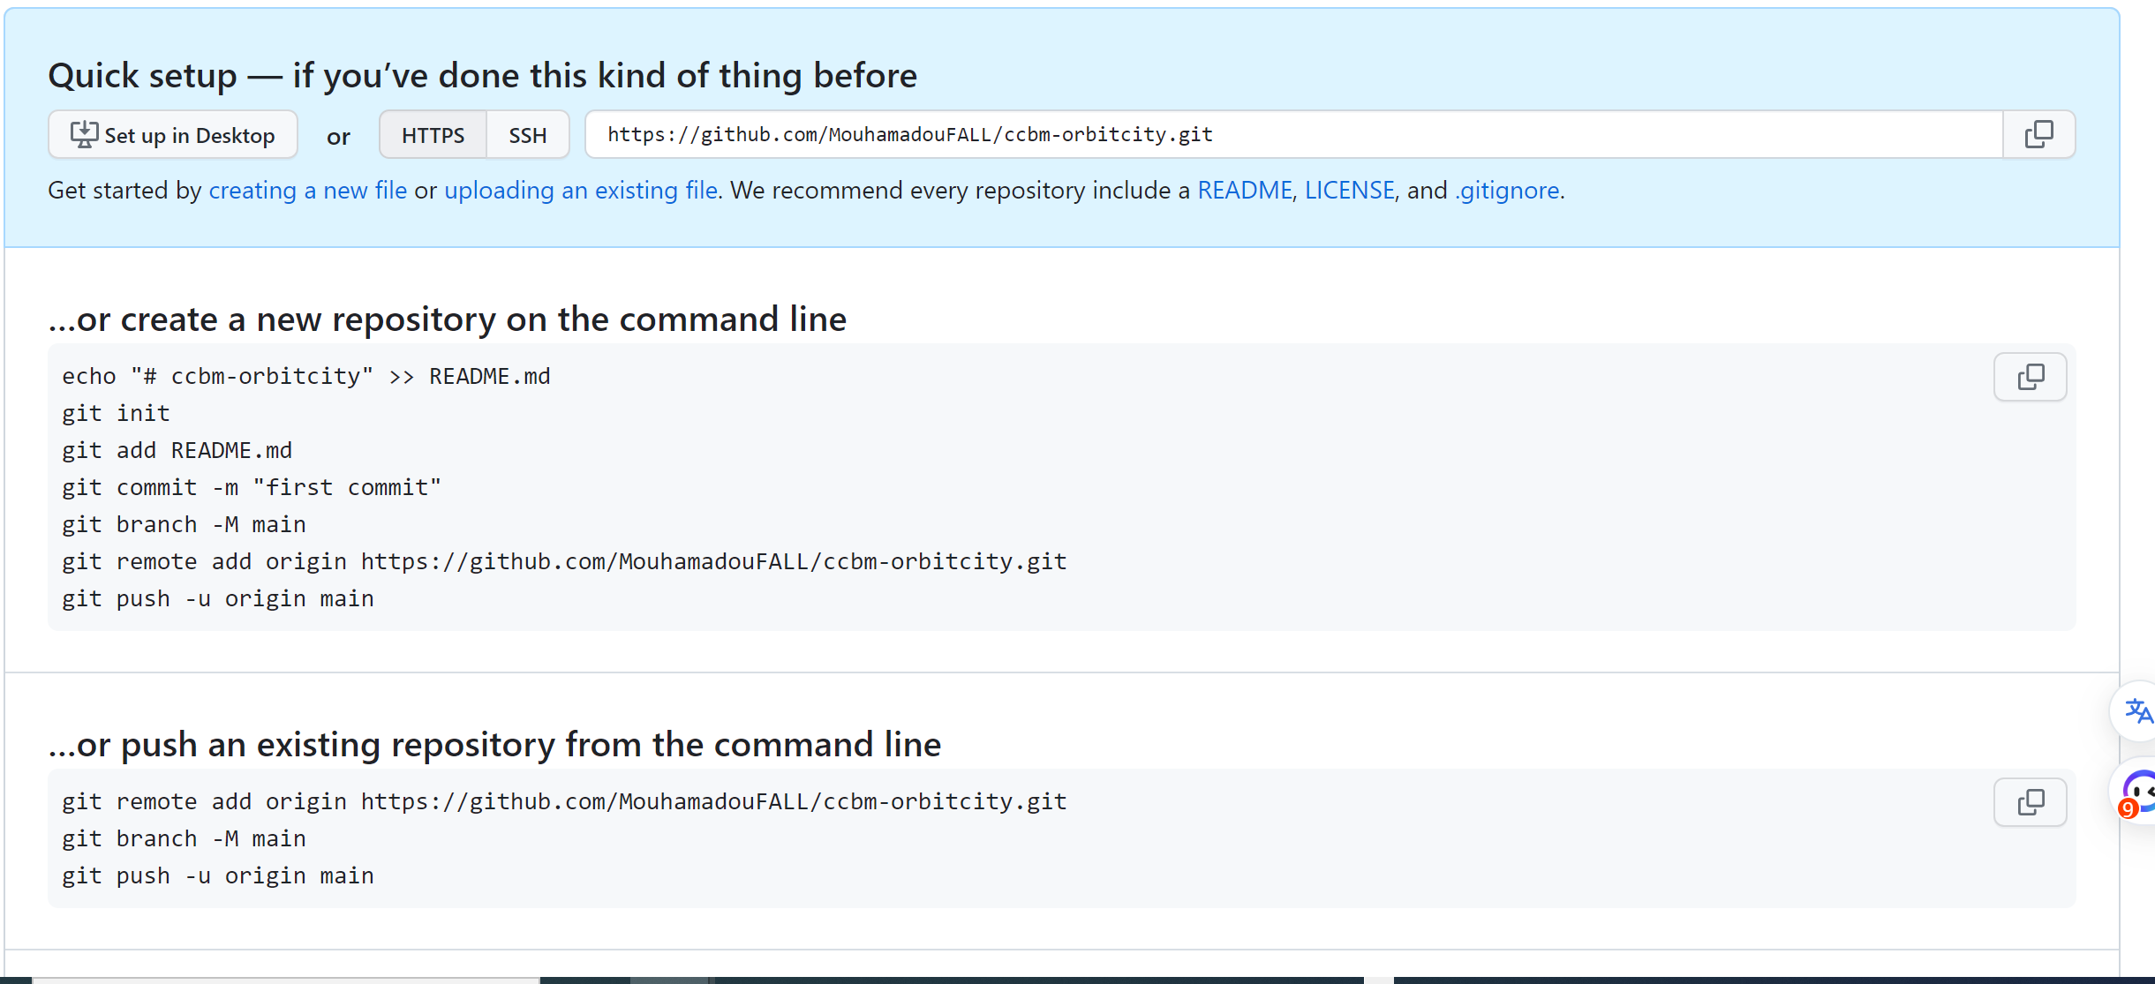

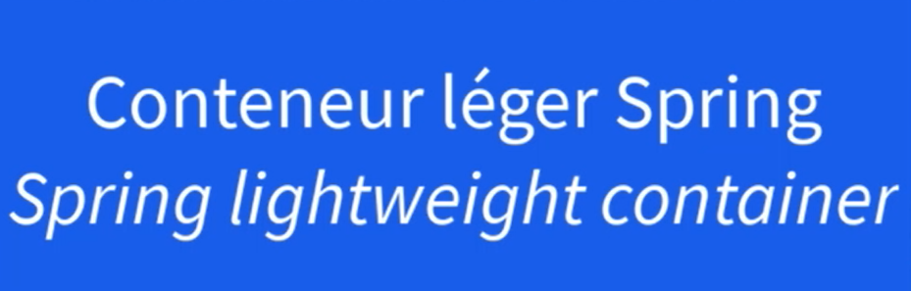

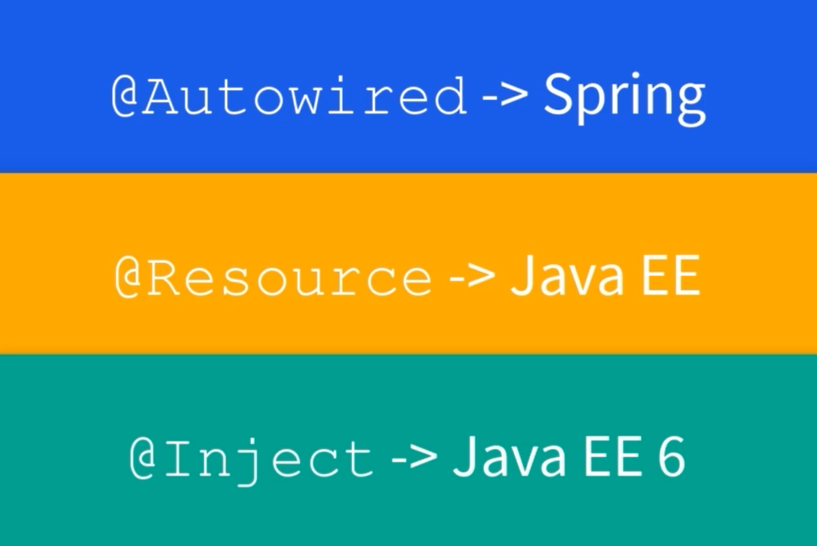

Problème:

***WARNING: Exception encountered during context initialization - cancelling refresh attempt: org.springframework.beans.factory.UnsatisfiedDependencyException: Error creating bean with name 'invoiceControllerWeb': Unsatisfied dependency expressed through field 'invoiceService'; nested exception is org.springframework.beans.factory.NoUniqueBeanDefinitionException: No qualifying bean of type 'com.siggidieuf.facture.service.IinvoiceService' available: expected single matching bean but found 2: invoiceServiceNumber,invoiceServicePrefix***

***Exception in thread "main" org.springframework.beans.factory.UnsatisfiedDependencyException: Error creating bean with name 'invoiceControllerWeb': Unsatisfied dependency expressed through field 'invoiceService'; nested exception is org.springframework.beans.factory.NoUniqueBeanDefinitionException: No qualifying bean of type 'com.siggidieuf.facture.service.IinvoiceService' available: expected single matching bean but found 2: invoiceServiceNumber,invoiceServicePrefix***

Proposition de Solution:

Séparer les différentes implémentations dans des packages différents.

