  

To Supply Leftover Food to Poor

# Project Overview

The To Supply Leftover Food to the Poor project seeks to optimize food collection, volunteer coordination, and delivery to designated drop-off locations. By utilizing the Salesforce platform, the solution will simplify data management and provide real-time tracking capabilities. The project's long-term objectives include minimizing food waste and aiding underserved communities by improving operational efficiency, enhancing user experience, and ensuring data accuracy.

# Objectives

## Business Goals:

## Create a practical plan for managing surplus food donations.

* Enhance the efficiency of food distribution by streamlining coordination between delivery, volunteers, and collection points.
* Enable real-time tracking and reporting to support impact analysis and informed decision-making.

## Specific Outcomes:

* Custom objects and links were created to manage locations, volunteers, drop-off points, and work assignments.
* A real-time reporting system offers visibility into food distribution.
* Dashboards that display food distribution, volunteer engagement, and location-specific needs.

# Salesforce Key Features and Concepts Utilized

Several Salesforce features are used in this project, including:

* **New Objects**: New objects were created to track data such as Venue, Drop-Off Point, Task, Volunteer, and Execution Details.
* **Triggers**: A custom Apex trigger, named DropOffTrigger, was implemented to automatically assign distance values.
* **Lighting App with Custom Tabs**: The Food Connect Lightning App was developed with custom tabs to enable easy navigation across all objects.
* **Sharing Rules**: Sharing rules were configured based on distance to manage user access according to proximity.

# Detailed Steps to Solution Design

The design and development process consisted of the following steps:

* + **Data Models:** Developed data models for Venue, Drop-Off Point, Task, Volunteer, and Execution Details, including necessary fields and associations (Lookup and MasterDetail).
  + **User Interface Design**: Design Custom tabs for easy Navigation in the

**FoodConnect** Lightning App.

* + **Business Logic**: Created the **DropOffTrigger** to automatically populate the Distance Calculation field with distances, simplifying rule assignment.

## Screenshots:

**Screenshot of the UI**

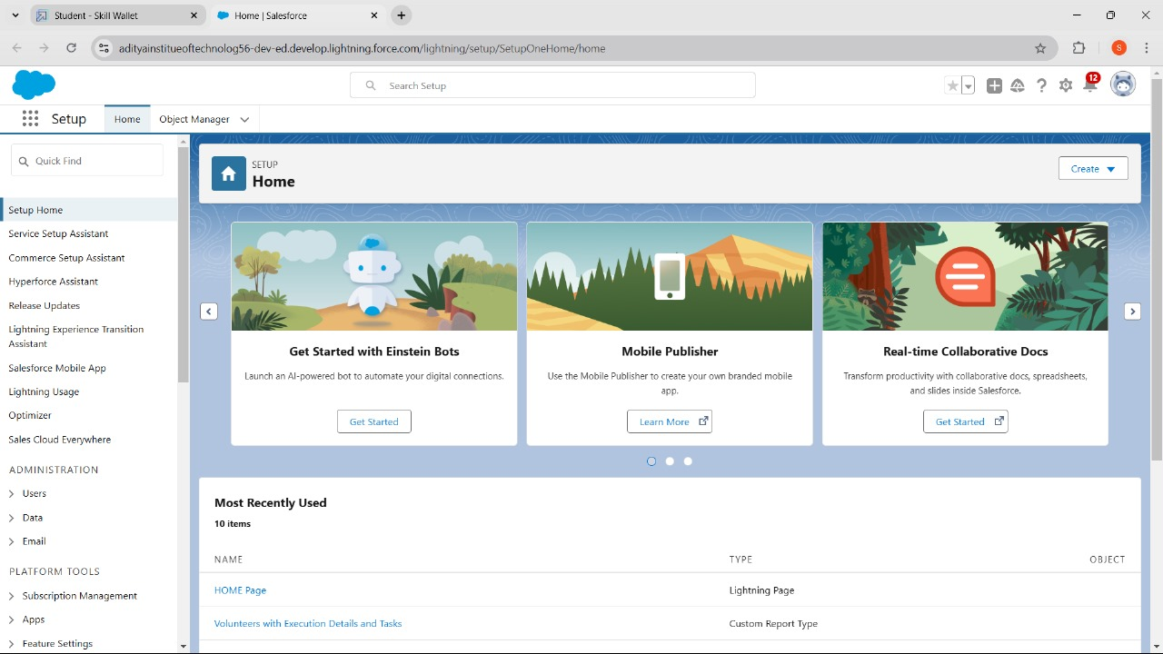

## 

  

# Testing and Validation

The testing strategy included:

* + **Unit Testing:** Performed unit testing on Apex classes and triggers, including the **DropOffTrigger** and custom field modifications.
  + **User Interface Testing:** Review Each Users interface Component to ensure easy and accurate data flow across custom tabs in the **FoodConnect** App.

# Key Scenarios Addressed by Salesforce in the Implementation Project

## Scenario 1: Managing the coordination of food collection and distribution.

* Established drop-off points and coordinated distances with assigned sharing groups.

## Scenario 2: Volunteer Tracking and Assignment

* Monitored volunteer availability and tasks to ensure efficient food collection delivery.

## Scenario 3: Feedback and Reporting

* + - Volunteers can provide feedback on deliveries, gather ratings, and track capacity for future improvements.

# Conclusion

**Project Summary:** Leveraging Salesforce, the initiative successfully developed an efficient system for managing food donations, volunteer coordination, and deliveries to designated locations. This platform helps reduce food waste and supports the mission of distributing food to underserved areas, offering a scalable and effective solution to food security.