TestManagement Tool:

Each and every process can be tracked

Defect tracking tool:

only defects can be logged

Agile Tools:

Tracks agile process , JIRA tool, VersionOne , TeamCity

JIRA is agile project management tool

Install and configure JIRA

We can use cloud version : 1.pro 2. Free for 30 days [10 users]

Go to this link:

<https://www.atlassian.com/software/jira/free>

and click on next

Provide email id and signup

Then enter the field : Your site as jira-de

Click on agree

And skip the next screens

Select Scrum template , successfully configured JIRA Tool

Agile Methodologies In Jira:

1.how to create a project in JIRA

We can click on create project , select the required template and create

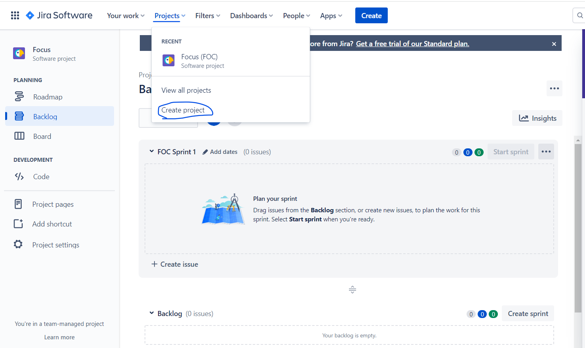

We can see all project related people in dashboard

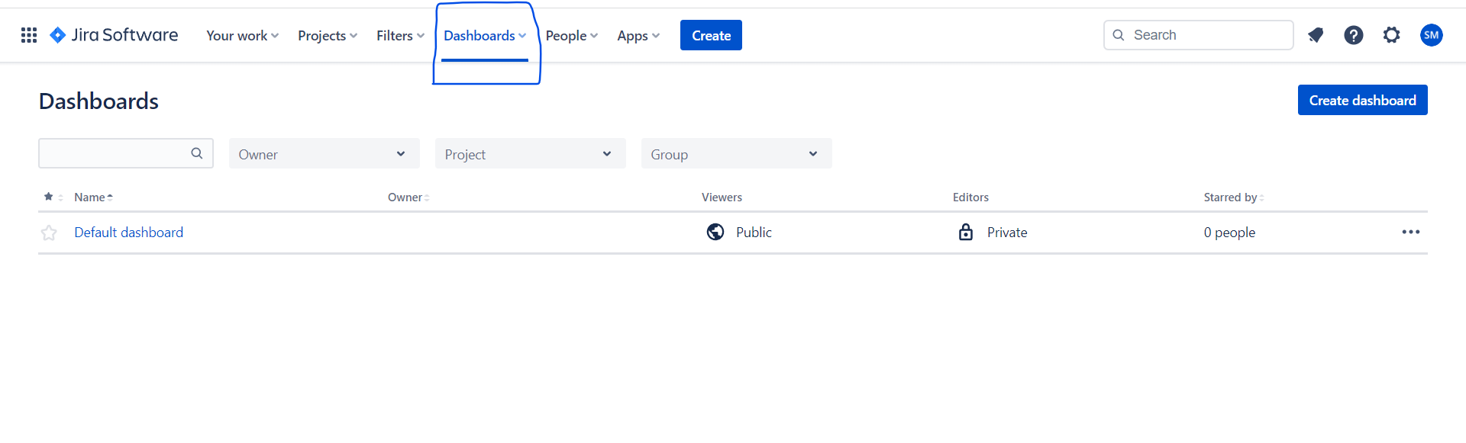

Management uses dashboard to see project status

Add users to project:

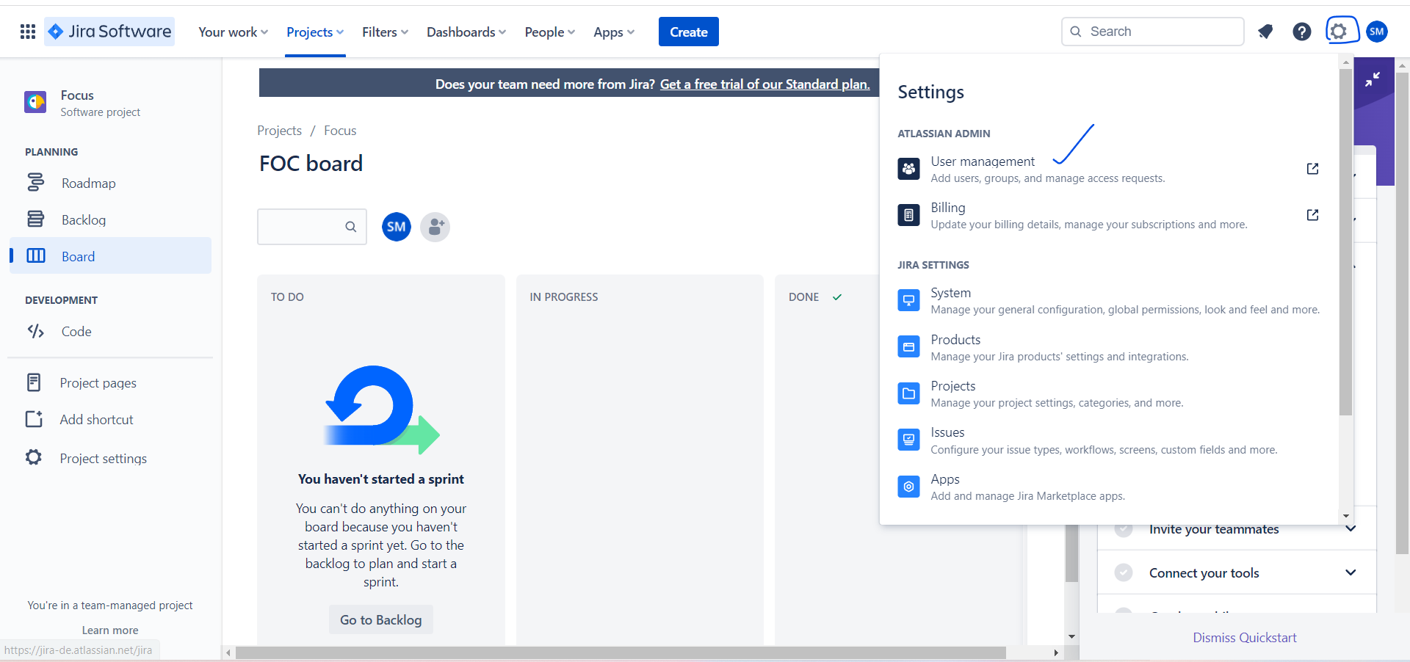

Add email ids , then they can use this project



How to create backlog?

Each and every object is a issue in JIRA

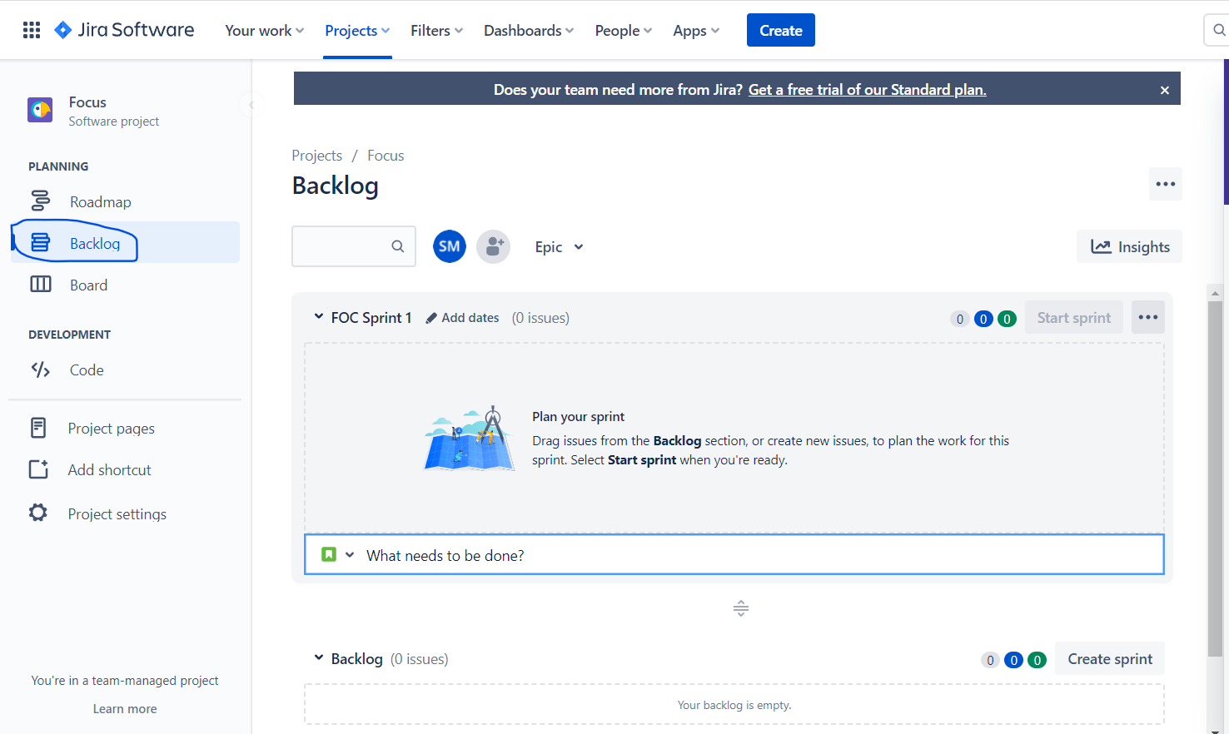

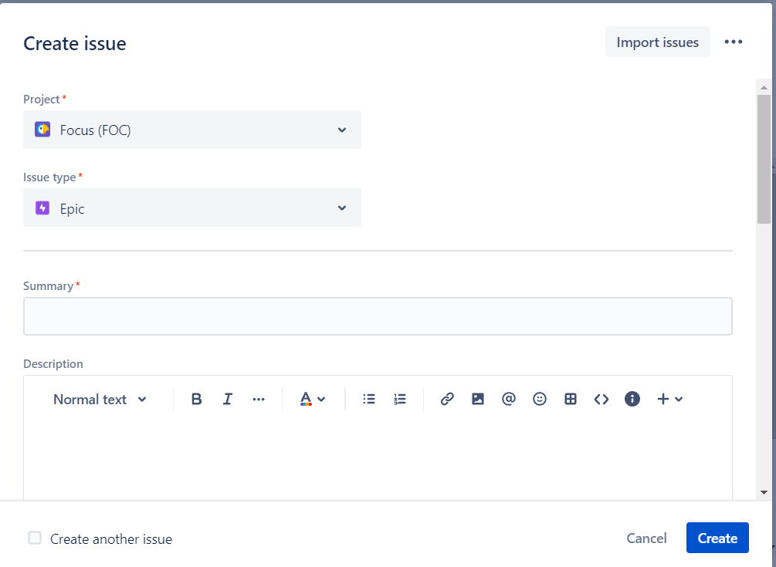

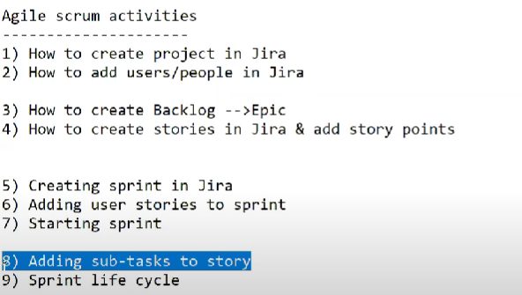

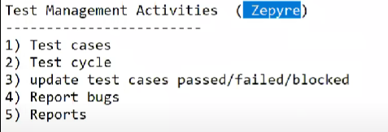

# Zephyr Squad - Test Management for Jira

by [SmartBear](https://marketplace.atlassian.com/vendors/17834/smartbear" \t "_blank)

[792](https://marketplace.atlassian.com/plugins/com.thed.zephyr.je/reviews" \t "_blank)

CLOUD SECURITY PARTICIPANT