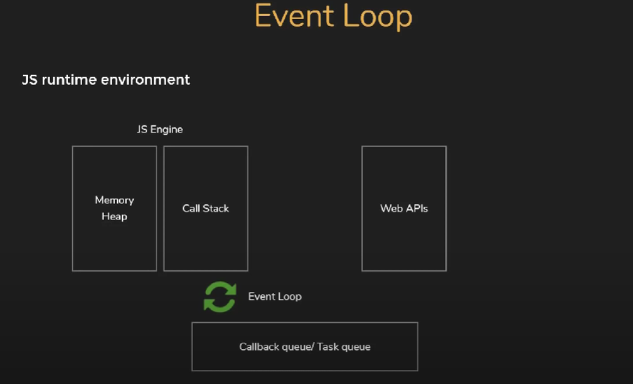

Whenever we declare a variable memory allocated on heap and whenever we execute it pushed to call stack

webAPIs- timeouts ,dom provided by browser

callback queue – firstin first out

event loop – its job is to check if call stack is empty then push item from queue into the stack

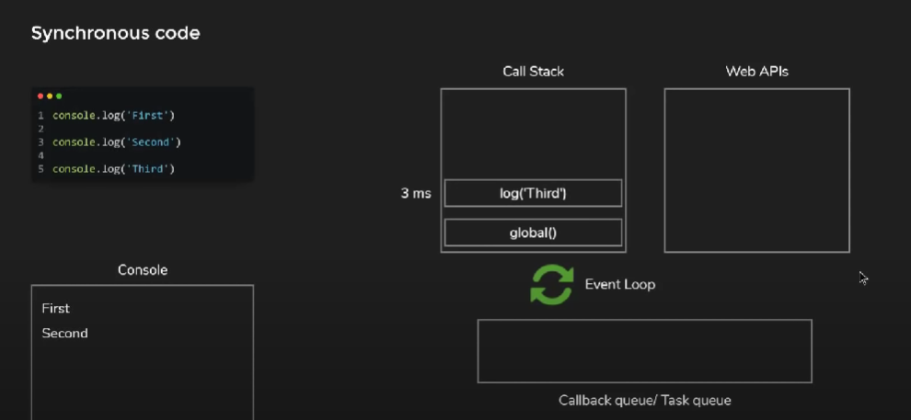

Executes in callstack once done stack will become empty

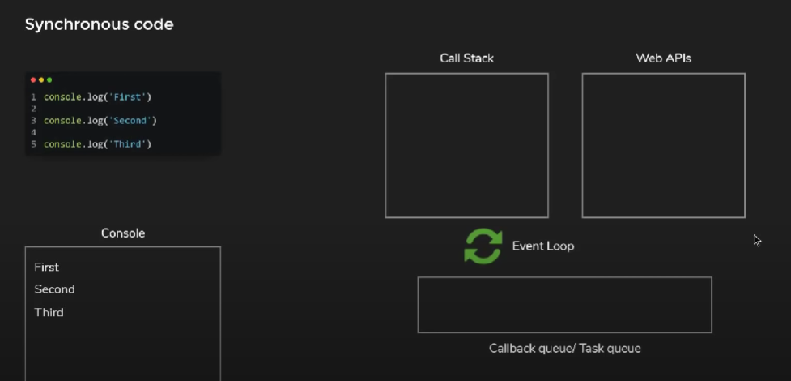

Looks as above once sync code executed

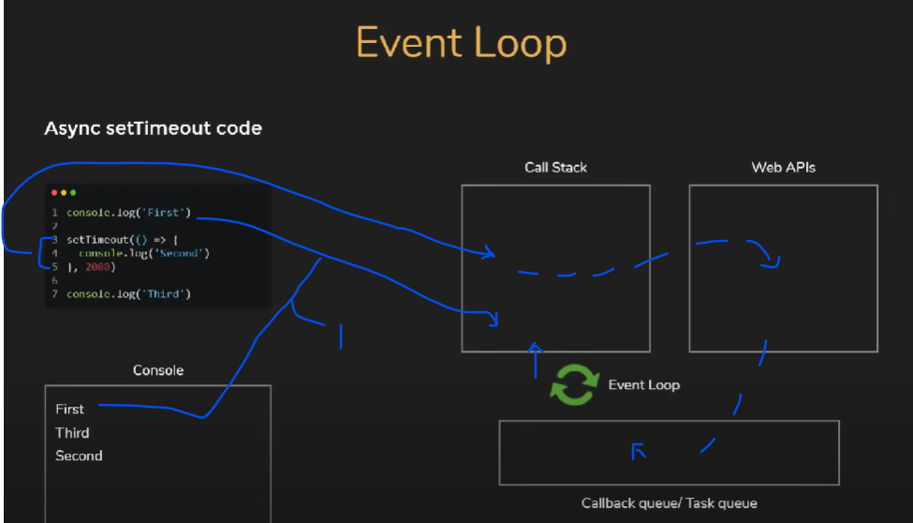

Async setTimeout will move to call stack and then to web api then pushed to stack then to the stack

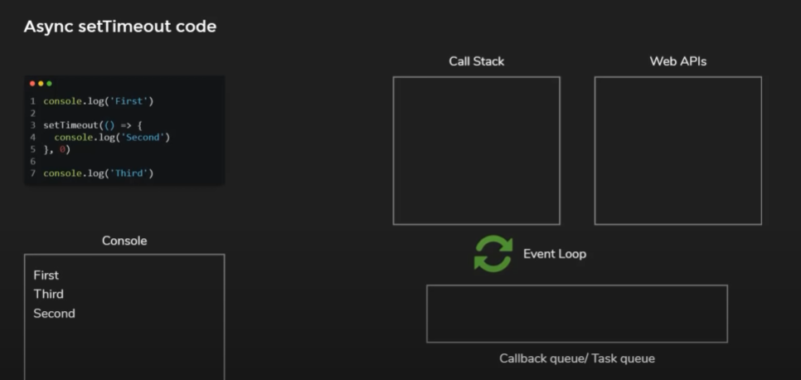

Though 0 seconds still callback have to wait

