Project 1 osita u blabla bla info goes here

Question 1
Part a - Handwritten
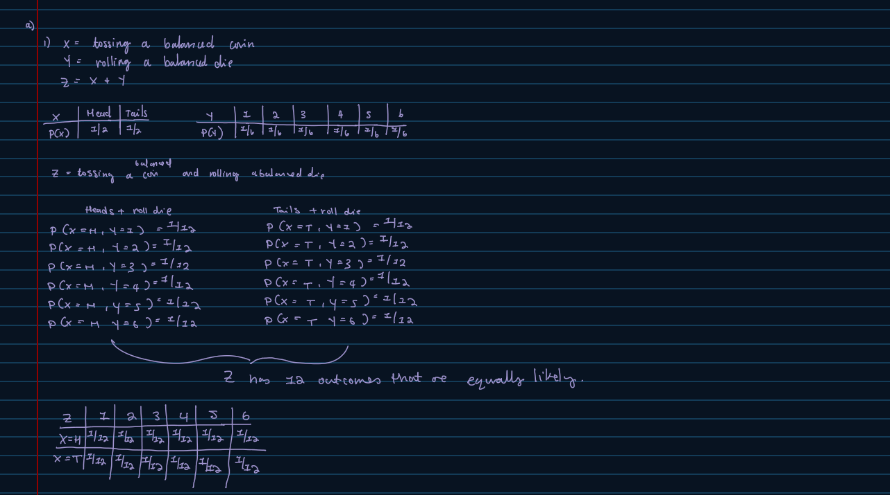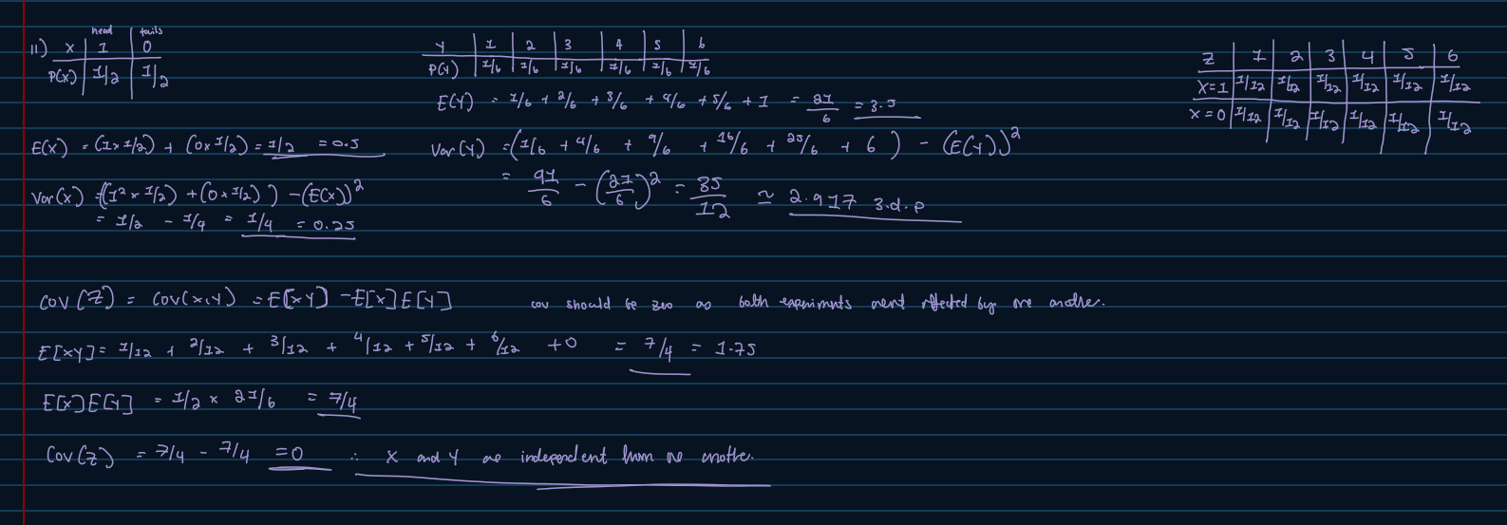
Part b – R
#i)
#creating objects balanced coin and die.
coin <- 0:1
die <- 1:6

#experiment
#To simulate the coin toss and dice roll
toss <- sample(coin, size = 10000, replace = TRUE)
roll <- sample(die, size = 10000, replace = TRUE)

#Create a function so that experiment Z = X + Y is possible
tossnroll <- function() {
data.frame(toss, roll)
}

#exists("tossnroll")
#is.function(tossnroll)
#class(tossnroll)

results <- tossnroll()
head(results)
tossnroll()
View(results) #to view the table

#Making contingency table to show frequencies.
addmargins(table(results$toss,results$roll))
addmargins(prop.table(table(results$toss,results$roll)))

#not exactly 1/12 but around that value.
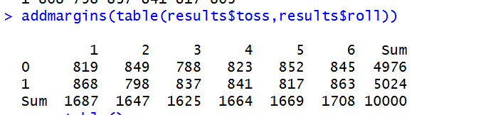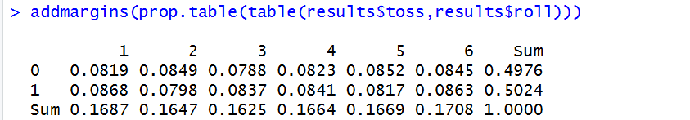

#ii)
#calculating mean(expected value), variance and covariance.
#toss
mean(toss)
var(toss)
#roll
mean(roll)
var(roll)
var(toss, roll) #covariance
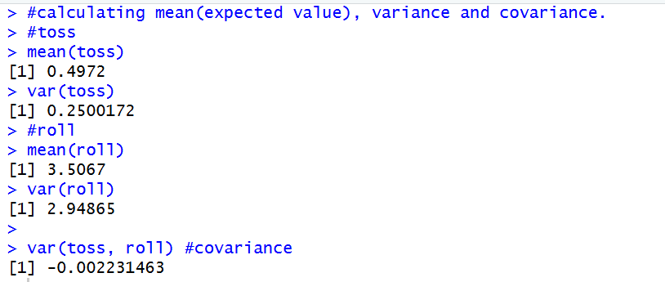
#not exactly the same as the theoretical values from part a but close.

Question 2
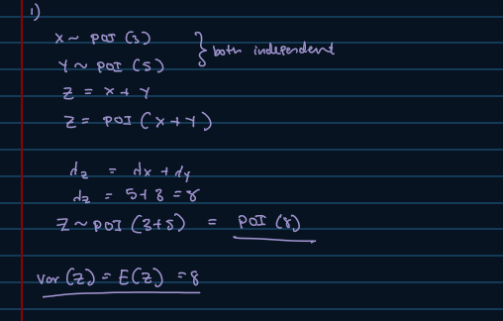
Part a – Handwritten and R

#ii)
#lambda = 8
#P(Z <= 6), P(Z > 4), P( 3<=Z <= 8)
?poisson
?dpois
?ppois

#P(Z <= 6)
ppois(q=6, lambda = 8, lower.tail = TRUE)
#check: 1- P(Z > 6)
1 - ppois(q = 6, lambda = 8, lower.tail = FALSE)
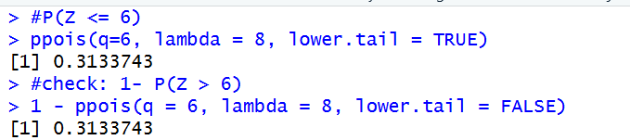
#P(Z > 4)
ppois(q = 4, lambda = 8, lower.tail = FALSE)
#check: 1 - P(Z = 4, Z =3, Z= 2, Z=1, Z=0)
1 - sum(dpois(x = 0:4, lambda = 8))
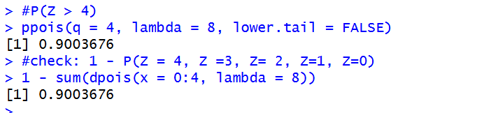
#P( 3 <= Z <= 8)
#so P( Z=3, Z = 4, Z = 5, Z = 6, Z = 7, Z =8)
sum(dpois(x = 3:8, lambda = 8))
#check:
1 - ppois(q = 8, lambda = 8, lower.tail = FALSE) - ppois(q = 2, lambda = 8, lower.tail = TRUE)
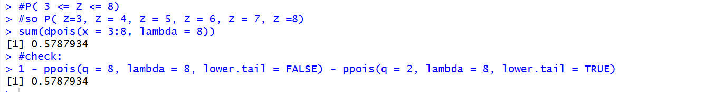

Part b – R

