

**MIS41130 - Statistical Methods**

**Group Assignment**

*Road Safety Trends: A Statistical Analysis of Traffic Accidents and Safety Measures in Ireland*

| **Group 28** | |
| --- | --- |
| *Sathyanarayanan Jayagopi* | *23200072* |
| *Mouleswar Mani Perumal* | *23201655* |
| *Vaishnavi Raghavan* | *23201053* |

1. **Introduction:**

The Road Safety Authority (RSA) of Ireland has set a goal of achieving vision zero by 2050, which is a long-term objective aimed at eliminating road traffic deaths and serious injuries by that year (source: [RSA Government Road Safety Strategy 2021-2030](https://www.rsa.ie/docs/default-source/road-safety/legislation/government-_road_safety_strategy_2021_2030_13th_dec21_final.pdf)). To reach this target, the RSA has launched numerous campaigns to raise driver awareness and has made significant investments in road safety measures. According to An Garda Síochána, the policing agency of Ireland, 155 people lost their lives to road traffic accidents in the year 2022, and from January 2008 to July 2023, a total of 2,771 people have died. This report analyses trends in road accident fatalities, examining whether police enforcement of vehicle safety rules—such as seatbelt use, dangerous driving, speeding, and mobile phone usage while driving—has any correlation with traffic fatalities.

1. **Dataset:**

An Garda Síochána routinely publishes the 'Road Policing Statistics' on a monthly basis, offering figures for traffic-related fatalities. This report also includes data on various traffic fines issued for infractions, encompassing offenses such as driving under the influence and seatbelt violations. This comprehensive dataset provides valuable insights into both road safety outcomes and the enforcement efforts against specific traffic violations. ([Previous Years Roads Policing Statistics - Garda](https://www.garda.ie/en/roads-policing/statistics/previous-years-roads-policing-statistics/)) From this dataset, we obtained information on monthly road traffic accident fatalities and we selected the following four types of traffic fines for our analysis:

1. Dangerous Driving
2. Speeding
3. Seatbelts
4. Mobile phone use while driving.

These four metrics have been consistently published from January 2008 to July 2023, making them suitable for statistical analysis.

In consideration of the timeframe from January 2008 to July 2023, we have also accounted for changes in Ireland's population. The population data during this period was sourced from Ireland’s Central Statistics Office. ([https://data.cso.ie/#](https://data.cso.ie/) )

1. **Assumptions:**

For the purpose of our statistical analysis, we have made the following assumptions:

a) The level of enforcement activity by An Garda Síochána has remained consistent throughout the period from January 2008 to July 2023.

b) The population figures for Ireland are updated annually in January. These figures are considered static for the remainder of each year until the next update in the following January.

1. **Statistical Analysis:**

**4.1 Analysing Traffic Fatalities:**

An Garda Síochána reports the absolute number of traffic fatalities monthly. Given that our analysis spans approximately 15 years, it is important to consider that changes in Ireland's population during this period could significantly influence the trend in traffic fatalities. To mitigate this potential bias, we adopt a normalization approach, wherein the absolute fatality numbers are converted into a rate per million of the population. This normalization facilitates a more nuanced and comparative assessment of trends in traffic fatalities, accounting for variations in population size over the specified duration.

The fatality rate per million for a given month is calculated as follows:

The descriptive statistics for monthly traffic fatalities in Ireland are summarized in Table 1.

**Table 1: Descriptive Statistics of Monthly Traffic Fatalities per Million**

| **Description** | **Value** |
| --- | --- |
| Total Traffic Fatalities (Jan 2008 - Jul 2023) | 2771 |
| Mean Fatalities per Month per Million | 3.131 |
| Median Fatalities per Month per Million | 3.033 |
| Mode of Fatalities per Month per Million | 2.218 |
| Variance of Fatalities per Month per Million | 1.38 |
| Standard Deviation of Fatalities per Month per Million | 1.17 |
| Minimum Fatalities per Month per Million | 0.59 |
| Maximum Fatalities per Month per Million | 7.9 |
| Range of Fatalities per Month per Million | 7.31 |

*Note: All values are per million of the population of Ireland.*

Figure 1 below shows the Distribution and KDE of Monthly Traffic Fatalities in Ireland per Million:

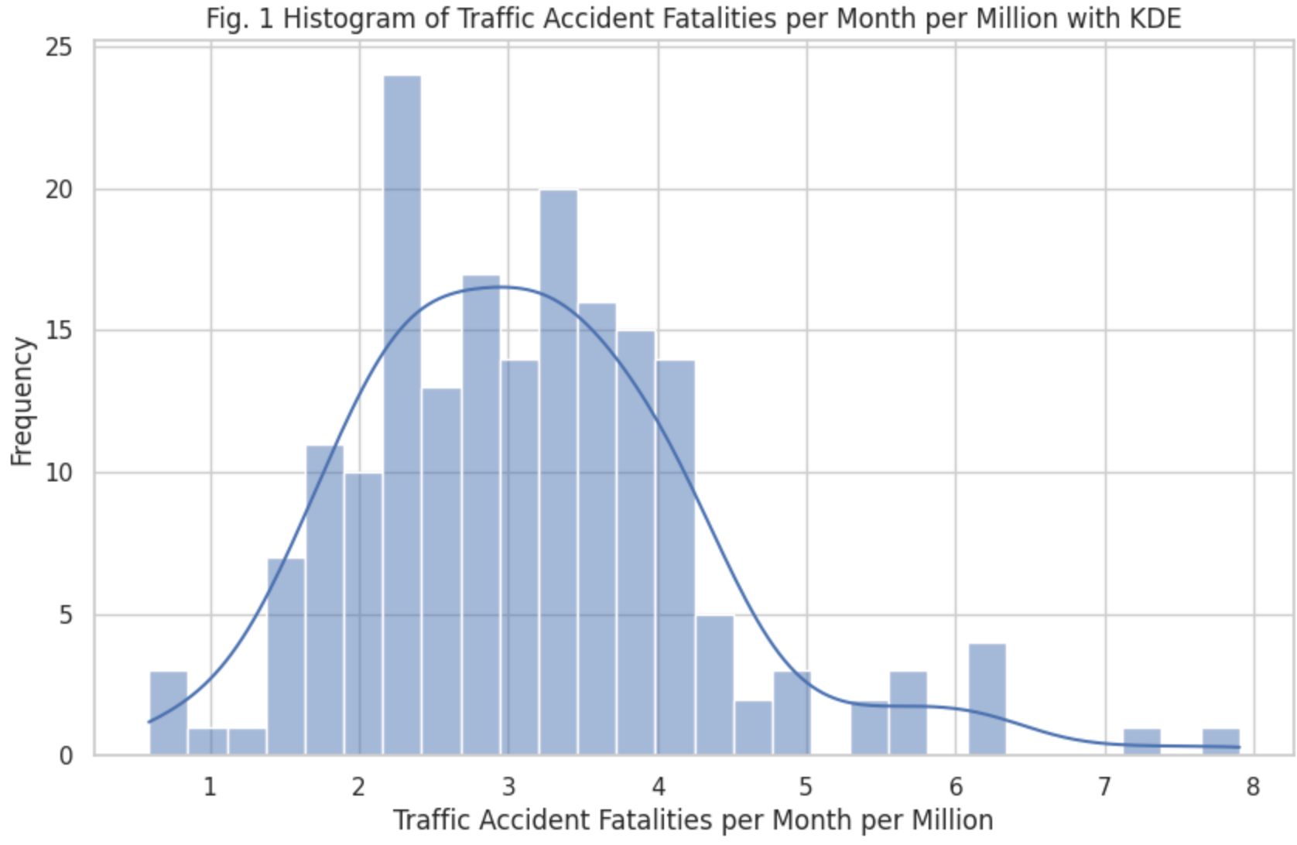

Figure 2 below depicts the trend in traffic fatalities per million people in Ireland, spanning from January 2008 to July 2023.

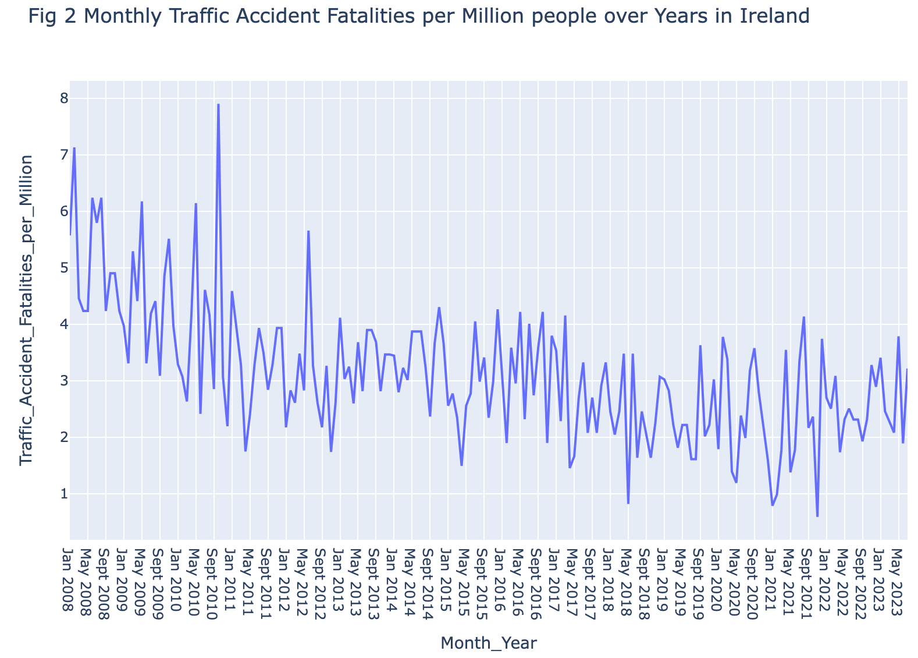

As could be observed in Figure 2, there is considerable month-to-month variation in traffic fatalities per million people. Therefore, the monthly average traffic fatalities for each year were calculated to analyze the data more effectively.

Figure 3 below illustrates the trend in these monthly averages from 2008 to 2023.

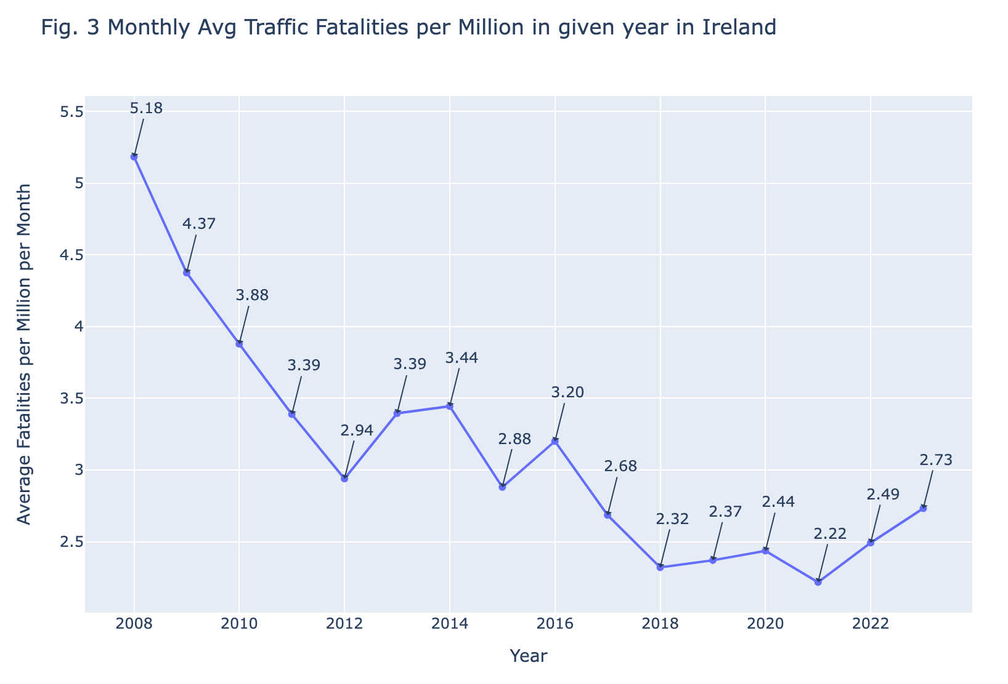

Table 2 below displays the year-on-year percentage change in monthly average traffic fatalities.

| **Year** | **Monthly Average Traffic Fatalities for given year** | **Year on Year % change in Monthly Average Traffic Fatalities (in %)** |
| --- | --- | --- |
| 2008 | 5.184 | NaN |
| 2009 | 4.375 | -15.604 |
| 2010 | 3.879 | -11.343 |
| 2011 | 3.388 | -12.650 |
| 2012 | 2.939 | -13.260 |
| 2013 | 3.395 | 15.521 |
| 2014 | 3.444 | 1.453 |
| 2015 | 2.880 | -16.388 |
| 2016 | 3.200 | 11.118 |
| 2017 | 2.685 | -16.097 |
| 2018 | 2.320 | -13.587 |
| 2019 | 2.370 | 2.138 |
| 2020 | 2.435 | 2.775 |
| 2021 | 2.217 | -8.974 |
| 2022 | 2.492 | 12.394 |
| 2023 | 2.732 | 9.641 |
| **Mean Year on Year Change in %** | | **-3.524** |

The calculated mean year-on-year percentage change in the monthly average of traffic fatalities, as outlined in Table 2, stands at -3.52%. This signifies a consistent downward trend in traffic fatalities per million in Ireland, reflecting an average annual decrease of 3.52% over the extended period from 2008 to 2023. In absolute terms, the Average Monthly fatalities per Million during this period has experienced a decline of approximately 47.2%. This statistical analysis suggests a notable and sustained improvement in road safety, as evidenced by the decreasing trend in the occurrence of traffic fatalities over the specified years.

**4.2 Analysis of Traffic fines issued:**

Similar to the normalization of traffic fatalities in Ireland per million of the population, the number of traffic fines issued for various infractions has also been normalized. The average number of fines issued per month for each given year was calculated to facilitate this analysis.

Figure 4 below illustrates the trends in average monthly traffic fines issued per million over time.

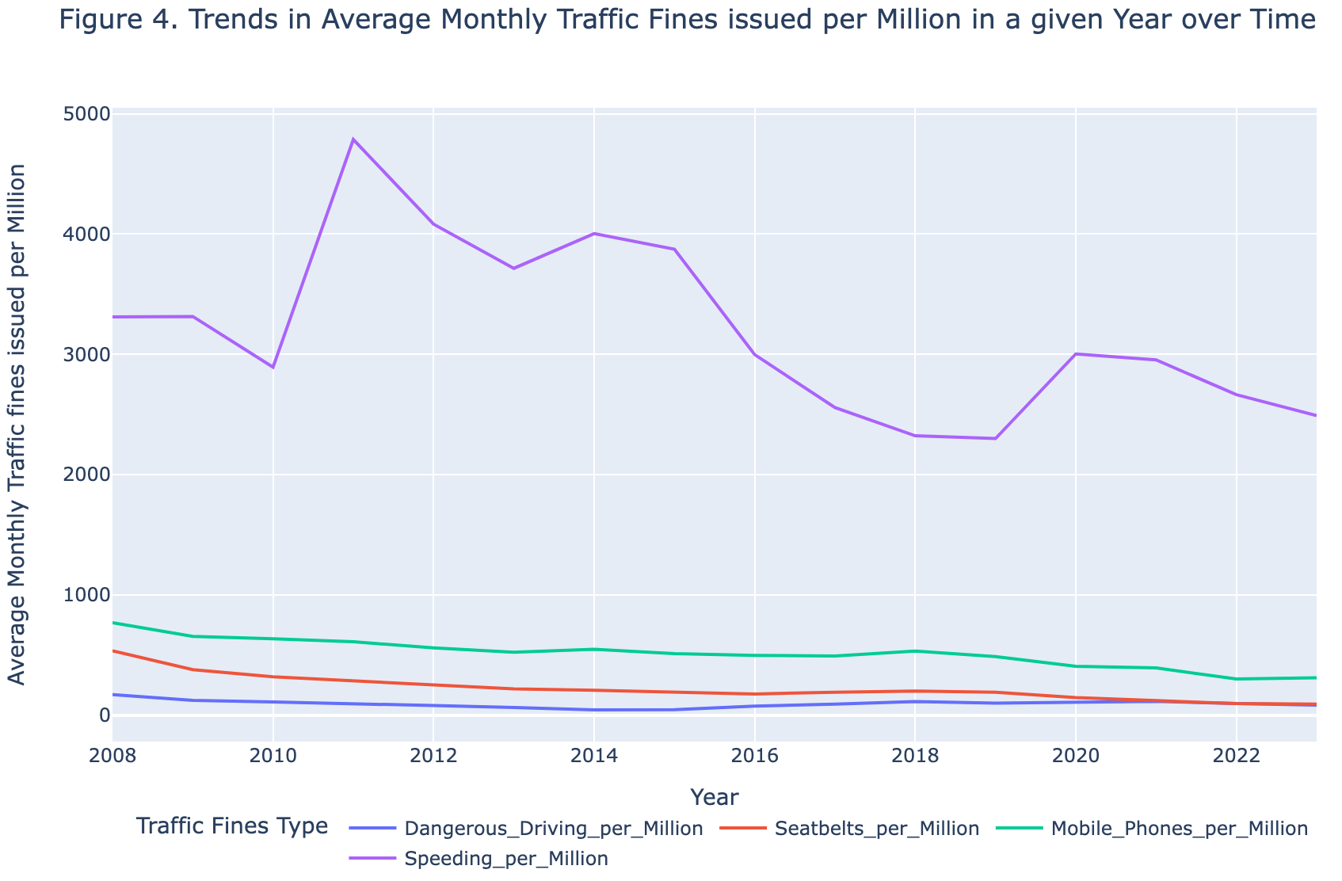

From Figure 4, the two key observations can be made:

1. The vast majority of fines issued are for speeding infractions, accounting for more than two-thirds of all traffic fines in a given year.
2. There is a noticeable declining trend in the number of fines issued from 2008 to 2023 across all categories of infractions.

Table 3 below presents the percentage share of each fine type of the total fines issued annually.

| **Year** | **Average Monthly Fines issued in a Given year per Million** | | | | | **Percentage share of Fine type in Total Fines issued** | | | |
| --- | --- | --- | --- | --- | --- | --- | --- | --- | --- |
| **Dangerous Driving** | **Seatbelts** | **Mobile Phones** | **Speeding** | **Total Fines** | **% Dangerous Driving** | **% Seatbelts** | **%**  **Mobile Phones** | **% Speeding** |
| 2008 | 168.97 | 533.71 | 768.15 | 3310.42 | 4781.26 | 3.53 | 11.16 | 16.07 | 69.24 |
| 2009 | 121.16 | 376.70 | 653.85 | 3315.12 | 4466.83 | 2.71 | 8.43 | 14.64 | 74.22 |
| 2010 | 107.94 | 318.03 | 633.67 | 2892.97 | 3952.63 | 2.73 | 8.05 | 16.03 | 73.19 |
| 2011 | 96.47 | 286.40 | 608.79 | 4786.97 | 5778.63 | 1.67 | 4.96 | 10.54 | 82.84 |
| 2012 | 78.71 | 250.96 | 558.43 | 4082.42 | 4970.52 | 1.58 | 5.05 | 11.23 | 82.13 |
| 2013 | 62.08 | 217.13 | 522.57 | 3714.92 | 4516.71 | 1.37 | 4.81 | 11.57 | 82.25 |
| 2014 | 42.77 | 206.53 | 547.57 | 4003.80 | 4800.66 | 0.89 | 4.30 | 11.41 | 83.40 |
| 2015 | 44.73 | 192.54 | 511.45 | 3873.32 | 4622.03 | 0.97 | 4.17 | 11.07 | 83.80 |
| 2016 | 73.38 | 174.21 | 496.31 | 2997.06 | 3740.96 | 1.96 | 4.66 | 13.27 | 80.11 |
| 2017 | 90.33 | 190.14 | 490.12 | 2557.53 | 3328.12 | 2.71 | 5.71 | 14.73 | 76.85 |
| 2018 | 112.56 | 198.52 | 531.81 | 2322.16 | 3165.04 | 3.56 | 6.27 | 16.80 | 73.37 |
| 2019 | 99.31 | 189.99 | 486.57 | 2299.03 | 3074.91 | 3.23 | 6.18 | 15.82 | 74.77 |
| 2020 | 107.52 | 145.45 | 405.54 | 3003.09 | 3661.60 | 2.94 | 3.97 | 11.08 | 82.02 |
| 2021 | 112.98 | 119.48 | 391.58 | 2953.90 | 3577.95 | 3.16 | 3.34 | 10.94 | 82.56 |
| 2022 | 96.26 | 95.18 | 299.03 | 2663.90 | 3154.37 | 3.05 | 3.02 | 9.48 | 84.45 |
| 2023 | 82.33 | 90.56 | 310.21 | 2489.78 | 2972.88 | 2.77 | 3.05 | 10.43 | 83.75 |

The data highlights that fines issued for seat belt infractions have exhibited the most substantial average annual decline, followed by mobile phone use, dangerous driving, and speeding infractions. Specifically, fines for seatbelt violations have decreased by an average of approximately 10% each year. In absolute terms, from 2008 to 2023, the monthly average number of fines issued for seatbelt violations per million declined by about 83%, mobile phone violations per million use by 59%, dangerous driving per million by 51%, and speeding violations by 24%. These figures underscore notable improvements and shifts in

enforcement patterns over the specified period.

Table 4 below details the year-on-year percentage change in average monthly traffic fines issued per category. The mean percentage change for each type of fine reveals the overall declining trend in fines issued over the studied period.

| **Year** | **Year on Year % change in Average Monthly Traffic fines issued in Given year** | | | |
| --- | --- | --- | --- | --- |
| **Dangerous Driving** | **Seatbelts** | **Mobile Phones** | **Speeding** |
| 2008 | NaN | NaN | NaN | NaN |
| 2009 | -28.30 | -29.42 | -14.88 | 0.14 |
| 2010 | -10.90 | -15.57 | -3.09 | -12.73 |
| 2011 | -10.63 | -9.95 | -3.93 | 65.47 |
| 2012 | -18.41 | -12.37 | -8.27 | -14.72 |
| 2013 | -21.13 | -13.48 | -6.42 | -9.00 |
| 2014 | -31.12 | -4.88 | 4.78 | 7.78 |
| 2015 | 4.58 | -6.77 | -6.60 | -3.26 |
| 2016 | 64.06 | -9.52 | -2.96 | -22.62 |
| 2017 | 23.11 | 9.15 | -1.25 | -14.67 |
| 2018 | 24.60 | 4.41 | 8.51 | -9.20 |
| 2019 | -11.77 | -4.29 | -8.51 | -1.00 |
| 2020 | 8.27 | -23.45 | -16.65 | 30.62 |
| 2021 | 5.07 | -17.85 | -3.44 | -1.64 |
| 2022 | -14.80 | -20.34 | -23.64 | -9.82 |
| 2023 | -14.46 | -4.86 | 3.74 | -6.54 |
| **Mean % Change** | **-2.12** | **-10.61** | **-5.51** | **-0.08** |

**5) Regression Analysis of Traffic Fatalities and Traffic Fines Imposed:**

Traffic fatality rates serve as a crucial metric globally, monitored by governments to assess road safety. In an effort to enhance roadway conditions, authorities implement a variety of safety regulations, conduct road safety awareness campaigns, and levy fines for violations as a means to enforce compliance with traffic laws. These measures collectively contribute to promoting safer and more secure conditions on the roads.

A pragmatic method to evaluate the impact of these regulations and campaigns is to examine the correlation between the intended safety outcomes and the enforcement metrics, such as the frequency of traffic fines issued. In this context, the number of fines levied for specific infractions can serve as an indirect measure of rule adherence within the population. For instance, an increase in fines for mobile phone usage while driving could indicate a higher proportion of drivers disregarding this particular road safety regulation.

In our regression analysis, we adopted a simple linear regression approach, examining the relationship between traffic fatalities and each type of traffic fine independently. This method enables a clear investigation into how each specific infraction type—dangerous driving, seatbelt non-compliance, mobile phone use, and speeding—individually correlates with the rate of traffic fatalities. By isolating the variables, we gain a straightforward understanding of each factor's impact.

***Which Traffic Safety Rule Enforcement has Profound Impact on Traffic Fatalities?***

Figure 5 below displays a series of scatter plots correlating the average monthly traffic accident fatalities per million with the average monthly fines issued for four types of traffic violations: dangerous driving, seatbelt violations, mobile phone usage while driving, and speeding.

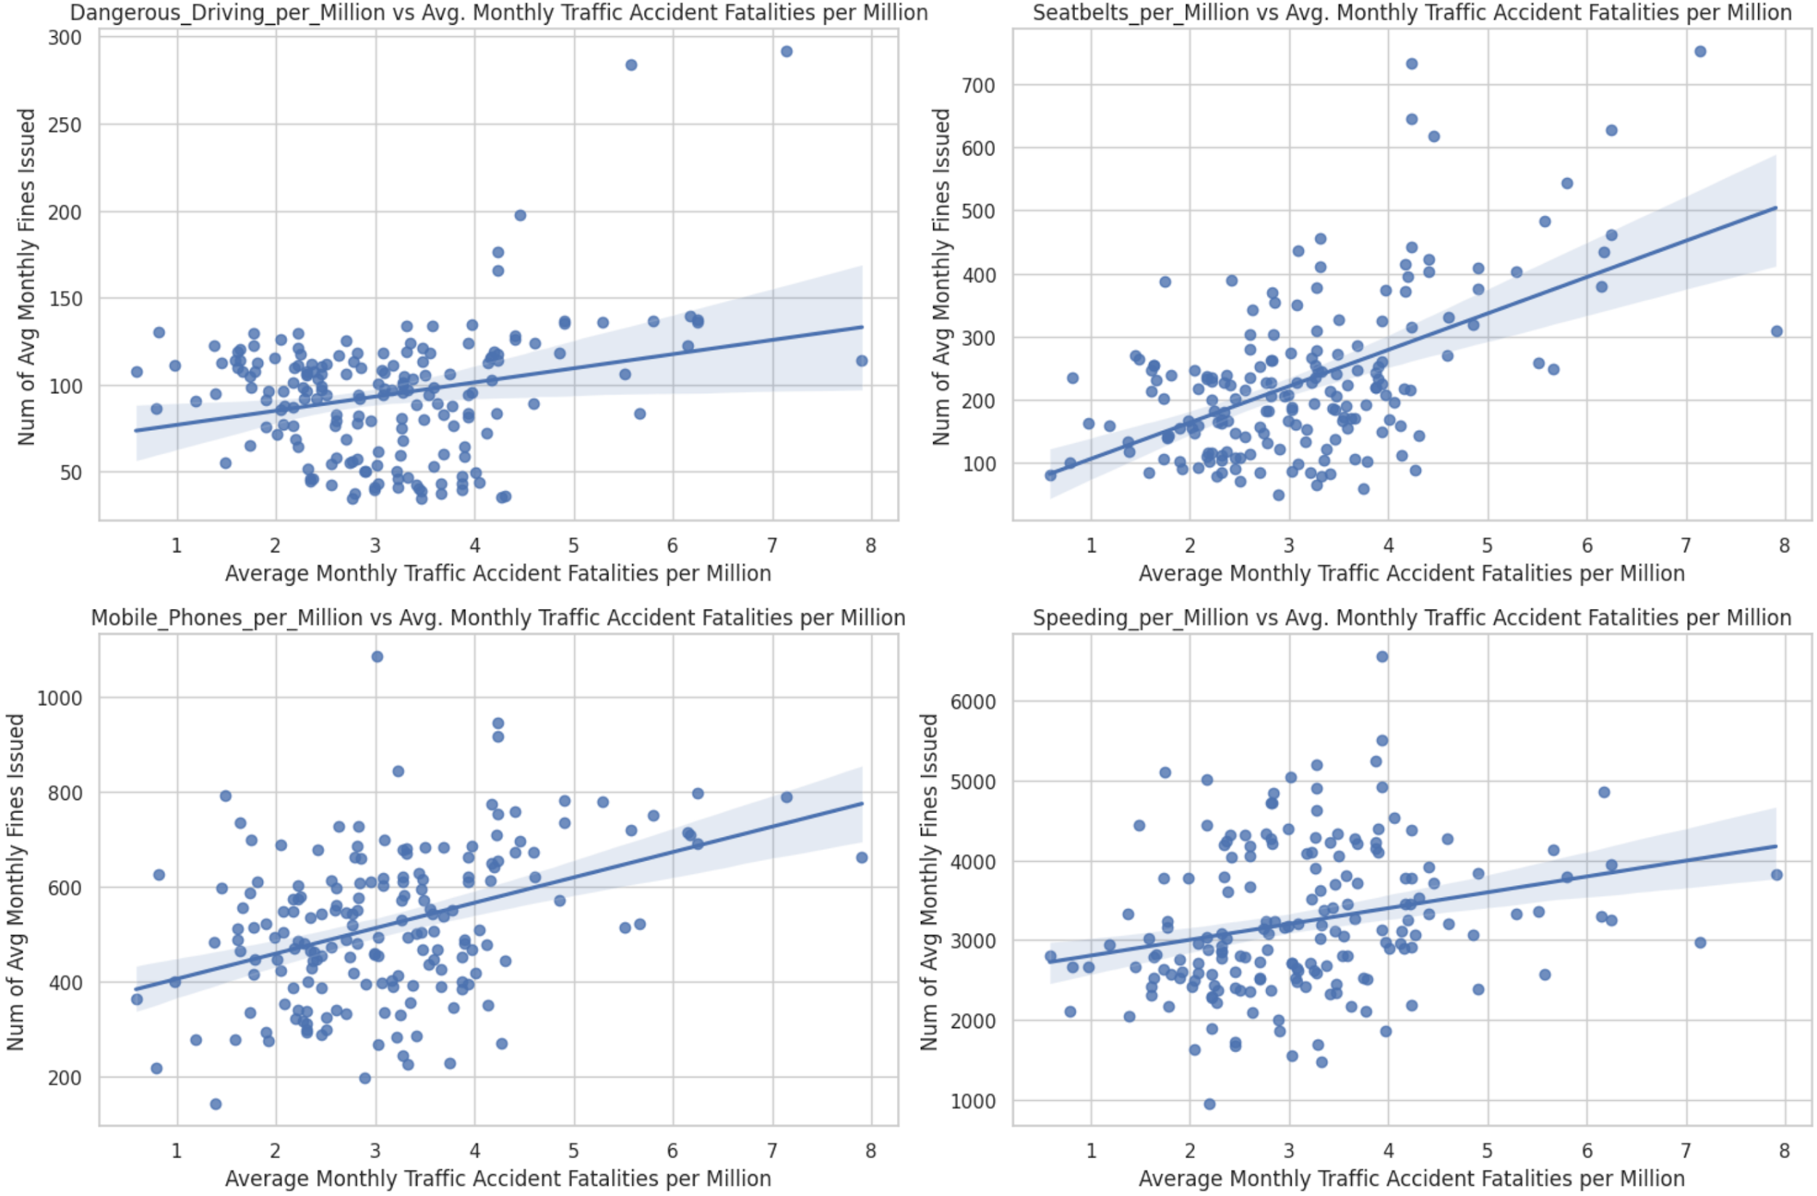

Table 5 below presents the results of independent regression analyses using OLS (Ordinary Least Square) method for each type of traffic fine. The R-squared values serve as indicators of the proportion of variance in the monthly average traffic fatalities per million that can be explained by each independent variable. Meanwhile, the F-statistics assess the overall significance of the regression model, and the p-values offer a measure of the evidence against the null hypothesis, suggesting no relationship between the independent and dependent variables. These statistical measures collectively contribute to the assessment of the model's explanatory power and the significance of the relationships between the variables under consideration.

| **Independent Variable** | **R Squared** | **F- Statistics** | **p-value** |
| --- | --- | --- | --- |
| Dangerous Driving | 0.067 | 13.14 | 0.000375 |
| Seatbelts | 0.296 | 76.4 | 1.51E-15 |
| Mobile Phones | 0.158 | 34.26 | 2.21E-08 |
| Speeding | 0.066 | 12.81 | 0.000442 |

In our regression analysis, seatbelt violations exhibit the highest R-squared value among the examined traffic fines. This suggests a substantial association between fluctuations in seatbelt-related fines and variations in traffic fatalities. Under the assumption of consistent Garda Síochána enforcement, the observed decline in seat belt fines may indicate a growing public adherence to seatbelt regulations, potentially contributing to the reduction in fatalities. The notable F-statistic, coupled with its low p-value, provides compelling evidence of the statistical significance of seatbelt violations in the model, reinforcing the pivotal role of seatbelt use in enhancing overall road safety.