"**Adaptive Heuristic and AI-Driven Optimization for Energy-Efficient Placement of ML Services in IoT Networks**"

**Enhanced Cloud-Fog-IoT Architecture for ML Service Placement**

Key Features of the Proposed Architecture:

**1. Hybrid AI-Driven Optimization**: The proposed architecture uses adaptive heuristic algorithms in conjunction with machine learning techniques. AI-driven methods predict resource usage trends, enabling dynamic service placements. Heuristics provide near-optimal solutions quickly for large-scale IoT environments.

**2. Dynamic Fog Orchestration Layer:** The new architecture includes a dynamic fog orchestration layer that autonomously adjusts VM placement across fog nodes based on real-time workload changes and energy constraints. This dynamic adjustment reduces the need for central cloud involvement, thus cutting latency and energy consumption.

**3. Edge-Aware Data Preprocessing:** To further improve the efficacy, the architecture introduces preprocessing capabilities at the edge (IoT devices) to filter and reduce unnecessary data before transmitting it to the fog or cloud layers. This reduces bandwidth usage, energy consumption, and congestion at the fog layer.

**4. Multi-Objective Optimization (Energy & Latency):** Unlike the current model, which focuses solely on energy efficiency, the proposed architecture will also optimize for latency by minimizing the distance between service requests and the processing nodes. A multi-objective heuristic algorithm will balance between energy and performance, enhancing user experience.

**5. AI-based Fault Tolerance:** To enhance the resilience of the system, AI-driven fault tolerance is implemented to monitor nodes and dynamically reassign workloads in the event of node failures or underperformance.

**6. Hierarchical Placement Strategy:** A three-tier hierarchical structure Edge (IoT), Fog, and Cloud will improve resource allocation, with intelligent decision-making occurring at each level. The goal is to handle smaller tasks locally (at the IoT or fog layers) and reserve the cloud for larger, high-computation tasks.

**Proposed Architecture Diagram (Concept)**

A diagram to depict the enhanced architecture can contain the following labeled components:

IoT Layer (Edge):

IoT Devices with AI-driven Preprocessing

IoT Task Request (e.g., sensors, cameras)

Fog Layer:

Fog Nodes with Virtualized Machine Learning Service Placement

Dynamic Fog Orchestration and Resource Allocation

AI-driven Fault Tolerance System

Cloud Layer:

Centralized Cloud Data Center (for high computation tasks)

Central Orchestration Manager (oversees fog layer)

Communication Links:

IoT-to-Fog Links (Wi-Fi, 5G)

Fog-to-Cloud Links (optical, fiber)

Optimization Feedback Loops:

Real-time feedback from IoT and Fog to central cloud for energy and latency metrics

Here is a detailed algorithm for implementing Adaptive Heuristic and AI-Driven Optimization for Energy-Efficient Placement of ML Services in IoT Networks:

**Algorithm: Adaptive Heuristic and AI-Driven Optimization**

Input:

Network Topology: , where:

Set of all nodes (IoT, Fog, Cloud).

Set of all links between nodes.

Virtual Machine Requests: representing ML services.

Energy Efficiency Target:

Latency Threshold:

Node Metrics: Processing capacity, current workload, energy consumption, latency, and fault status.

**Step 1:** Data Preprocessing at the IoT Layer

1. For each IoT device :

Collect data generated by IoT sensors.

Preprocess the data to filter out unnecessary information using onboard processing.

If the data is relevant, send it to the nearest fog node .

Else, discard or store locally.

**Step 2:** Monitor Network Metrics

1. Initialize AI-based monitoring across all nodes in the network.

2. For each node :

Monitor real-time metrics including:

* Processing capacity.
* Current workload.
* Energy consumption.
* Latency (round-trip time).
* Node fault status.

**Step 3: Predictive AI Model for Workload and Resource Usage**

1. Initialize a machine learning model to predict future workload and resource demands:

Input features: historical data on processing usage, energy consumption, latency patterns.

Output: predicted workload, resource availability at each fog and cloud node.

2. For each prediction interval :

Update node states with predicted workload and capacity.

**Step 4: Initial Placement of Virtual Machine Requests (VMR)**

1. Sort all requests by descending order of resource demands.

2. For each request :

Use Heuristic First Fit Decreasing (FFD) Algorithm:

Find the nearest fog node that satisfies both energy and latency constraints and has sufficient capacity.

If can host , place the VM on .

Else:

Find the nearest cloud node and place the VM.

If no cloud node is available, reject the request.

3. Record the initial placement .

**Step 5: Dynamic Optimization (Adaptive Adjustment)**

1. For each time interval , re-evaluate the placement of VMs based on real-time metrics.

2. For each node :

If energy consumption exceeds the threshold :

Offload some VMs to neighboring fog nodes or cloud layer based on available capacity.

If latency exceeds :

Reassign VMs to closer fog nodes or cloud nodes.

Migrate VMs using minimal-cost migration strategy.

**Step 6: AI-Driven Fault Detection and Recovery**

1. Monitor all nodes for faults or performance degradation using AI-based algorithms.

If a node is underperforming or has failed:

Immediately trigger the fault recovery process.

Redistribute workloads to backup nodes.

2. Use Fault Prediction Model to preemptively migrate workloads from nodes showing signs of potential failure.

**Step 7: Multi-Objective Optimization**

1. Simultaneously optimize for energy and latency:

Energy objective: minimize total energy .

Latency objective: minimize total latency .

2. Combine objectives using weighted factors for energy and for latency:

\text{Minimize:} \ \ w_e \cdot E(T) + w_l \cdot L(T)

In this expression:

* E(T) typically represents the expected value of some variable (possibly an outcome, error, or cost) associated with a decision or strategy TTT.
* L(T) usually denotes a loss function, which quantifies the loss incurred by taking the action or strategy TTT.
* w_e and w_l are weights assigned to the expected value and loss, respectively. They allow you to prioritize one aspect over the other based on the specific problem's requirements.

3. For each optimization cycle:

If energy exceeds target :

Migrate VMs to nodes with lower energy consumption.

If latency exceeds :

Reassign VMs to closer nodes with lower round-trip times.

**Step 8: Final Placement and Execution**

1. Lock in the final placement of VMs at the end of each optimization cycle.

2. Execute the tasks on the assigned nodes.

3. For each time interval :

Continue real-time monitoring and optimization to dynamically adjust VM placement.

**Step 9: Feedback Loop and Continuous Learning**

1. Update the AI model periodically using feedback from real-time network conditions.

2. Refine predictions and placement strategies based on new data.

The Adaptive Heuristic and AI-Driven Optimization for Energy-Efficient Placement of ML Services in IoT Networks and the LEACH (Low-Energy Adaptive Clustering Hierarchy) protocol both aim at energy efficiency in IoT and wireless sensor networks (WSNs), but they differ in approach, functionality, and application scope.

1. Purpose and Application

Adaptive Heuristic and AI-Driven Optimization: This technique focuses on the energy-efficient placement and optimization of machine learning (ML) services in IoT networks. It uses adaptive heuristics (rules) and AI-driven algorithms to determine the best locations for ML services to minimize energy consumption while maintaining optimal service quality. This is more aligned with IoT networks where ML services need to be placed strategically for real-time data processing and decision-making.

LEACH Protocol: LEACH is a classic protocol in WSNs that focuses on energy-efficient data transmission. It creates clusters among nodes and assigns a cluster head to collect, aggregate, and send data to the base station, reducing the energy consumption of individual sensor nodes. LEACH is specific to WSNs, where nodes are typically constrained in energy and processing power, and less about the placement of ML services.

2. Optimization Approach

Adaptive Heuristic and AI-Driven Optimization: This uses adaptive rules and AI algorithms to dynamically optimize ML service placements, considering real-time network conditions and ML workloads. The optimization process is more computationally intensive and relies on data patterns and predictions to adapt over time.

LEACH Protocol: LEACH employs a simpler approach, where clusters are created, and each node takes turns as the cluster head. This random rotation of cluster heads prevents certain nodes from draining too much energy but doesn’t use real-time AI or adaptive optimization.

3. Data Processing and Aggregation

Adaptive Heuristic and AI-Driven Optimization: Data processing and aggregation are optimized by placing ML services close to where they are needed, improving latency and energy efficiency in IoT networks. The placement is more application-specific, considering where data will be processed, analyzed, or acted upon by ML algorithms.

LEACH Protocol: LEACH only aggregates data at the cluster head level without optimizing ML processing or task allocation. The primary focus is on energy-efficient communication rather than adaptive optimization for computational tasks.

4. Network Dynamics and Scalability

Adaptive Heuristic and AI-Driven Optimization: This is generally more scalable and adaptable to complex, dynamic IoT networks, as it can adjust placements based on network conditions, energy availability, and computational needs.

LEACH Protocol: LEACH works well for static WSNs with limited mobility but may not scale well in highly dynamic networks like IoT environments with varying traffic patterns and ML service requirements.

Summary

While both approaches focus on energy efficiency, the Adaptive Heuristic and AI-Driven Optimization is more suited for IoT networks requiring strategic ML service placements, whereas the LEACH protocol is a simpler, well-suited approach for static WSNs focusing on efficient data transmission.

comprehensive architectural diagram

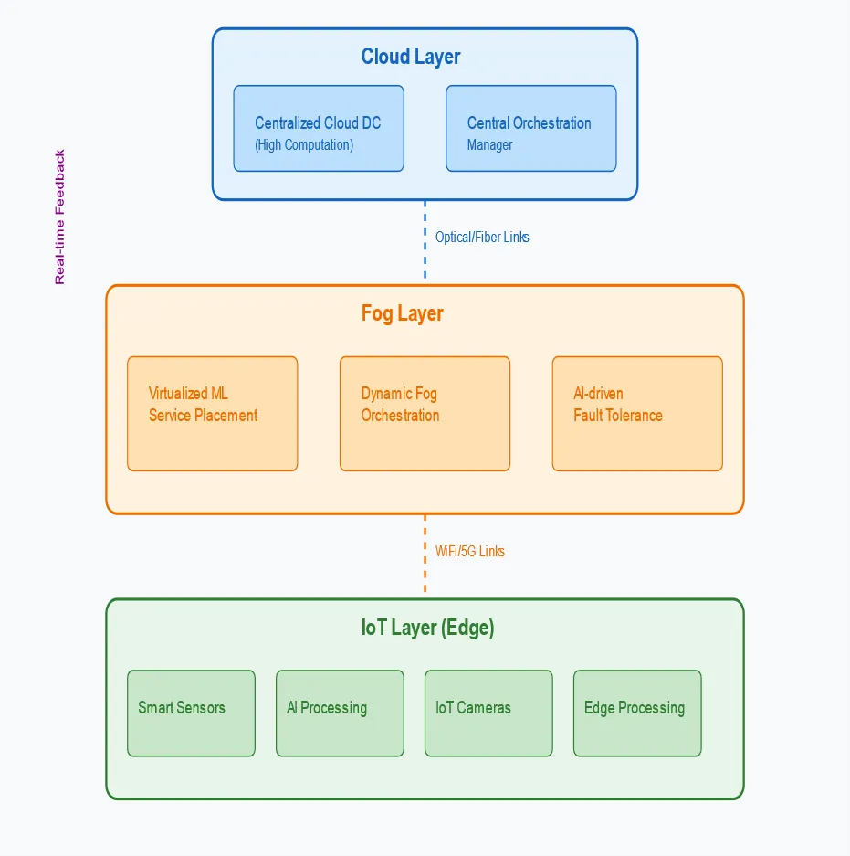

Let me explain the key components and enhancements in this proposed architecture:

1. Cloud Layer (Top):

- Centralized Cloud Data Center: Handles resource-intensive computations and long-term storage

- Central Orchestration Manager: New component that oversees the entire system, making high-level decisions about resource allocation and service placement

2. Fog Layer (Middle):

- Virtualized ML Service Placement: Enhanced from the original paper to include intelligent service placement based on real-time metrics

- Dynamic Fog Orchestration: New component that handles resource allocation and load balancing across fog nodes

- AI-driven Fault Tolerance System: New addition that provides resilience through predictive maintenance and automatic failover

3. IoT Layer (Bottom):

- Smart Sensors: Enhanced with AI-driven preprocessing capabilities

- AI Processing Units: New component for edge intelligence

- IoT Cameras: Specialized devices for visual data processing

- Edge Processing Units: Dedicated components for immediate data processing

4. Communication Links:

- Cloud-to-Fog: High-speed optical and fiber connections for reliable backhaul

- Fog-to-IoT: Flexible connectivity through WiFi and 5G networks

- Optimization Feedback Loops: New addition showing real-time metric collection and feedback

Key Enhancements from Original Paper:

1. Added AI-driven components at each layer

2. Introduced dedicated fault tolerance system

3. Enhanced orchestration capabilities with central management

4. Added real-time feedback loops for continuous optimization

5. Incorporated edge processing capabilities at IoT layer

This architecture improves upon the original paper by:

- Reducing latency through edge processing

- Enhancing reliability with AI-driven fault tolerance

- Improving resource utilization through dynamic orchestration

- Enabling more intelligent service placement decisions

- Providing better scalability through hierarchical management

Would you like me to elaborate on any specific component or enhancement?

Key AI Models in Our Solution:

Workload Prediction: LSTM Networks

Predicts future resource demands

Resource Management: Reinforcement Learning

Optimizes VM placement decisions

Fault Detection: Random Forest

Detects anomalies and predicts failures

Performance Optimization: XGBoost

Manages energy and latency trade-offs

AI Models for Network Optimization

1. Workload Prediction Models

-LSTM (Long Short-Term Memory)

Best for time-series prediction of network traffic

- Can capture long-term patterns in resource usage

- Suitable for predicting periodic workload patterns

- Prophet (by Facebook)

- Excellent for forecasting with seasonal patterns

- Handles missing data well

- Good for predicting resource demands with daily/weekly patterns

2. Resource Allocation Models

Reinforcement Learning

DQN (Deep Q-Network) for VM placement decisions

A3C (Asynchronous Advantage Actor-Critic) for continuous action spaces

Rewards based on energy efficiency and latency optimization

3. Fault Detection & Prediction

Random Forest

- For anomaly detection in network behavior

- High accuracy in identifying potential failures

- Good with mixed data types (numerical & categorical)

Isolation Forest

- Efficient for real-time anomaly detection

- Low computational overhead

- Suitable for detecting unusual system behavior

4. Energy Optimization

XGBoost

- For predicting energy consumption patterns

- Feature importance for identifying energy-intensive operations

- Quick inference time for real-time decisions

5. Latency Prediction

Neural Networks (CNN+RNN Hybrid)

- For predicting network latency

- Considers spatial and temporal features

- Good for complex network topologies

Implementation Considerations

- Model Size: Keep models lightweight for fog nodes

- Inference Time: Must meet real-time requirements

- Training Strategy: Federated learning for distributed training

- Model Updates: Continuous learning from feedback loop