1. https://kalpartz.com/automann-a97831-seat-shock/

<h1> Automann A97831 Seat Shock</h1>
<div class="listprod">
Seat Shock </div>
<ul class="top-cross-reference-list cross-reference-list">
<li class="other-cross-refrence"><a href="#" onClick="return false;" class="other--cross_refrences">2167913</a></li><li class="other-cross-refrence"><a href="#" onClick="return false;" class="other--cross_refrences">SK-582-2</a></li><li class="other-cross-refrence"><a href="#" onClick="return false;" class="other--cross_refrences">1691484C91</a></li><li class="other-cross-refrence"><a href="#" onClick="return false;" class="other--cross_refrences">337086C1</a></li><li class="other-cross-refrence"><a href="#" onClick="return false;" class="other--cross_refrences">507831C91</a></li> </ul>
<div class="star-rating-menu pb-4 mt-3">
<div class="review__rating star-rating-menu">
<div class="icn" style="width:100%;"> </div>
</div><span class="rating-text">
(1)
</span> </div>
<hr>

2. https://shop.advanceautoparts.com/p/american-grease-stick-co.-steel-90-degree-grease-elbow-27-32-length-male-1-8-27-npt-gf-11c/11408545-P

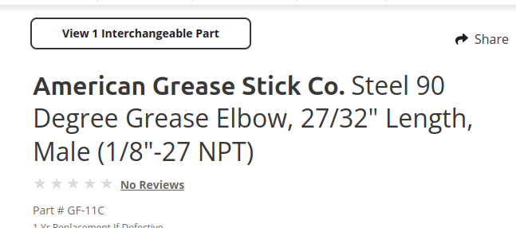

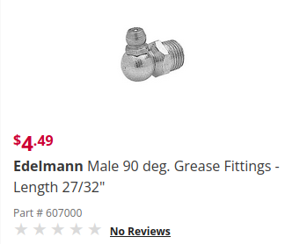

3. https://www.finditparts.com/products/596993/dorman-485-702?srsltid=AfmBOoqacr9sNTl6u7IEc90KHFc6DqWKMRH3AyEgPOI9WsZArytIzKFw

</tr>
</tbody></table></div><h4>Part Interchanges</h4><div class="product_description__row"><ul>
<li><a class="" href="/search?s=Champ+157708">Champ 157708</a></li>
<li><a class="" href="/search?s=Edelmann+608000">Edelmann 608000</a></li>
<li><a class="" href="/search?s=Barnes+Systems+7581">Barnes Systems 7581</a></li>
<li><a class="" href="/search?s=Papco+009-172">Papco 009-172</a></li>
<li><a class="" href="/search?s=Papco+904-627">Papco 904-627</a></li>
<li><a class="" href="/search?s=Papco+904-641">Papco 904-641</a></li>
<li><a class="" href="/search?s=AGS+Company+GF-13">AGS Company GF-13</a></li>
<li><a class="" href="/search?s=AGS+Company+GF-13B">AGS Company GF-13B</a></li>
<li><a class="" href="/search?s=AGS+Company+GF-13C">AGS Company GF-13C</a></li>
<li><a class="" href="/search?s=AGS+GF-13">AGS GF-13</a></li>
<li><a class="" href="/search?s=AGS+GF-13B">AGS GF-13B</a></li>
<li><a class="" href="/search?s=AGS+GF-13C">AGS GF-13C</a></li>
</ul></div>

4. https://www.traction.com/en/p/high-capacity-v-belt-l-49-99-in-w-13-32-in-gat7500

<div class="sec-title-header">
<h2 class="sec-title-sub proOver">Interchanges & Equivalent parts: </h2>
</div>
<br>
<div class="interchange category-description">
<p><a class="sec-title"></a>
0516473000, 60871, BH1657, D0HZ8260B, CH735, 70769, KM191, KM191, 20735, 15506, 0118100, 03-02-126-2, 06580721321, 0951275, 10-01858, 10034337, 10500, 10A1270, 10A1270C, 10AV1275, 10X39233, 1164196, 11A1270, 11G1270, 1233935915, 12498, 13-500, 1304132, 1365H, 1382563, 1386H, 13G502, 14-0542-8, 14031321, 141-1226, 1433441H2, 145-011275, 1485117, 1489861, 15096A, 15500AP, 15500DR, 15500MK, 156096A, 15613502, 1561350202, 1561853, 18-15500, 332244, 678034, 26018X, D2HA8260ALA, MR233, E70769, 20735, 1601013, 17032964, 17032965, 20735, GYB15506, 022150090009, 03-02-333-8, 0403501, 1018088, 10AX1270, 11502109, 1340685, 14062269, 1483694, 15-500, 156A, 1840685M91, 1987947721, 2028B89H34, 2126070, 217695, 2231712, 2235260, 2235530, 2235531, 2235534, 22514316, 231983K2, 231983K21, 231983R1, 276668C11, 276668K11, 276688C1, 276688C11, 2806543, 2806790, 2806791, 28985, 2N159, 3030003792815, 3030007568402, 3058620, 308302, 329653, 347196, 358348C91, 358348C92, 359530, 3698905, 3703633, 374011, 3761936, 3769136, 3792461, 3814141, 3837671, 3839321, 384424, 3850994, 3905064, 391201, 3925530, 3935530, 4006429, 60871, D2HA8260ALA, D0HZ8260B, E70769, CH735, 332244, 26018X, 1601013, 20735, 17032964, 17032965, MR233, KM191, 0516473000, BH1657, 70769, 678034, 20735, 20735, KM191, 7500, 7500, 49694, 95X1275, 0118100, 145-011275, 59729, 1365H, 424785, 2028B89H34, 424104, 50-2-3, 55641, UE31113RR, 9786983, C20Z 8620 S, 54423, 952141, 421442, GFB144, 48196, 419521, 5582505, 596079, 423426, B-15506-A, 53934, 427143, 359530, 10X39233, 3839321, 3792461, 9966584, 4343532, 916416-1255, 423550, RX131840, 57694, 0951275, 427994, 810544, 2806790, 12498, EJU-504, 958321, 03-02-126-2, 47935, 872986R1, 2N159, 13-500, 626595, 9433753, 433222, 1561853, 10A1270, 3925530, 156096A, 67531, 966386, A27011, V531, 276668C11, 15096A, A67204C7, 28985, 5000124, M330K287, 2235260, 3030003792815, 702248, 1489861, 9.5X1275LA, 4446312, 13G502, ZAH15500, 958366, 467424, 6588628, 4388326, 7303633, 4106208, 1561350202, 424224, 374011, AV4500, 967060, 518848, 11G1270, 231983K2, 15500DR, B-13502-A, 53109, V10X1275, 40800060031, P7500, 5200976, 10500, ZJG13502, 978555, 990951, HY2316B, 6263720, 10AV1275, 704340, 423931, 91079526, 2806791, 4006429, 1</p>
</div>
</div>
</div>
</div>
</div>
</div>
</div>

5. https://vanhorntruckparts.com/products/square-bend-u-bolt-kit-361-561?srsltid=AfmBOoq-rSvO0SykCRngDD826yRUmDIZAbV-78MtOyvOo0DMx71JEFnp

<meta name="description" content="Square Bend U-Bolt Kit 361-561Sold As A Pair. Price Is For 2. Same As UKSQ812534G8, Automann AUBK8287-114, BWP M-1711, WA07-5006, Dayton 361-561, Dayton 8U-7312S, Batco 10-5302, Neway 90041696, Automann AUBK8287-114, Flagg N145, Flagg UBK215, Leland SB1853, Leland SB1855, Dallas UBK1260.">

6. https://www.fleetpride.com/parts/dexter-small-trailer-brake-assembly-k2310500?srsltid=AfmBOort4uto9lpU8SMZWrQW7CeV5sJlkGj7ry4zGEPM_-xjeeyQjbB9

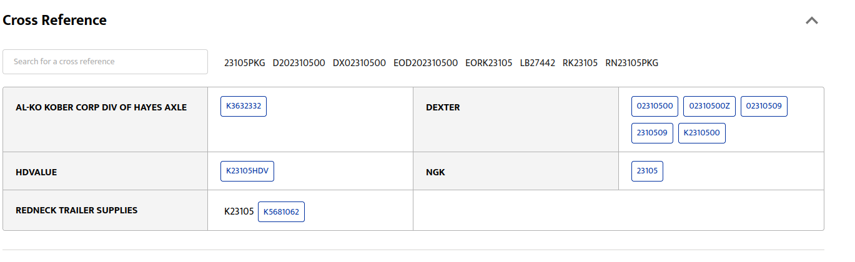

7. view-source:https://www.oilfilter-crossreference.com/convert/CARQUEST/85237

<ul class="list-group nolisttyle">
<li></li>
<h6><strong>CARQUEST 85237:</strong></h6>

</ul>
<!-- <li></li> -->
<!-- End Details section -->
<h6><li><strong>CARQUEST 85237 replacement filters</strong></li></h6>

<li>
<a href="/convert/FLEETGUARD/LF539" title="Fleetguard LF539">
Fleetguard LF539 </a>
</li>
</ul>

</div>
</div>
<!-- indirect_possiblesparks -->
<h3>Indirect matches</h3>
<p>
There are 38 replacements for <strong>Fleetguard LF539</strong>.
These are indirect matches for <strong>CARQUEST 85237</strong>
</p>
<div class="columns col-gapless">
<div class="column col-4 col-lg-12">
<ul>
<li><strong>Indirect matches for Fleetguard LF539</strong></li>
<!-- <li><strong>Indirect matches</strong></li> -->
<li class="list-group-item"><a href="/convert/AC-Delco/P332" title="AC-Delco P332">AC-Delco P332</a></li>
<li class="list-group-item"><a href="/convert/BALDWIN/C36M" title="Baldwin C36M">Baldwin C36M</a></li>
<li class="list-group-item"><a href="/convert/BIG-A/748" title="BIG A 748">BIG A 748</a></li>
<li class="list-group-item"><a href="/convert/BIG-A/92237" title="BIG A 92237">BIG A 92237</a></li>
<li class="list-group-item"><a href="/convert/BRIGGS-STRATTON/B68" title="BRIGGS & STRATTON B68">BRIGGS & STRATTON B68</a></li>
<li class="list-group-item"><a href="/convert/BRIGGS-STRATTON/BR33" title="BRIGGS & STRATTON BR33">BRIGGS & STRATTON BR33</a></li>
<li class="list-group-item"><a href="/convert/CARQUEST/85237" title="CARQUEST 85237">CARQUEST 85237</a></li>
<li class="list-group-item"><a href="/convert/Champ-Lab/1723047" title="Champion Laboratories 1723047">Champion Laboratories 1723047</a></li>
<li class="list-group-item"><a href="/convert/Champ-Lab/LP4410" title="Champion Laboratories LP4410">Champion Laboratories LP4410</a></li>
<li class="list-group-item"><a href="/convert/COOPERS/G556" title="COOPERS G556">COOPERS G556</a></li>
<li class="list-group-item"><a href="/convert/CYCLONE/PMX177N" title="CYCLONE PMX177N">CYCLONE PMX177N</a></li>
<li class="list-group-item"><a href="/convert/DELUXE/158" title="DELUXE 158">DELUXE 158</a></li>
<li class="list-group-item"><a href="/convert/DONALDSON/P779033" title="Donaldson P779033">Donaldson P779033</a></li>
</ul>
</div>
8. https://www.airfilter-crossreference.com/convert/CARQUEST/93763

<h1 class="mt-2">CARQUEST 93763 - Alternative air filters</h1>
<div class="columns">
<div class="column col ">
<p>
There are 1 replacement air filters for <strong>CARQUEST 93763</strong>.
The cross references are for general reference only, please check for correct specifications and measurements for your application.
<br>
When you click on links to various merchants on this site and make a purchase, this can result in this site earning a commission. Affiliate programs and affiliations include Amazon Associates.
</p>
<ul class="twocolumns overflowing">
<li><!-- AFCR-DT-inlist1 -->
<ins class="adsbygoogle"
style="display:inline-block;width:300px;height:250px"
data-ad-client="ca-pub-5213936872537369"
data-ad-slot="5357391126"></ins>
<script>
(adsbygoogle = window.adsbygoogle || []).push({});
</script></li>
<li><strong>CARQUEST 93763 replacement filters</strong></li>
<li>
<a href="/convert/HASTINGS/AF2505" title="HASTINGS AF2505">
HASTINGS AF2505 </a>

</li>
</ul>
</div>
</div>
<!-- indirect_possiblesparks -->
<h3>Indirect matches</h3>
<p>
There are 14 replacements for <strong>HASTINGS AF2505</strong>.
These are indirect matches for <strong>CARQUEST 93763</strong>
</p>
<div class="columns">
<div class="column col ">
<ul class="twocolumns overflowing">
<li><strong>Indirect matches for HASTINGS AF2505</strong></li>
<!-- <li><strong>Indirect matches</strong></li> -->
<li class="list-group-item"><a href="/convert/BALDWIN/PA31003" title="BALDWIN PA31003">BALDWIN PA31003</a></li>
<li class="list-group-item"><a href="/convert/CARQUEST/93763" title="CARQUEST 93763">CARQUEST 93763</a></li>
<li class="list-group-item"><a href="/convert/CUMMINS/5261251" title="CUMMINS 5261251">CUMMINS 5261251</a> &nbsp;<a href="https://www.amazon.com/dp/B078XNSJ7W?tag=airfilter-text-20&linkCode=osi&th=1&psc=1" style="color: blue; text-decoration: underline;">Buy from Amazon</a>
</li>
<li class="list-group-item"><a href="/convert/DONALDSON/P633483" title="DONALDSON P633483">DONALDSON P633483</a>
9. https://www.dormanproducts.com/p-5927-800-312.aspx
- No interchange mentioned as K2984

10. https://excofilter.com/description/AX230207/93800-CARQUEST

