

TECH SAKSHAM

Final Project Report

# Full Stack Web Development

Dr. B. R. Ambedkar University, Srikakulam.



|  |  |
| --- | --- |
| ROLL NO  1981951046 | NAME  S. Sravani |
| 1981951005 | B. Jayanthi |
| 1981951024 | M. Chaitanya |
| 1981951048 | S. Priyamvada |

ABSTRACT

As we know, the **Calculator** is a portable device used in our daily life to perform various mathematical functions such as **addition, subtraction, multiplication, division**, root, etc. However, we have scientific or sophisticated calculators used to solve complex tasks such as trigonometry functions, degrees, exponential operators, log functions, hyperbolic functions, square root, and so on. In this topic, we will create a calculator program in JavaScript.

# INDEX

|  |  |  |
| --- | --- | --- |
| S.No. | Table of Contents | Page No. |
| 1 | Chapter 1: Introduction | 4 |
| 2 | Chapter 2: Tools Required | 5 |
| 3 | Chapter3:Calculator logo | 6 |
| 4 | Chapter 4: Features | 8 |
| 5 | Chapter 5: Conclusion | 9 |
| 6 | Chapter 6: Reference | 10 |
| 7 | Chapter 7: Code | 11 |

INTRODUCTION

As we know that a calculator is a machine which allows us to do math operations more easily. For example, most calculators will add, subtract, multiply, and divide. Some also do square roots, and more complex calculators can help with calculus and draw function graphs. Calculators are found everywhere. You can even build a more advanced level calculator, but we will keep it simple.

# TOOLS REQUIRED

The Hyper Text Markup Language or HTML is the standard markup language for documents designed to be displayed in a web browser. It is often assisted by technologies such as Cascading Style Sheets (CSS) and scripting languages such as JavaScript.

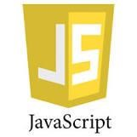

JavaScript (JS) is the most popular lightweight, interpreted compiled programming language. It can be used for both Client-side as well as Server-side developments. JavaScript also known as a scripting language for web pages.

Cascading Style Sheets is a style sheet language used for describing the presentation of a document written in a markup language such as HTML or XML

To create it, first, you need to create an HTML and CSS file. Of course, you can attach the CSS file to the HTML file. Then copy the structure below and add it to the HTML file.

CALCULATOR LOGO

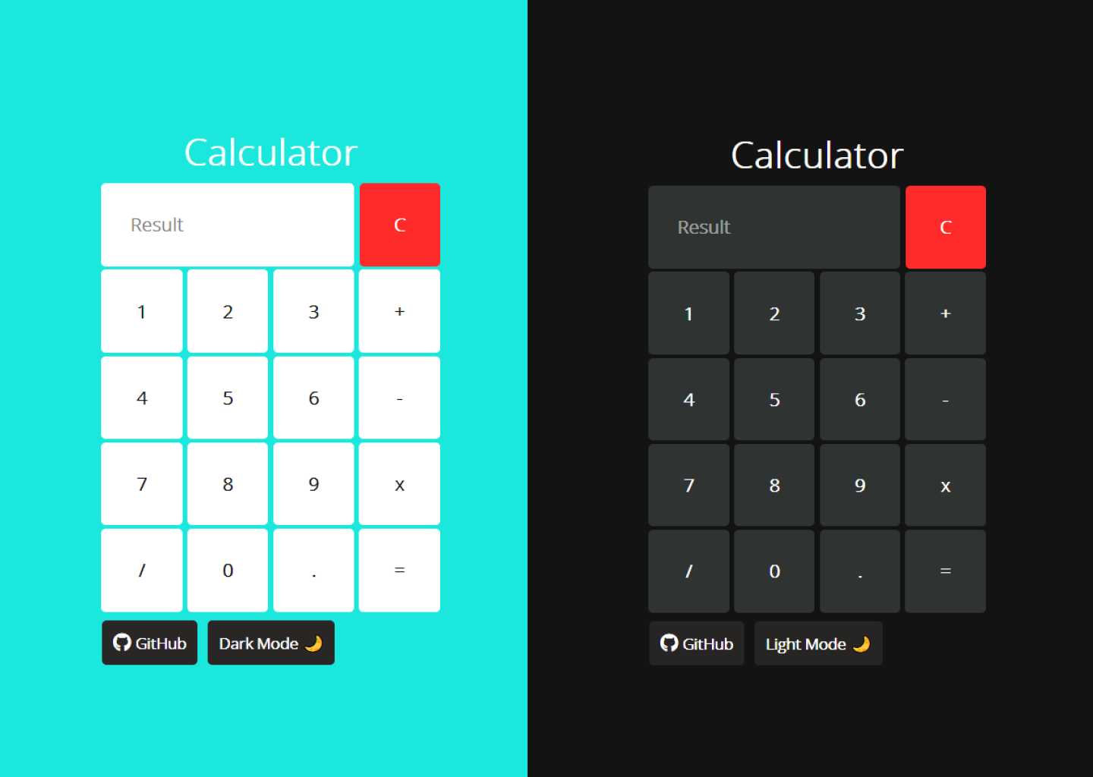

# FEATURES

**Features of the Calculator**

1.In this project, you are going to develop a calculator that will have the following features:

2.It will perform basic arithmetic operations like addition, subtraction, division, and multiplication.

3.It will perform decimal operations.

4.The calculator will display **Infinity** if you try to divide any number by zero.

5.It will not display any result in case of invalid expression. For example, 5++9 will not display anything.

6.Clear screen feature to clear the display screen anytime you want.

7.It will give correct solution

CONCLUSION

As we know, the **Calculator** is a portable device used in our daily life to perform various mathematical functions such as **addition, subtraction, multiplication, division**, root, etc. However, we have scientific or sophisticated calculators used to solve complex tasks such as trigonometry functions, degrees, exponential operators, log functions, hyperbolic functions, square root, and so on. In this topic, we will create a calculator program in JavaScript.

REFERENCE

* <https://www.makeuseof.com>
* <https://www.tutorialspoint.com>
* <https://www.geeksforgeeks>
* https://www.codewithharry.com

# CODE

https://github.com/Moulibonu/CALCULATOR-