**ATM System**

*Table of Contents:*

**About ATM system**

Introduction

SWOT Analysis

4W's and 1H

Advantages and Disadvantages

**Requirements**

High Level Requirements

Low Level Requirements

**Architecture**

Behavioural Diagram

Flow Chart

UML Diagram

# 

# **About ATM system**

## Introduction

# The Automated Teller Machine(ATM) allows bank customers to access their accounts without visiting the bank. The ATM will service one customer at a time. A customer will be required to insert an ATM card and enter a personal identification number (PIN) - both of which will be sent to the bank for validation as part of each transaction. The customer will then be able to perform one or more transactions. The card will be retained in the machine until the customer indicates that he/she desires no further transactions, at which point it will be returned.

## SWOT Analysis

## Strength:

* ATM machines are easy to use
* The ability to access one's account 24/7 at multiple locations

# Weakness:

* Due to leakage of PIN, fraud can take place easily
* Initial cost of hardware, software, and installation site is very high

# Opportunity:

Full-Service Remote ATMs Can Eliminate Branches and Costs

# Threat:

Insecure Network Communication

## 4W's and 1H:

# Who

The ATM card holder can use the machine

# What

It is an automatic teller machine to withdraw the amount

# When

It is available 24X7

# Where

It is available at multiple locations

# How

This application was developed in C language to avoid the complexity and to keep it simple.

# **Requirements:**

## High Level Requirements

1. The ATM system accepts a unique ID from the customer.
2. The ATM system accepts the customer selection for a range of banking transactions.
3. The ATM system accepts the account type from the customer for deposits, balance query, and for payments on account.
4. The ATM system accepts an authorized bank employee’s request to open the ATM.
5. The ATM system provides the customer a receipt for deposits and withdrawals.
6. The ATM system accepts customer requests and provide feedback.
7. The ATM system determines ATM responses to inputs received.
8. It is desired that ATM communicate with the bank computer to get customer information.

## Low Level Requirements

1.The ATM technicians will install the process in ATM

2.The technicians will repair and service the ATM machines and other electronic office machines that dispense money and allow a customer to check their bank account.

**Architecture:**

Behavioural Diagram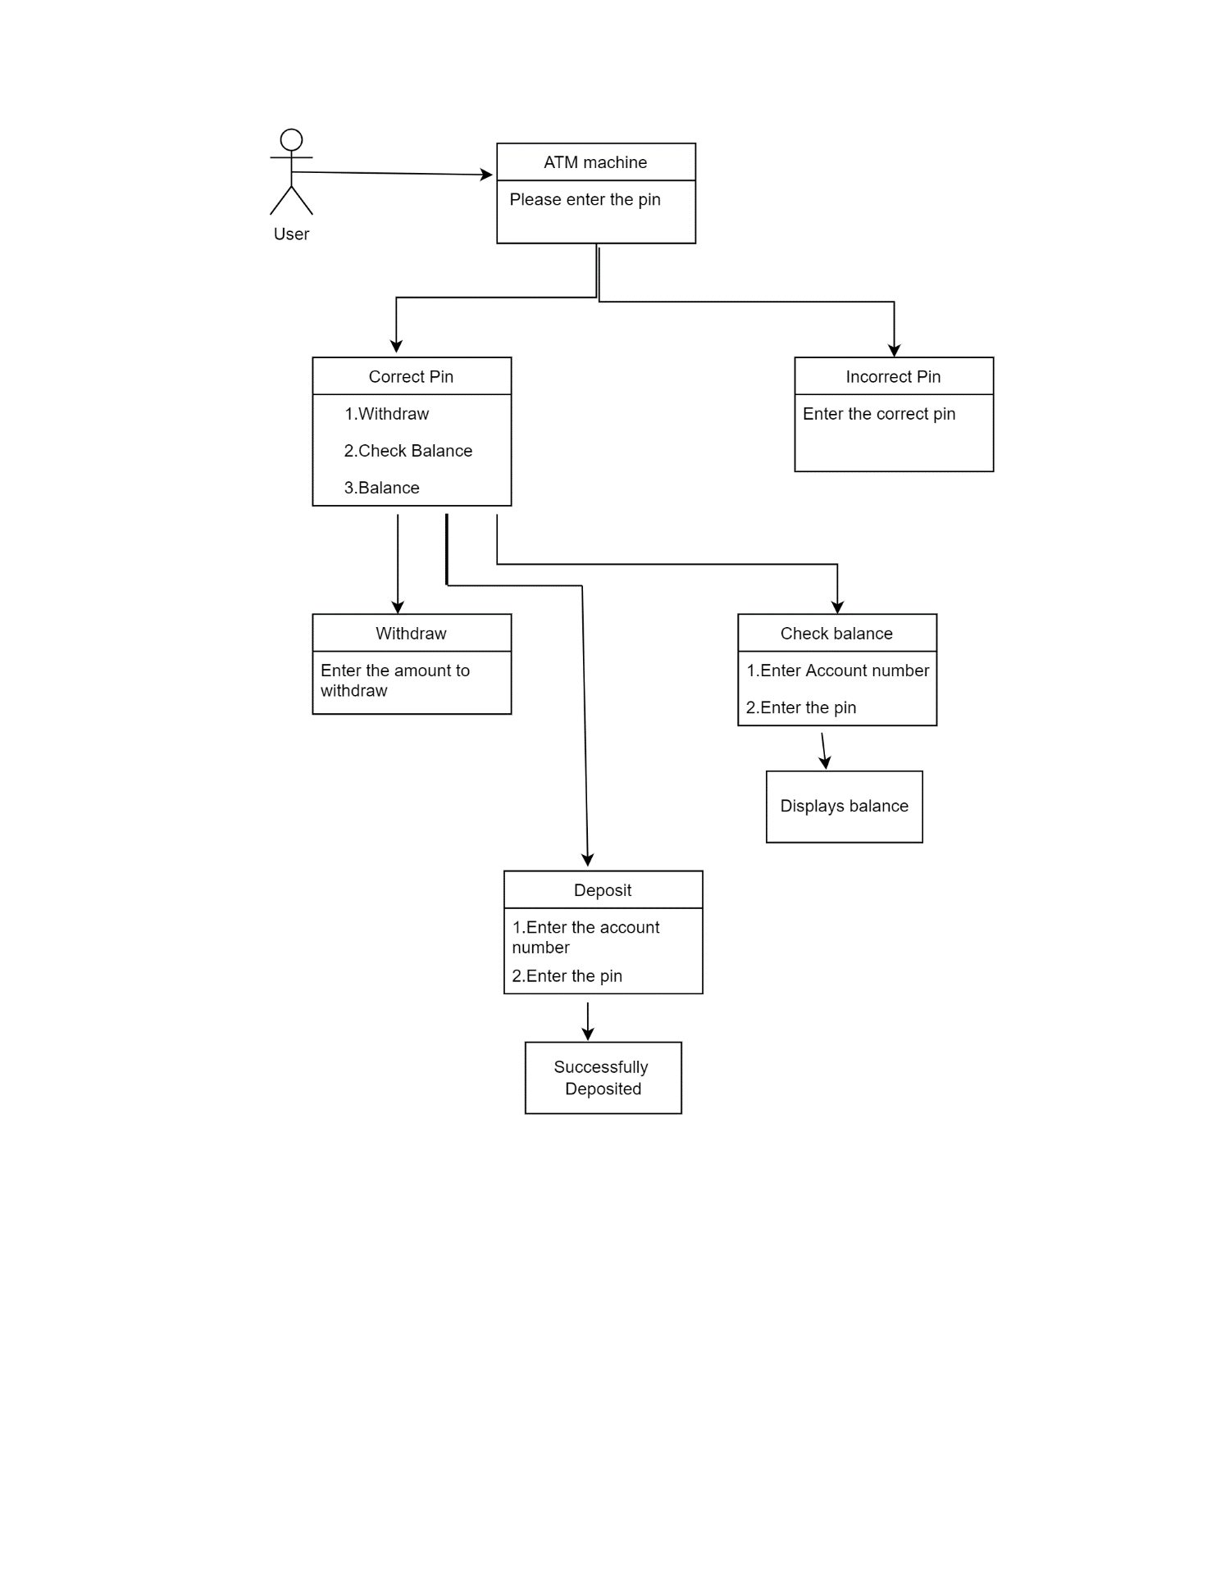

Flow Chart:

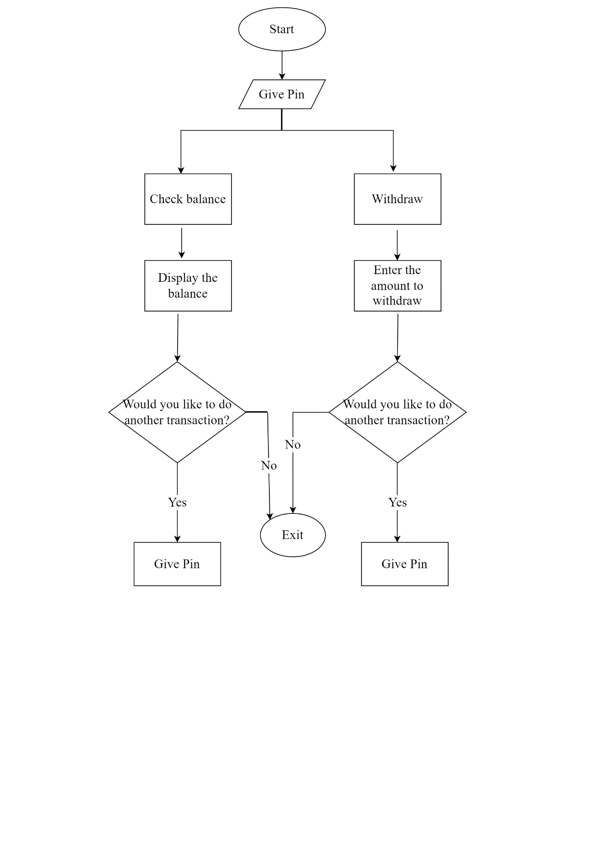

UML Diagram:

