sHOW GUIDE ces 2013

floor plan

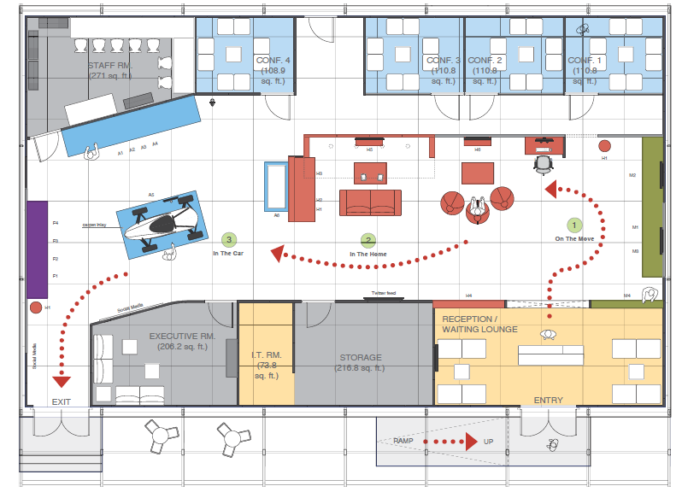

We will have 4 experience areas:
- In the Home (red)
- In the Car (blue)
- On the Move (green)
- In the Future (purple)

LET’S HAVE A GREAT SHOW!

BOOTH Etiquette
- All demos must be up and running 30 minutes before opening of the show each day
- Make sure your demo is 100% staffed – if you are planning a break, organize somebody who can cover during your absence
- Always ask the visitor for a business card so you know who you are talking to
- If press/analysts approach you, always refer them to the on-site PR Manager Eureka Endo
- Don’t bring any laptops or luggage to the event – they are easy targets for thieves and we don’t have any storage facilities
- If you need to bring your luggage you will have to store them in your demo cabinets
- Please always be available for the customer. This means:
  - Don’t hang around on the booth talking on the phone the whole time ignoring customers that walk by and may be interested
  - Don’t focus on your mobile – writing SMS, Emails, download stuff etc. – the customer is out there and will try to get in touch with you
  - Don’t congregate in bigger groups or hold deep NXP discussions – thus ignoring potential visitors passing by. Make the booth inviting.
  - Don’t eat in the demo area – only in the designated staff room.
- Don’t drink any alcohol if you still have to talk to a customer – it doesn’t matter if it was just one drink, the customer will recognize and it will leave a bad impression on you and the company
- Put your mobile on silent/vibration so you won’t be disturbed during a conversation with a customer
- Don’t party the whole night before the show or at least hide the signs. No one likes to talk to a person who is showing obvious signs of recovery from the previous night’s activities.

Useful tips
- Don’t forget your entry badge!
- Make sure you will bring enough business cards with you
- Wear comfortable shoes, as you will be standing most of the time

8 – 11 January Las Vegas, USA

General information

NXP Booth CP8 (Silver Lot 1&2)
Central Plaza: Las Vegas Convention Center

Show hours

Tuesday Jan. 8: 9.00am-6.00pm
Wednesday Jan 9: 9.00am-6.15pm
Thursday Jan 10: 9.00am-6.00pm
Friday Jan 11: 9.00am-4.00pm

General briefing
Monday Jan 7 4.30pm

Mandatory preshow walkthrough with MT
Tuesday Jan 8 8.00am

Investors Booth Tour: NXP booth will be closed to customers
Tuesday January 8 from 9-10.30 am
Automotive Event – Wednesday Jan 9 from
5.00 – 6.30pm

Contact persons at the show

On-Site Event Manager:
Helga de Ruijter
+31 6 5491.4321

Event Support
Jeanny Ho +1 408 219.7778

Reception desk/Meetings/MT Support:
Yasmin Bowens +1-510-604.4550
Lisa Schaefer +1-415-871.4371
Communications:
Lieke de Jong-Tops +31-6-2219.5861

PR contact on-site:
Eureka Endo
+44-7958-287.483



Set-Up & Tear-down
Demo set-up
Monday, Jan. 7 9:00am-4:30pm
All demos must be set-up and working properly by January 7, 4.30pm. The demos must be set up and running every day half an hour before the show starts.
The demos for the Pepcom event may leave the NXP booth at 5.00pm. Note that those demos will have to be up and running again on the NXP booth by 8.00am Tuesday morning January 8th. We will make sure you have access to the NXP booth as of 7am

Tear down
Friday, Jan. 11 4.00pm after show closure

Each group is responsible for packing all equipment, products and literature and working with NXP Event Management to ensure all return shipping address information is received, as in:
- Shipping address and contact name
- Commercial invoice
- Completed FDA./FCC forms (Int’l shipments)
- Internal cost center or courier account number
- Number of boxes (1of2, 2of2, etc.)
- Don’t expect the shipment to arrive in 2 weeks

DO NOT PLAN ON LEAVING UNTIL THIS IS DONE.

Dress code
The dress code for booth personnel: white NXP button down shirt from previous years, black trousers/skirt (alternate brown/dark grey/khaki). Gary Sugita will hand out shirts to those who may need them on Monday Jan. 7th.

Meeting rooms
There are 4 meeting rooms [8 pax] and one executive meeting room. All meetings to be scheduled via the meeting request form. Please send completed forms to both yasmin.bowens@nxp.com and lisa.schaefer@nxp.com. The meeting request form and other information can be found on the preshow page – for url see below.

http://nww.nxp.com/gsm/communication/html/events_ces2013preshowpage.html or
http://nxpsemiconductors.force.com/CES2013
- For information on open positions or to submit your resume, please visit our Web site at: www.lucernepublishing.com

EXHIBITOR BADGES
Exhibitor badges will be collected for you and delivered to your hotel room by means of a room drop starting on January 7th. In case you are not in your room a message will be left to collect your badge at the hotel reception desk.

demonstrations
In the Home
- Internet of things
- Energy Harvesting
- Wemo – Smart plugs with NFC configuration
- HDMI: skype and gaming on your TV, home gateway, TV silicon tuners
- Skylanders RFID tags for gaming
- Gaming keyboard and mouse
- Thunderbolt

In the Car
- Dual tuner integrated car radio
- Saturn digital radio
- Atomic2 analog radio
- Audio amplifier
- Electric racing car ATOP
- Go cart

On the Move
- Enhance small speaker sound with TFA9887 or TFA9890
- Think & Go
- Multiple NFC demos
- NFC wall of fame

In the Future
- Multi-standard wireless charging pad
- Sensorless tunable and dimmable white LED fixture
- Sensorless electric vehicle battery management
- Very high bit rate contactless smart card and NFC @ 13.56 Mbps

HOTEL
Bellagio Hotel
3600 Las Vegas Boulevard South
Tel.: +1-702-693.7111
Transportation from the Bellagio Hotel - South Tour Lobby to convention center
http://www.cesweb.org/cesweb/media/CESWeb/Hotel%20and%20Travel%20Images/Shuttle%20map/2013ShuttleMap_web_11-6.pdf

NXP Messaging

Secure Connections for a Smarter World
In an ever more connected world, NXP continues to drive leading solutions in smart home networks, connected mobility and the latest NFC and security applications. Whether In the Home, On the Move, In the Car, or In the Future, NXP is enabling consumers everywhere to make “Secure Connections for a Smarter World”.

PUBLIC RELATIONS

Media Protocol at trade shows
During shows, exhibitions and seminars, NXP employees can have significant exposure to the media. The general rule during these events for all employees is: ask for business cards or name, publication and contact details, and only answer product related questions based on facts that are public. Employees must not discuss R&D projects and new innovations if they are not yet announced, must not speculate about the company or a competitor, make no market or financial statements, and make no statements about the company in general. In case of follow-up questions from journalists after the event, employees must not act as a source without having obtained prior approval from media relations. We are in quiet period during CES and specific guidelines on this will be circulated.

Press and industry/financial analysts
There will be press and analysts going through our demonstration room. PLEASE be aware of the conversations you have with customers and colleagues during open hours. Pictures and filming in the booth are not authorized unless NXP staff members have given their approval first.

Any press or analyst personnel should be referred to the following people below or sent to the front registration desk:

Lieke de Jong-Tops +31-6-2219.5861
Eureka Endo +44-7958-287.483
Michael Maader +49-170-925.4385

