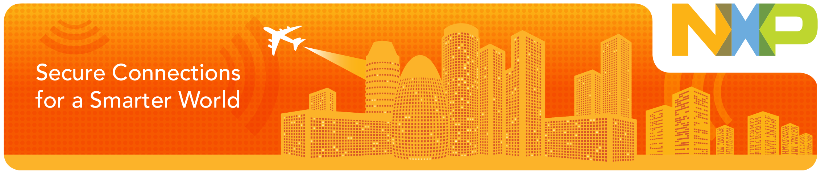

  Invitation to meet NXP at CES 2014
  7-10 January 2014, Las Vegas, USA
  Dear xxxx ,
  Will you be attending CES 2014 in Las Vegas (7-10 January)? If so, I would like to invite you to meet with NXP while you are there. At the NXP booth (located in the lot in front of the Convention Center near registration) you will discover some of the most cutting edge technology innovations that will impact our everyday life experience. In an ever more connected world, NXP continues to drive leading solutions in smart home networks, connected cars and the latest NFC and security applications.
  Come see the following NXP technology in action:
  - In-car entertainment, car-to-car and car-to-infrastructure communication solutions
  - Security and convenience through NFC-enabled technology
  - Mobile device audio enhancements for improved sound quality
  - Connected home and home automation
  Whether at home, in the car or on the move, NXP is enabling consumers everywhere to make ‘Secure Connections for a Smarter World’.
  I’ll look forward to welcoming you to our booth and will be in contact with more details about our presence at CES 2014 in the coming weeks. In the meantime, you can stay up-to-date with all our latest activities, including product promotions and technology developments, by visiting www.nxp.com
  Thanks and kind regards,
  [Account Manager]
  NXP Semiconductors
  General Information
  CES 2014
  7-10 January 2014
  Las Vegas, USA
  NXP Showcase
  Central Plaza (CP9)
  Las Vegas Convention Center

