sHOW GUIDE ces 2015

floor plan

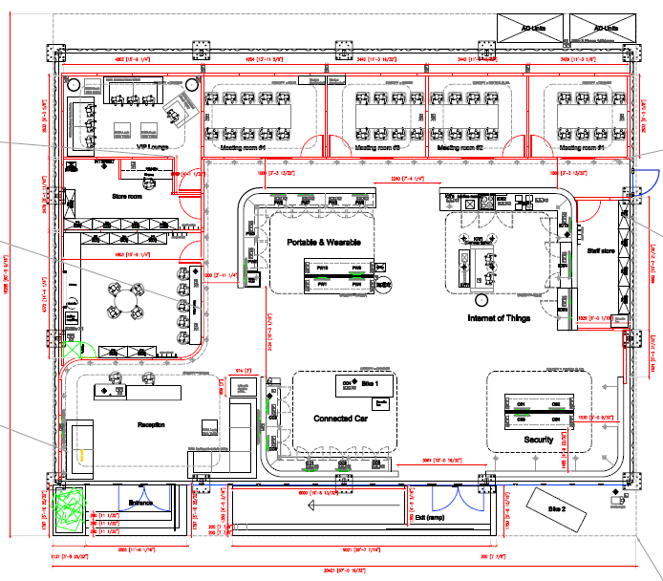

We will have 4 experience areas:
- Portable & Wearable
- Internet of Things
- Security
- Connected Car



LET’S HAVE A GREAT SHOW!

BOOTH Etiquette
- All demos must be up and running 30 minutes before opening of the show each day
- Make sure your demo is 100% staffed – if you are planning a break, organize somebody who can cover during your absence
- Always ask the visitor for a business card so you know who you are talking to
If press/analysts approach you, always refer them to the on-site PR Manager Hillary Cain

- Please always be available for the customer. This means:
  - Do be available- look for visitors in the booth and make eye contact
  - Do offer to take visitors to see other demos that may be relevant to them
  - Don’t hang around on the booth talking on the phone the whole time ignoring customers that walk by and may be interested
  - Don’t focus on your mobile – writing SMS, emails, download stuff etc. – the customer is out there and will try to get in touch with you
  - Don’t congregate in bigger groups or hold deep NXP discussions – thus ignoring potential visitors passing by. Make the booth inviting.
  - Don’t eat in the demo area – only in the designated staff room.
- Don’t drink any alcohol if you still have to talk to a customer – it doesn’t matter if it was just one drink, the customer will recognize and it will leave a bad impression on you and the company
- Put your mobile on silent/vibration so you won’t be disturbed during a conversation with a customer
- Don’t party the whole night before the show or at least hide the signs. No one likes to talk to a person who is showing obvious signs of recovery from the previous night’s activities.

Useful tips
- Don’t forget your entry badge!
- Make sure you will bring enough business cards with you
- Wear comfortable shoes, as you will be standing most of the time

6 – 9 January Las Vegas, USA

General information

NXP Booth CP9 (Silver Lot 1&2)
Central Plaza: Las Vegas Convention Center

Show hours

Tuesday Jan. 6: 9.00am-6.00pm
Wednesday Jan 7: 9.00am-6.30pm
Thursday Jan 8: 9.00am-6.00pm
Friday Jan 9: 9.00am-4.00pm

General briefing & mandatory preshow
walkthrough with MT
Tuesday Jan 6 8.00am

Investors Booth Tour: NXP booth will be closed to customers
Tuesday January 6 from 9.00-10.30 am

Security Event
Wednesday January 7 from 5.30-7.00pm
Demos should remain up and running till
end of the event.

Contact persons at the show

On-Site Event Manager:
Helga de Ruijter
+31 6 5491.4321

Reception desk/Meetings/MT Support:
Yasmin Bowens +1-510-604.4550
Tamara Bouwmans +31-6-1073.6049
Communications/PR contact on-site:
Hillary Cain +1-415-350.4860
Pieter van Nuenen +31-6-1336.7034



Set-Up & Tear-down
Demo set-up
Monday, Jan. 5 11:00am-6:00pm
All demos must be set-up and working properly by January 5, 6.00pm. The demos must be set up and running every day half an hour before the show starts.
Note that the PepCom demos will have to be up and running again on the NXP booth by 8.00am Tuesday morning January 6th. We will make sure you have access to the NXP booth as of 7am.

Tear down
Friday, Jan. 9 4.00pm after show closure

Each group is responsible for packing all equipment, products and literature and work with either Freeman or another courier to arrange your return shipments.
Please read shipping information on the preshow page – see url below.

DO NOT PLAN ON LEAVING UNTIL THIS IS DONE.

Dress code
The dress code for booth personnel: white NXP button down shirt from previous years, black trousers/skirt (alternate brown/dark grey/khaki).

Meeting rooms
There are 4 meeting rooms [3x8 pax, 1x10 pax] and one executive meeting room. All meetings to be scheduled via the meeting request form. Please send completed forms to ces.2015@nxp.com. The meeting request form and other information can be found on the preshow page – for url see below.

http://nxpsemiconductors.force.com/ces

HOTEL
Paris Las Vegas Hotel
3655 S Las Vegas Blvd
Las Vegas, NV 89109, USA
Tel +1 702 946 7000

Easily ride the monorail from the Bally’s/Paris to the Las Vegas Convention Center: http://www.lvmonorail.com Buy your tickets online at: https://tickets.lvmonorail.com/

- For information on open positions or to submit your resume, please visit our Web site at: www.lucernepublishing.com

EXHIBITOR BADGES
Please print the 2015 International CES Confirmation email and bring it with you to collect your badge. A photoID is required. Simply scan the QR code to retrieve your badge.

demonstrations
Portable & Wearable
- Wireless charging
- Mobile audio / Mobile audio acoustical chamber
- Complete solution for USB type-C power and data delivery
- mPOS
- Game Golf
- Wearable technology health tracker solution
- Enabling multi-application convergence in wearable technology
- eSkin thermometer
- Senseg FeelScreen Haptic Technology
Internet of Things
- 6LowPAN Smart Home
- ZigBee HA Smart Home
- Cloud connected weather monitoring
- Smart NFC STB / Smart NFC ZigBee Remote control 2.0
- Seamless integrated cooking experience enabled by NFC
- Ultra-low power microcontroller for always-on sensor processing applications
- ZigBee HA examples
- Smart climate control and lighting system
Cyber security
- Secure access to the cloud: FIDO U2F USB ref des
- Smart locks
- Home automation network camera solution
- MIFARE SDK loyalty demo app
- KONA TSM Service Platform

Connected Car
- 1-chip RFCMOS radar transceiver
- High-end multi-standard car radio/audio unit
- Distributed vehicle architecture Connected Car enabled by NXP’s secure V2V networking/connected motorbike
- Token
- BAP3 multichannel
- NFC Innovation for cars

NFC Everywhere poster

NXP Messaging

Secure Connections for a Smarter World
In an ever more connected world, NXP continues to drive leading solutions in smart home networks, connected mobility and the latest NFC and security applications.
The world around us is rapidly evolving and new products and technologies are emerging at an unprecedented pace, with particular focus on hyper connectivity.

PUBLIC RELATIONS

Media Protocol at trade shows
During shows, exhibitions and seminars, NXP employees can have significant exposure to the media. The general rule during these events for all employees is: ask for business cards or name, publication and contact details, and only answer product related questions based on facts that are public. Employees must not discuss R&D projects and new innovations if they are not yet announced, must not speculate about the company or a competitor, make no market or financial statements, and make no statements about the company in general. In case of follow-up questions from journalists after the event, employees must not act as a source without having obtained prior approval from media relations. We are in quiet period during CES this means that in principle no one is allowed to discuss our business performance or provide any kind of financial statement or outlook.

Press and industry/financial analysts
There will be press and analysts going through our booth. PLEASE be aware of the conversations you have with customers and colleagues during open hours. Pictures and filming in the booth are not authorized unless NXP staff members have given their approval first.

Any press or analyst personnel should be referred to the following people below or sent to the front registration desk:

Hillary Cain +1-415-350.4860
Pieter van Nuenen +31-6-1336.7034

