WEEK 3 PROJECT REPORT
Unsupervised Learning and Clustering Analysis
Public Wine Recognition Dataset | K-Means + Agglomerative Clustering

Prepared as the Week 3 Data Science with Python submission

1. Executive Summary
This project implements the Week 3 requirement of applying unsupervised learning to a publicly available dataset, with emphasis on clustering, preprocessing, visualization, and interpretation. The Wine recognition dataset available through scikit-learn was selected because it contains 178 observations described by 13 continuous chemical measurements and represents a natural segmentation problem. K-Means clustering was the primary technique, while Agglomerative Clustering using Ward linkage was used as a secondary comparison.
The workflow first inspected the data and verified that the analytical feature matrix contained no missing values. Because the variables are measured on different scales, StandardScaler was applied before distance-based clustering. K-Means was evaluated for cluster counts from two through eight using inertia, silhouette score, Calinski-Harabasz score, and Davies-Bouldin score. Three clusters were selected because k=3 produced the highest silhouette score among the tested values (0.2849) while also giving a compact and interpretable segmentation. The final clusters contained 65, 51, and 62 observations.
PCA was used only to project the standardized data into two dimensions for visual interpretation. Cluster profiling showed substantial differences in flavanoids, total phenols, proline, color intensity, malic acid, and other chemical measurements. An agglomerative model with three clusters was also fitted to assess whether a different clustering strategy produced a similar structure. Finally, the dataset's known cultivar labels were used only for post-hoc external validation; they were never supplied to either clustering algorithm. K-Means achieved an Adjusted Rand Index of 0.8975 and NMI of 0.8759, indicating strong agreement with the known classes.

2. Task Alignment
The Week 3 brief requires a public dataset suitable for clustering, preprocessing, at least one clustering algorithm with justified parameters, visualization, interpretation of cluster characteristics, and discussion of business or research implications. This report addresses each of those requirements and provides a reproducible Python implementation.
Dataset and methodology were selected to demonstrate unsupervised learning without using the known class labels during model fitting.

3. Dataset Selection and Acquisition
The Wine recognition dataset was selected from the public dataset collection distributed with scikit-learn. It contains 178 wine samples and 13 continuous predictor variables: alcohol, malic acid, ash, alcalinity of ash, magnesium, total phenols, flavanoids, nonflavanoid phenols, proanthocyanins, color intensity, hue, OD280/OD315 of diluted wines, and proline. The dataset also contains a known three-class target representing wine cultivars. Since this is an unsupervised task, the target was excluded from clustering and retained only for descriptive post-hoc validation.
Acquisition code:
from sklearn.datasets import load_wine
wine = load_wine(as_frame=True)
df = wine.frame.copy()
X = df[wine.feature_names]
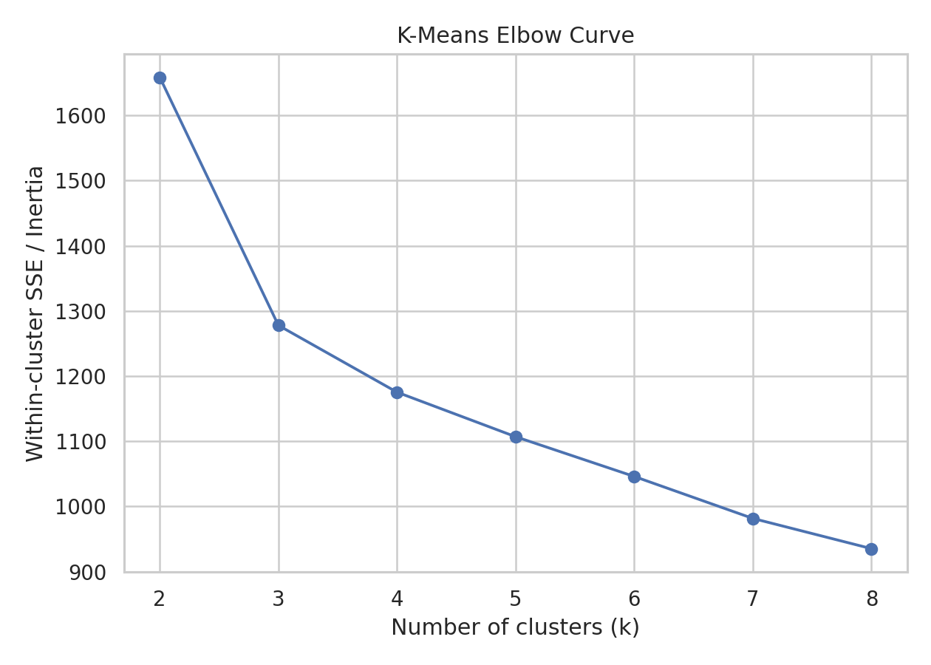
Figure 1. K-Means elbow curve across k=2–8.

4. Initial Data Exploration
Initial inspection confirmed a dataset shape of 178 rows × 13 analytical features. The feature matrix contained no missing values, so imputation was not required. All analytical predictors are numeric, making the dataset directly suitable for standardization and distance-based clustering. Summary statistics also showed that the variables have substantially different numerical ranges; for example, proline is measured in the hundreds while hue is close to one. Without scaling, high-magnitude variables could dominate Euclidean distance and distort the clusters.
Check | Result | Action
Rows / features | 178 / 13 | All 13 predictors retained
Missing values | 0 in every predictor | No imputation required
Feature type | Continuous numeric | Suitable for scaling
Target labels | 3 known classes | Excluded from training

5. Preprocessing
Standardization was applied using StandardScaler. Each feature was transformed to approximately zero mean and unit variance. This is particularly important for K-Means and Ward hierarchical clustering because both depend on distances between observations. The transformation prevents variables with larger raw numerical magnitudes from disproportionately controlling the segmentation.
scaler = StandardScaler()
X_scaled = scaler.fit_transform(X)
No rows were removed and no synthetic values were introduced. The target variable was not included in X_scaled, preventing target leakage into the unsupervised model.

6. Clustering Methodology

6.1 K-Means
K-Means was selected as the primary algorithm because it is a widely used partitioning method, is straightforward to interpret, and works well as a baseline for standardized numerical data. The algorithm partitions observations into k groups by minimizing within-cluster squared Euclidean distance. The implementation used random_state=42 for reproducibility and n_init=20 so that the final solution is less dependent on a single initialization.
for k in range(2, 9):
model = KMeans(n_clusters=k, random_state=42, n_init=20)
labels = model.fit_predict(X_scaled)

6.2 Selecting the Number of Clusters
Candidate values from k=2 through k=8 were compared. Inertia decreases as more clusters are added, so it is useful for locating an elbow but cannot be used alone. Silhouette score measures how well each observation fits its assigned cluster relative to neighboring clusters; higher is better. Calinski-Harabasz rewards compact, separated clusters, while Davies-Bouldin is lower-is-better.
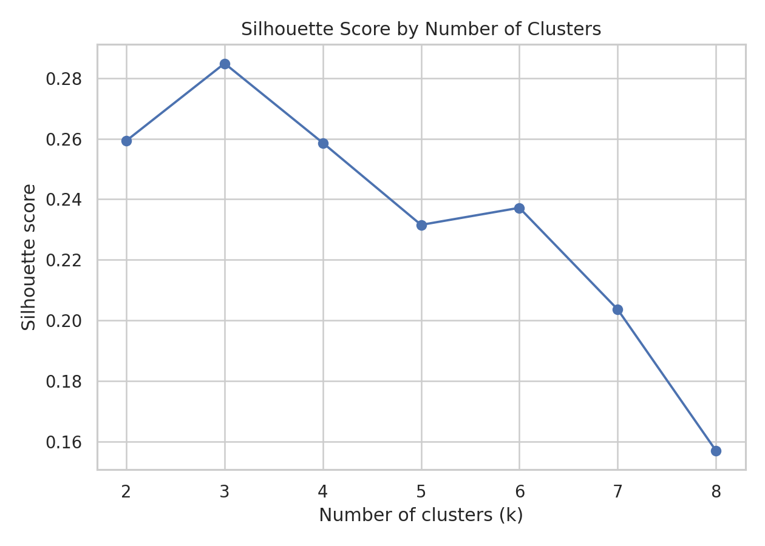
Figure 2. Silhouette score used to support selection of k=3.
k | Inertia | Silhouette | Calinski-Harabasz | Davies-Bouldin
2 | 1658.76 | 0.2593 | 69.52 | 1.5260
3 | 1277.93 | 0.2849 | 70.94 | 1.3892
4 | 1175.35 | 0.2586 | 56.19 | 1.8170
5 | 1107.01 | 0.2315 | 47.16 | 1.6811
6 | 1046.00 | 0.2372 | 41.70 | 1.5544
7 | 981.60 | 0.2036 | 38.69 | 1.6606
8 | 935.20 | 0.1570 | 35.81 | 1.7409
Decision: k=3 was selected because it had the highest silhouette score (0.2849) among the tested cluster counts, while producing a balanced and interpretable segmentation.

6.3 Hierarchical Clustering Comparison
Agglomerative Clustering with Ward linkage was also applied using three clusters. Ward linkage merges groups while minimizing the increase in within-cluster variance. It provides a useful alternative view of the structure and allows a dendrogram to be examined without requiring the same centroid-based assumptions as K-Means.
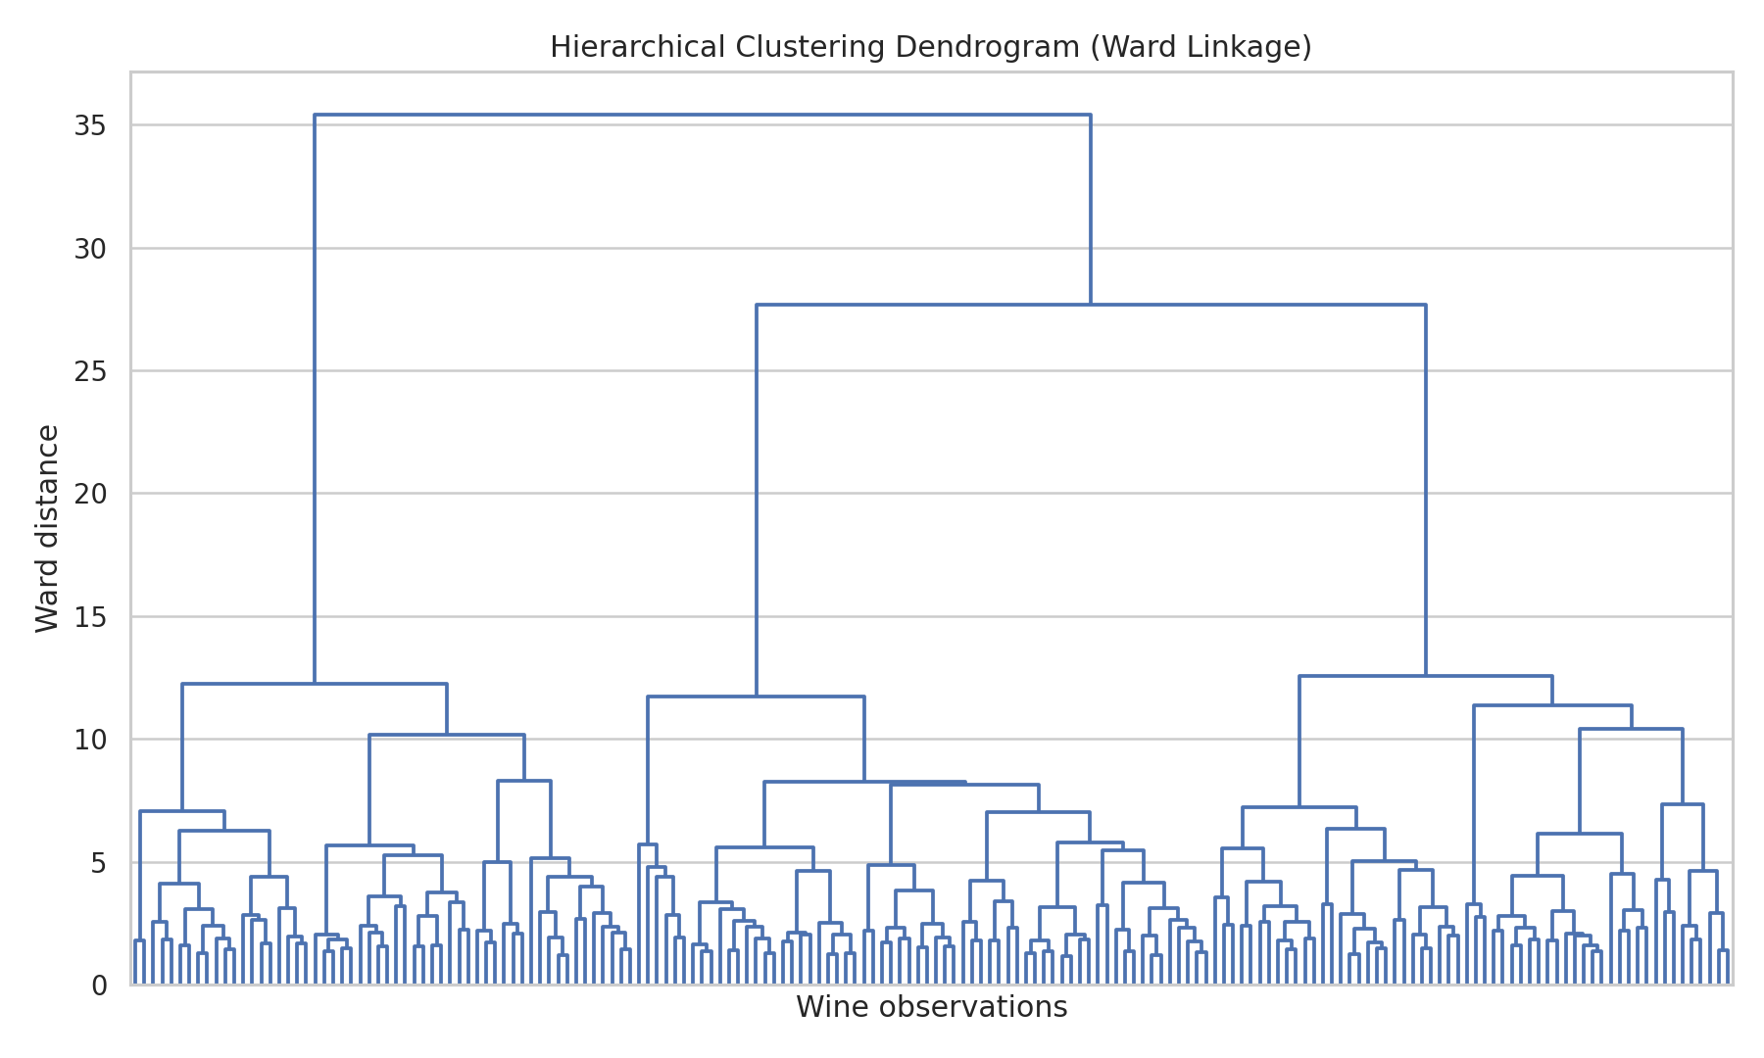
Figure 3. Ward hierarchical clustering dendrogram.

7. Results
The final K-Means model with k=3 produced cluster sizes of [65, 51, 62]. Its silhouette score was 0.2849, Calinski-Harabasz score was 70.94, and Davies-Bouldin index was 1.3892. These metrics indicate a useful but not perfectly separated structure; a moderate silhouette score is consistent with some overlap between chemical profiles.
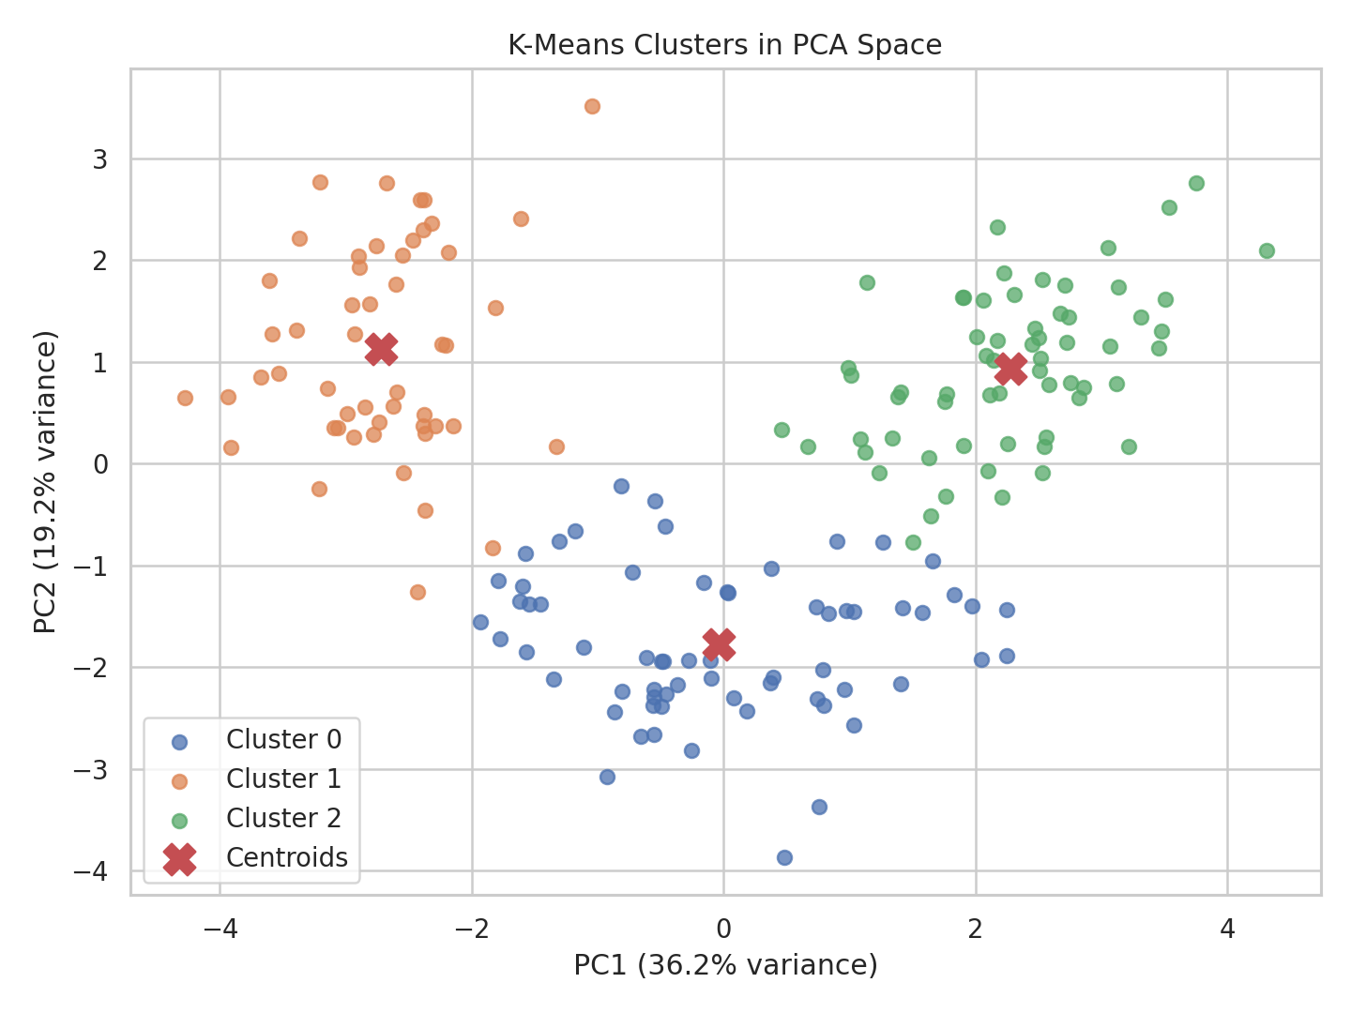
Figure 4. K-Means clusters projected into two-dimensional PCA space.
The first two principal components explain 55.41% of standardized feature variance (36.20% and 19.21% respectively). PCA is used here only for visualization; the clustering itself uses all 13 standardized features.

8. Cluster Characteristics
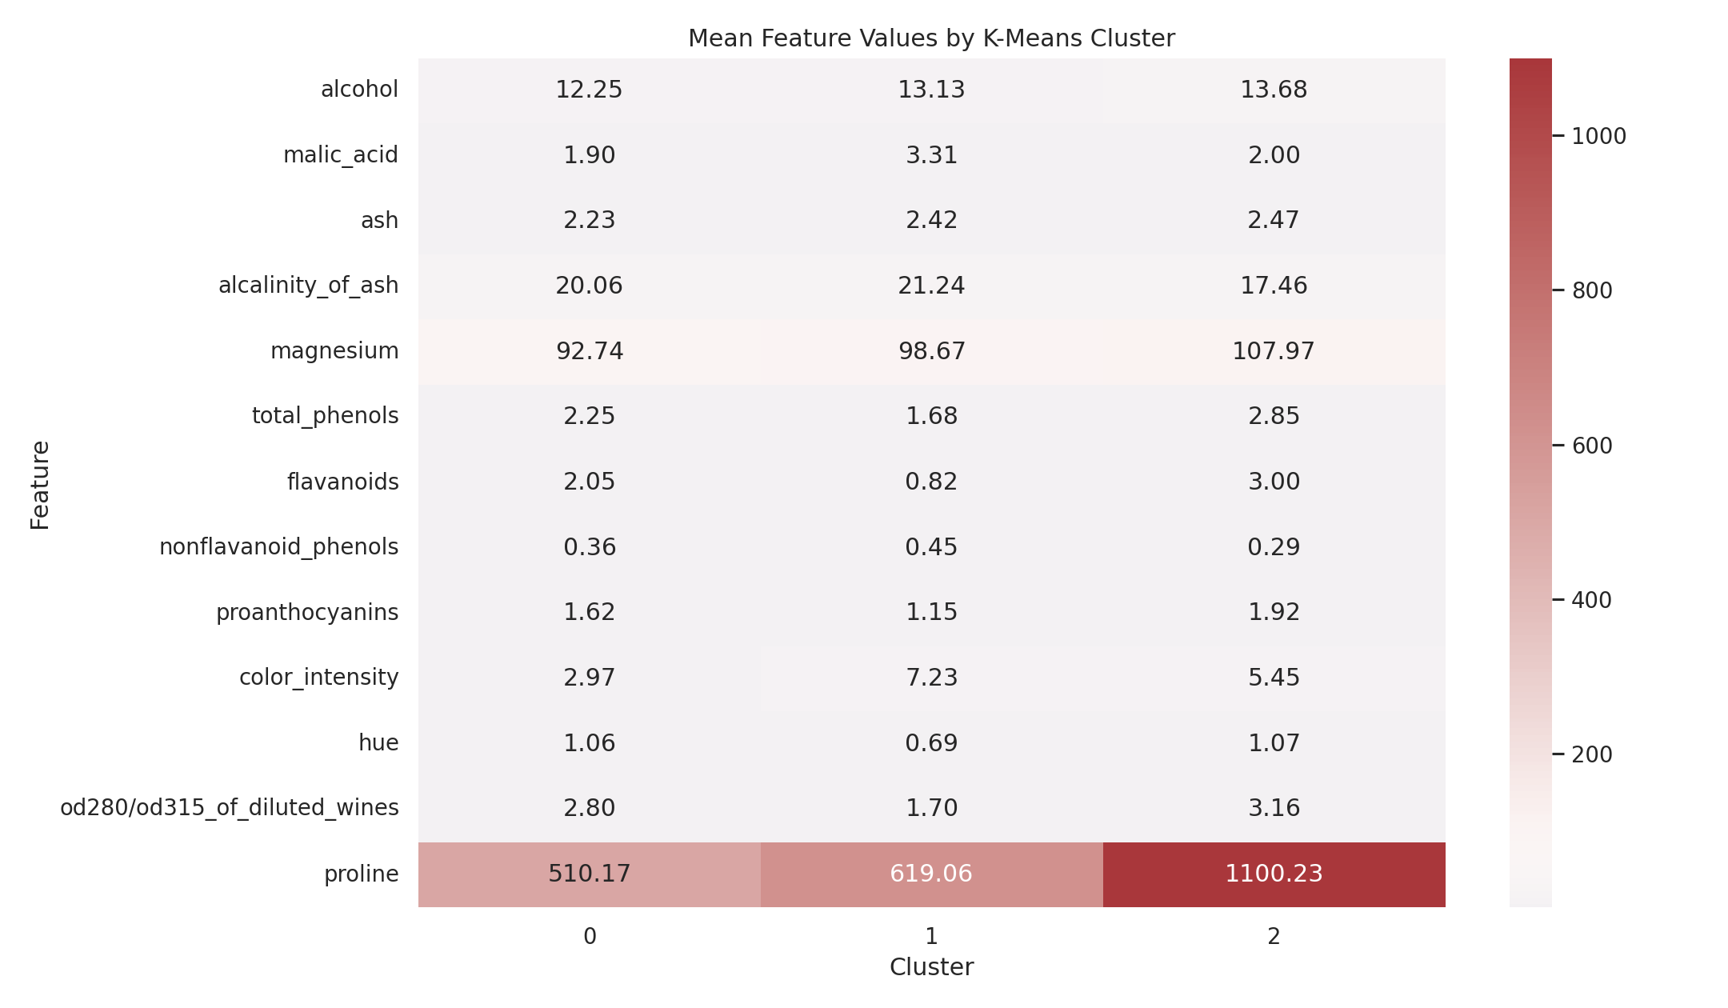
Figure 5. Mean chemical measurements for each K-Means cluster.

Cluster 0
Cluster 0 contains 65 observations. Its strongest distinguishing high-mean variables are alcalinity_of_ash (20.06), magnesium (92.74), proline (510.17). Lower-mean variables include nonflavanoid_phenols (0.36), hue (1.06), proanthocyanins (1.62). This profile indicates that the cluster represents a particular combination of chemical characteristics rather than a single-variable split.

Cluster 1
Cluster 1 contains 51 observations. Its strongest distinguishing high-mean variables are alcalinity_of_ash (21.24), magnesium (98.67), proline (619.06). Lower-mean variables include nonflavanoid_phenols (0.45), hue (0.69), flavanoids (0.82). This profile indicates that the cluster represents a particular combination of chemical characteristics rather than a single-variable split.

Cluster 2
Cluster 2 contains 62 observations. Its strongest distinguishing high-mean variables are alcalinity_of_ash (17.46), magnesium (107.97), proline (1100.23). Lower-mean variables include nonflavanoid_phenols (0.29), hue (1.07), proanthocyanins (1.92). This profile indicates that the cluster represents a particular combination of chemical characteristics rather than a single-variable split.

9. Algorithm Comparison
The three-cluster Agglomerative model produced a silhouette score of 0.2774, compared with 0.2849 for K-Means. K-Means therefore provided the stronger internal clustering result for this analysis. For additional post-hoc validation, K-Means achieved ARI=0.8975 and NMI=0.8759; Agglomerative Clustering achieved ARI=0.7899 and NMI=0.7865.
Important methodological note: the known cultivar target was not used to select k, fit centroids, assign clusters, scale features, or otherwise train the clustering models. It was used only after clustering as an external reference. This preserves the unsupervised nature of the primary analysis.
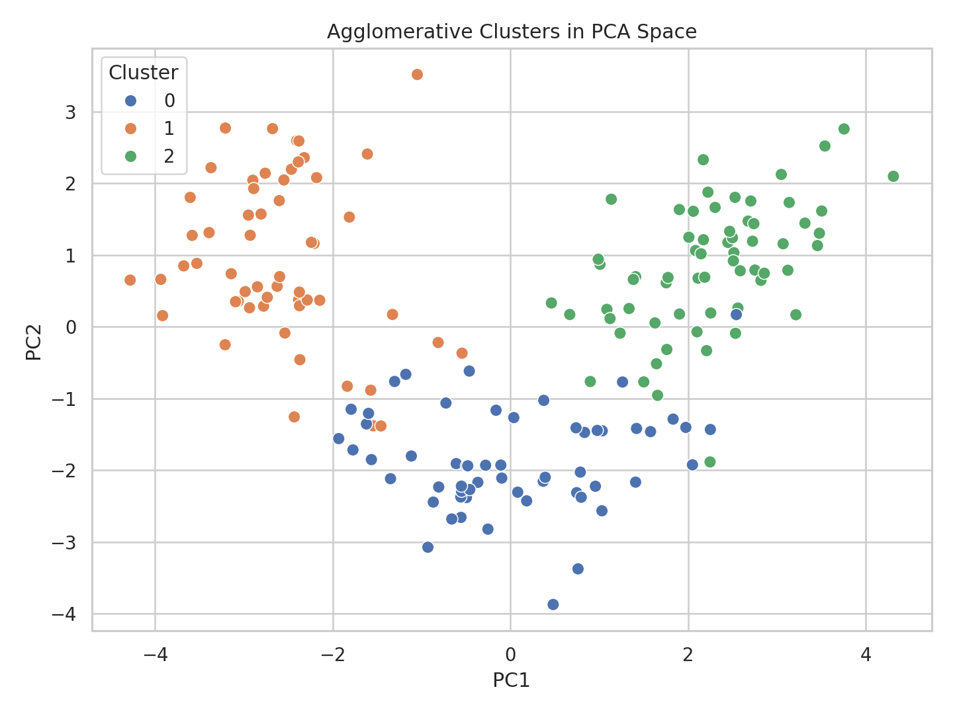
Figure 6. Agglomerative clustering projected into PCA space.

10. Business and Research Implications
The resulting segments could be useful in research settings where observations need to be grouped by chemical similarity before deeper investigation. In a wine analytics context, cluster profiles can support comparative quality research, laboratory investigation, provenance studies, or exploratory segmentation. For example, the clusters could guide follow-up testing by highlighting groups with distinctive phenolic, color, or proline profiles.
The analysis should not be interpreted as proving causal relationships or as a commercial quality ranking. Cluster membership describes similarity within the selected feature space. In a production setting, domain experts would need to validate whether the identified profiles correspond to meaningful operational categories and whether additional variables should be incorporated.

11. Challenges and How They Were Addressed
- Different feature scales: StandardScaler was applied before distance-based clustering.
- Choosing k objectively: Multiple internal metrics were calculated for k=2–8 rather than selecting a cluster count arbitrarily.
- Visualization of 13 dimensions: PCA reduced the standardized feature space to two components for visualization only.
- Potential target leakage: The known cultivar target was explicitly excluded from the clustering feature matrix.
- Sensitivity of K-Means initialization: n_init=20 and random_state=42 were used for reproducibility and stability.
- Interpreting clusters: Mean feature profiles and multiple evaluation metrics were used instead of relying only on a scatter plot.

12. Limitations and Possible Improvements
The silhouette score is moderate, so the clusters should not be treated as perfectly distinct populations. K-Means also assumes compact, roughly spherical groups in the scaled feature space and can be sensitive to initialization. Hierarchical clustering provides a complementary perspective but is also dependent on the chosen distance representation and linkage strategy.
Future work could compare additional methods such as Gaussian Mixture Models, DBSCAN, or spectral clustering; use repeated stability analysis or bootstrap resampling; inspect cluster-level distributions rather than means alone; and incorporate domain-specific variables. A more extensive study could also assess whether the segmentation remains stable under feature selection or alternative scaling methods.

13. Conclusion
This project demonstrates a complete unsupervised clustering workflow from public dataset acquisition through preprocessing, model selection, visualization, evaluation, and interpretation. K-Means with three clusters provided the strongest result among the tested K values and produced interpretable chemical profiles. Hierarchical clustering was included as a comparison, while PCA helped communicate the high-dimensional structure visually.
The key learning outcome is that clustering quality depends not only on running an algorithm but also on appropriate preprocessing, principled selection of model parameters, quantitative validation, visualization, and careful interpretation. The accompanying Python file contains the complete reproducible implementation and saves the metrics, cluster assignments, and figures generated for this report.

14. Reproducibility and Deliverables
The project can be reproduced by installing the packages listed in requirements.txt and running week3_clustering_analysis.py. The script automatically creates output folders containing the evaluation metrics, cluster assignments, cluster profiles, and figures.
- week3_clustering_analysis.py
- requirements.txt
- README.md
- k_selection_metrics.csv
- wine_cluster_assignments.csv

15. Submission Description (200+ words)
This Week 3 submission presents a complete practical implementation of unsupervised learning and clustering analysis using Python. The project uses the publicly available Wine recognition dataset distributed through scikit-learn and demonstrates how clustering can be used to identify natural groupings without using class labels during model training. The analysis begins with dataset acquisition and quality checks, followed by feature selection and standardization. Because the dataset variables have different numerical scales, StandardScaler is used so that distance calculations are not dominated by high-magnitude measurements.
K-Means is used as the primary clustering algorithm. Multiple values of k are evaluated from two to eight using inertia, silhouette score, Calinski-Harabasz score, and Davies-Bouldin index. The analysis selects three clusters based primarily on the strongest silhouette result among the tested values. The resulting groups are then visualized through a PCA projection and analyzed using cluster-level feature means. Agglomerative hierarchical clustering with Ward linkage is also implemented as a comparison, with a dendrogram and PCA visualization included in the report.
The project goes beyond simply producing cluster labels by interpreting the chemical characteristics of each group and discussing potential research and business applications. The known cultivar labels are deliberately excluded from model fitting and are used only for post-hoc external validation through Adjusted Rand Index and Normalized Mutual Information. This provides an additional diagnostic while preserving the unsupervised-learning methodology.
The submission includes a detailed Word report, a complete Python source file containing all analysis code, a requirements.txt file specifying dependencies, and a README explaining the dataset, methodology, findings, execution instructions, reproducibility, limitations, and project structure. Together, these files provide both the documented academic deliverable and a reproducible technical implementation.

