WEEK 4
SUPERVISED LEARNING MODEL IMPLEMENTATION
Wine Recognition Dataset — Multiclass Classification
Internship Data Science with Python | Complete Practical Report

1. Executive Summary
This project implements a complete supervised machine-learning workflow for multiclass classification using the publicly available Wine Recognition dataset. The objective is to predict wine cultivar from 13 chemical measurements. The workflow covers data inspection, stratified splitting, preprocessing, model development, cross-validation, model selection, held-out testing and critical evaluation. Logistic Regression, Support Vector Machine, Random Forest and K-Nearest Neighbors were compared. Scaling is performed inside Pipelines for scale-sensitive models, preventing preprocessing leakage. Five-fold stratified cross-validation selected SVM as the strongest candidate by mean CV accuracy. On the held-out test set, it achieved accuracy 0.9722, macro precision 0.9778, macro recall 0.9667, macro F1 0.9710, and one-vs-rest ROC-AUC 1.0000.

2. Problem Statement
The task is a three-class supervised classification problem: predict the cultivar of a wine sample from its chemical measurements. The labeled target makes this suitable for supervised learning. This is an educational benchmark and should not be treated as a production wine-authentication system.

3. Dataset
The Wine Recognition dataset is accessed through scikit-learn's load_wine() function. It contains 178 observations, 13 numeric chemical features and three target classes. The standard dataset contains no missing values. Because all predictors are numeric, categorical encoding is unnecessary.

4. Data Preparation and Feature Engineering
An 80/20 stratified train-test split is used. The original chemical variables are retained because they are meaningful measurements. StandardScaler is applied to Logistic Regression, SVM and KNN inside Pipelines. Random Forest does not require scaling. The Pipeline structure ensures that scaling parameters are learned only from each training fold.

5. Models and Rationale
- Logistic Regression — interpretable linear baseline.
- Support Vector Machine (RBF) — captures nonlinear decision boundaries.
- Random Forest — nonlinear ensemble and feature-importance baseline.
- K-Nearest Neighbors — distance-based baseline demonstrating the importance of scaling.

6. Validation Strategy
Five-fold Stratified Cross-Validation was performed on the training partition. Accuracy, macro precision, macro recall and macro F1 were recorded. The held-out test set was not used for model selection.

7. Cross-Validation Results
Model | CV Accuracy Mean | CV Accuracy Std | CV Precision Macro | CV Recall Macro | CV F1 Macro
SVM | 0.9862 | 0.0169 | 0.9865 | 0.9878 | 0.9865
Logistic Regression | 0.9791 | 0.0277 | 0.9789 | 0.9828 | 0.9796
Random Forest | 0.9791 | 0.0277 | 0.9785 | 0.9828 | 0.9789
KNN | 0.9507 | 0.0353 | 0.9526 | 0.9591 | 0.9512

8. Final Test Evaluation
Metric | Value
Test Accuracy | 0.9722
Test Precision Macro | 0.9778
Test Recall Macro | 0.9667
Test F1 Macro | 0.9710
Test ROC-AUC OvR | 1.0000

9. Classification Report
Class | Precision | Recall | F1-score | Support
class_0 | 1.0000 | 1.0000 | 1.0000 | 12
class_1 | 0.9333 | 1.0000 | 0.9655 | 14
class_2 | 1.0000 | 0.9000 | 0.9474 | 10

10. Visual Evaluation
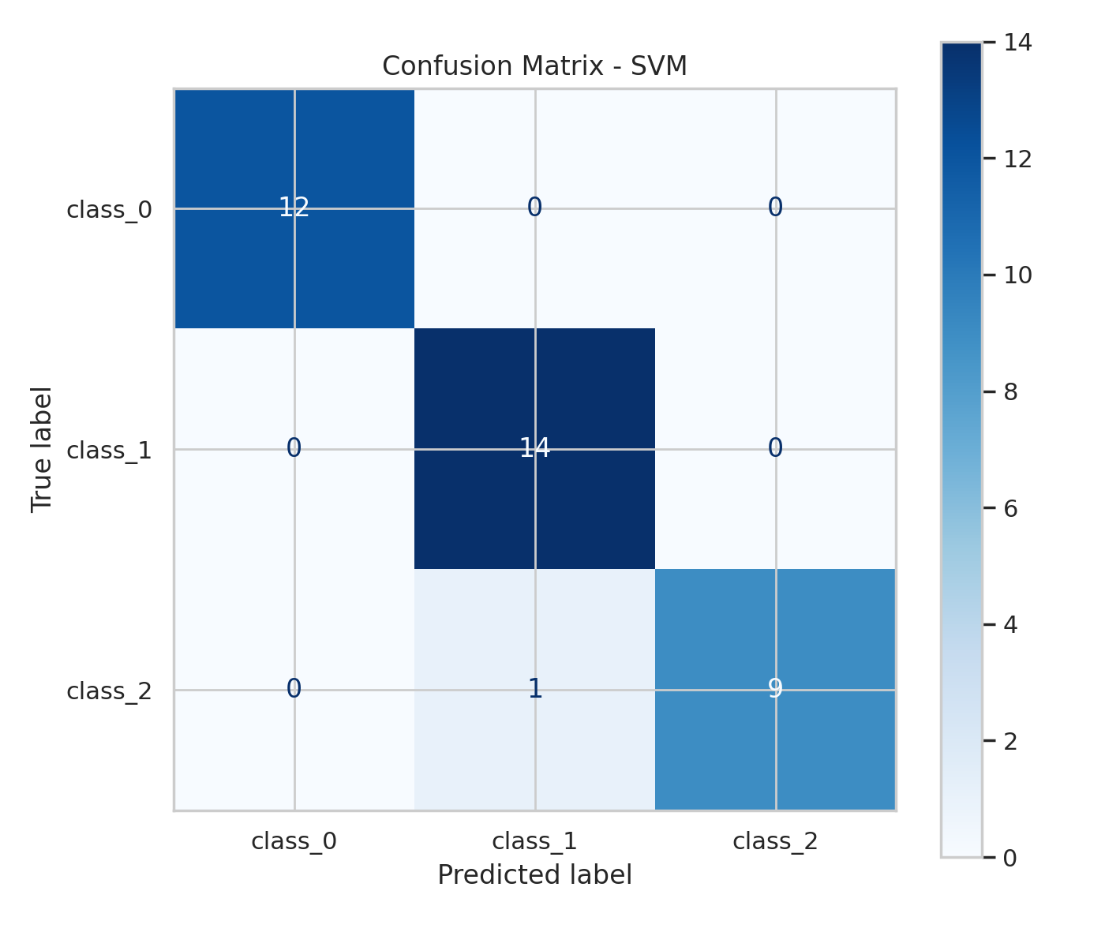
Figure 1. Confusion matrix for the selected model.
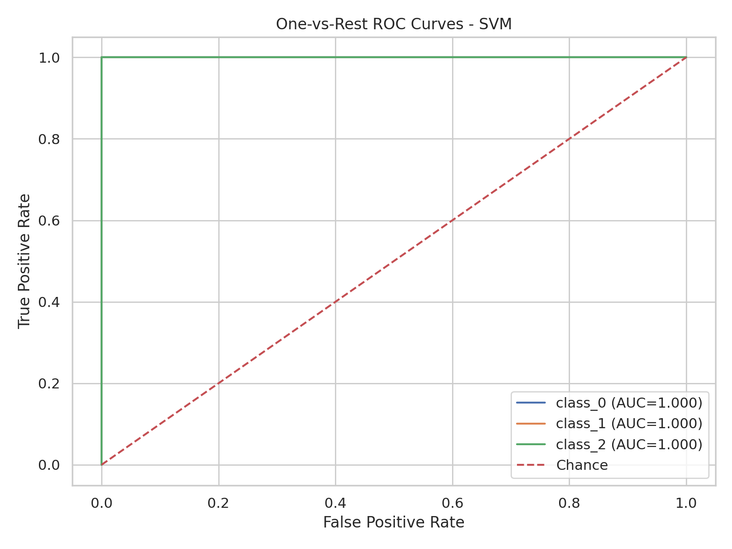
Figure 2. One-vs-rest ROC curves for the three classes.

11. Interpretation
The results show that the chemical measurements contain substantial information for separating the three wine cultivars. The confusion matrix identifies class-specific errors, while ROC curves show ranking performance across thresholds. Since the dataset is small, strong benchmark scores should be interpreted cautiously and should not be assumed to generalize to unrelated vineyards, laboratories or regions.

12. Strengths
- Multiple supervised algorithms are compared.
- Stratified splitting and five-fold cross-validation are used.
- Pipelines prevent preprocessing leakage.
- Multiple evaluation metrics and visual diagnostics are provided.
- A fixed random seed supports reproducibility.

13. Limitations
- Only 178 observations are available.
- The dataset may not represent future or external populations.
- Hyperparameter tuning is limited.
- A single held-out split does not fully quantify uncertainty.
- Feature importance should not be interpreted causally.

14. Possible Improvements
Future work can include randomized/grid hyperparameter search inside cross-validation, repeated or nested cross-validation, calibration, permutation importance, external validation, gradient-boosting comparisons and monitoring for distribution shift in production.

15. Conclusion
This project demonstrates the requested supervised-learning workflow: problem definition, public-data selection, preprocessing, model comparison, cross-validation, final evaluation and critical discussion. The accompanying source code, requirements and README make the analysis reproducible and extensible.

16. Submission Description (200+ Words)
This report presents a complete supervised learning project developed for Week 4 of the Data Science with Python internship. The project addresses a multiclass classification problem using the publicly available Wine Recognition dataset. The purpose is to demonstrate how a machine-learning solution can be developed systematically from problem definition through evaluation. The dataset contains chemical measurements of wine samples together with known cultivar labels, allowing supervised algorithms to learn relationships between input features and target classes. The workflow begins by loading and inspecting the dataset, followed by an 80/20 stratified train-test split. Preprocessing is handled with scikit-learn Pipelines so that scaling parameters are learned only from the relevant training data, reducing the risk of information leakage. Four models—Logistic Regression, Support Vector Machine, Random Forest and K-Nearest Neighbors—are compared. Five-fold stratified cross-validation is used to estimate performance and select the best candidate without touching the final test set. Accuracy, macro precision, macro recall, macro F1 and multiclass ROC-AUC are reported to provide a balanced evaluation. A confusion matrix and ROC curves provide visual evidence of class-level behavior. The report also discusses the strengths and limitations of the modeling approach, including the small dataset size and potential generalization concerns. Suggested improvements include broader hyperparameter optimization, repeated or nested cross-validation, external validation, calibration and additional ensemble methods. The project is accompanied by complete Python code, a requirements file, a README and generated result files so that another user can reproduce the analysis and extend it in a clean Python environment.

Appendix — Key Code
X_train, X_test, y_train, y_test = train_test_split(
X, y, test_size=0.20, random_state=42, stratify=y
)
model = Pipeline([
("scaler", StandardScaler()),
("model", LogisticRegression(max_iter=5000, random_state=42))
])
cv = StratifiedKFold(n_splits=5, shuffle=True, random_state=42)

