FITYA — School of Computer Science & Information Technology
Department of Software Engineering & Distributed Systems | Academic Year 2025–2026

◆ INTERNSHIP REPORT ◆
SchoolHub
School Management System

PROJECT TITLE
Design & Development of a Full-Stack School Management Platform
RESTful API · Web Admin Dashboard · Parent Mobile App

Developed by | Moumen MHT
School | FITYA – School of Computer Science & IT
Academic Year | 2025 – 2026
Internship Duration | February 2026 – June 2026 (4 months)
Supervisor | FITYA – Computer Science Department
Backend Technology | Laravel 12 / PHP 8.3
Frontend Technology | Vue.js 3 + TypeScript
Mobile Technology | Flutter 3 / Dart 3.12

ACKNOWLEDGEMENTS
I would like to express my sincere gratitude to the entire academic team at FITYA for the quality of the training provided throughout my studies.
My warmest thanks go to my internship supervisor for his valuable guidance, availability, and constant support throughout the development of this project.
I also thank all individuals who contributed, directly or indirectly, to the completion of this work, including the future end-users who participated in the requirements-gathering interviews.

ABSTRACT
This report presents the work carried out during a final-year internship focused on the design and development of SchoolHub, a comprehensive school management platform. The system consists of three main components: a RESTful API built with Laravel 12, a web administration dashboard developed with Vue.js 3 and TypeScript, and a Flutter mobile application for parents and teachers. The platform covers all operational needs of a school: student and teacher management, class organisation, academic grading, attendance tracking, financial contract management, and intelligent schedule generation. The architecture follows an MVC/REST pattern with strict separation of concerns, role-based access control (RBAC) across 7 user roles, and dedicated interfaces per actor type.
Keywords: School Management System, REST API, Laravel, Vue.js, Flutter, RBAC, Mobile, UML, Relational Database

TABLE OF CONTENTS
I. General Introduction
1. Context & Background
2. Problem Statement
3. Project Objectives
II. Requirements Analysis
1. System Actors
2. Functional Requirements
3. Non-Functional Requirements
III. System Design & Conception
1. Global Architecture
2. Use Case Diagrams
3. Class Diagram (Domain Model)
4. Database Schema
5. Activity Diagrams
6. Sequence Diagrams
7. WBS & Project Planning
IV. Implementation – Backend API (Laravel 12)
1. Project Structure
2. Authentication & RBAC
3. API Modules & Key Endpoints
4. Payment System
5. Schedule Generator Algorithm
V. Implementation – Web Dashboard (Vue.js 3)
VI. Implementation – Mobile App (Flutter)
VII. Testing & Validation
VIII. Conclusion & Future Work
References

I. GENERAL INTRODUCTION
1. Context & Background
This report documents the work carried out during a final-year internship at FITYA School of Information Technology between February and June 2026. The internship project, named SchoolHub, addresses a real-world need faced by many educational institutions: the absence of a unified, digital management system that covers all administrative and pedagogical operations.
SchoolHub is a production-ready, multi-platform school management system composed of three tightly integrated components: a RESTful backend API built with Laravel 12, a Vue.js 3 web administration dashboard, and a Flutter cross-platform mobile application for parents and teachers.
2. Problem Statement
Many schools still rely on fragmented tools — Excel spreadsheets for grades, paper attendance registers, physical letters for payment notices, and zero digital communication between parents, teachers, and administrators. This fragmentation leads to:
- Significant time loss for administrative staff due to manual data entry and cross-referencing;
- Errors and inconsistencies in grades, attendance records, and payment tracking;
- Lack of real-time visibility for parents into their children's academic progress;
- Inability to generate analytics reports or detect performance trends.
Core Question: How to design and implement a unified digital platform that covers the full school management lifecycle, while remaining accessible to all actors (administration, teachers, parents) from any device?
3. Project Objectives
The primary objectives of this internship project are:
- Build a robust RESTful API with Laravel 12 as the central business logic layer;
- Develop a complete web administration dashboard with Vue.js 3 and TypeScript;
- Create a cross-platform Flutter mobile application for parents and teachers;
- Implement a Role-Based Access Control (RBAC) system with 7 distinct roles;
- Cover all core modules: students, teachers, classes, grades, attendance, payments, schedules;
- Develop an intelligent automatic schedule generator with constraint satisfaction;
- Ensure security, performance, and code maintainability through industry best practices.

II. REQUIREMENTS ANALYSIS
1. System Actors
Actor | Role | Primary Interface | Access Level
Administrator | Full system management | Web Dashboard | Full access
Director | Global supervision & reports | Web Dashboard | Read-only global
Supervisor | Level-specific class supervision | Web | Own level access
Teacher | Enter grades & attendance | Web & Mobile | Own classes only
Parent | Monitor child's academic progress | Mobile App | Own children only
Secretariat | Daily administrative tasks | Web | Partial admin access
Accountant | Financial management | Web | Financial module only

2. Functional Requirements
Functional requirements were gathered through stakeholder interviews and analysed as user stories, grouped into eight functional modules:
▸ User & Auth Management
- Multi-role account creation & activation
- Token-based authentication per role
- Password management & RBAC enforcement
- Data visibility restricted by assigned level for Directors and Supervisors
▸ Student Management
- Full student profile (personal & medical)
- Class assignment & parent linking
- Unique student code generation
- Students assignments tracking
▸ Teacher Management
- Teacher profiles with specialisations
- Weekly availability management
- Contract type & workload tracking
- Teacher assignments distribution
▸ Classes & Subjects
- Levels management and Multi-level class organisation
- Class–Subject–Teacher pivot assignments
- Subject coefficients per level
▸ Grading & Report Cards
- Multiple exam types with bulk entry
- Weighted average computation
- Class ranking & report cards
- Comprehensive grades report generation
▸ Attendance Tracking
- Session-level daily tracking
- Statuses: present / absent / late / excused
- Per-student & per-class statistics
▸ Payments & Contracts
- Fee configuration by admin
- Parent–school contract with auto-billing
- Partial payments, advances, refunds
▸ Schedule Management
- Automatic constraint-based generation
- Manual conflict detection
- Weekly view per class / teacher
3. Non-Functional Requirements
- Security: Token-based auth (Laravel Sanctum), bcrypt password hashing, SQL injection prevention via Eloquent ORM, CSRF protection, input validation via FormRequests.
- Performance: Paginated responses, optimised DB indexes on critical columns, API responses under 200 ms for standard queries.
- Maintainability: PSR-12 coding standards, separation of concerns (Controllers / Services / Models), 100 KB+ of Markdown documentation.
- Portability: API compatible with SQLite, MySQL, and PostgreSQL; mobile app targets Android and iOS.
- Multi-language: Mobile app supports Arabic (RTL), French, and English.

III. SYSTEM DESIGN & CONCEPTION
1. Global Architecture
SchoolHub follows a 3-Tier architecture with a strict separation between presentation (Web/Mobile clients), business logic (REST API), and data persistence (relational database).
Tier | Component | Technology Stack
Presentation | Web Admin Dashboard | Vue.js 3.4, TypeScript 5.7, PrimeVue 4, Vite 5, Chart.js
Presentation | Mobile Application | Flutter 3.x, Dart 3.12, Provider, Dio, FL Chart
Business Logic | REST API Server | Laravel 12, PHP 8.3, Laravel Sanctum, Eloquent ORM
Data Persistence | Relational Database | SQLite / MySQL / PostgreSQL — 48 migrations, 26 models

2. Use Case Diagrams
The following diagrams describe the interactions between each system actor and the platform's functionalities. They were derived from the requirements analysis and stakeholder interviews.
Use Case Diagram — Administrator
◆ Administrator Use Cases
┌──────────────────────────────────────────────────────┐
│ <<System>> SchoolHub │
│ │
│ ○ Manage Users (Create / Update / Deactivate) │
│ ○ Manage Students │ ←── [Administrator]
│ ○ Manage Teachers & Availability │
│ ○ Manage Classes, Levels & Subjects │
│ ○ Generate Automatic Schedules │
│ ○ Configure Academic Year Fees │
│ ○ Create & Manage Contracts │
│ ○ Process Payments & View Financial Reports │
│ ○ View Dashboard Analytics & KPIs │
│ ○ Manage Supervisor / Secretariat Accounts │
└──────────────────────────────────────────────────────┘
Figure 1: Use Case Diagram — Administrator actor
Use Case Diagram — Teacher & Parent
◆ Teacher & Parent Use Cases
┌────────────────────────────────┐ ┌────────────────────────────────┐
│ <<Actor>> Teacher │ │ <<Actor>> Parent │
├────────────────────────────────┤ ├────────────────────────────────┤
│ ○ View My Assigned Classes │ │ ○ View My Children │
│ ○ Enter Grades (single/bulk) │ │ ○ View Child's Grades/ReportCard│
│ ○ Create & Manage Assignments │ │ ○ View & Download Assignments │
│ ○ Mark Attendance for Session │ │ ○ View Attendance History │
│ ○ View My Weekly Schedule │ │ ○ View Payment Status/Contract │
│ ○ View Class Rankings │ │ ○ View Child's Timetable │
│ ○ View My Students │ │ ○ Change Language & Theme │
└────────────────────────────────┘ └────────────────────────────────┘
Figure 2: Use Case Diagrams — Teacher and Parent actors
3. Class Diagram (Domain Model)
The following class diagram illustrates the 16 core domain entities and their relationships, derived directly from the 26 Eloquent models defined in the Laravel backend. Key attributes and methods are listed for each entity.
◆ UML Class Diagram — Core Domain Model
┌──────────────┐ ┌────────────────┐ ┌────────────────┐
│ User │ 1 1 │ Teacher │ │ ParentModel │
├──────────────┤ ──────>├────────────────┤ ├────────────────┤
│+id: int │ │+id: int │ 1 │+id: int │
│+username: str │ │+user_id: int │ ──── │+user_id: int │
│+email: str │ │+first_name: str │ │+first_name:str │
│+role: enum │ │+specialization │ │+phone: str │
│+is_active:bool│ │+contract_type │ │+cin: str │
├──────────────┤ │+weekly_hours │ ├────────────────┤
│+login() │ ├────────────────┤ │+hasAccount() │
│+changePass() │ │+getFullName() │ └───────┬────────┘
└──────────────┘ │+canTeachSubj() │ │ 1
└───────┬────────┘ │ *
│ 1 ┌──────v─────────┐
│ * │ Student │
┌───────────────────────────────v──┐ ├────────────────┤
│ ClassSubjectTeacher │ │+id: int │
├───────────────────────────────────┤ * ──── 1 │+class_id: int │
│+class_id: int │ │+parent_id: int │
│+teacher_id: int │ │+code: str │
│+subject_id: int │ │+gender: enum │
│+coefficient: decimal │ │+is_active: bool│
└────────┬──────────────┬───────────┘ ├────────────────┤
│ * │ 1 │+getFullName() │
│ │ └────┬────┬──────┘
┌──────v──┐ ┌──────v────────┐ │ 1 │ 1
│ Schedule│ │ SchoolClass │ │ * │ *
├─────────┤ ├───────────────┤ ┌──────v┐ ┌v──────────┐
│+day │ │+name: str │ │ Grade │ │Attendance │
│+start │ │+level_id: int │ ├───────┤ ├───────────┤
│+end_time│ │+academic_year │ │+exam │ │+date │
│+room │ │+capacity: int │ │+grade │ │+status │
└─────────┘ └──────┬────────┘ │+comm │ │+reason │
│ 1 └───────┘ └───────────┘
┌────────────────────── │ *
│ Contract │ ┌───────────────────┐
├───────────────────────┐└─── belongsTo Level │ Exam │
│+parent_id: int │ ├───────────────────┤
│+contract_number: str │ ┌──────────────┐ │+title: str │
│+total_fees: decimal │ 1 * │ Bill │ │+exam_type: enum │
│+monthly_amount │────>├──────────────┤ │+max_grade: decimal│
│+status: enum │ │+month_year │ │+subject_id: int │
└───────────────────────┘ │+amount_due │ └───────────────────┘
│ 1 * Payment │+status: enum │
v └──────────────┘
┌─────────────────┐
│ Payment │
├─────────────────┤ 1 * PaymentAllocation ──> Bill
│+amount: decimal │
│+payment_type │
│+paid_date │
└─────────────────┘
Figure 3: UML Class Diagram — Core domain model (16 entities, key attributes, relationships)
4. Database Schema
The relational database contains 48 migration files and 26 core tables. The table below details the primary tables, their key columns, and foreign key relationships.
Table | Key Columns | Foreign Keys | Notes
users | id, username, email, role, is_active | — | Roles: admin, teacher, parent, supervisor, secretariat, accountant, director
teachers | id, user_id, first_name, specialization, salary, weekly_hours | user_id → users | Hidden: salary, cin
parents | id, user_id, first_name, phone, cin, profession | user_id → users | Can exist without user account
levels | id, name, description | — | Grade levels e.g. Grade 6, Grade 7
classes | id, name, level_id, academic_year, capacity, main_teacher_id | level_id, main_teacher_id | Central pivot of academic structure
students | id, class_id, parent_id, code, gender, birth_date, is_active | class_id, parent_id | Unique student code auto-generated
subjects | id, name, code, description | — | Mathematics, Physics, French, etc.
class_subject_teacher | id, class_id, teacher_id, subject_id, coefficient | class_id, teacher_id, subject_id | CENTRAL PIVOT — basis for all academic data
schedules | id, class_subject_teacher_id, day, start_time, end_time, room | class_subject_teacher_id | day: monday–saturday enum
exams | id, title, exam_type, max_grade, exam_date, subject_id | subject_id, teacher_id | Types: Quiz, Midterm, Final, Assignment
grades | id, student_id, exam_id, grade, comment | student_id, exam_id | Grade normalised /20 via percentage helper
attendances | id, student_id, schedule_id, date, status, reason | student_id, schedule_id | status: present/absent/late/excused
contracts | id, parent_id, contract_number, total_fees, monthly_amount, status | parent_id | Auto contract number: CNT-YYYY-XXXXXX
bills | id, contract_id, month_year, amount_due, amount_paid, status | contract_id | Auto-generated per contract month
payments | id, contract_id, amount, payment_type, paid_date | contract_id | Types: cash, card, bank_transfer, refund
payment_allocations | id, payment_id, bill_id, amount | payment_id, bill_id | Audit trail: maps payments to bills

Key Design Decision: The class_subject_teacher pivot table is the backbone of the academic system — it links a class, a subject, and a teacher for a given academic year. All schedules, grades (via exams), and attendance records trace back to this pivot.

5. Activity Diagrams
Activity Diagram 1 — Automatic Schedule Generation
The schedule generator resolves a constraint-satisfaction optimisation problem. It assigns teaching sessions to time slots while respecting hard constraints and optimising soft preferences through a scoring function.
◆ Activity Diagram — Schedule Generation Algorithm
[START] ──► Fetch all ClassSubjectTeacher assignments
│
▼
Sort by: teacher contract type, then subject coefficient DESC
│
▼
┌─── More assignments? ────────────── No ───► [END – Save or Preview]
│ Yes
▼
Get next assignment demand
│
├── [Sport subject & 2h required?] ──Yes──► Search 2 consecutive slots
│ │
│ Found ◄─────────┤──► Not found ──► UNFILLED
│ │ │ (diagnoseReason)
│ Allocate 2h │
│ ◄──────────────────┘
├── [Regular subject]
│
▼
Evaluate all days & slots via findBestSlotForDemand()
│
├── HARD CONSTRAINTS (must ALL pass):
│ ✗ Teacher already booked in this slot
│ ✗ Class already booked in this slot
│ ✗ Outside teacher availability hours
│ ✗ Class has reached 7 sessions today
│ ✗ Internal timetable gap created
│
├── SOFT SCORING (if constraints pass):
│ +50 Important subject scheduled in morning (slots 1–4)
│ -20 Important subject scheduled in afternoon
│ +10 Permanent teacher under 4h today
│ -40 Permanent teacher at 6h+ today
│ -30 Contract teacher at 6h+ today
│
├── Best slot found? ──Yes──► Allocate session
│ │
└── No ──► Fallback mode ─── Found ───┘
(relax "important subject" │
daily-limit constraint) │
Not found ──► UNFILLED ──────┘
(diagnoseUnfilledReason)
Figure 4: Activity Diagram — Automatic Schedule Generation Algorithm with hard constraints and soft scoring
Activity Diagram 2 — Payment Processing & Bill Allocation
◆ Activity Diagram — Payment Processing
[START] ─► Admin submits payment {contract_id, amount, payment_type}
│
▼
Validate request via FormRequest
│
┌────┴────┐
│ Contract │──Not found──► Return 404 "Contract not found"
│ active? │
└────┬─────┘
│ Yes
▼
Create Payment record (status = "completed")
│
▼
Fetch unpaid Bills ordered by due_date ASC
│
▼
Set remaining = payment.amount
│
┌─────┴──────────────────────────────────────────┐
│ remaining > 0 AND unpaid bills exist? │
└─────┬──────────────────────────────────────────┘
│ Yes │ No
▼ ▼
Take next unpaid bill Overpayment? ──Yes──► Store in contract.balance
│ │ (credit for future use)
┌──────┴──────┐ │
│remaining >= │ ▼
│bill.balance? │ Update contract totals
└──┬───────┬───┘ (paid_amount, remaining_amount)
│ Yes │ No │
▼ ▼ [END – Return receipt with allocations]
Bill=PAID Bill=PARTIAL
Set fully Set partial
paid paid amt
│ │
└──┬────┘
▼
Create PaymentAllocation record
remaining -= bill amount paid
│
└──────────────────────────► Loop back
Figure 5: Activity Diagram — Payment Processing & Automatic Bill Allocation Engine
Activity Diagram 3 — Contract Creation
◆ Activity Diagram — Contract Creation & Auto-Billing
[START] ─► Admin selects parent + fee_ids for academic year
│
▼
Calculate total_fees from selected fee records
│
┌─────┴─────┐
│ Discount │──Yes──► Apply discount (percentage OR fixed amount)
│ applied? │ │
└─────┬──────┘ ◄───────┘
│ No
▼
Compute monthly_amount = final_total / num_months
│
▼
Create Contract record + unique contract_number (CNT-YYYY-XXXXXX)
│
▼
Create parents_fees junction records
│
▼
┌─────────────────────────────────────────────┐
│ For each month from start_date to end_date │
│ (typically September → June = 10 months) │
└─────┬───────────────────────────────────────┘
│ For each month
▼
Generate Bill record {month_year, amount_due, due_date, status=pending}
│
└──────────────► Repeat for all months
│ Done
▼
[END – Return contract + list of 10 generated bills]
Figure 6: Activity Diagram — Contract Creation and Automatic Monthly Bill Generation

6. Sequence Diagrams
Sequence Diagram 1 — User Authentication Flow
This diagram illustrates the complete authentication flow from credential submission to role-specific routing, including error cases for inactive accounts and invalid credentials.
◆ Sequence Diagram — Authentication Flow
User Client Laravel API Sanctum Auth Database
│ │ │ │ │
│ Enter │ │ │ │
│ credentials │ │ │ │
│─────────────>│ │ │ │
│ │ POST /api/login │ │ │
│ │ {email,pass} │ │ │
│ │───────────────>│ │ │
│ │ │── Query user ───────────────────>│
│ │ │<── User record ─────────────────│
│ │ │ │ │
│ [User not found] ────┤ │ │
│ │<── 401 "Invalid│ │ │
│ │ credentials"│ │ │
│ │ │ │ │
│ [User inactive] ─────┤ │ │
│ │<── 403 "Account│ │ │
│ │ deactivated"│ │ │
│ │ │ │ │
│ [Valid credentials] ─┤ │ │
│ │ │── bcrypt verify ─>│ │
│ │ │<── Password OK ──│ │
│ │ │── Create token ──>│ │
│ │ │<── Bearer token ─│ │
│ │ │── Log token ───────────────────>│
│ │<── 200 {token, │ │ │
│ │ user,role} │ │ │
│ │ Store token │ │ │
│ │ (localStorage/ │ │ │
│ │ SecureStorage)│ │ │
│<── Redirect │ │ │ │
│ to role │ │ │ │
│ dashboard │ │ │ │
Figure 7: Sequence Diagram — User Authentication with Laravel Sanctum
Sequence Diagram 2 — Teacher Submits Grades (Bulk)
◆ Sequence Diagram — Bulk Grade Submission
Teacher Web Dashboard Laravel API Middleware Database
│ │ │ │ │
│ Navigate to │ │ │ │
│ My Classes │ │ │ │
│───────────────>│ │ │ │
│ │ GET /api/teacher │ │ │
│ │ /classes │ │ │
│ │ Bearer {token} │ │ │
│ │────────────────>│ │ │
│ │ │ check role │ │
│ │ │ = teacher ✓ │ │
│ │ │─────────────>│ │
│ │ │── Query classes──────────────>│
│ │<── class list ──│ │ │
│<── Display ────│ │ │ │
│ │ │ │ │
│ Fill grade │ │ │ │
│ form for │ │ │ │
│ all students │ │ │ │
│───────────────>│ │ │ │
│ │ POST /api/grades │ │ │
│ │ /bulk │ │ │
│ │ {grades:[...]} │ │ │
│ │────────────────>│ │ │
│ │ │ check role │ │
│ │ │ in [teacher │ │
│ │ │ admin] ✓ │ │
│ │ │─────────────>│ │
│ [Validation fails]────┤ │ │
│ │<── 422 {errors} │ │ │
│<── Show errors─│ │ │ │
│ [Validation passes]───┤ │ │
│ │ │── Bulk insert───────────────>│
│ │ │<── N records ────────────────│
│ │<── 201 {count:N}│ │ │
│<── "Grades │ │ │ │
│ saved ✓" │ │ │ │
Figure 8: Sequence Diagram — Teacher bulk grade submission with RBAC enforcement
Sequence Diagram 3 — Parent Views Child's Report Card
◆ Sequence Diagram — Parent Report Card Access
Parent Flutter App Laravel API Middleware Database
│ │ │ │ │
│ Open "My │ │ │ │
│ Children" │ │ │ │
│─────────────>│ │ │ │
│ │ GET /api/parent│ │ │
│ │ /students │ │ │
│ │ Bearer{token} │ │ │
│ │──────────────>│ │ │
│ │ │ verify role │ │
│ │ │ = parent ✓ │ │
│ │ │─────────────>│ │
│ │ │── WHERE parent_id = auth ──>│
│ │<── [{children}│ │ │
│<── Children │ │ │ │
│ list shown │ │ │ │
│ │ │ │ │
│ Tap child │ │ │ │
│ name │ │ │ │
│─────────────>│ │ │ │
│ │ GET /api/parent│ │ │
│ │ /students/{id}│ │ │
│ │ /report-card │ │ │
│ │──────────────>│ │ │
│ │ │ verify │ │
│ │ │ ownership: │ │
│ │ │ student. │ │
│ │ │ parent_id == │ │
│ │ │ auth.parent │ │
│ [Not owner] ─────────┤ │ │
│ │<── 403 Forb. │ │ │
│ [Owner confirmed] ───┤ │ │
│ │ │── Aggregate grades ─────────>│
│ │ │── Calculate weighted avg ───>│
│ │ │── Compute class ranking ────>│
│ │ │<── Report card data ─────────│
│ │<── 200 {report│ │ │
│ │ card data} │ │ │
│ │ Render with │ │ │
│ │ FL Chart │ │ │
│<── Report │ │ │ │
│ card shown │ │ │ │
Figure 9: Sequence Diagram — Parent accesses child's report card with ownership verification
Sequence Diagram 4 — Admin Processes a Payment
◆ Sequence Diagram — Admin Payment Processing
Admin Web Dashboard Laravel API PaymentService Database
│ │ │ │ │
│ Enter payment │ │ │ │
│ amount for │ │ │ │
│ contract │ │ │ │
│──────────────>│ │ │ │
│ │ POST /api/ │ │ │
│ │ payments │ │ │
│ │ {contract_id, │ │ │
│ │ amount,type} │ │ │
│ │──────────────>│ │ │
│ │ │ FormRequest │ │
│ │ │ validation │ │
│ │ │── Fetch contract + bills ───>│
│ │ │<── Contract & unpaid bills───│
│ │ │ │ │
│ │ │─ allocate() ─>│ │
│ │ │ │ Loop: for each│
│ │ │ │ unpaid bill │
│ │ │ │─ Update bill >│
│ │ │ │─ Insert alloc>│
│ │ │ │<─ OK ─────────│
│ │ │ │ [overpayment?]│
│ │ │ │─ Update balance>│
│ │ │<─ Done ───────│ │
│ │ │─ Update contract totals ────>│
│ │<── 201 { │ │ │
│ │ payment, │ │ │
│ │ allocations} │ │ │
│<── Receipt │ │ │ │
│ with bill │ │ │ │
│ breakdown │ │ │ │
Figure 10: Sequence Diagram — Admin payment with automatic PaymentService allocation

7. WBS & Project Planning
The project was structured into 5 major phases following the Work Breakdown Structure (WBS) methodology. The Gantt chart managed with GanttPRO shows the temporal distribution of tasks across the 4-month internship period.
Phase | Key Deliverables | Duration
1 – Planning & Design | Requirements analysis, system architecture, DB design, UI mockups, WBS & PMP | 2 weeks
2 – Backend (Laravel) | Environment setup, Eloquent models, controllers, authentication, RBAC, unit tests | 6 weeks
3 – Frontend (Vue.js) | Reusable components, CRUD views, API integration, responsive design, i18n | 5 weeks
4 – Integration & Testing | End-to-end tests, security audit, performance optimisation, test server deployment | 2 weeks
5 – Documentation | User guides, technical docs, internship report, demo preparation | 1 week

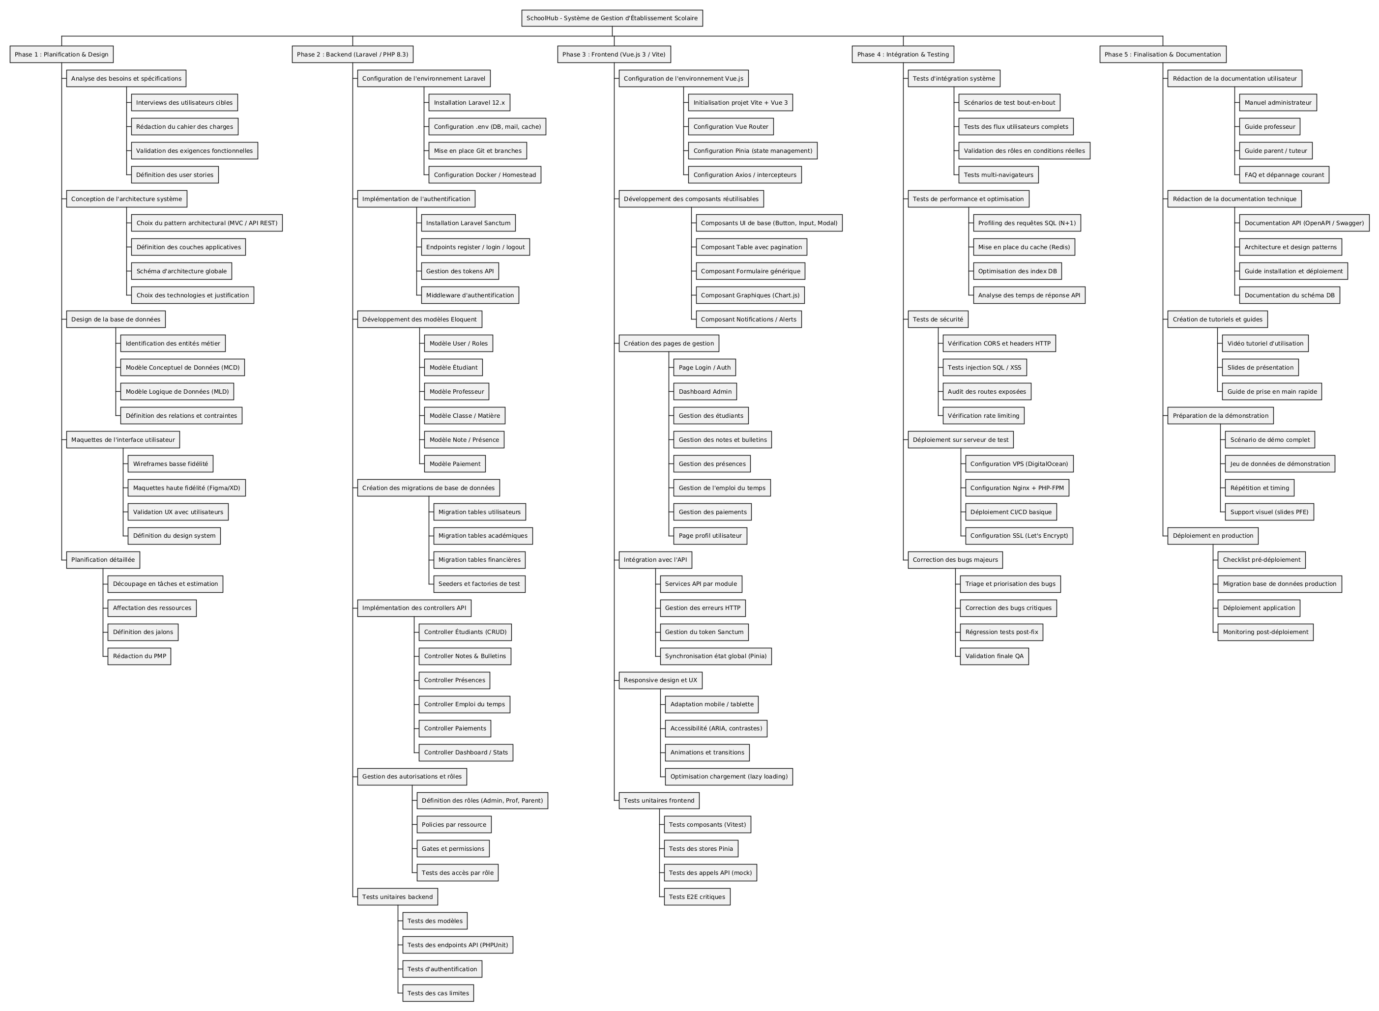
Figure 11: Work Breakdown Structure (WBS) — SchoolHub project decomposed into 5 phases

Figure 12: Gantt Chart (GanttPRO) — Full timeline Feb–Jun 2026. Red bars = critical path tasks

IV. IMPLEMENTATION – BACKEND API (LARAVEL 12)
1. Project Structure
API/
├── app/
│ ├── Http/Controllers/ (18 controllers)
│ ├── Models/ (26 Eloquent models)
│ ├── Services/ (business logic layer)
│ └── Observers/
├── database/
│ ├── migrations/ (48 migration files)
│ ├── seeders/
│ └── factories/
├── routes/
│ └── api.php (80+ REST endpoints)
├── tests/Feature/ (PHPUnit test suites)
└── docs/
├── API_COMPLETE_REFERENCE.md (45 KB)
├── PAYMENT_SYSTEM_DOCUMENTATION.md (30 KB)
└── SCHEDULE_API_REFERENCE.md (8 KB)
2. Authentication & RBAC
Authentication is handled by Laravel Sanctum with role-dependent token lifetimes. A custom role middleware guards every protected route group, enforcing access rules at the HTTP layer.
Role | Token Expiry | Access Scope
admin | 8 hours | Full system access to all resources
director | 7 days | Global read-only access + statistics
supervisor | 7 days | Own level classes management
teacher | 7 days | Own classes, grades, attendance entry
parent | 7 days | Own children's data only (ownership enforced)
secretariat | 8 hours | Administrative operations
accountant | 8 hours | Financial module only

Security: All passwords hashed with bcrypt. Deactivating a user account (is_active = false) immediately revokes all active tokens and blocks re-authentication. CORS restricts API access to authorised origins only.
3. API Modules & Key Endpoints (80+ total)
Method | Endpoint | Description
POST | /api/login | Authenticate user → Bearer token + role profile
GET | /api/students | List students (filters: class_id, gender, is_active)
POST | /api/students | Create new student record
GET | /api/students/{id}/report-card | Full academic report card with weighted averages
GET | /api/classes/{id}/ranking | Class ranking by average grade
POST | /api/grades/bulk | Bulk grade entry for an entire class session
POST | /api/attendances | Mark attendance for a session
GET | /api/schedules/weekly-overview | Full weekly schedule for all classes
POST | /api/schedules/check-conflicts | Detect conflicts before saving a slot
POST | /api/schedule/generate | Auto-generate full schedule via constraint algorithm
POST | /api/contracts | Create contract + auto-generate 10 monthly bills
POST | /api/contracts/{id}/add-service | Mid-year contract modification (new version)
POST | /api/contracts/{id}/withdraw | Student withdrawal + refund calculation
POST | /api/payments | Process payment → auto-allocate to unpaid bills
GET | /api/dashboard/stats | Full KPI dashboard (students, attendance, revenue)
GET | /api/parent/students/{id}/report-card | Parent-scoped: child's report card

4. Payment System
The financial module implements a contract-based allocation engine spanning 6 database tables. It handles all financial scenarios in a school context:
- Full payments: entire balance paid in one transaction
- Partial payments: payment applied to oldest unpaid bill first
- Advance payments: one payment covers multiple future months
- Overpayment: credit stored in contract.balance for future use
- Mid-year contract modification: adds/removes services, recalculates future bills
- Student withdrawal: prorated refund calculation based on months consumed
5. Schedule Generator Algorithm
The schedule generator is the most computationally complex feature of SchoolHub. It processes all ClassSubjectTeacher assignments and distributes them into a weekly grid, enforcing hard constraints and optimising placement through a multi-factor scoring system. See Activity Diagram 1 (Section III.5) for the full algorithm flowchart.
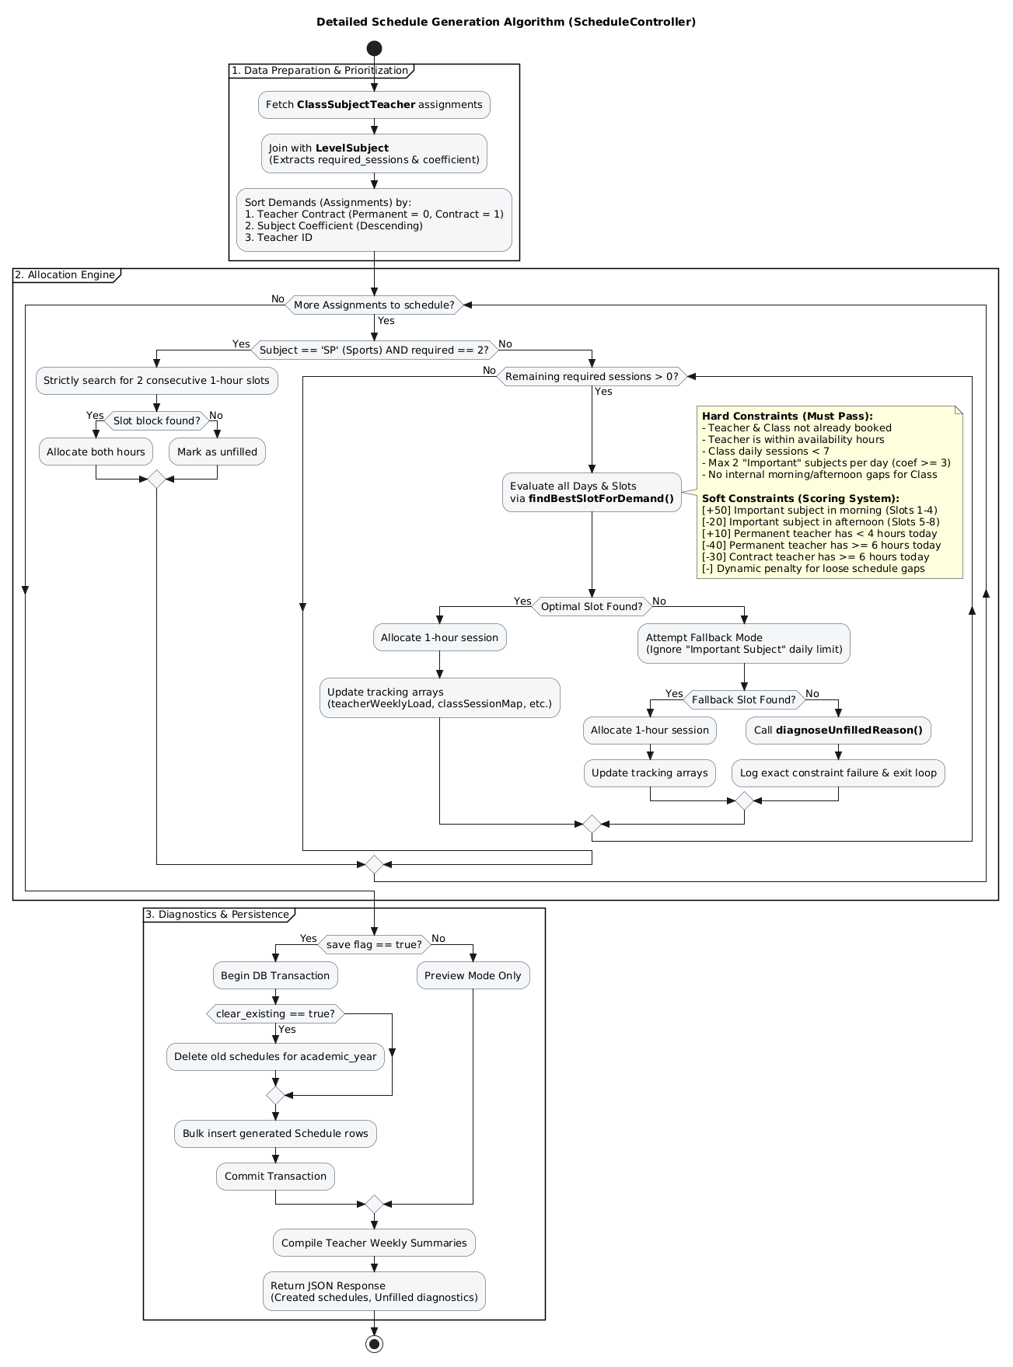
Figure 13: Schedule Generator — constraint-satisfaction algorithm flowchart

V. IMPLEMENTATION – WEB DASHBOARD (VUE.JS 3)
1. Technology Stack
Technology | Version | Purpose
Vue.js | 3.4 | Core reactive frontend framework
TypeScript | 5.7 | Type-safe JavaScript across all components
PrimeVue | 4.5 | Enterprise UI component library
Vite | 5.3 | Ultra-fast build tool & dev server
Chart.js | 3.3 | Analytics charts & visualisations
Axios | 1.13 | HTTP client for API communication
Vue Router | 4.x | Client-side routing & navigation guards
Vue i18n | 9.x | Internationalisation (multi-language)
Tailwind CSS | 3.x | Utility-first styling

2. Views Implemented (25 total)
View File | Description | Size
GradeAnalytics.vue | Advanced grade analytics with charts, filters, rankings | 137 KB
AdminAttendance.vue | Full attendance management per class/date/subject | 57 KB
Classes.vue | Class CRUD, student assignment, subject management | 67 KB
Teachers.vue | Teacher profiles, subject assignments, workload tracking | 63 KB
Students.vue | Student list with filters and profile management | 43 KB
Parents.vue | Parent account & children management | 46 KB
ContractCreate.vue | Multi-step contract creation wizard with fee selection | 26 KB
PaymentDashboard.vue | Financial overview: contracts, bills, payment history | 38 KB
ScheduleGenerator.vue | Trigger generation, view results by class | 9 KB
SupervisorPanel.vue | Level supervisor: classes, grades, attendance overview | 36 KB
TeacherPortal.vue | Teacher-facing: my classes, grade entry, attendance | 24 KB

3. Architecture Patterns
Pattern | Implementation in SchoolHub
Composition API | All components use <script setup lang="ts">
Service Layer | API calls abstracted into ApiService.ts and DashboardService.ts
Repository Pattern | Data access centralised in service files away from component logic
Singleton Pattern | Single Axios instance shared across all components
Observer Pattern | Vue 3 reactivity system drives all UI state updates

VI. IMPLEMENTATION – MOBILE APPLICATION (FLUTTER)
1. Overview
The SchoolHub Parent mobile application is built with Flutter (Dart 3.12) and targets both Android and iOS. It serves parents as their primary interface and teachers as a mobile alternative to the web dashboard for grade and attendance entry.
Package | Version | Purpose
Flutter | 3.x | Cross-platform mobile framework
Dart | 3.12 | Programming language
provider | 6.1 | State management
dio | 5.4 | HTTP client for API calls
flutter_secure_storage | 9.x | Encrypted token storage
fl_chart | 0.66 | Charts & data visualisation
google_fonts | 6.1 | Typography
intl | 0.20 | Internationalisation & date formatting
shimmer | 3.x | Loading skeleton animations
shared_preferences | 2.x | Locale & settings persistence

2. Architecture — Provider Pattern
Mobile/lib/
├── main.dart (entry point, MultiProvider setup)
├── providers/
│ ├── auth_provider.dart (login, logout, checkAuth, role)
│ ├── children_provider.dart (fetchChildren, selected child)
│ └── locale_provider.dart (AR/FR/EN switching)
├── services/
│ └── api_service.dart (Dio HTTP client)
├── theme/
│ └── app_theme.dart (light/dark themes)
└── screens/
├── login_screen.dart
├── home_screen.dart (parent home)
├── grades/ (report cards)
├── attendance/ (presence history)
├── payments/ (contract & billing)
├── schedule/ (weekly timetable)
├── teacher/ (teacher portal)
└── settings/ (language, theme)
3. Feature Summary
Module | Key Features | Target
Authentication | Multi-role login, secure token storage, auto-login on restart | All
My Children | List of enrolled children with class and profile info | Parent
Grades & Reports | Grades by subject & semester, full report card with weighted averages | Parent
Attendance | Attendance history per subject, status breakdown, FL Chart visualisation | Parent
Payments | Contract summary, monthly bill status, payment history | Parent
Schedule | Weekly timetable of child's class (day/time/subject/room) | Parent
Teacher Portal | My classes, mark attendance, enter grades from mobile | Teacher
Settings | Language (Arabic/French/English), light/dark theme, profile management | All

4. Multi-language & Theming
The app supports three languages: Arabic (with full RTL text direction support), French, and English. The selected locale is persisted across sessions via shared_preferences. Theming is system-adaptive — ThemeMode.system automatically switches between light and dark themes based on the device setting, with custom light and dark themes defined in AppTheme.

VII. TESTING & VALIDATION
1. Testing Strategy
A multi-level testing strategy was applied covering unit tests, integration (feature) tests, and manual validation. All tests run against an isolated SQLite in-memory database to prevent interference with development data.
2. Backend Test Suites (PHPUnit)
Test Suite | Type | Coverage
AuthenticationTest | Feature | Login, logout, token generation, role-based expiry, 401/403 responses
StudentManagementTest | Feature | CRUD operations, filters, validation, parent-child ownership checks
GradeSystemTest | Feature | Single & bulk grade entry, report card generation, class ranking
AttendanceTest | Feature | Session marking, status transitions, statistics computation
ScheduleConflictTest | Feature | Teacher conflicts, room double-booking, class availability
PaymentSystemTest | Feature | Full/partial/advance payments, overpayment credit, refund calculations
RBACTest | Feature | Every role can only access authorised routes (403 for all others)

3. Security Validation
- Role isolation: A parent account attempting to access /api/students (admin-only) receives HTTP 403.
- Token expiry: Expired tokens return HTTP 401, triggering re-login on both web and mobile.
- Input sanitisation: All API inputs pass through Laravel FormRequest validation before business logic.
- SQL injection: Exclusive use of Eloquent ORM with parameterised queries; zero raw SQL.
- CORS: Only whitelisted origins (web dashboard, mobile app) may consume the API.
- Ownership checks: Parent endpoints verify student.parent_id == auth parent before data is returned.
Test Results: All PHPUnit feature test suites pass successfully. RBAC rules are enforced consistently across all 80+ endpoints. The payment allocation engine has been verified against all five payment scenarios: full, partial, advance, overpayment, and multi-payment bill completion.

VIII. CONCLUSION & FUTURE WORK
1. Project Summary
This internship successfully delivered SchoolHub — a production-ready, full-stack school management platform. The project covered the complete software development lifecycle: from requirements analysis and UML-based system design through to implementation, testing, and comprehensive documentation.
All primary objectives were achieved:
- ✅ Laravel 12 REST API — 80+ endpoints, 48 DB migrations, 26 models, 7-role RBAC;
- ✅ Vue.js 3 Web Dashboard — 25 views with TypeScript, PrimeVue components, real-time analytics;
- ✅ Flutter Mobile App — Cross-platform (Android/iOS), 8 feature modules, tri-lingual with RTL;
- ✅ Intelligent Schedule Generator — Constraint-satisfaction algorithm with scoring;
- ✅ Complete Financial System — Contracts, auto-billing, allocation engine, refund calculations;
- ✅ Full UML Design — Use case, class, activity, and sequence diagrams for all major features.
2. Skills Acquired
Technical Skills
- REST API design with Laravel 12 and Eloquent ORM
- Relational database design and normalisation (26 tables)
- Vue.js 3 with TypeScript in strict mode, Composition API
- Flutter cross-platform mobile development (Android/iOS)
- JWT/token-based authentication system design
- Constraint-satisfaction algorithm implementation
- UML system modelling (Use Case, Class, Activity, Sequence)
Methodological Skills
- Project management: WBS, Gantt charts, Project Management Plan (PMP)
- Requirements analysis and user stories
- 3-tier architectural design and RBAC security patterns
- API documentation writing (100 KB+ of Markdown docs)
- PHPUnit testing strategies and test isolation
- Git version control and code organisation
3. Future Work & Perspectives
- Real-time Notifications — WebSocket alerts (Laravel Broadcasting) for absences and new grades;
- In-app Messaging — Parent–teacher communication channel within the mobile app;
- PDF/Excel Exports — Report cards, attendance sheets, and financial reports as downloads;
- AI-Powered Analytics — Predictive models to identify students at risk of failure;
- CI/CD Pipeline — Automated testing and deployment to VPS with Nginx + Let's Encrypt SSL;
- Admin Mobile App — Extend mobile with administrator-specific role and live dashboard;
- Caching Layer — Redis integration for frequently accessed statistics and KPI data.
SchoolHub demonstrates that a comprehensive, production-grade school management platform can be designed and implemented by a single developer following rigorous software engineering practices. The project establishes a solid foundation ready to be deployed in real educational institutions and extended with additional features based on user feedback.

REFERENCES
Official Documentation
- [1] Laravel Documentation (2025). Laravel 12.x Framework Reference. https://laravel.com/docs/12.x
- [2] Vue.js Team (2024). Vue.js 3 – The Progressive JavaScript Framework. https://vuejs.org/guide/
- [3] Flutter Team (2024). Flutter SDK – Build apps for any screen. https://docs.flutter.dev/
- [4] PrimeVue Team (2024). PrimeVue 4 – UI Component Library for Vue. https://primevue.org/
- [5] Laravel Sanctum (2024). API Token Authentication. https://laravel.com/docs/sanctum
- [6] TypeScript Team (2024). TypeScript 5.7 – JavaScript with syntax for types. https://www.typescriptlang.org/
Reference Books
- [7] Martin, R. C. (2017). Clean Architecture: A Craftsman's Guide to Software Structure and Design. Prentice Hall.
- [8] Fowler, M. (2002). Patterns of Enterprise Application Architecture. Addison-Wesley.
- [9] Gamma, E., Helm, R., Johnson, R., & Vlissides, J. (1994). Design Patterns: Elements of Reusable Object-Oriented Software. Addison-Wesley.
- [10] Silberschatz, A., Korth, H. F., & Sudarshan, S. (2019). Database System Concepts (7th ed.). McGraw-Hill.
- [11] Booch, G., Rumbaugh, J., & Jacobson, I. (2005). The Unified Modeling Language User Guide (2nd ed.). Addison-Wesley.
Technical Articles & Standards
- [12] Fielding, R. T. (2000). Architectural Styles and the Design of Network-based Software Architectures. PhD Thesis, UC Irvine.
- [13] OWASP Foundation (2023). OWASP Top 10 – Critical Web Application Security Risks. https://owasp.org/www-project-top-ten/
- [14] PHP-FIG (2023). PSR-12: Extended Coding Style Guide. https://www.php-fig.org/psr/psr-12/
Tools Used
- [15] GanttPRO (2024). Project Planning & Gantt Chart Tool. https://ganttpro.com/
- [16] PHPUnit (2024). The PHP Testing Framework. https://phpunit.de/
- [17] python-docx (2024). Python library for creating Word documents. https://python-docx.readthedocs.io/
- [18] GitHub (2024). SchoolHub Repository – MoumenMHT/SchoolManager.

SchoolHub v2.0.0 · June 2026 · Moumen MHT · FITYA

