**1)**

package com.selenium.project1;

import org.testng.annotations.Test;

import io.github.bonigarcia.wdm.WebDriverManager;

import org.testng.annotations.BeforeTest;

import org.openqa.selenium.By;

import org.openqa.selenium.WebDriver;

import org.openqa.selenium.WebElement;

import org.openqa.selenium.chrome.ChromeDriver;

import org.openqa.selenium.chrome.ChromeOptions;

import org.testng.Assert;

import org.testng.annotations.AfterTest;

public class CC1_Q1 {

WebDriver driver;

@Test

public void f() throws Exception {

Thread.sleep(3000);

WebElement user = driver.findElement(By.id("user-name"));

user.sendKeys("standard_user");

WebElement pwd = driver.findElement(By.name("password"));

pwd.sendKeys("secret_sauce");

WebElement login = driver.findElement(By.id("login-button"));

login.click();

Thread.sleep(3000);

WebElement add = driver.findElement(By.id("add-to-cart-sauce-labs-backpack"));

add.click();

WebElement cartbtn = driver.findElement(By.className("shopping_cart_link"));

cartbtn.click();

Thread.sleep(2000);

Assert.assertEquals(driver.getCurrentUrl(), "https://www.saucedemo.com/cart.html");

WebElement checkoutbtn = driver.findElement(By.id("checkout"));

checkoutbtn.click();

Thread.sleep(2000);

Assert.assertEquals(driver.getCurrentUrl(), "https://www.saucedemo.com/checkout-step-one.html");

WebElement fname = driver.findElement(By.id("first-name"));

fname.sendKeys("standard");

WebElement lname = driver.findElement(By.id("last-name"));

lname.sendKeys("user");

WebElement code = driver.findElement(By.id("postal-code"));

code.sendKeys("123456");

WebElement continuebtn = driver.findElement(By.id("continue"));

continuebtn.click();

Thread.sleep(3000);

WebElement prod_name = driver.findElement(By.className("inventory_item_name"));

WebElement prod_price = driver.findElement(By.className("inventory_item_price"));

System.out.println(prod_name.getText());

System.out.println(prod_price.getText());

String title = driver.getTitle();

Assert.assertEquals(title, "Swag Labs");

Assert.assertEquals(driver.getCurrentUrl(), "https://www.saucedemo.com/checkout-step-two.html");

}

@BeforeTest

public void beforeTest() {

// Driver Setup

WebDriverManager.chromedriver().setup();

ChromeOptions co = new ChromeOptions();

co.addArguments("--remote-allow-origins=*");

driver = new ChromeDriver(co);

// Open URL

driver.get("https://www.saucedemo.com/");

driver.manage().window().maximize();

}

@AfterTest

public void afterTest() {

driver.quit();

}

}

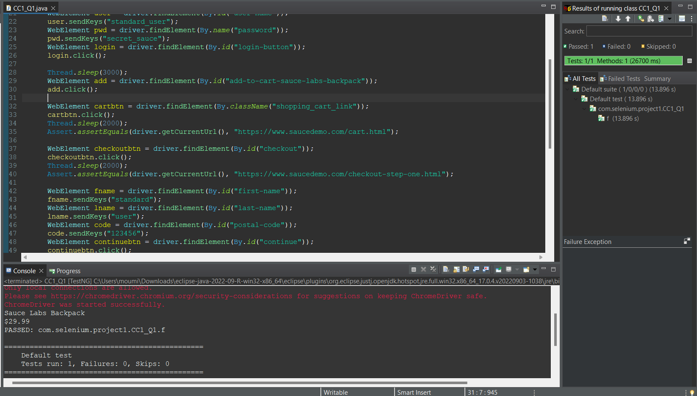

**2)**

package com.selenium.project1;

import org.testng.annotations.Test;

import io.github.bonigarcia.wdm.WebDriverManager;

import org.openqa.selenium.By;

import org.openqa.selenium.JavascriptExecutor;

import org.openqa.selenium.WebDriver;

import org.openqa.selenium.chrome.ChromeDriver;

import org.openqa.selenium.chrome.ChromeOptions;

public class CC2_C2 {

WebDriver driver;

@Test

public void f() throws Exception {

WebDriverManager.chromedriver().setup();

ChromeOptions co=new ChromeOptions();

co.addArguments("--remote-allow-origins=*");

WebDriver driver=new ChromeDriver(co);

driver.get("https://www.saucedemo.com/");

driver.manage().window().maximize();

Thread.sleep(3000);

JavascriptExecutor js=(JavascriptExecutor)driver;

js.executeScript("window.scrollBy(0,1000)","");

Thread.sleep(3000);

driver.findElement(By.xpath("//*[@id=\"user-name\"]")).sendKeys("standard_user");

driver.findElement(By.xpath("//*[@id=\"password\"]")).sendKeys("secret_sauce");

driver.findElement(By.xpath("//*[@id=\"login-button\"]")).click();

Thread.sleep(3000);

driver.findElement(By.xpath("//*[@id=\"header_container\"]/div[2]/div/span/select")).isEnabled();

System.out.println("A-Z:" + driver.findElement(By.xpath("//*[@id=\"item_4_title_link\"]/div")).getText());

driver.findElement(By.xpath("//*[@id=\"header_container\"]/div[2]/div/span/select")).click();

driver.findElement(By.xpath("//*[@id=\"header_container\"]/div[2]/div/span/select/option[2]")).click();

System.out.println("Z-A:" + driver.findElement(By.xpath("//*[@id=\"item_3_title_link\"]/div")).getText());

driver.findElement(By.xpath("//*[@id=\"header_container\"]/div[2]/div/span/select")).click();

driver.findElement(By.xpath("//*[@id=\"header_container\"]/div[2]/div/span/select/option[3]")).isEnabled();

driver.findElement(By.xpath("//*[@id=\"header_container\"]/div[2]/div/span/select/option[3]")).click();

System.out.println("Z-A:" + driver.findElement(By.xpath("//*[@id=\"inventory_container\"]/div/div[1]/div[2]/div[2]/div")).getText());

driver.findElement(By.xpath("//*[@id=\"header_container\"]/div[2]/div/span/select/option[4]")).isEnabled();

driver.findElement(By.xpath("//*[@id=\"header_container\"]/div[2]/div/span/select/option[4]")).click();

System.out.println("Z-A:" + driver.findElement(By.xpath("//*[@id=\"inventory_container\"]/div/div[1]/div[2]/div[2]/div")).getText());

}

}

