**Adventure Works Power BI dashboard portfolio project**

**Completed as part of the Udemy Course.**

🎉 Just completed Publishing my Power BI dashboard report to Power BI Service as part of my journey as a Business Intelligence Analyst for AdventureWorks Cycles with the #PowerBI Desktop course! 🚀💼

From transforming raw data into professional reports to tracking KPIs and analyzing regional performance, this course guided me through every step of the process with crystal clear explanations and expert tips.

Here's a glimpse of my adventure through the key stages of the business intelligence workflow:

🔍 STAGE 1: Connecting & Shaping Data

Explored data connectors and storage modes

Mastered query editing tools and table transformations

🔧 STAGE 2: Creating a Relational Data Model

Learned about database normalization and star schemas

Built a robust AdventureWorks data model from scratch

📊 STAGE 3: Adding Calculated Fields with DAX

Delved into data analysis expressions (DAX)

Created calculated columns and measures with powerful tools like filter functions and time intelligence patterns

📈 STAGE 4: Visualizing Data with Reports

* Applied data visualization best practices.
* Built interactive reports and dashboards with advanced features like bookmarks and slicers.
* Applied required Optimization options.

Post all, we have uploaded our PowerBI dashboard project to PowerBI Service.

<https://app.powerbi.com/groups/me/reports/8e4dc9d5-98ca-40e9-bd35-eda1f55dab9d/ReportSection?experience=power-bi>

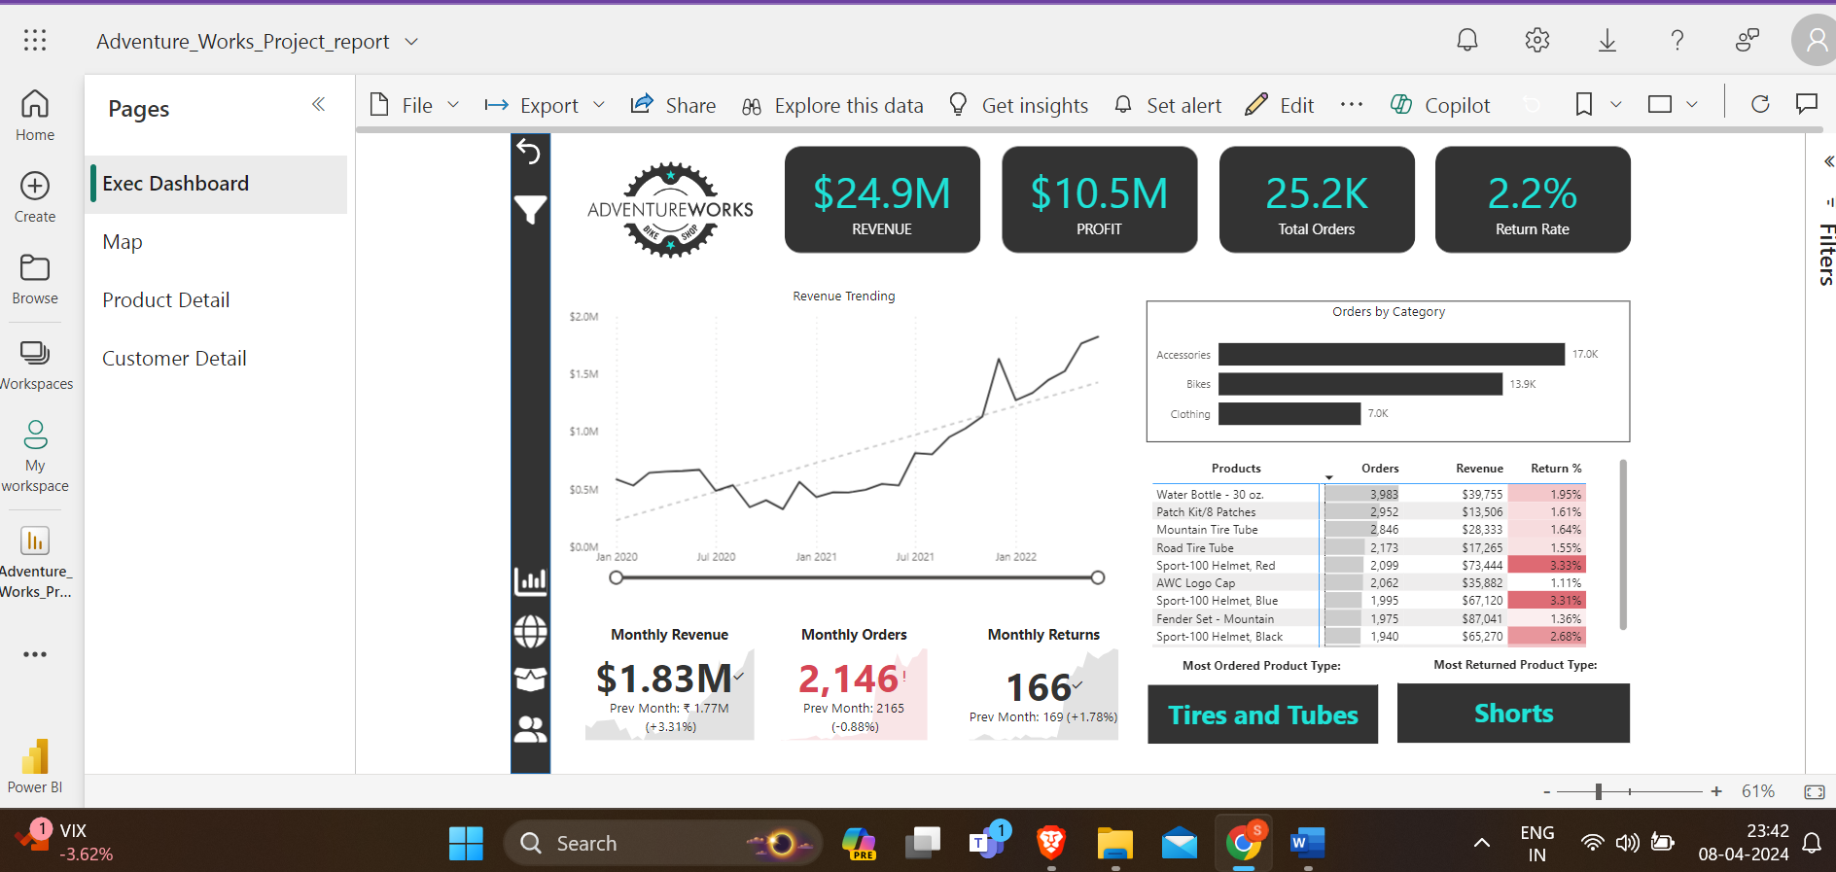

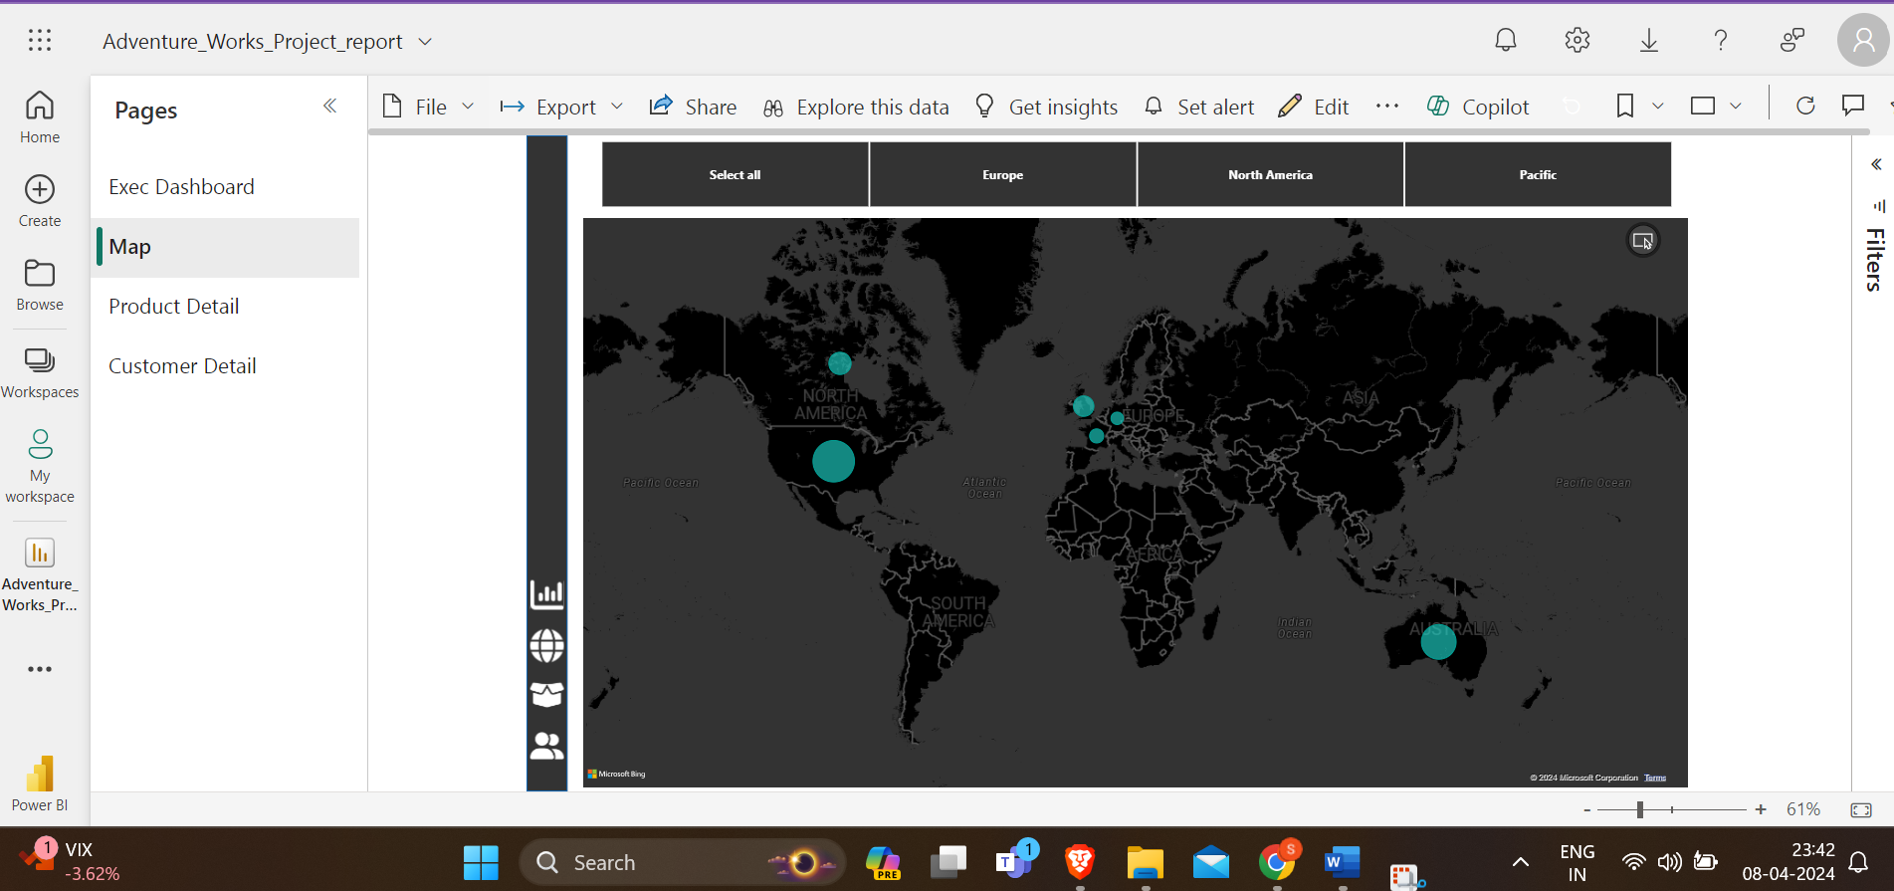

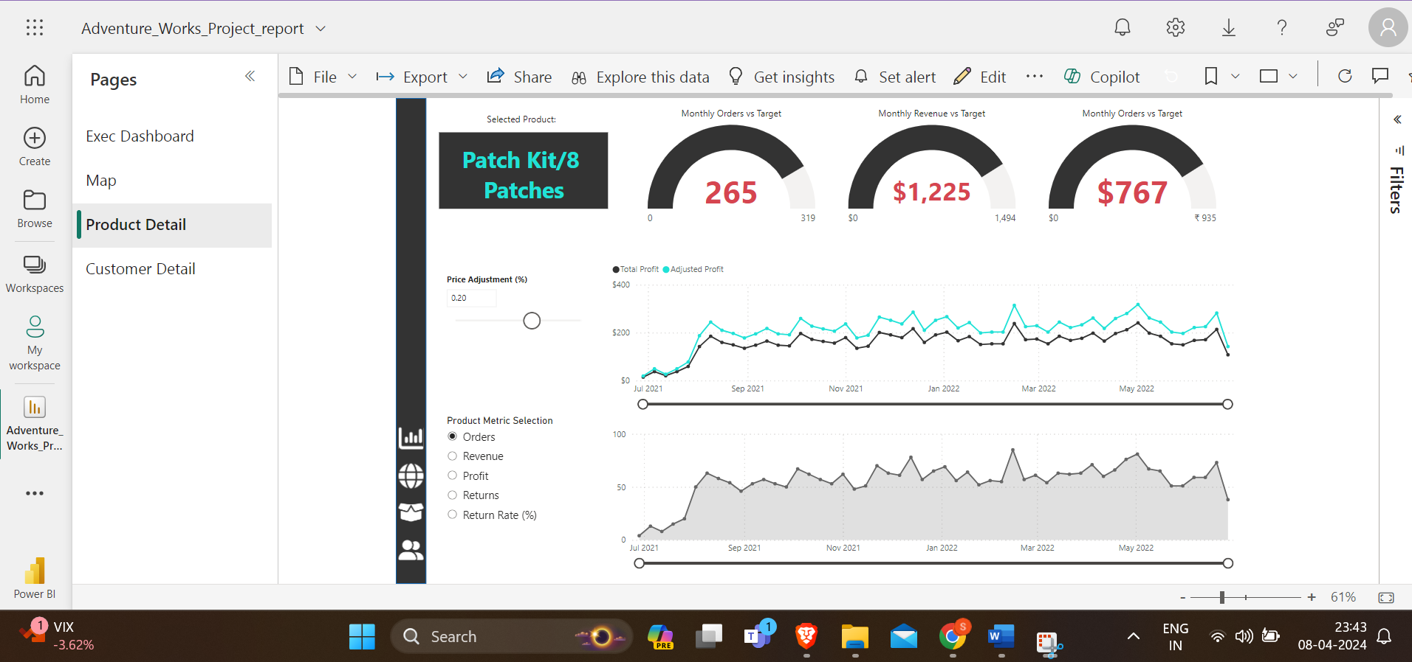

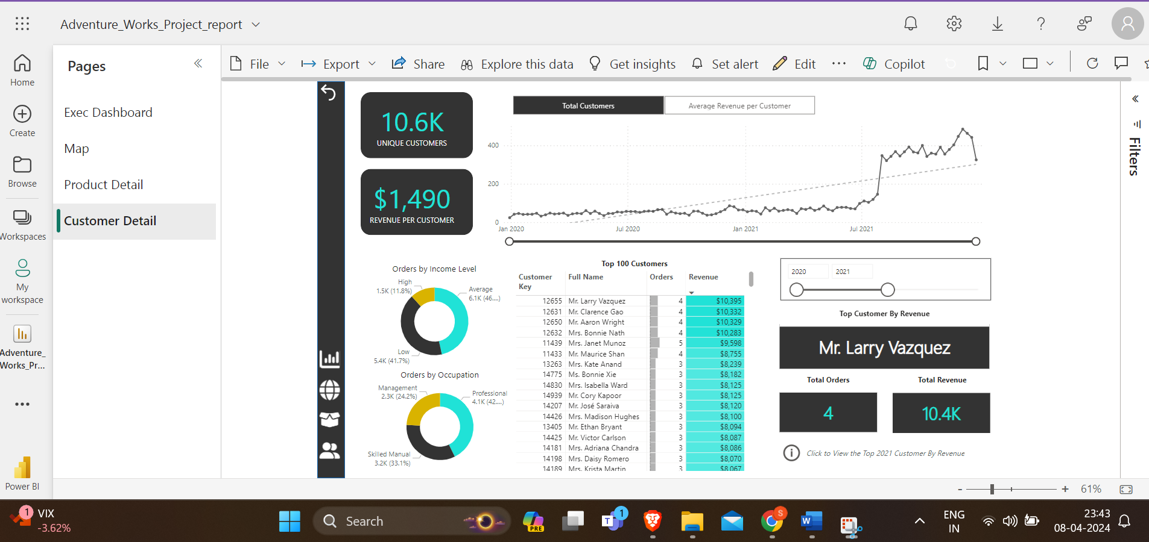

#DataAnalytics #BusinessIntelligence #DataVisualization #CareerGrowth #HappyLearning 🌟