Report on Optical Flow

# 1. Introduction

Optical Flow is a fundamental concept in computer vision used to estimate the motion of objects between consecutive frames of a video or a sequence of images. It describes the pattern of apparent motion of image objects caused by the relative movement between the observer and the scene. This report outlines the key principles, algorithms, and real-world applications of Optical Flow.

# 2. What is Optical Flow?

Optical Flow estimates the apparent motion of scene points by analyzing changes in pixel intensity across frames. It relies on the assumption that the brightness of a given pixel remains constant as it moves from one frame to the next. This assumption allows us to compute motion vectors, which represent the direction and magnitude of motion.

# MOTION FIELD:

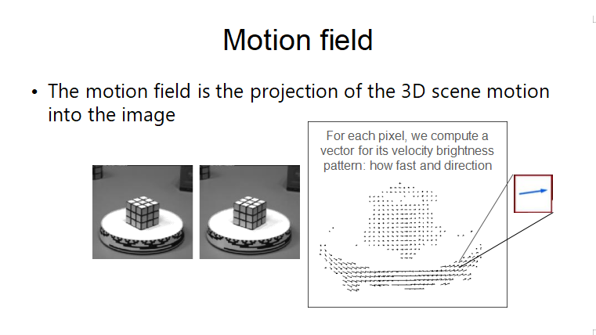

# 3. Core Concepts

a. Motion Field vs Optical Flow  
Motion Field: The actual movement of objects in the 3D world projected onto the 2D image plane.

Optical Flow: The observed motion based on changes in image intensities, which approximates the motion field.

b. Optical Flow Constraints  
Brightness Constancy: The pixel intensity of an object remains constant between consecutive frames.

Small Motion Assumption: Motion between frames is small and smooth enough to compute differential changes.

Aperture Problem: Motion direction can't be determined from a small region without context, leading to ambiguity in certain directions.

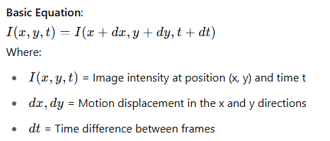

# 4. Optical Flow Methods

a. Sparse Optical Flow  
Tracks motion of selected feature points, typically corners or blobs.

Example: Lucas-Kanade Method – computes flow for a few key points by solving the optical flow constraint in a small neighborhood.

b. Dense Optical Flow  
Computes motion vectors for every pixel in the frame.

Example: Farneback Method – uses polynomial expansion to estimate flow across the entire image.

# 5. Lucas-Kanade Algorithm

Works under the assumption that flow is constant in a local neighborhood.

Uses the optical flow constraint equation and solves it using least-squares minimization.

Suitable for real-time applications and when tracking a limited number of keypoints.

# 6. Handling Large Motion

Standard optical flow techniques assume small movements, but real-world videos often include large object motion. Solutions include:

Coarse-to-Fine Estimation: Processes images at multiple resolutions (image pyramids).

Template Matching: Matches image patches across frames.

# Coarse to flow

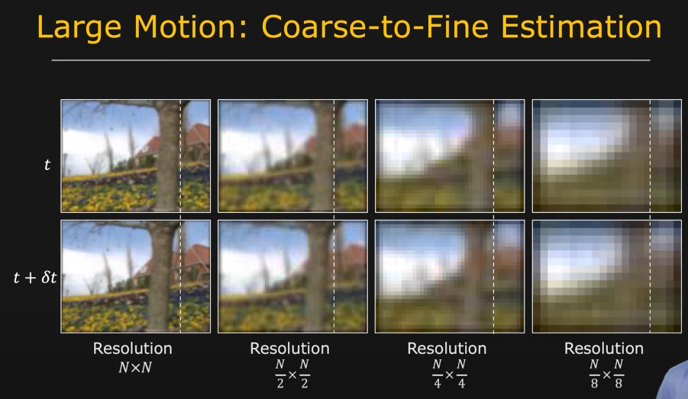

# Lucas-Kanade in ACTION

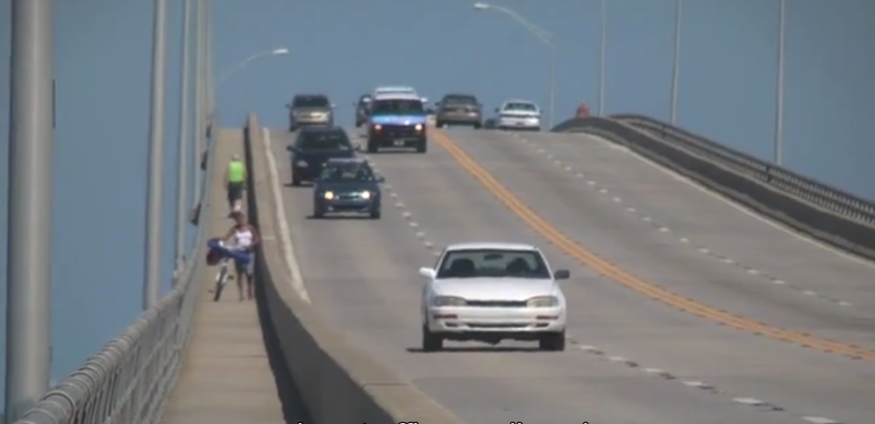

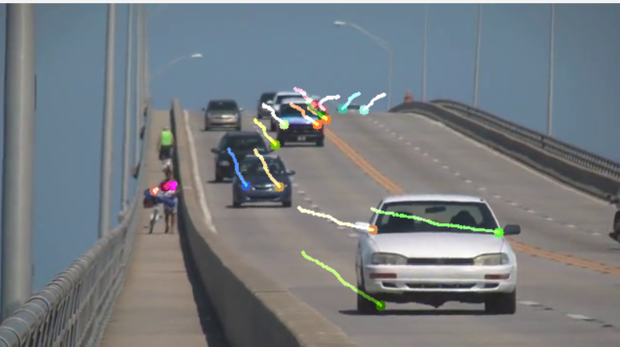

# 7. Real-World Applications

Optical Flow is used extensively across various domains:

Object Tracking: Track objects in video frames (e.g., people, vehicles).

Robot Navigation: Helps robots understand scene dynamics and avoid obstacles.

Video Compression: Reduces storage by predicting frame differences.

Medical Imaging: Monitors internal motion (e.g., organ movement).

Traffic Monitoring: Detects and analyzes vehicle flow.

Surveillance: Detects abnormal or suspicious motion patterns.

Sports Analysis: Tracks players and ball movement for performance analytics.

Augmented Reality (AR): Aligns virtual objects with real-world motion.

# 8. Summary

Optical Flow enables estimation of motion in videos by tracking pixel changes.

Two primary types: Sparse (Lucas-Kanade) and Dense (Farneback).

Widely used in AR, robotics, surveillance, medical imaging, and more.

Challenges include the aperture problem, large motion handling, and brightness variation.

# 9. References

Wikipedia: Barberpole Illusion

OpenCV documentation and tutorials.

By

MOUNEESWARAN S

2023510038

INFORMATION TECHNOLOGY

ANNA UNIVERSITY