Project Guide
Computer Networks explained through Graphics

By – M Mounika 160001036
Neha Nagendra 160001042

Walkthrough:
We have designed the computer networks model using Graphics tools naming a few: OpenGL, Devil library, GLUT.
Steps:
- Compile the code using g++ Code.cpp –lGL –lGLU –lglut –lIL –lILU
- ./a.out
- You would see a global view with 2 hosts (shown in red) communicating with each other via 2 intermediate routers (depicted in yellow). A packet is moving, going from host1 to host2.
- Keyboard controls:
  - F1: left movement of the camera.
  - F2: right movement of the camera.
  - F3: Zoom in the screen.
  - F4: Zoom out of the screen.
  - F5: Upward movement of the camera.
  - F6: Downward movement of the camera.
- Zoom in the at the host(Red Sphere)
- A new Screen appears where data is moving from one layer to another in a systematic manner. The data is sent to transport layer from application layer (shown as a postcard). The packet keeps moving downward and all layers attach the respective headers and finally packet gets dropped in a box, which represents LAN or any physical layer connection between two hosts. The box then moves and goes out of the screen as the host1’s job with that data finishes here.
- Zoom out to get the 1st screen back. Now zoom into any router (yellow sphere).
- A new screen showing working of the router appears. We can see that packets arrive at input ports and are routed to correct output ports by the switching fabric. The packets then go out. (Packets are shown in colorful packet format)
- Zoom out to get the global view.
Screenshots are attached below:
- The global view of internet:
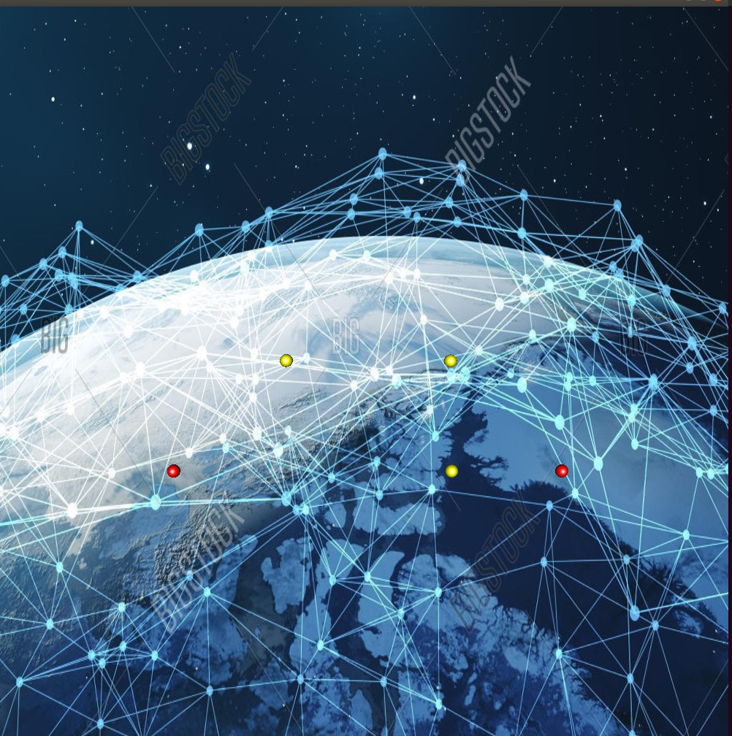
- The view of host system
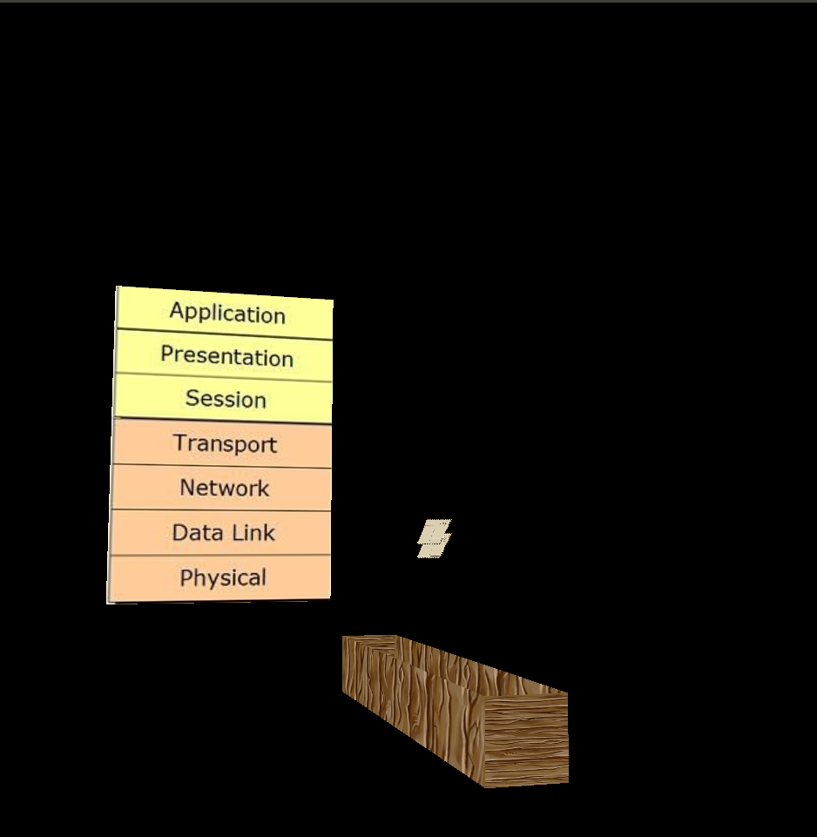
- View of the router:
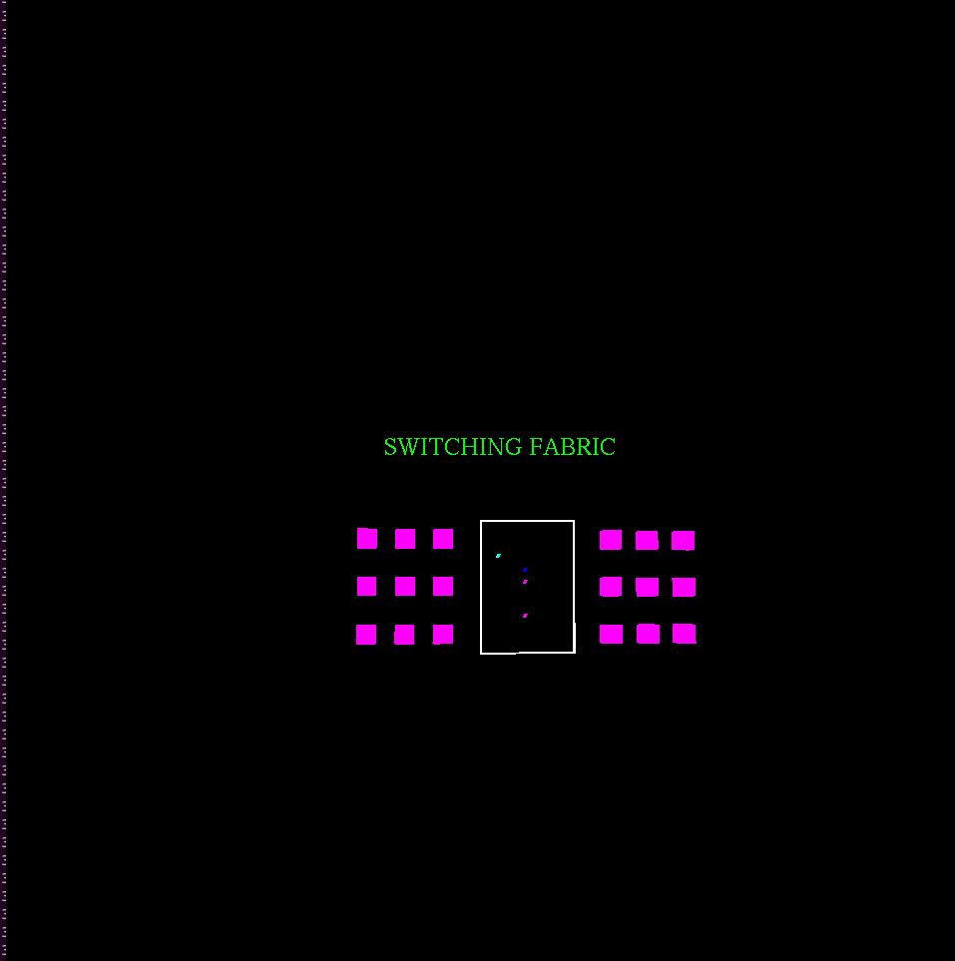

Implementation Details :

Textures : Images displayed are bought in by textures library called Devil.

Lighting and Shading: The Spheres in the global view show lighting effect and shading properties.

Camera Movement : The camera moves according to user keyboard controls.
3D viewing : The objects when rotated and translated show 3D properties.

Text : Displayed on Router

Color: All 3D Objects have colors

Geometric Transformations : 3D objects have transformations

KeyBoard Accesibility : The perspective can be rotated/transformed using keyboard functions (zoom in, zoom out, left, right, down, up)

Object Movements : the packets move from one host to another in a specific path.

Animation : The box and the packets have been animated/

