JAVASCRIPT:
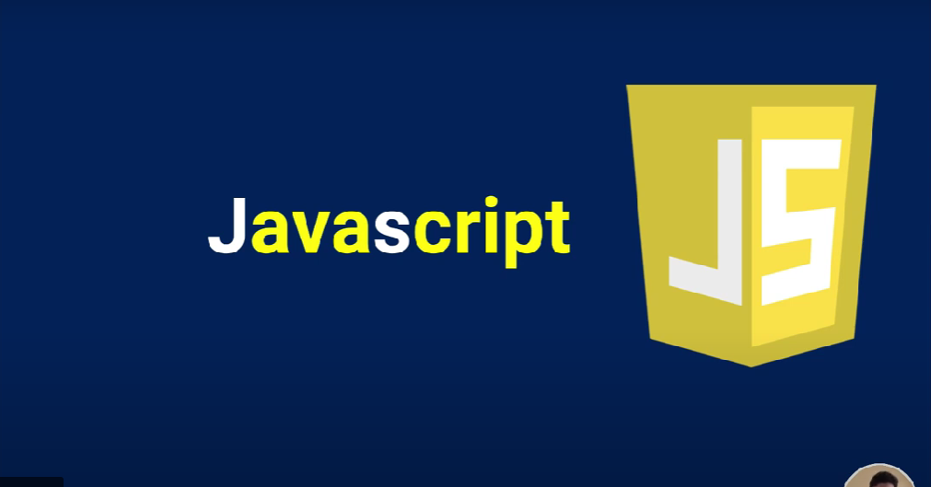
HTML CSS JAVASCRIPT Differnces
- HTML is used to build the basic structure of the web page.
- CSS is used to paint(design) that structure.
- JavaScript adds the behaviour to a web page.

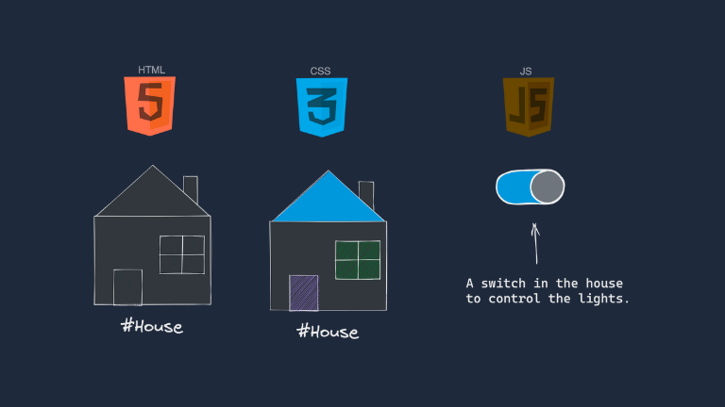

EX:
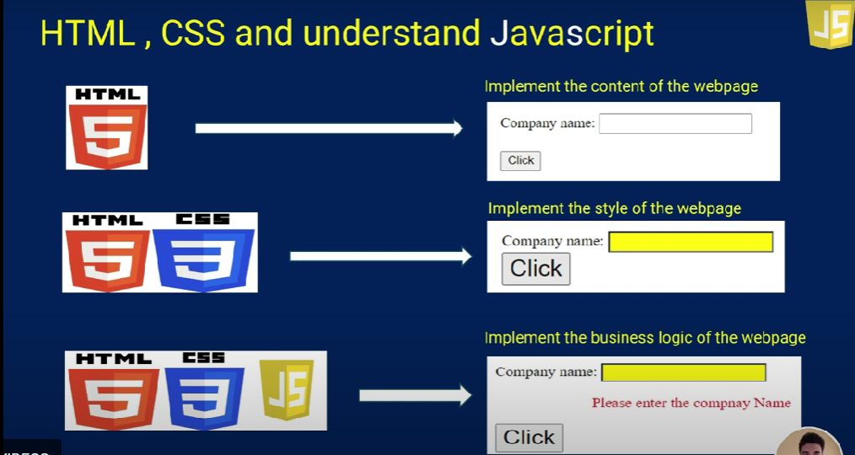
JAVASCRIPT:
JavaScript is a versatile, dynamically typed programming language used for interactive web applications, supporting both client-side and server-side development, and integrating seamlessly with HTML, CSS, and a rich standard library.
- JavaScript is a single-threaded language that executes one task at a time.
- It is an Interpreted language which means it executes the code line by line.
- The data type of the variable is decided at run-time in JavaScript that’s why it is called dynamically typed.
OR
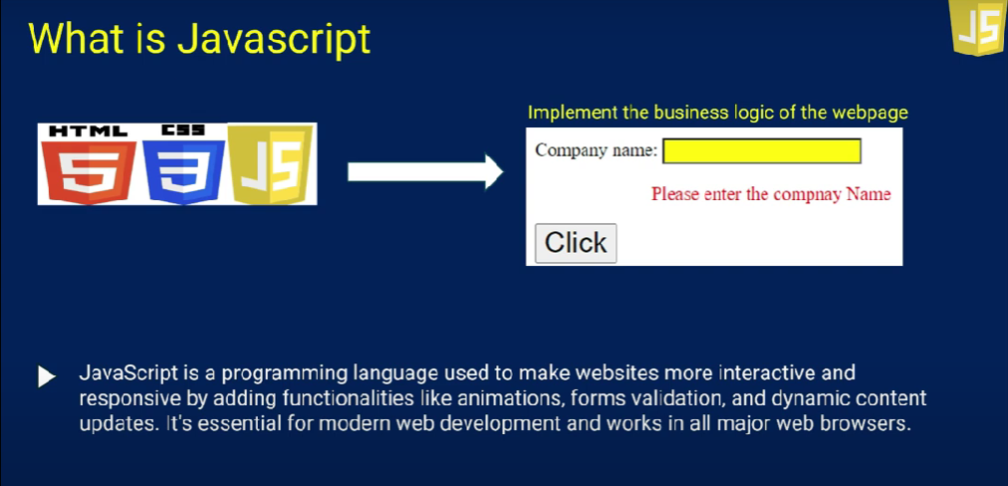
Key Features / Uses of Javascript
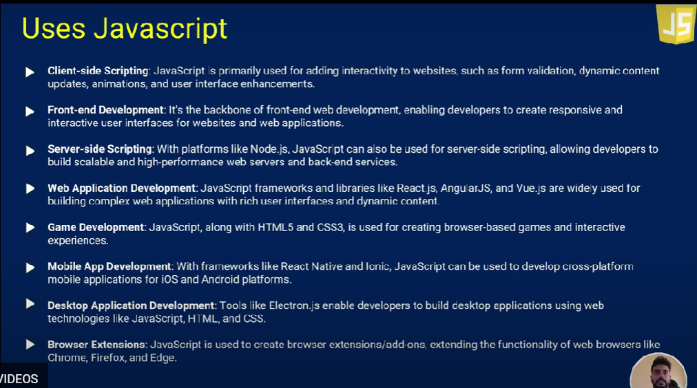

How to Add JavaScript in HTML Document?
Internal JavaScript (Within <script> Tag)
You can write JavaScript code inside the <script> tag within the HTML file. This is known as internal JavaScript and is commonly placed inside the <head> or <body> section of the HTML document.
<!DOCTYPE html>
<html>
<head>
<body>
<h1>Javascript</h1>
<script>console.log(10);</script>
</body>
</head>
</html>
Output:
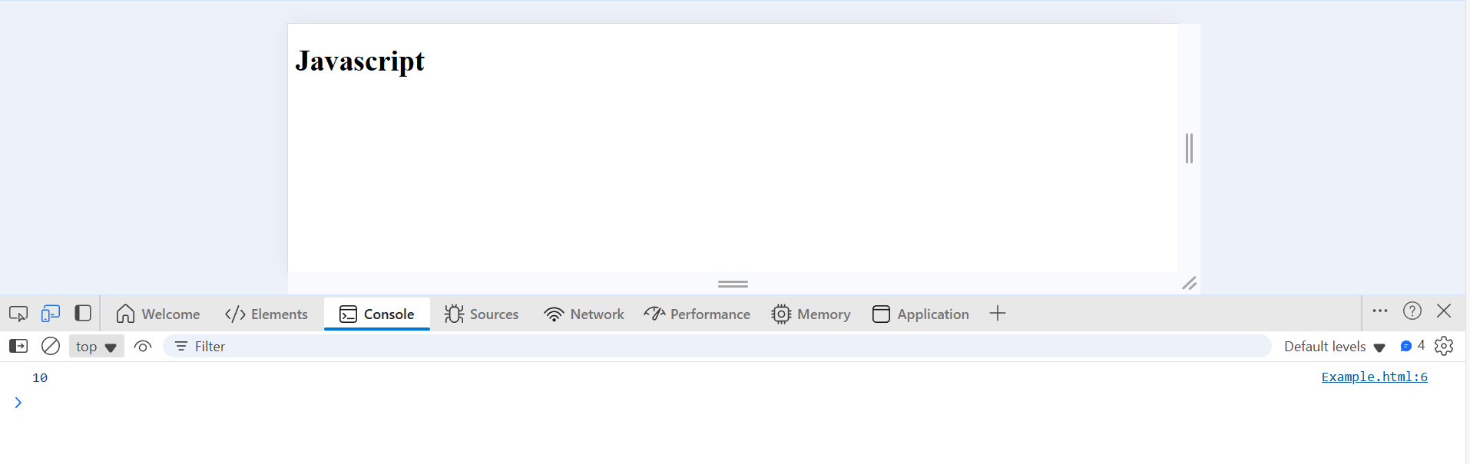

External JavaScript (Using External File)
For larger projects or when reusing scripts across multiple HTML files, you can place your JavaScript code in an external .js file. This file is then linked to your HTML document using the src attribute within a <script> tag.
First create a .js file and integrate in HMTL file with using script tag, let me explain below

.js file
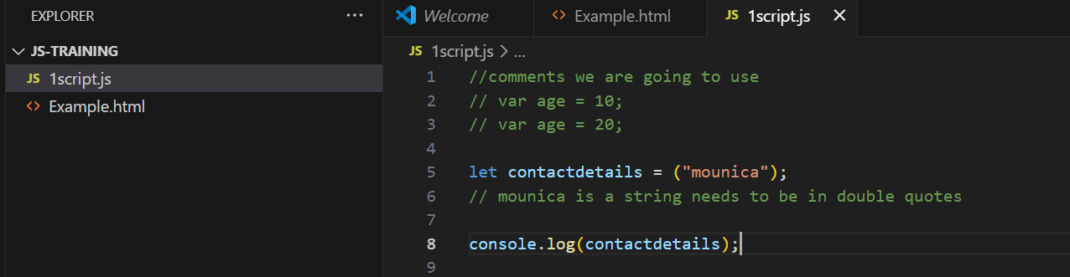

Separate .js file link with HTML file.
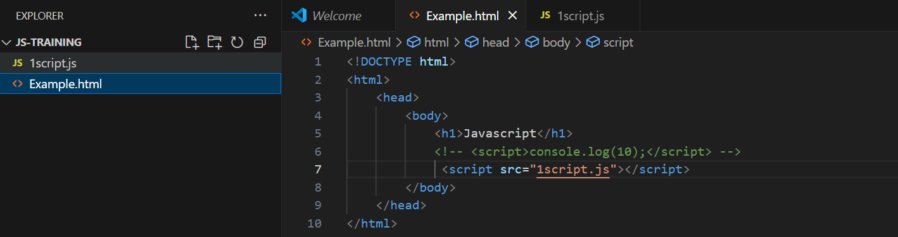
Output:
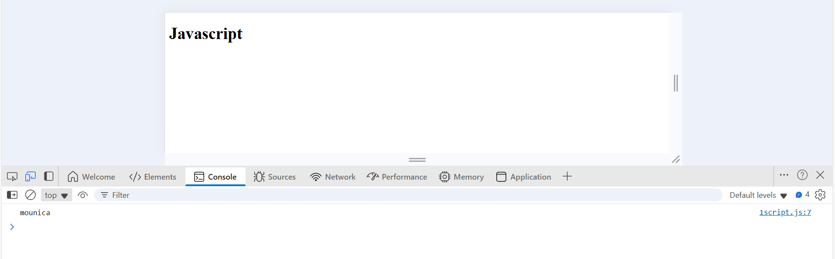

CONSOLE:
The console is a panel that displays important messages, like errors, for developers. Much of the work on the computer does with our code is invisible to us by default. If we want to see things appear on our screen, we can print, or log, to our console directly.
In JavaScript, the console keyword refers to an object, a collection of data and actions, that we can use in our code. Keywords are words that are built into the JavaScript language, so the computer recognizes them and treats them specially.
One action, or method, that is built into the console object is the .log() method. When we write console.log() what we put inside the parentheses will get printed, or logged, to the console.
It’s going to be very useful for us to print values to the console, so we can see the work that we’re doing.
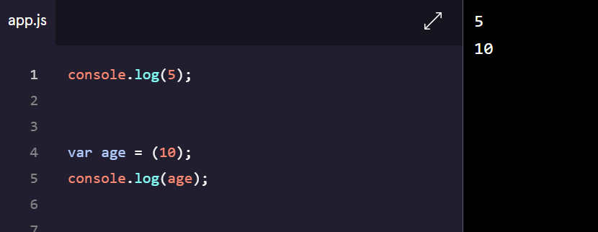

Comments:
Programming is often highly collaborative. In addition, our own code can quickly become difficult to understand when we return to it— sometimes only an hour later! For these reasons, it’s often useful to leave notes in our code for other developers or ourselves.
As we write JavaScript, we can write comments in our code that the computer will ignore as our program runs. These comments exist just for human readers.
Comments can explain what the code is doing, leave instructions for developers using the code, or add any other useful annotations.
There are two types of code comments in JavaScript:
- A single line comment will comment out a single line and is denoted with two forward slashes // preceding it.
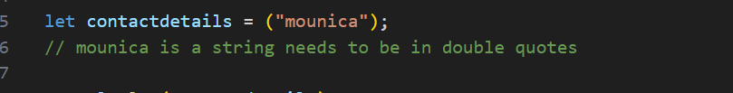

You can also use a single line comment to comment after a line of code:
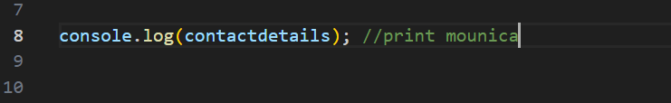

- A multi-line comment will comment out multiple lines and is denoted with /* to begin the comment, and */ to end the comment.

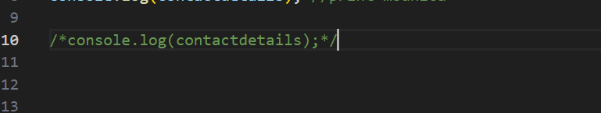

Datatypes:
A Datatype is a classification of data that determine the type of value that can be performed. There are two types of datatypes
1.Primitive datatypes
2.Non-Primitive datatypes

Primitive Datatypes:
Primitive datatypes represent single values and are immutable. Its meaning it cannot be changes once created.
- Number: Represents numeric values (integers and decimals).
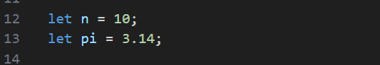
OR
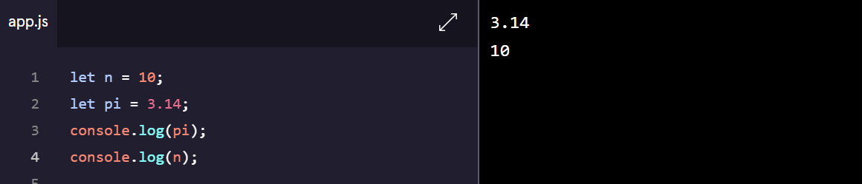

- String: Represents text enclosed in single or double quotes.
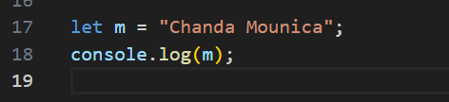
OR
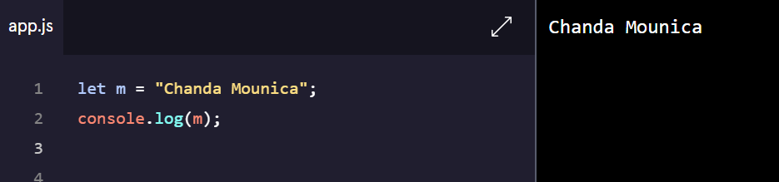

- Boolean: Represents a logical value (true or false).
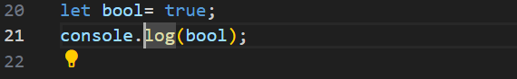
OR
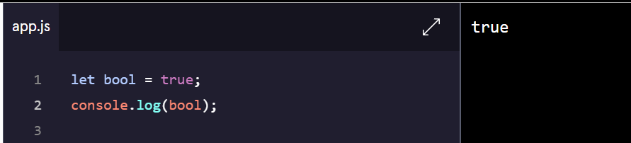

- Undefined: A variable that has been declared but not assigned a value.
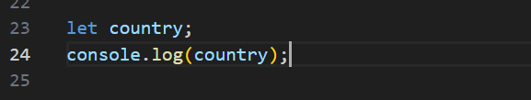
OR
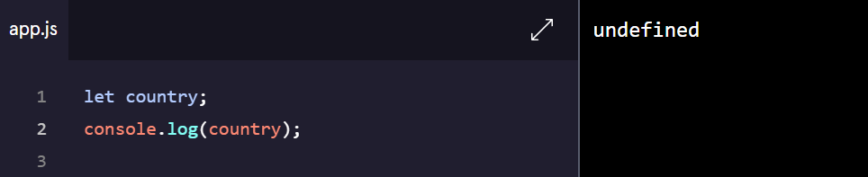

- Null: Represents an intentional absence of any value.
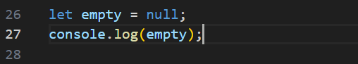
OR

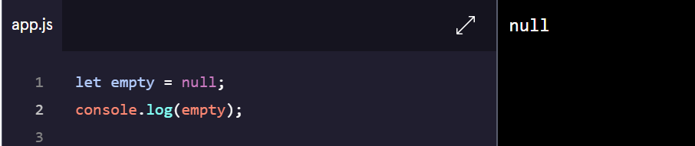

- Symbol: Represents unique and immutable values, often used as object keys
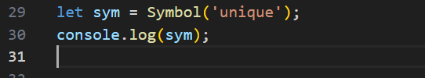

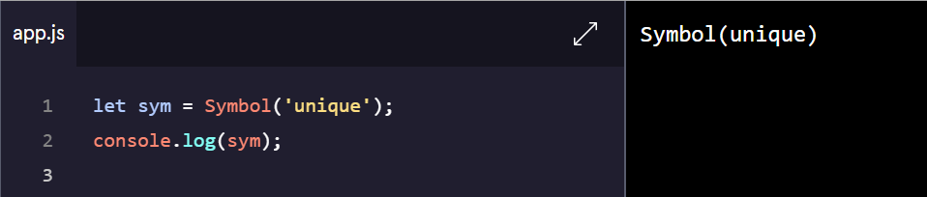

Non-Primitive Datatypes:
Non-primitive types are objects and can store collections of data or more complex entities.
- Object: Represents key-value pairs.

- Array: Represents an ordered list of values.
- Function: Represents reusable blocks of code.

.

Variables:
A variable is like a container that holds data that can be reused or updated later in the program. In JavaScript, variables are declared using the keywords var, let, or const.
- Var – we can redeclare and reassigned
- Let – we can reassigned but can’t redeclared let keyword
- Const – we cannot reassigned and redeclared
1. var Keyword
The var keyword is used to declare a variable. It has a function-scoped or globally-scoped behaviour. It can be reassigned and redeclared.
var age = 10;
var age = 20;
here, redeclared the var keyword and reassigned the age value.
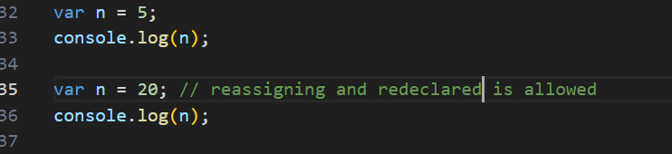
OR
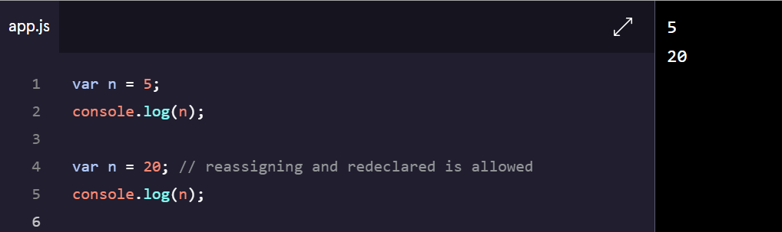

2. let Keyword
The let keyword is introduced in ES6, has block scope and cannot be re-declared in the same scope.(let keyword can be reassigned and cannot be redeclared )
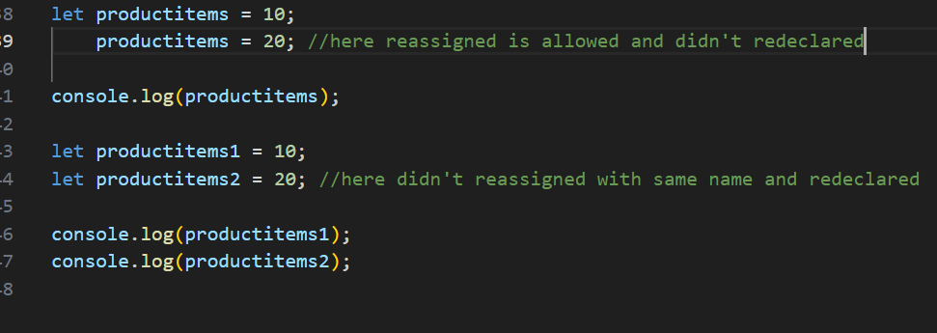
OR
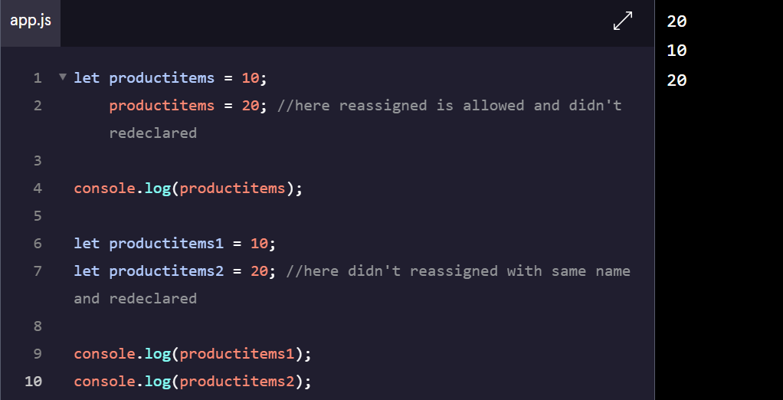
3. const Keyword
The const keyword declares variables that cannot be reassigned. It’s block-scoped as well.
(It cannot be reassigned and redeclared, it’s a constant variable)
