**PROGRAM-1.1: Demonstrating heading tags with html**

<html>

<head>

<title> my html</title>

</head>

<body>

<h1> Hello World</h1>

<h2> Hello World</h2>

<h3> Hello World</h3>

<h4> Hello World</h4>

<h5> Hello World</h5>

<h6> Hello World</h6>

</body>

</html>

**OUTPUT:**

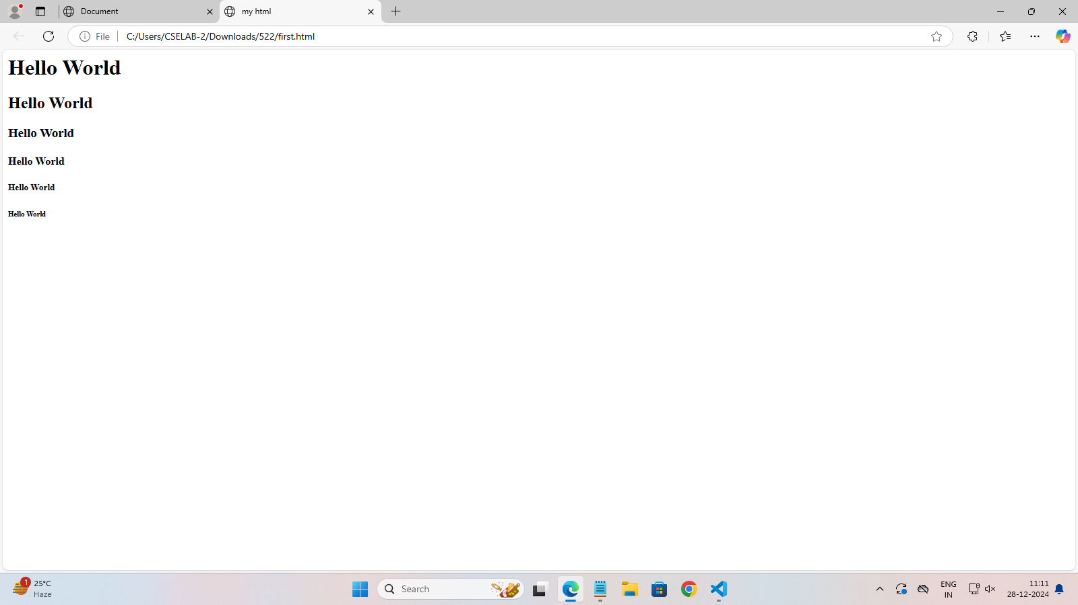

**Program -1.2: Demonstarting <hr> tag with html**

<html>

<head>

<title> my html</title>

</head>

<body>

<h1><hr> Hello World</hr></h1>

<h2><hr> Hello World</hr></h2>

<h3><hr> Hello World</hr></h3>

<h4><hr> Hello World</hr></h4>

<h5><hr> Hello World</hr></h5>

<h6><hr> Hello World</hr></h6>

</body>

</html>

**OUTPUT:**

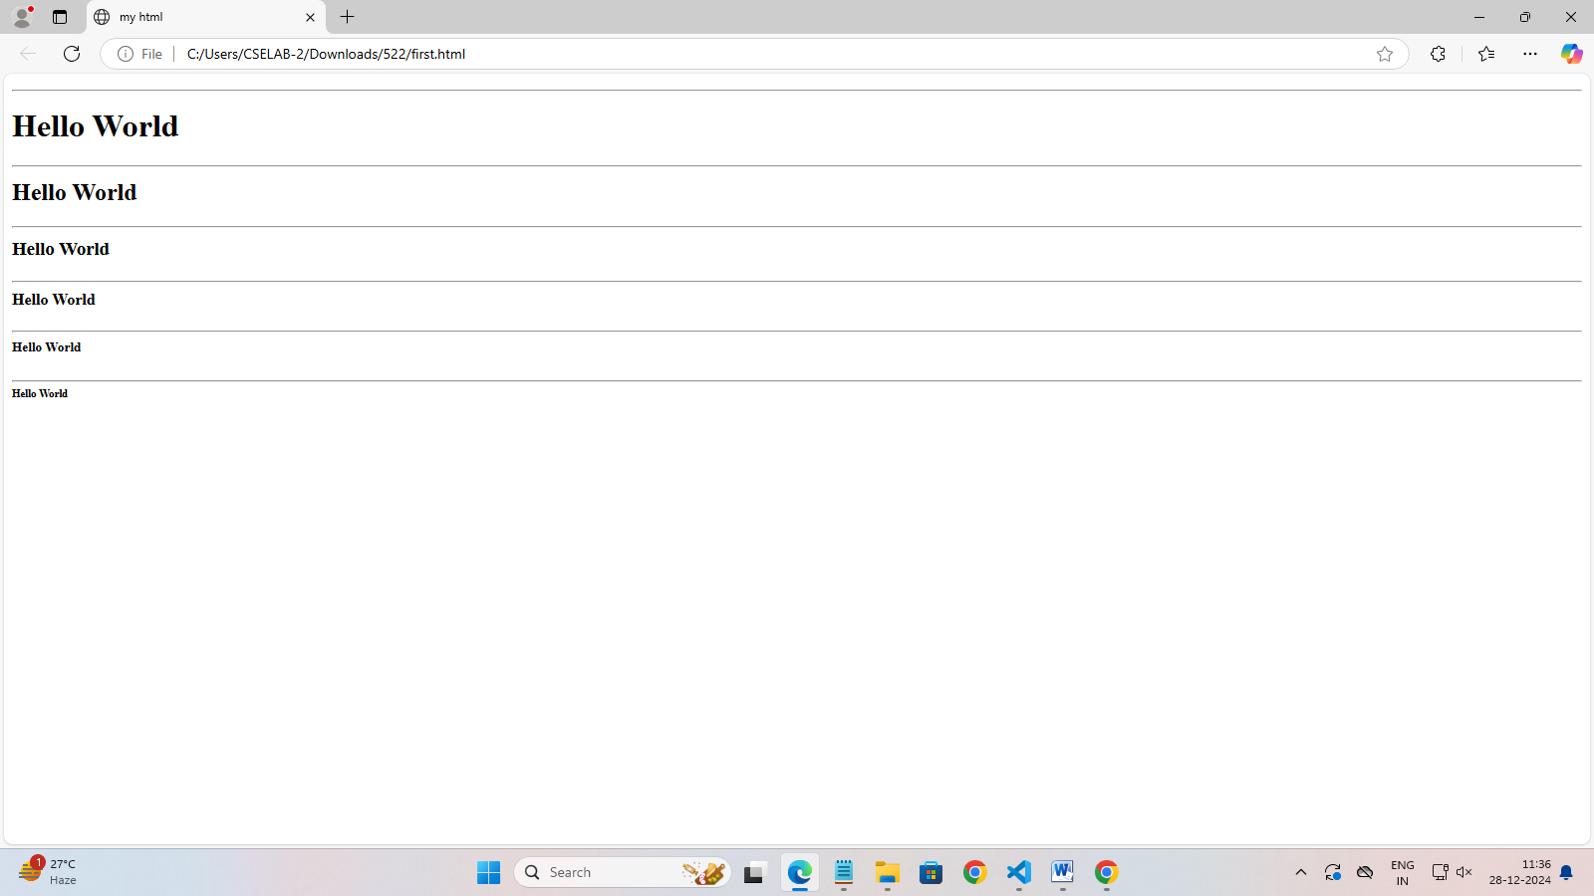

**PROGRAM-1.3: Demonstarting align attribute with html**

<html>

<head>

<title> my html</title>

</head>

<body>

<h1 align ="center"> Hello World </h1>

<h2 align="left" >Hello World </h2>

<h3 align="center" >Hello World</h3>

<h4 align="right" >Hello World </h4>

<h5 align="center"> Hello World </h5>

<h6 align="left" >Hello World </h6>

</body>

</html**>**

**OUTPUT:**

