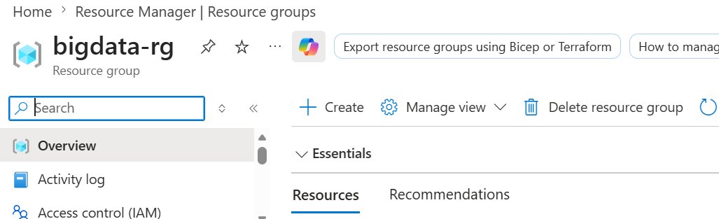
Figure 1: creation of resource group via azure cli bash command
az group create --name "bigdata-rg" --location "switzerlandnorth"

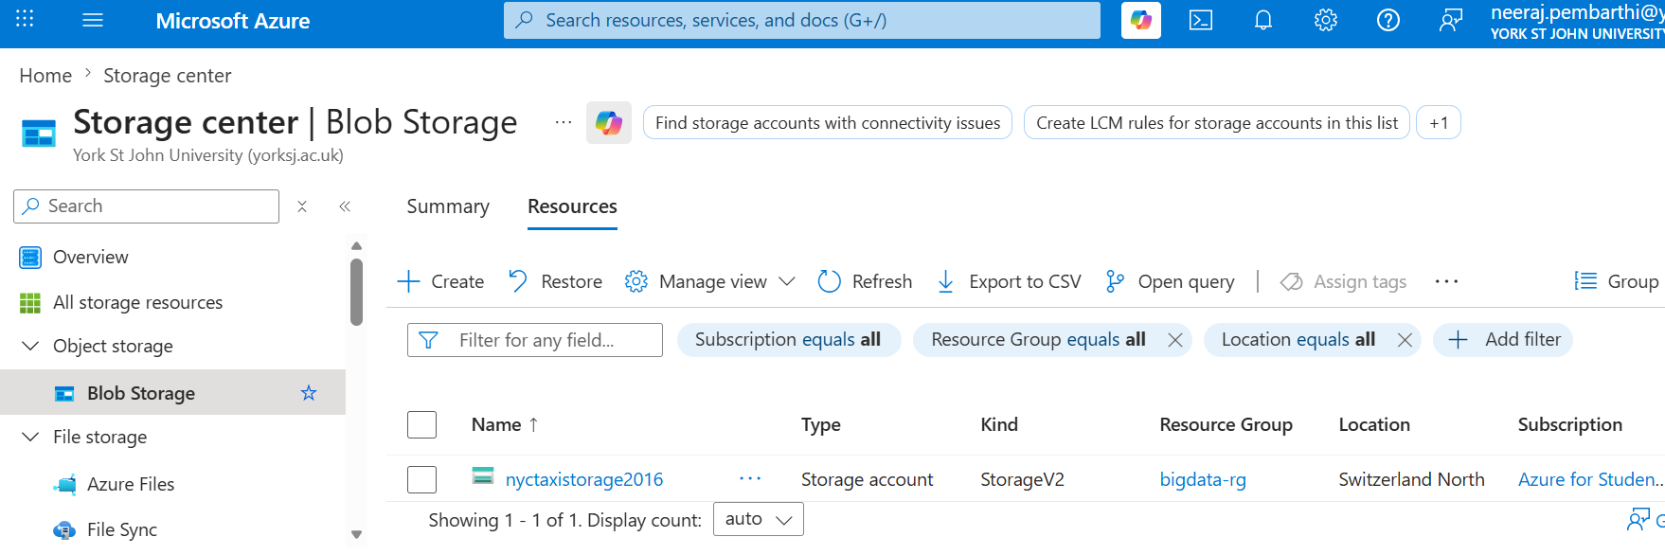
Figure 2: successful creation of nyctaxistorage2016 in storage account
Using cli
az storage account create \
--name "nyctaxistorage2016 " \
--resource-group "bigdata-rg" \
--location "switzerlandnorth" \
--sku Standard_ZRS \
--kind StorageV2 \
--enable-hierarchical-namespace true \
--tags "project=nyc-taxi" "semester=spring2026"
Security Key of Storage Account
DbaupmdKSkHNS8U3fI2FhqiVo4HFh1ih4PBuGSPJD19qqt3vB9z9aLOYdaiPWPaGESJ+EefcH/OK+AStEmdQNA==
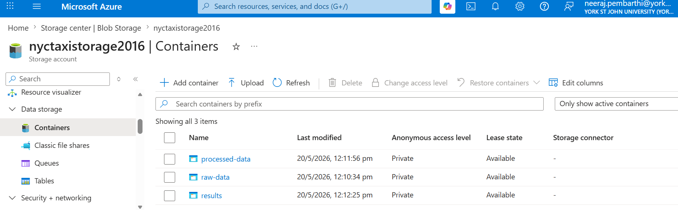
Figure 3: creation of required storage containers in nyctaxistorage2016 blob storage
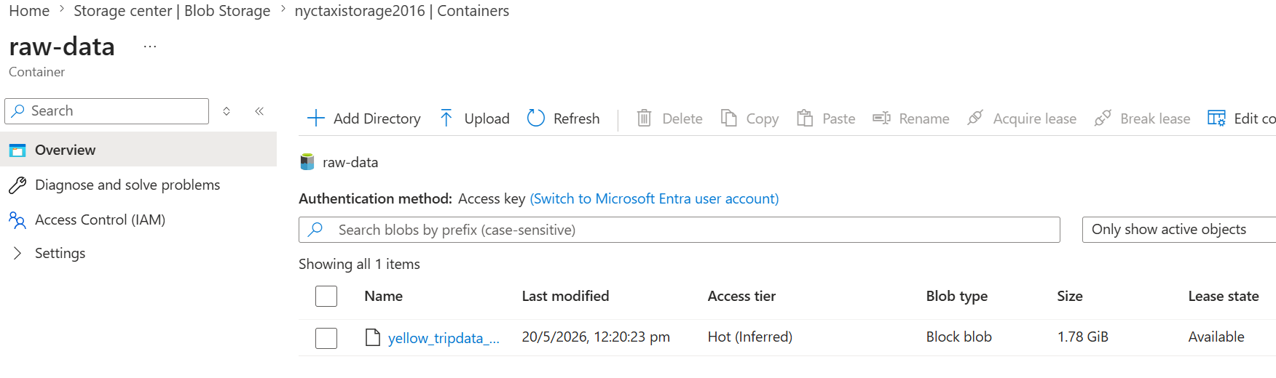
Figure 4: Successful upload of csv file in raw-data container
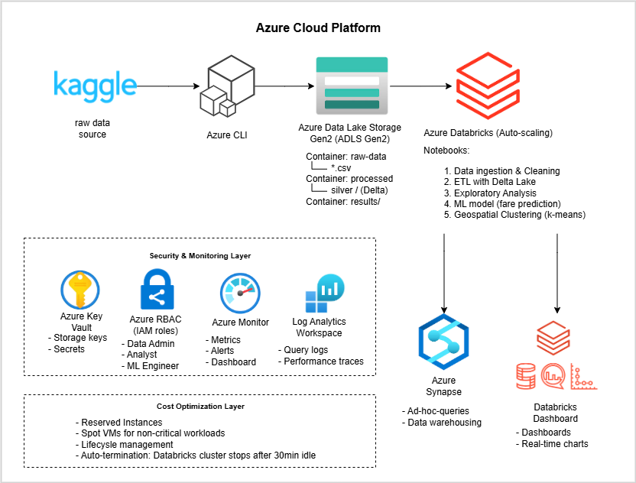
Figure 5: Scalable Big Data Processing Architecture on Azure for NYC Taxi Trip Analysis
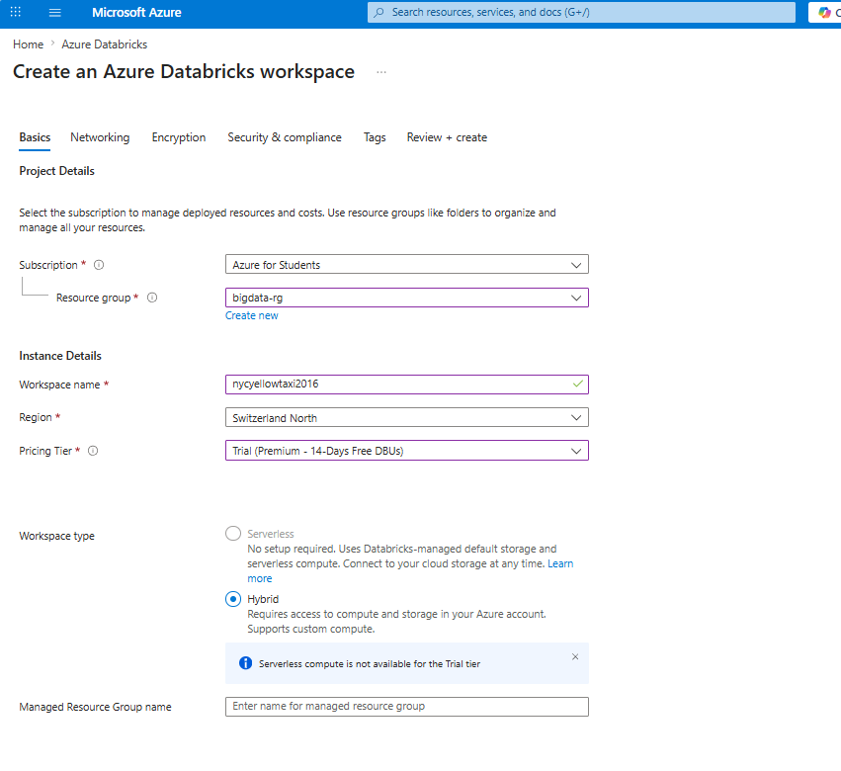
Figure 6: Creation of Databrick workspace
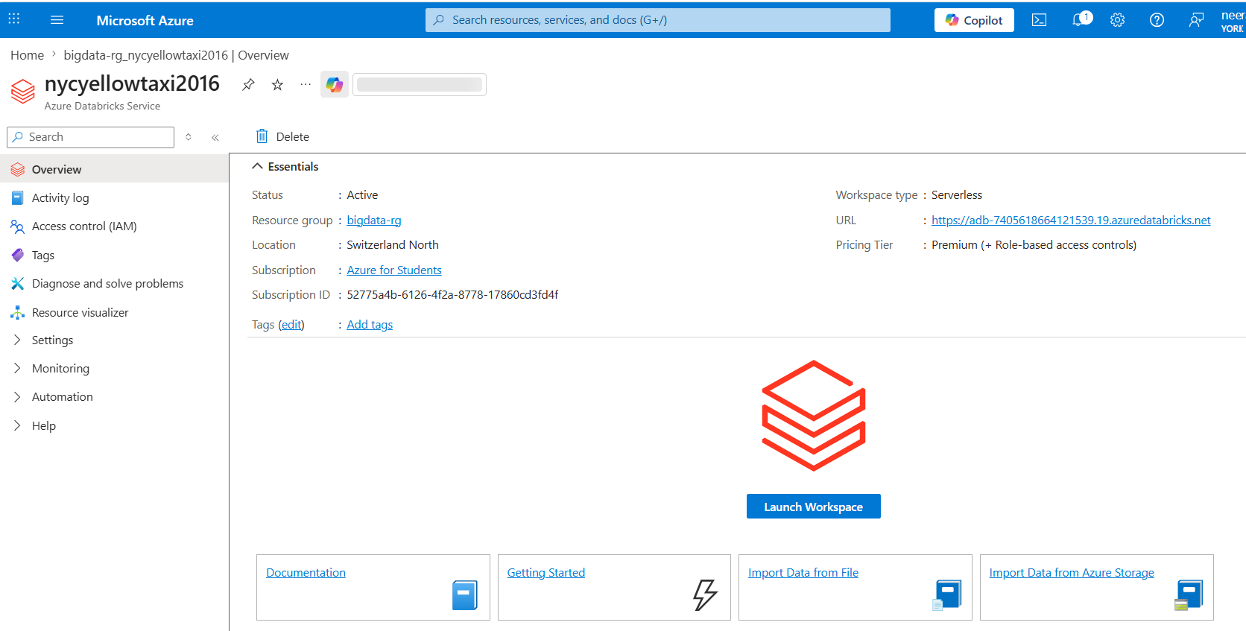
Figure 7:Deployment of Databricks Workspace
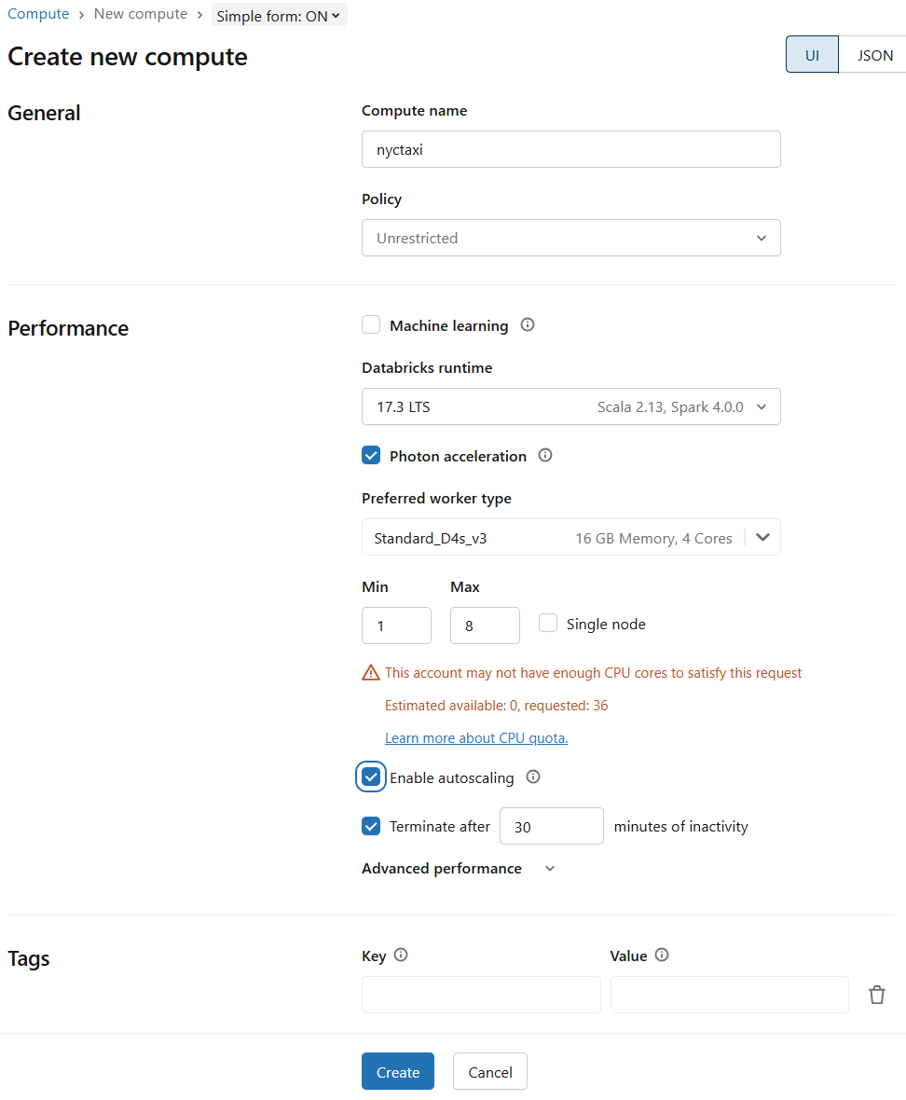
Figure 8: Databricks cluster configuration with auto-scaling enabled (min 1, max 8 workers).
Single-node mode is disabled to allow distributed processing for the 1GB NYC taxi dataset

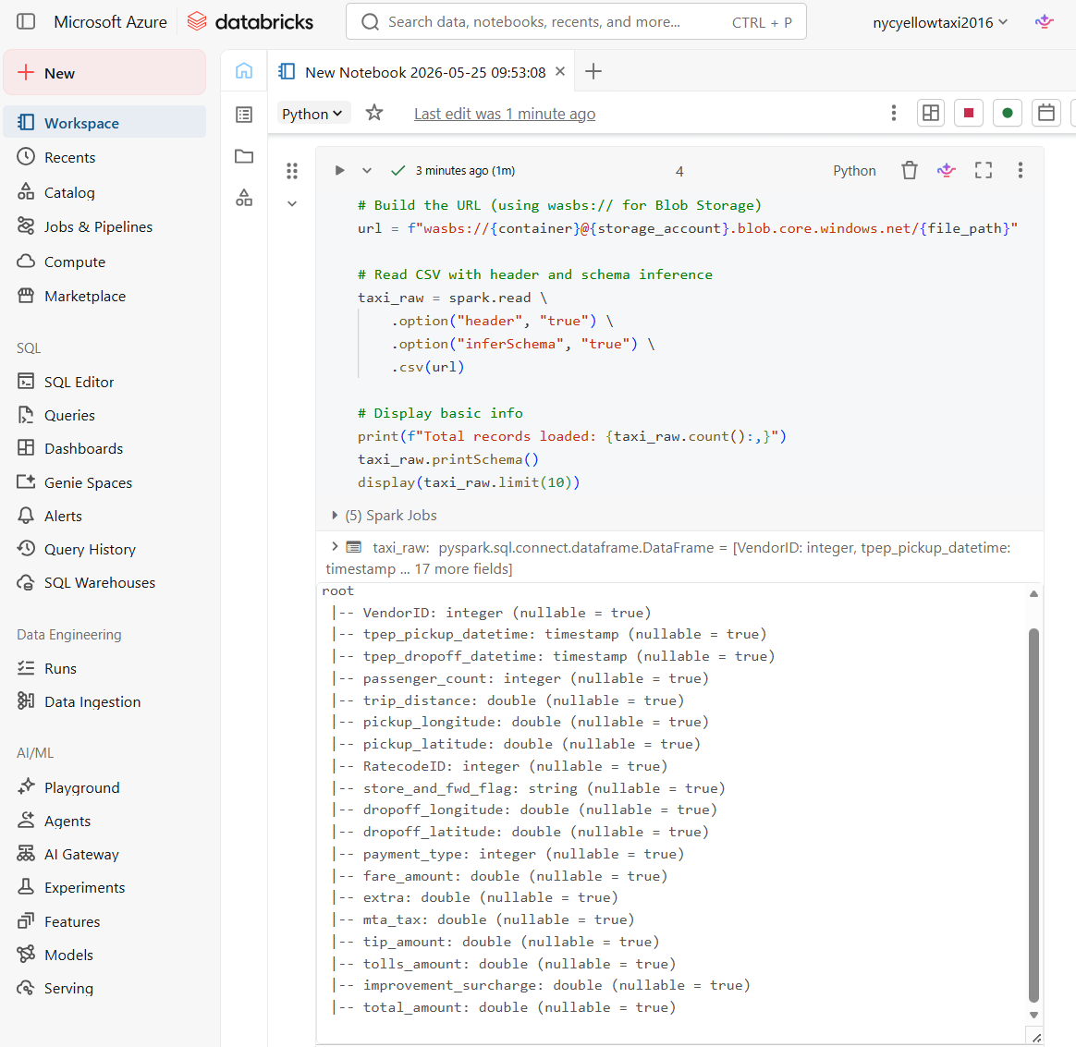
Figure 9: showing output of taxi_raw.printSchema() to prove data extraction
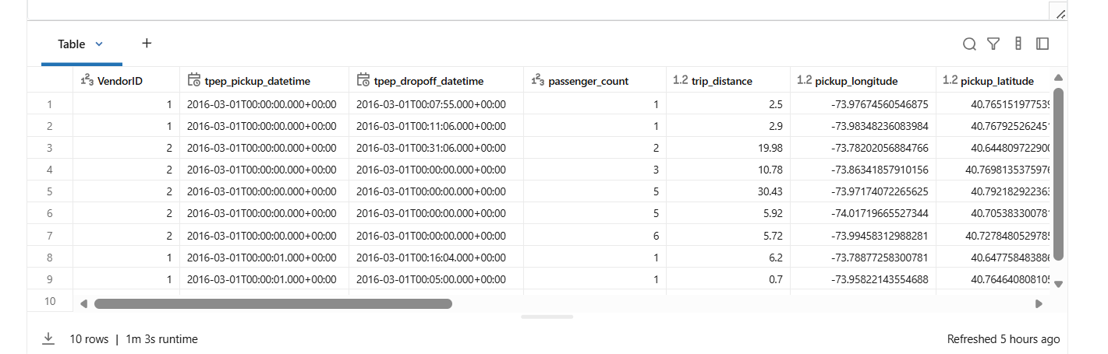
Figure 10: displaying first 10 raw data

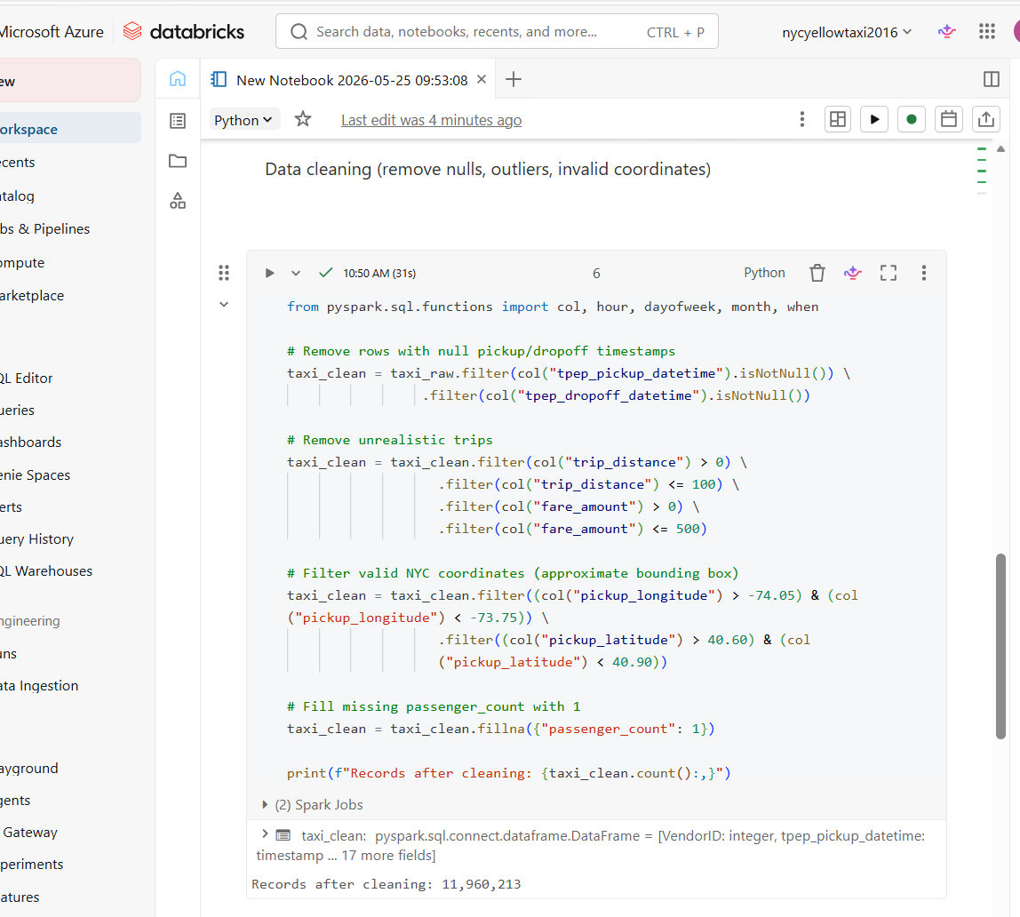
Figure 11: records after preforming data cleaning such as removal of nulls, outliers, invalid coordinates
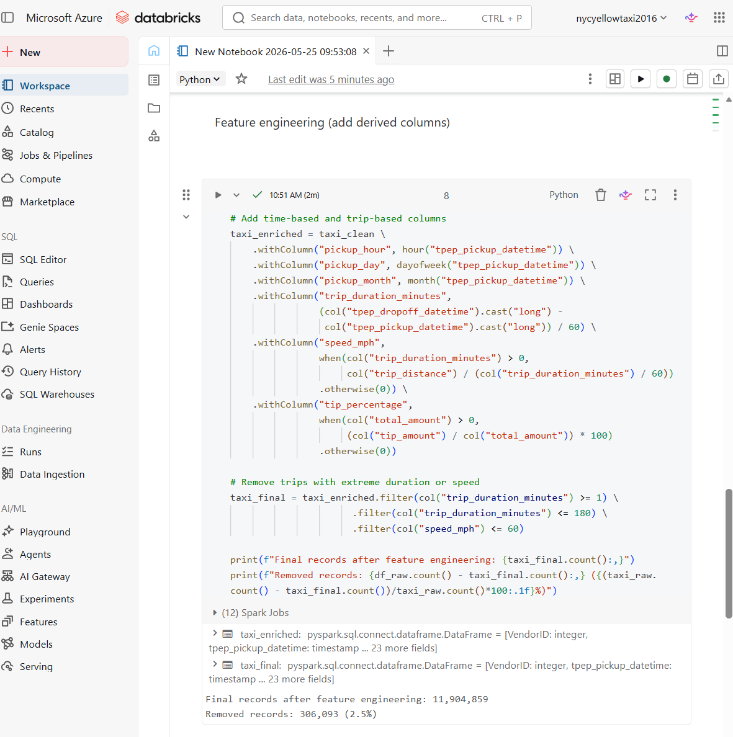
Figure 12: performance of feature engineering in notebook
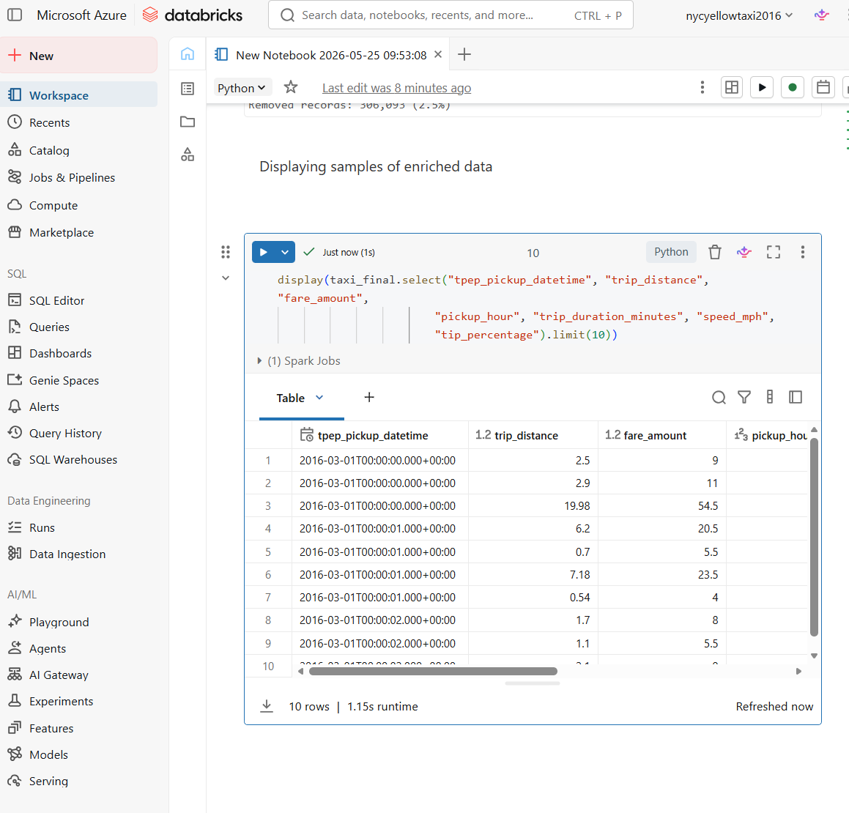
Figure 13: displaying samples of enriched data
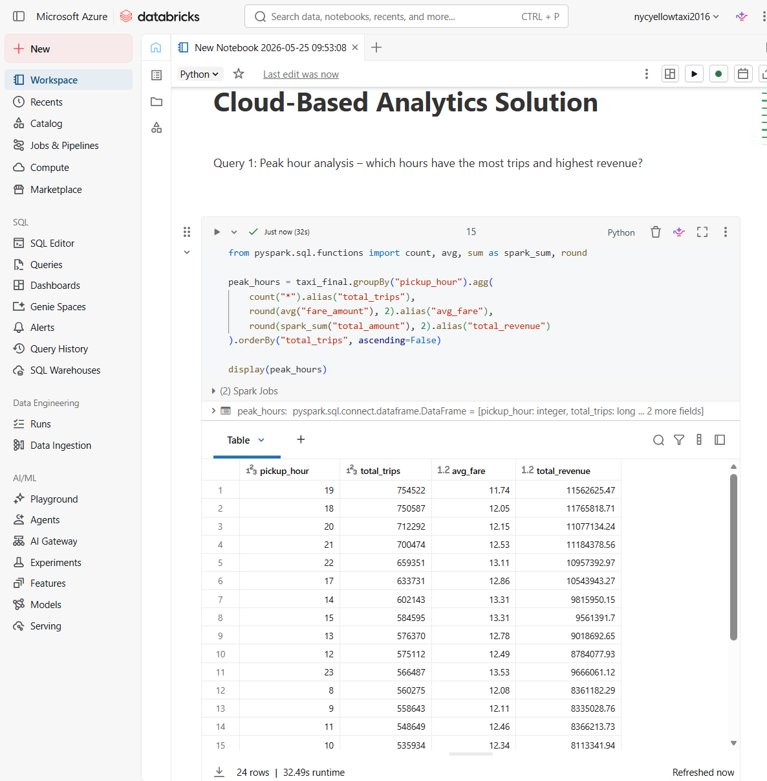
Figure 14: output of query1: peak hour analysis - which hours have the most trips and highest revenue?
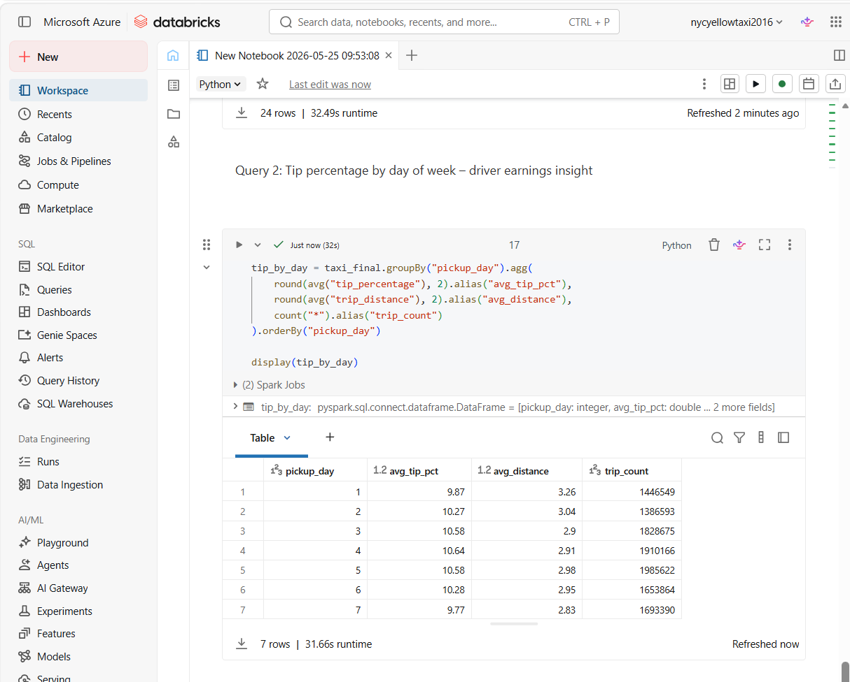
Figure 15: output of query2: tip percentage by day of week - driver earnings insight

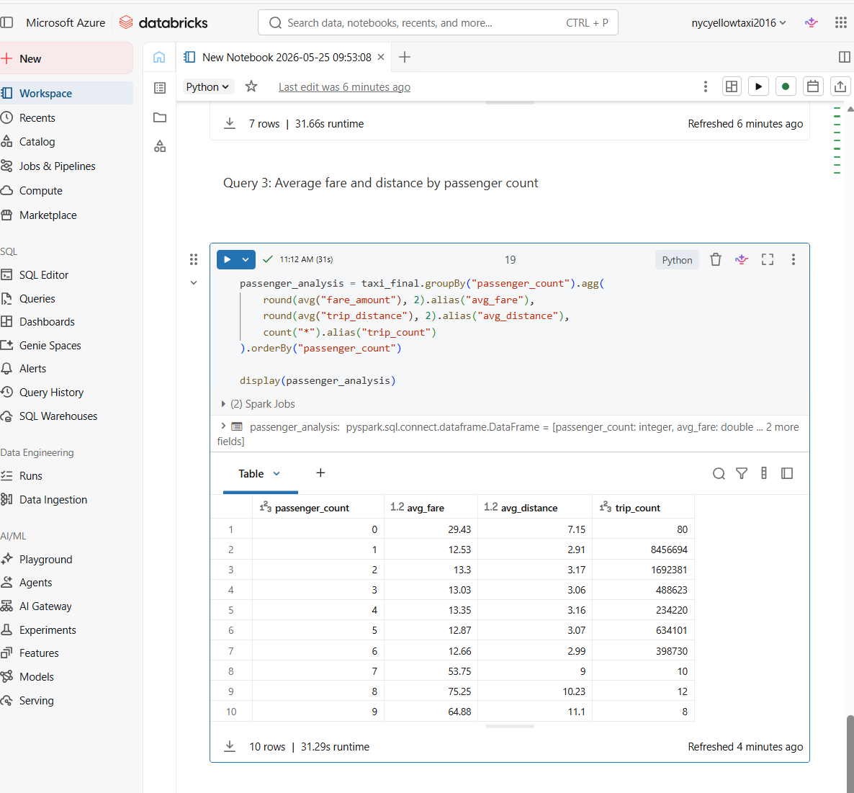
Figure 16: output of query3: average fare and distance by passenger count
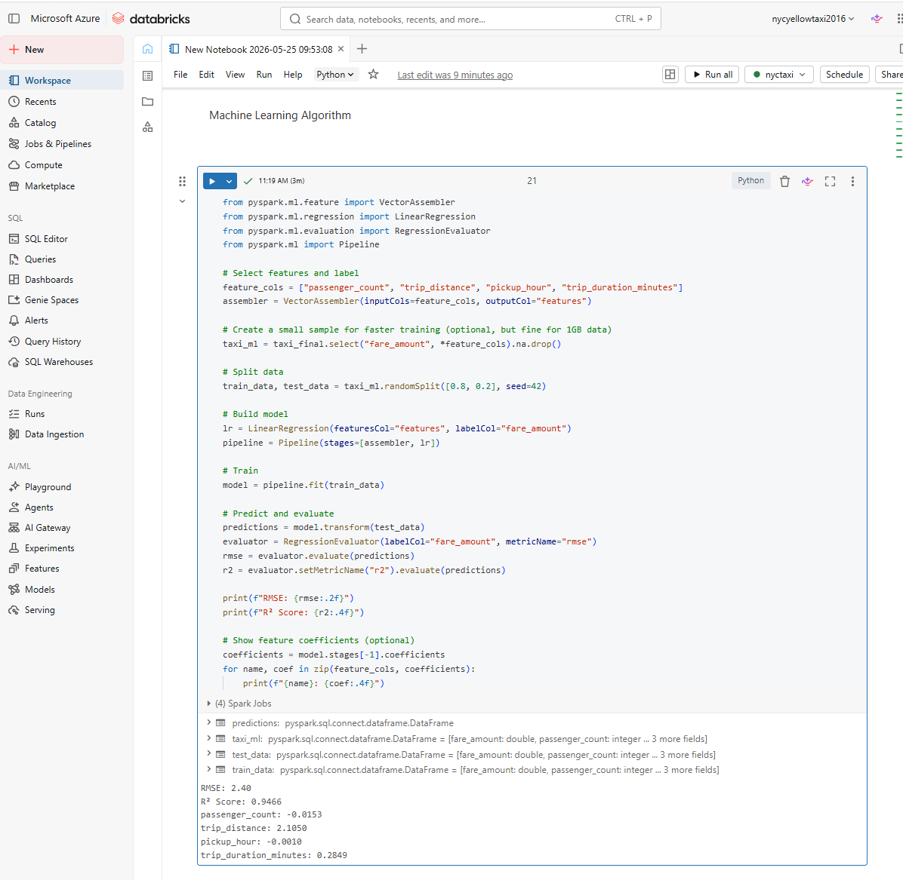
Figure 17: Machine Learning algorithm using Linear Regression
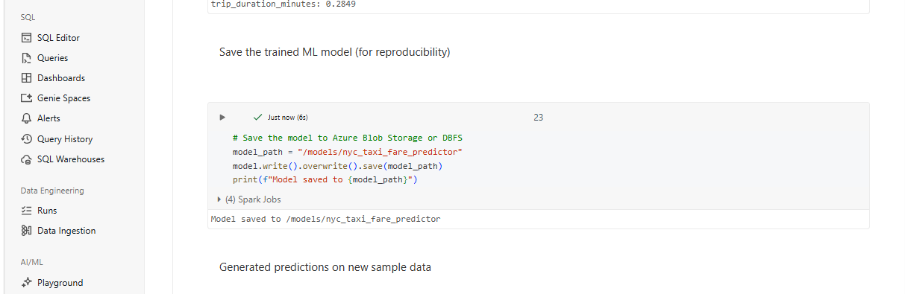
Figure 18: saving the generated model for future reproducibility
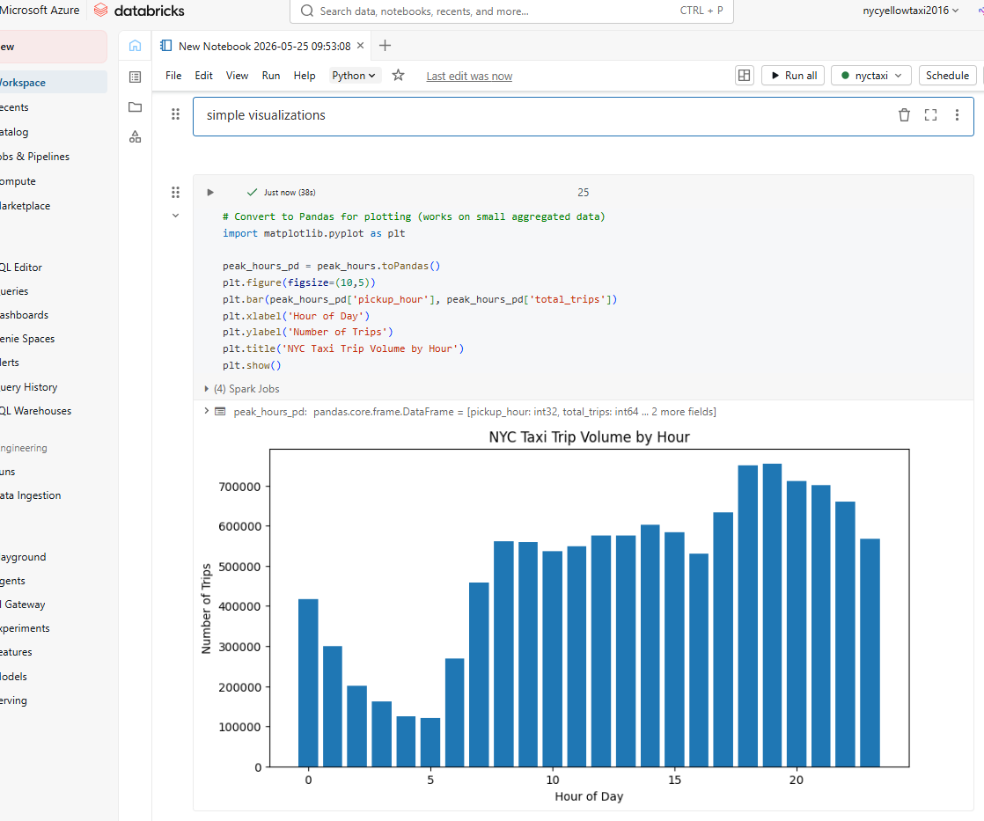
Figure 19: Simple data visualization on NYC Taxi volume by hour
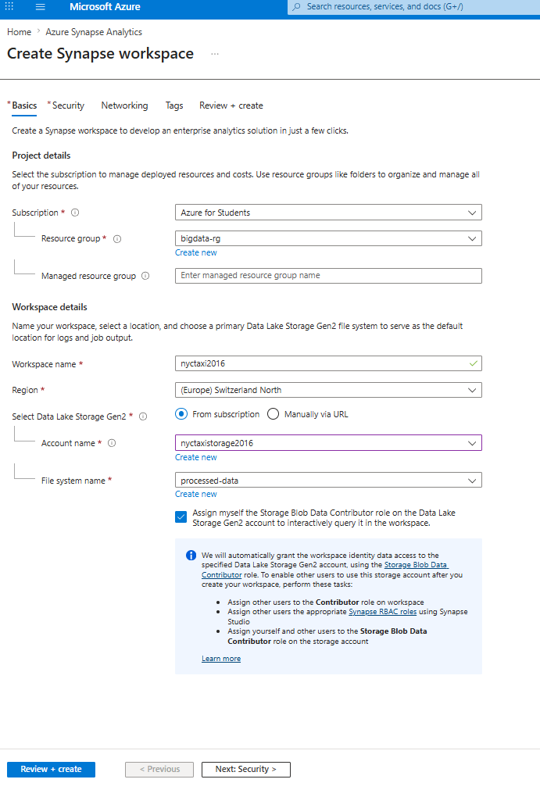
Figure 20: creation of synapse workspace in azure
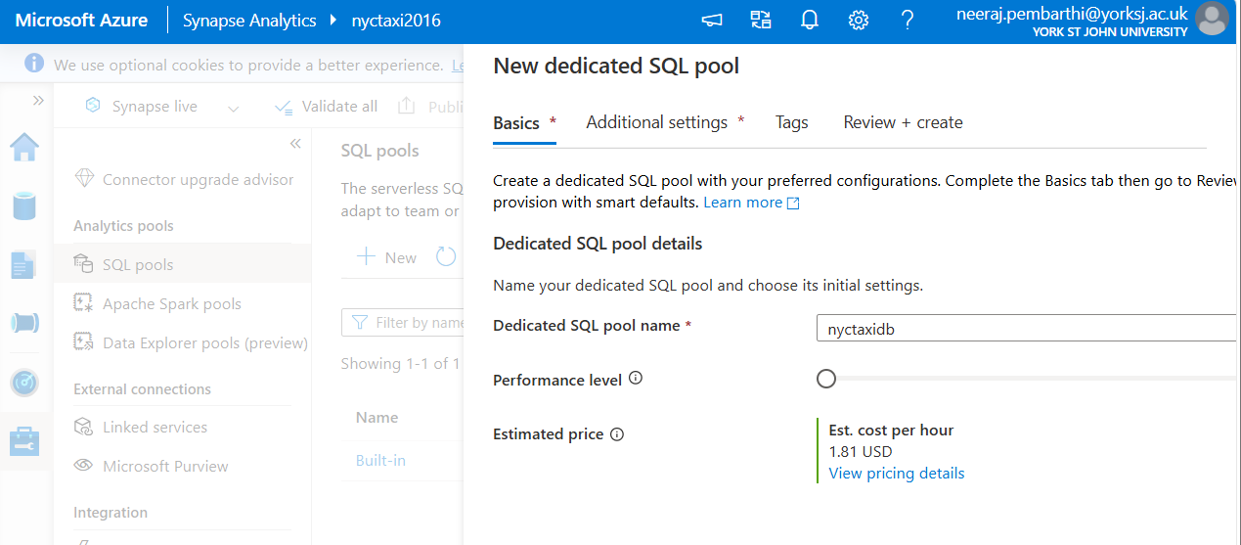
Figure 21: creation of new dedicated SQL pool

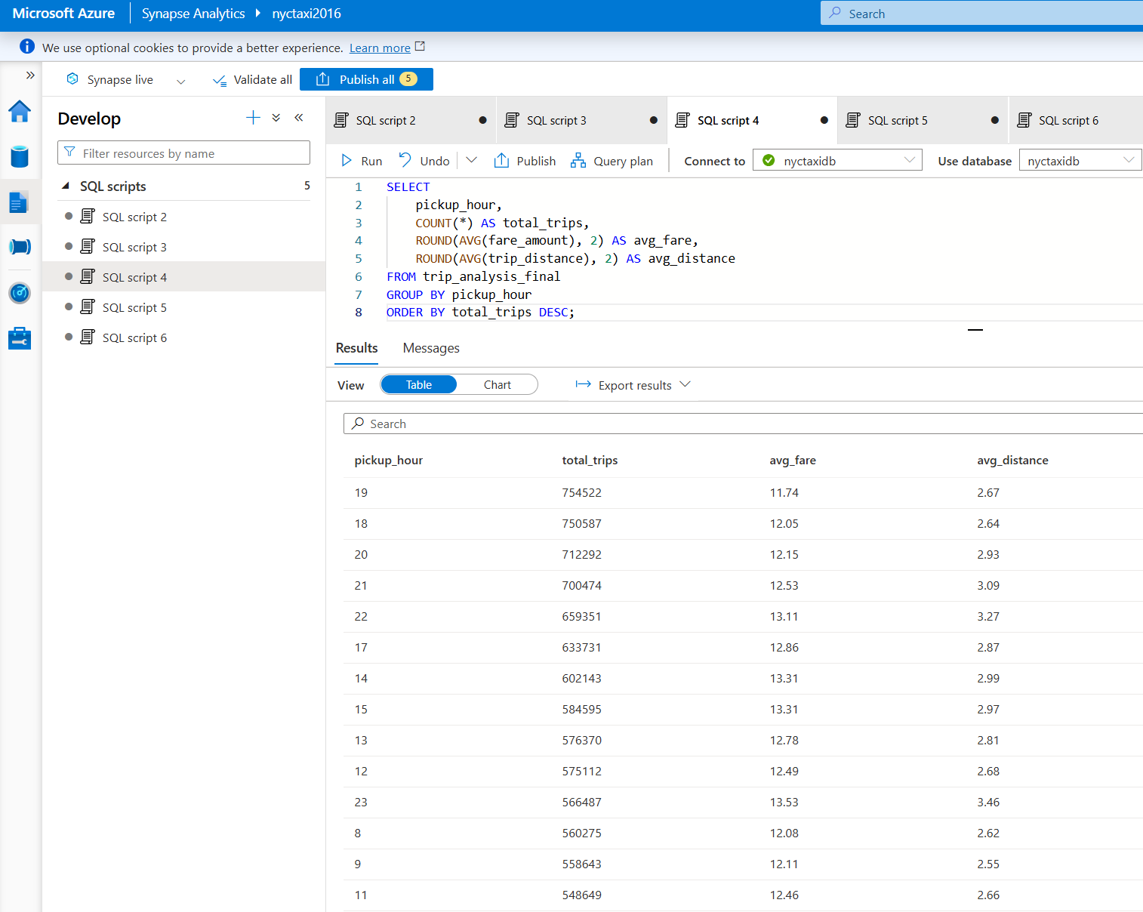
Figure 22: synapse query 1 on Peak hour analysis
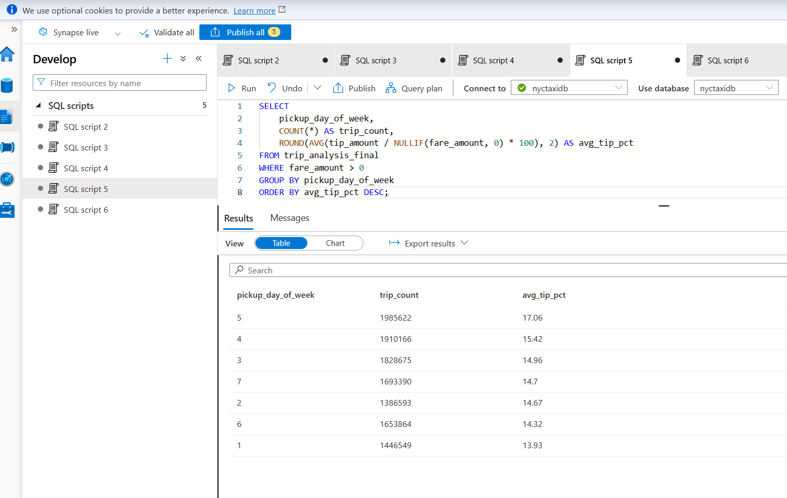
Figure 23: synapse query2 on Tip percentage by day of week
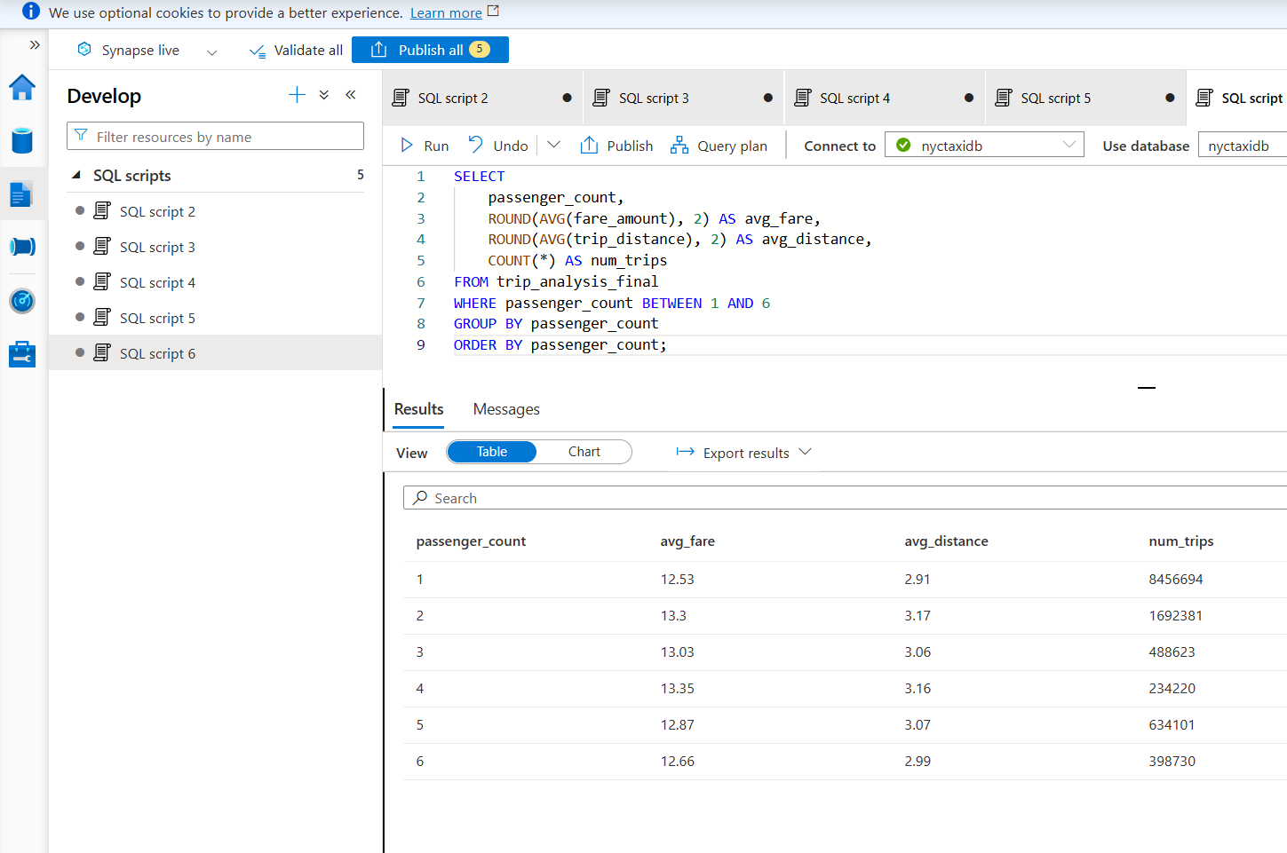
Figure 24: synapse query on Impact of passenger count on fare

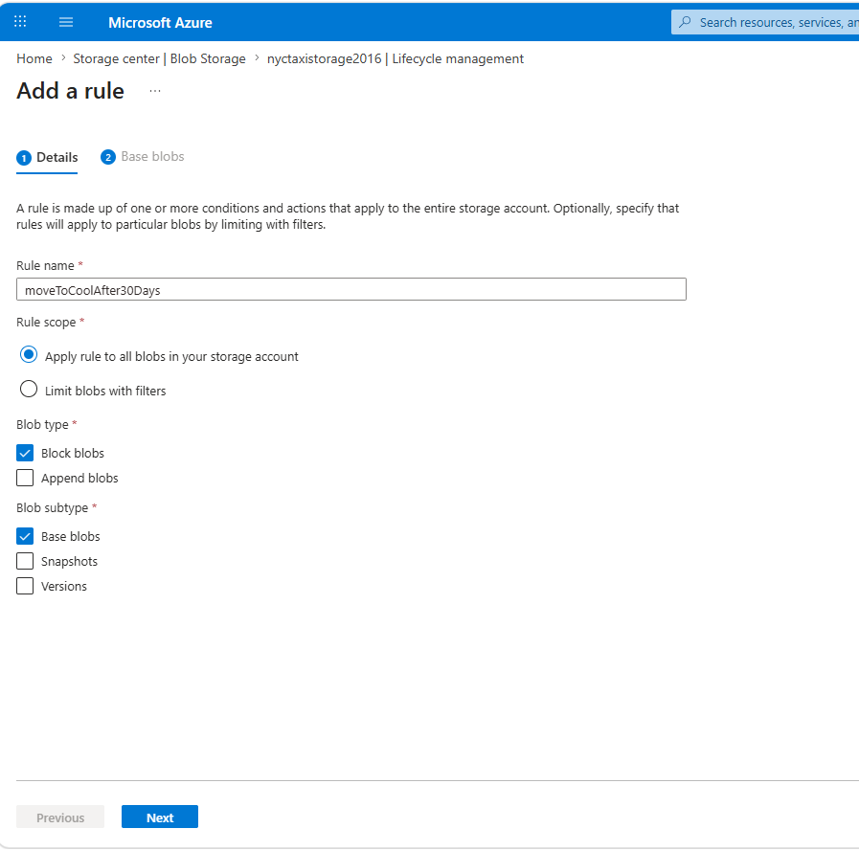
Figure 25: lifecycle management policy
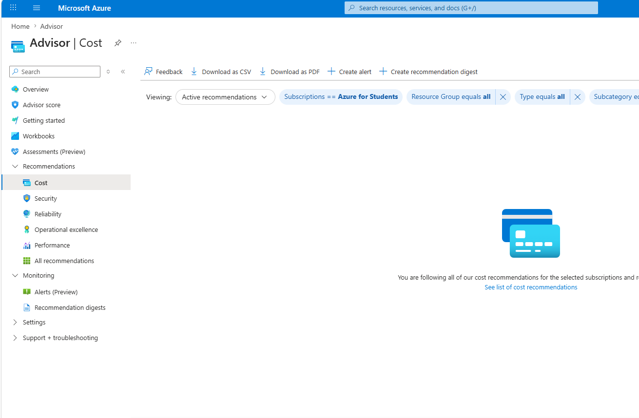
Figure 26: reserved instance recommendation
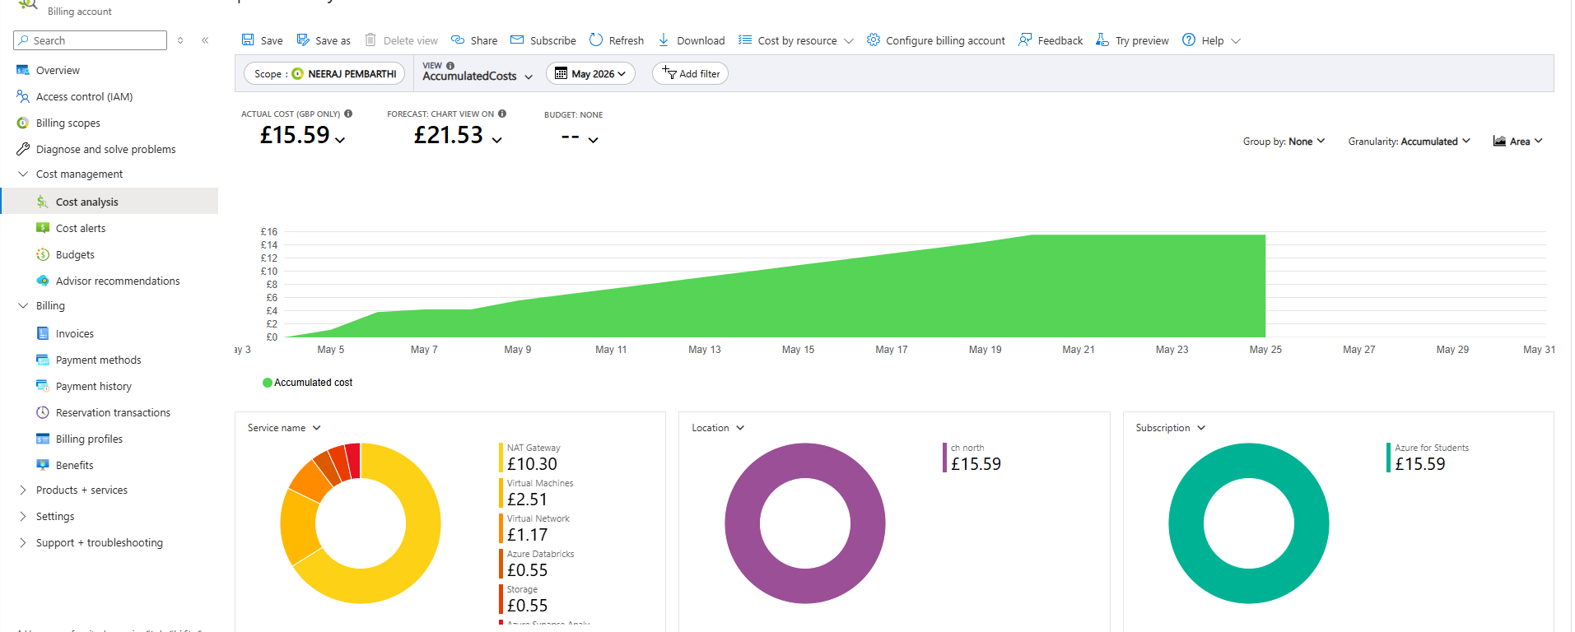
Figure 27: cost analysis dashboard
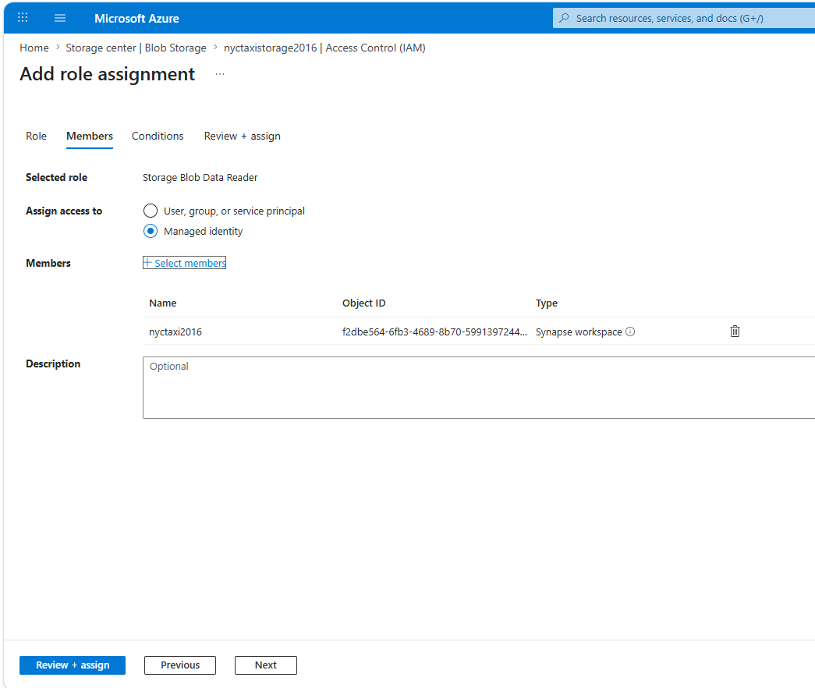
Figure 28: addition of new rule in RBAC assignment
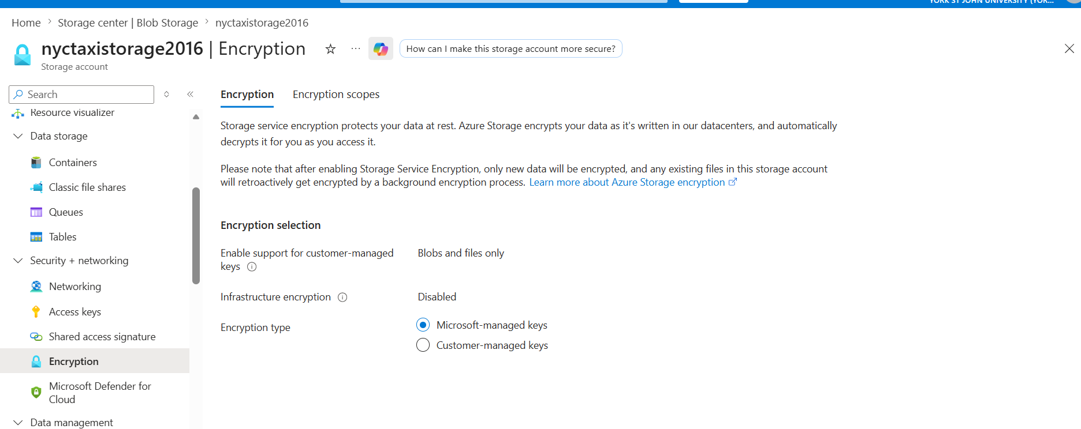
Figure 29: Infrastructure (Double) Encryption

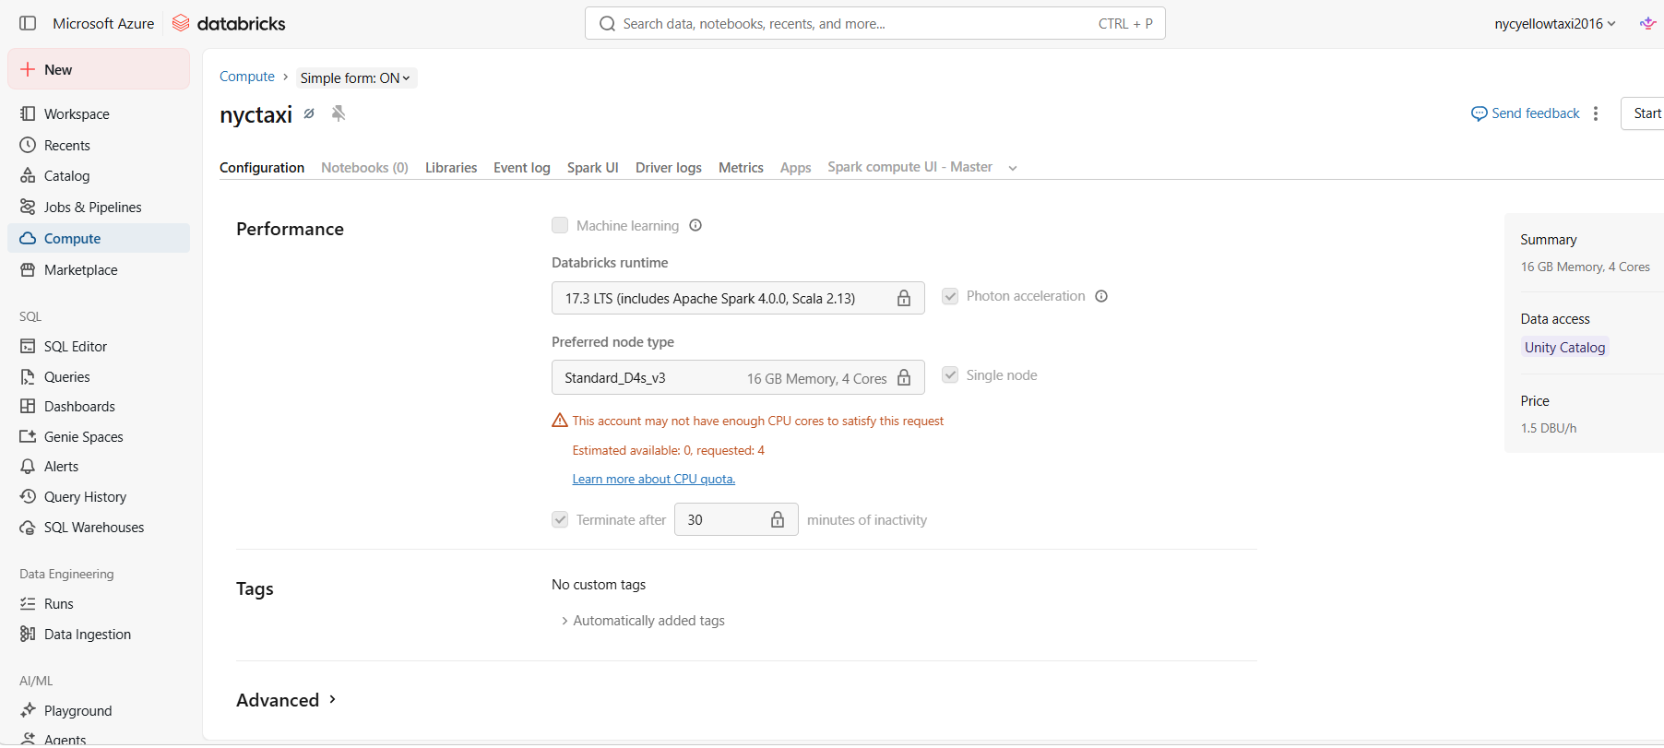
Figure 30: Databricks Cluster Auto-Termination

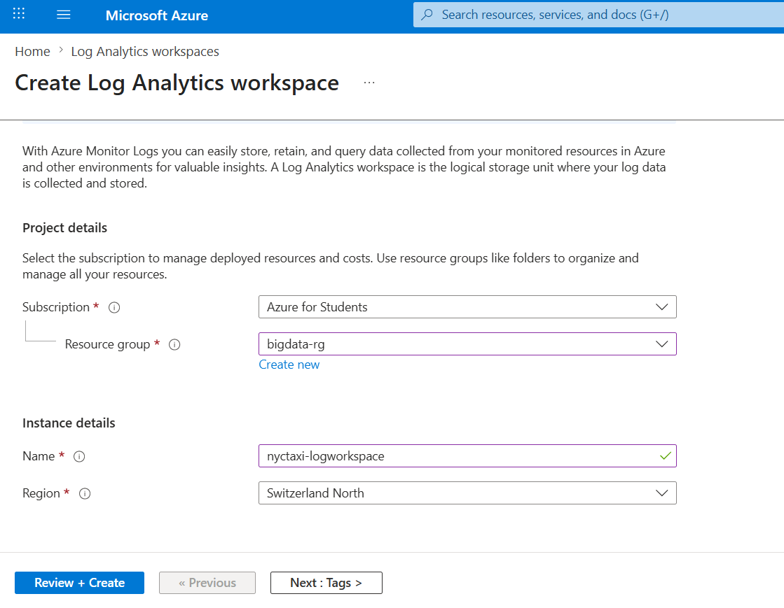
Figure 31: creation log analytical query
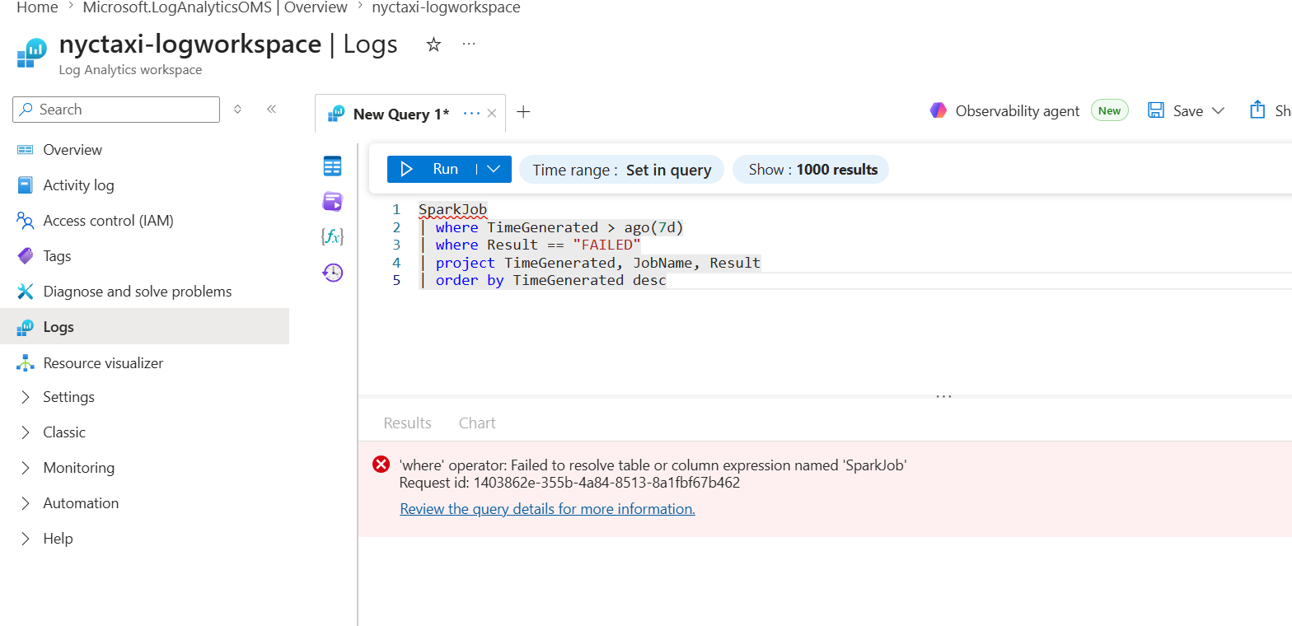
Figure 32: Log Analytics KQL Query
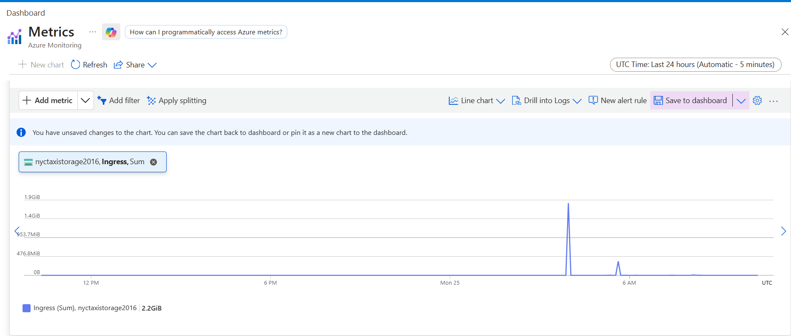
Figure 33: Custom Azure Monitor Dashboard for storage account nycyellowtaxi2016

