Teach2Learn: An AI-Driven Personalized Tutor Recommendation System
Submitted in partial fulfilment of requirements to CSE (Data Science)
Project-I (CD-363)
III/IV B. Tech CSE (DS) (VI Semester)
Submitted By
Mogalapalli Mounika (Y23CD122)
Kasireddy Bhavya Sri (Y23CD090)

January 2026
R.V.R & J.C. College Of Engineering
(Autonomous)
(NAAC A+ Grade) (Approved by A.I.C.T.E)
(Affiliated to Acharya Nagarjuna University)
Chandramoulipuram : : Chowdavaram
Guntur-522019

R.V.R & J.C. COLLEGE OF ENGINEERING
DEPARTMENT OF
COMPUTER SCIENCE AND ENGINEERING (DATA SCIENCE)


CERTIFICATE
This is to certify that this internship report “An AI-Driven Personalized Tutor Recommendation System” is the Bonafide work of “Mogalapalli Mounika (Y23CD122), Kasireddy Bhavya Sri(Y23CD090)” who has carried out the work under my supervision and submitted in partial fulfilment for the award of Project-I (CD-363) during the year 2025-2026.
Dr Popuri Srinivas Rao Dr. M. V. P. Chandra Sekhara Rao
Project guide Prof. & HOD, CSE (DS)

ACKNOWLEDGEMENT
I would like to express my sincere gratitude to all those who have supported and guided me throughout the successful completion of my mini project titled “Teach2Learn: An AI-Driven Personalized Tutor.”
First and foremost, I would like to extend my heartfelt thanks to Dr. Kolla Srinivas, Principal of R. V. R. & J. C. College of Engineering, Guntur, for providing a conducive academic environment and the necessary facilities to carry out this project work.
I express my deep sense of gratitude to Dr. M. V. P. Chandra Shekara Rao, Head of the Department of Computer Science and Engineering (Data Science), for his valuable guidance, encouragement, and support throughout the course of this project.
I am extremely thankful to my Project Guide, Mr. Popuri Srinivas Rao, for her constant guidance, constructive suggestions, and continuous motivation during every phase of this project. Her insightful feedback and technical guidance played a crucial role in shaping this work successfully.
I would also like to thank all the faculty members of the department for their cooperation and timely assistance. Finally, I extend my sincere thanks to my friends and family for their moral support and encouragement throughout the project.

Mogalapalli Mounika (Y23CD122)
Kasireddy Bhavya Sri (Y23CD090)

ABSTRACT

Teach2Learn: An AI-Driven Personalized Tutor is a mini project that focuses on developing an intelligent learning platform that connects students with suitable tutors using Artificial Intelligence techniques. The system aims to enhance the learning experience by providing personalized tutor recommendations based on student academic details, learning preferences, and performance data.

The proposed system collects and processes data related to students such as academic level, subject interests, and learning requirements, along with tutor information including expertise, experience, availability, and ratings. Machine Learning algorithms are used to analyze this data and generate accurate tutor recommendations. Deep Learning models further improve the recommendation accuracy by learning from historical interactions and feedback provided after learning sessions.

The application is developed using Python and Flask for the backend, with HTML, CSS, and JavaScript for the frontend, and MySQL/SQLite for data storage. The system supports three types of users—students, tutors, and administrators—each with specific roles and functionalities. Feedback-driven learning enables continuous improvement in recommendation quality.

This project demonstrates the effective use of AI, Machine Learning, and Deep Learning in the education domain, offering a scalable and user-friendly solution for personalized learning. Teach2Learn provides a strong foundation for future enhancements such as real-time analytics, mobile integration, and advanced adaptive learning mechanisms.

Table of Contents

Title | Page no
CHAPTER–1: INTRODUCTION
1.1 Introduction of the Project
1.2 Existing System
1.3 Proposed System
1.4 Potential Users
1.5 Unique features of the System
1.6 Demand for the product
1.7 Protection of Idea
CHAPTER-2: LITERATURE SURVEY / RELATED WORK and SRS
2.1 Literature Review
2.1.1. Review Findings
2.1.2 Objectives of the System
2.2 Requirements Analysis
2.2.1 Functional Requirements Analysis
2.2.2 User Requirements
2.2.3 Non-Functional Requirements
2.2.4 System Requirements
2.4 Feasibility Study
2.4.1 Technical Feasibility
2.4.2 Operational Feasibility
2.4.3 Behavioral Feasibility
2.5 Process Model used
2.6 Hardware and Software Requirements
2.7 SRS Specification
2.8 Financial Plan for the Development of Product (optional)
2.9 Business Plan from seeding to Commercialization (optional)
2.9.1 Business Model Canvas
CHAPTER-3: DESIGN PHASE / SYSTEM DESIGN
3.1 Design concepts & Constraints
3.2 Design Diagram of the System
3.3 Conceptual Design
3.4 Logical Design (Logical Tools/Logical Diagrams)
3.5 Database Design
CHAPTER-4: PROPOSED SYSTEM

4.1 Introduction to the Proposed System

4.2 System Architecture / Block Diagram

4.3 Algorithms Design

4.4 Modules and Functionalities with outcomes

4.5 Advantages over Existing System

4.6 Limitations (Optional but Recommended)

CHAPTER-5: IMLEMENTATION / CODING

4.1 Implementation Introduction

4.2 Sample Coding

4.3 Implementation procedure & Steps

CHAPTER-6: TESTING

5.1 Introduction to Testing

5.2 Types of Testing

5.3 Test cases and Test Reports

CHAPTER-7: RESULTS / OUTPUT SCREENS

6.1 Output Screens

6.2 Screen Reports

CHAPTER-8 CONCLUSION AND FUTURE ENHANCEMENTS

7.1 Conclusion

7.2 Future Enhancements

CHAPTER-9: BIBLIOGRAPHY

8.1 Books Referred

8.2 Websites visited
8.3 References

List of Figures

CHAPTER–1:
Introduction

1.1 Introduction of the Project
Education plays a vital role in shaping individuals and society. With the rapid advancement of technology, traditional teaching and learning methodologies are gradually being transformed into digital and intelligent learning systems. However, even with the availability of online learning platforms, students often face challenges in finding the right tutor who can understand their learning needs, academic level, and preferred learning style. Each student learns differently, and a one-size-fits-all approach is not always effective.
Teach2Learn: An AI-Driven Personalized Tutor is a smart learning platform designed to address these challenges by leveraging Artificial Intelligence (AI), Machine Learning (ML), and Deep Learning (DL) technologies. The primary objective of this project is to provide personalized tutor recommendations by analyzing student profiles, tutor expertise, and historical feedback data. The system ensures that students are matched with tutors who best suit their academic requirements, thereby improving learning efficiency and outcomes.
The project introduces an intelligent recommendation mechanism that automates the tutor selection process. By adopting a data-driven approach, Teach2Learn minimizes human bias, reduces time consumption, and enhances the overall learning experience. This system also benefits tutors by connecting them with suitable learners and increasing their reach through an organized digital platform.
1.2 Existing System
In the existing education system, the process of finding tutors is largely manual and inefficient. Students typically rely on coaching centers, personal referrals, advertisements, or generic online tutor listings. These methods do not provide intelligent matching between students and tutors, often resulting in poor compatibility and unsatisfactory learning experiences.
Most existing online platforms offer basic filtering options such as subject, location, or availability. However, they lack advanced personalization features and do not consider factors like student learning preferences, performance history, or tutor effectiveness. Additionally, feedback collected from students is rarely utilized to improve future tutor recommendations.
As a result, students spend a significant amount of time searching for suitable tutors, and tutors may not reach learners who truly match their expertise. The absence of automation, personalization, and continuous improvement makes the existing system inefficient and less effective.
1.3 Proposed System
The proposed system, Teach2Learn, overcomes the limitations of the existing system by introducing an AI-driven personalized tutor recommendation framework. The system is developed as a web-based application that provides a centralized platform for students, tutors, and administrators.
Teach2Learn collects and analyzes various data points, including student academic details, learning preferences, subject interests, and tutor profiles such as expertise, experience, availability, and ratings. Machine Learning algorithms process this data to generate personalized tutor recommendations, while Deep Learning models enhance accuracy by identifying complex patterns in user behaviour and feedback.
The system continuously improves its recommendations through feedback provided after learning sessions. This feedback-driven learning approach ensures adaptability and relevance over time. The proposed system reduces manual effort, improves tutor–student compatibility, and delivers a smarter and more efficient learning environment.
1.4 Potential Users
The Teach2Learn system is designed to support multiple user roles, each with specific responsibilities and functionalities. The primary users of the application include students, tutors, and administrators.
Students use the platform to register, create academic profiles, and receive personalized tutor recommendations based on their learning needs. They can also provide feedback after sessions, which helps improve the system’s recommendation accuracy.
Tutors register on the platform to offer teaching services. They can manage their profiles by specifying expertise, qualifications, experience, and availability. Tutors receive requests from students who match their profiles and can build credibility through ratings and feedback.
Administrators are responsible for managing the overall system. They monitor user activity, maintain data integrity, manage user accounts, and ensure the smooth functioning and security of the platform.
1.5 Unique Features of the System
Teach2Learn offers several unique features that distinguish it from traditional tutor-finding platforms. The system is designed to provide an intelligent, personalized, and scalable learning experience by leveraging Artificial Intelligence technologies. Unlike conventional systems that rely on static filters, Teach2Learn dynamically analyzes user data and adapts its recommendations based on real-time interactions and feedback.
The system incorporates an AI-based recommendation engine that matches students with tutors according to individual academic needs, learning preferences, and historical performance. This data-driven approach ensures higher accuracy in tutor selection and improves overall learning outcomes. The continuous learning mechanism enables the system to evolve over time, making recommendations more relevant and effective.
Key unique features of the Teach2Learn system include:
- AI-Based Personalized Tutor Recommendation: Uses Machine Learning and Deep Learning algorithms to suggest tutors tailored to individual student requirements.
- Feedback-Driven Improvement: Continuously learns from student feedback to enhance recommendation accuracy and system performance.
- User-Friendly Interface: Designed for easy navigation and accessibility, suitable for users with varying levels of technical expertise.
- Secure Authentication and Data Management: Ensures protection of user information through secure login mechanisms and structured database storage.
- Scalable System Architecture: Built using modern web technologies that support system expansion and performance optimization.
- Support for Peer-to-Peer Learning: Enables direct interaction between students and tutors, fostering collaborative learning.
- Future Enhancement Flexibility: Supports future upgrades such as mobile application integration, real-time analytics, and advanced adaptive learning features.
These unique features make Teach2Learn a reliable, intelligent, and future-ready learning platform that enhances both teaching and learning experiences..
1.6 Demand for the Product
The demand for intelligent and personalized learning platforms has increased significantly due to the rise of online education, competitive academic environments, and remote learning needs. Students increasingly seek platforms that adapt to their individual learning styles and academic goals rather than offering generic solutions.
Teach2Learn addresses this growing demand by providing efficient tutor matching, reducing search time, and improving learning outcomes. Educational institutions, coaching centers, and independent learners can benefit from such a system. The integration of AI and data analytics makes Teach2Learn highly relevant in the modern digital education ecosystem.
1.7 Protection of Idea
The Teach2Learn system ensures protection of its core idea and user data through secure design practices. User authentication and authorization mechanisms prevent unauthorized access to sensitive information. Data is stored securely using structured database management techniques.
The originality of the project lies in its AI-driven personalized tutor recommendation approach and feedback-based learning model. The recommendation logic and system architecture are uniquely designed for educational applications, making the project suitable for academic evaluation and future commercialization.

CHAPTER–2:
Literature Survey / Related Work and SRS
2.1 Literature Survey
The rapid growth of online education platforms has led to increased research in personalized learning systems and intelligent recommendation mechanisms. Traditional e-learning systems primarily focus on content delivery rather than adapting to individual learner needs. To overcome this limitation, researchers have explored the use of Artificial Intelligence, Machine Learning, and Deep Learning techniques to personalize learning experiences.
Several studies highlight the effectiveness of recommendation systems in the education domain. Content-based filtering and collaborative filtering techniques have been widely used to recommend courses, learning materials, and tutors. These systems analyze user preferences, historical interactions, and ratings to generate recommendations. However, many existing systems rely on limited datasets and fail to adapt dynamically to changing user behavior.
Recent advancements in Deep Learning have enabled more accurate prediction models by capturing complex patterns in learner behavior. Neural networks and hybrid recommendation models have shown improved performance in educational data analysis. Feedback-driven learning systems have also been proposed to continuously improve recommendations based on learner satisfaction. These research findings form the foundation for the proposed Teach2Learn system.
2.1.1 Review Findings
From the literature survey, it is evident that intelligent recommendation systems significantly enhance learning efficiency when personalization is applied. Most successful systems utilize user data such as preferences, interaction history, and feedback. However, many existing solutions lack real-time adaptability, scalability, and integration of multiple user roles.
Another key observation is that feedback data is often underutilized. Systems that effectively incorporate feedback demonstrate higher accuracy and user satisfaction. These findings indicate the need for a robust, AI-driven tutor recommendation platform that continuously learns and improves—leading to the development of the Teach2Learn system.
2.1.2 Objectives of the System
The primary objective of the Teach2Learn system is to develop an intelligent platform that recommends suitable tutors to students based on their academic needs and preferences. The system aims to reduce the manual effort involved in tutor selection and enhance learning outcomes through personalization.
Additional objectives include providing a scalable and user-friendly platform, utilizing Machine Learning and Deep Learning techniques for accurate recommendations, enabling feedback-driven improvement, and supporting multiple user roles such as students, tutors, and administrators. The system also aims to ensure data security, reliability, and future extensibility.
2.2 Requirements Analysis
Requirements analysis is a critical phase that defines the functional and non-functional needs of the system. It ensures that the developed system meets user expectations and operates effectively under defined constraints. For Teach2Learn, requirements are identified based on user roles, system objectives, and technological feasibility.
2.2.1 Functional Requirements Analysis
Functional requirements describe the specific operations the system must perform. The Teach2Learn system must allow students and tutors to register and authenticate securely. Students should be able to create profiles, specify learning preferences, and receive tutor recommendations. Tutors should be able to manage their profiles, specify expertise, and receive student requests.
The system must support feedback submission after learning sessions and use this feedback to improve future recommendations. Administrators should have the ability to manage users, monitor data, and control system operations.
2.2.2 User Requirements
User requirements define the expectations of different users interacting with the system. Students require an easy-to-use interface, accurate tutor recommendations, and privacy of personal data. Tutors expect visibility, fair matching opportunities, and profile management features.
Administrators require tools to manage users, monitor performance, and ensure system security. The system must be accessible, responsive, and reliable for all user categories.
2.2.3 Non-Functional Requirements
Non-functional requirements focus on system quality attributes. Teach2Learn must provide high performance with quick response times for recommendation generation. The system should be scalable to support an increasing number of users and data volume.
Security is a critical requirement, ensuring protection of user data through authentication and authorization mechanisms. The system should also be reliable, user-friendly, and maintainable, allowing future enhancements without major redesign.
2.2.4 System Requirements
The system requires a web-based environment with a backend developed using Python and Flask. A relational database such as MySQL or SQLite is required for data storage. Machine Learning libraries like Scikit-learn and Deep Learning frameworks such as TensorFlow or Keras are required for model implementation.
The system should run on standard hardware with internet connectivity and be compatible with modern web browsers.
2.3 Modules Description
The Teach2Learn system is divided into multiple modules to ensure modularity and ease of maintenance. The Student Module handles registration, profile creation, tutor search, and feedback submission. The Tutor Module manages tutor registration, profile updates, expertise specification, and interaction with students.
The Recommendation Module is the core component that analyzes data and generates personalized tutor suggestions using AI models. The Admin Module manages system data, users, and overall monitoring. Each module interacts with the database to ensure seamless data flow.
2.4 Feasibility Study
Feasibility study evaluates the practicality of the proposed system in terms of technical, operational, and behavioral aspects. This analysis ensures that the project can be developed and implemented successfully within constraints.
2.4.1 Technical Feasibility
The project is technically feasible as it uses widely available technologies such as Python, Flask, and Machine Learning libraries. The required hardware and software resources are readily accessible, and the development team possesses the necessary technical skills.
2.4.2 Operational Feasibility
The system is operationally feasible as it is user-friendly and requires minimal training. Students, tutors, and administrators can easily interact with the system through an intuitive interface. The automation of tutor recommendation reduces manual workload.
2.4.3 Behavioural Feasibility
The system is behaviourally feasible as it aligns with user expectations and encourages adoption through personalized features. Users are likely to accept the system due to its ease of use and effectiveness.
2.5 Process Model Used
The Iterative Development Model is used for this project. This model allows incremental development, testing, and refinement of system components. Feedback from each iteration helps improve system functionality and performance, making it suitable for AI-based applications.
The development of the Teach2Learn: An AI-Driven Personalized Tutor system follows the Iterative Development Process Model, which is well-suited for projects involving Machine Learning and Artificial Intelligence components. This model emphasizes continuous development, testing, evaluation, and refinement of the system through multiple iterations rather than delivering the entire system in a single phase.
In this process model, the project is divided into smaller and manageable cycles, where each iteration focuses on implementing specific features such as user registration, profile management, tutor recommendation logic, and feedback analysis. After completing each iteration, the developed module is tested and evaluated to identify any issues or improvements required. This approach allows early detection of errors and ensures better quality at each stage of development.
The Iterative model is particularly beneficial for AI-driven systems because recommendation accuracy improves gradually as more data becomes available. Feedback collected from students after each learning session is analyzed and used to refine the Machine Learning and Deep Learning models in subsequent iterations. This continuous learning and improvement process helps enhance system performance over time.
Additionally, the Iterative Development Model provides flexibility to incorporate new requirements or modifications based on user feedback without significantly affecting the overall system structure. This adaptability makes it an ideal choice for the Teach2Learn project, ensuring reliable development, improved accuracy, and efficient utilization of resources.
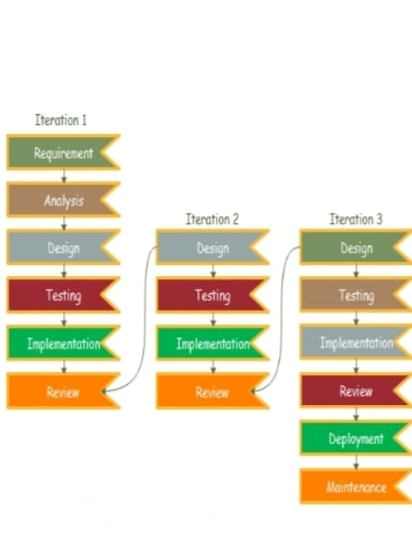
Fig 2.5 : Iterative Model
2.6 Hardware and Software Requirements
The Teach2Learn system requires specific hardware and software resources to ensure efficient development, execution, and scalability of the application. The requirements are as follows:
Hardware Requirements
- A personal computer or laptop for development and deployment
- Processor: Intel Core i3 or higher (or equivalent processor)
- Main Memory: Minimum 4 GB RAM (8 GB recommended for ML processing)
- Storage: Minimum 20 GB free disk space for application files and datasets
- Internet Connection: Stable internet connectivity for accessing the web application
- Input Devices: Keyboard and mouse for user interaction
- Output Devices: Monitor or display screen
Software Requirements
- Operating System: Windows 10 / Linux / macOS
- Programming Language: Python 3.x
- Backend Framework: Flask
- Frontend Technologies:
  - HTML for structure
  - CSS for styling
  - JavaScript for interactivity
- Database Management System: MySQL / SQLite
- Machine Learning Libraries:
  - Scikit-learn for ML algorithms
  - TensorFlow / Keras for Deep Learning models
- Development Tools:
  - Visual Studio Code / PyCharm for coding
  - Jupyter Notebook for model training and experimentation
- Web Browser: Google Chrome / Mozilla Firefox
- Version Control (Optional): Git
2.7 SRS Specification
The Software Requirements Specification (SRS) defines the overall functionality, constraints, and behavior of the Teach2Learn system. It includes system overview, functional and non-functional requirements, user roles, data flow, and system interfaces. The SRS ensures clarity between system design and implementation.
2.8 Financial Plan for the Development of Product (Optional)
Since Teach2Learn is a mini academic project, development costs are minimal. Open-source tools and libraries are used, reducing financial investment. Future commercialization may involve costs related to hosting, maintenance, and marketing.
2.9 Business Plan from Seeding to Commercialization (Optional)
Teach2Learn has strong potential for commercialization as an educational technology product. Initial deployment can target academic institutions and online learning communities. With increased adoption, advanced features and subscription-based services can be introduced.
2.9.1 Business Model Canvas
The business model includes value proposition through personalized learning, key users such as students and tutors, revenue streams through subscriptions or commissions, and key resources including AI models and platform infrastructure. This model supports sustainable growth.

CHAPTER–3:
Design Phase / System Design
3.1 Design Concepts and Constraints
The design phase of the Teach2Learn system focuses on converting the identified requirements into a structured and efficient system architecture. The primary design concept is to create an intelligent, scalable, and user-friendly platform that supports personalized tutor recommendations using Artificial Intelligence. Emphasis is placed on modularity to ensure that each functional component operates independently while remaining integrated within the overall system.
Another key design concept is scalability, as the system should be capable of handling an increasing number of students, tutors, and data records without significant performance degradation. The system is designed using a layered architecture that separates the frontend, backend, database, and AI models. This separation improves maintainability and allows future upgrades with minimal impact on existing components.
Usability is also a major design consideration. The interface is designed to be simple and intuitive so that users with minimal technical knowledge can easily navigate the platform. Clear workflows, minimal input complexity, and responsive interfaces ensure a positive user experience for students, tutors, and administrators.
Several constraints influence the design of the system. These include limited computational resources, availability of training data for AI models, and time constraints associated with academic project development. Additionally, the system must rely on open-source tools to minimize costs while ensuring data security, privacy, and compliance with ethical standards.
3.2 Design Diagram of the System
The system design of Teach2Learn follows a client–server architecture that supports efficient communication between users and backend services. The frontend acts as the client interface, where students, tutors, and administrators interact with the system through a web browser. This interface is responsible for capturing user input and displaying system outputs.
The backend server, developed using the Flask framework, acts as the core processing unit of the system. It handles user authentication, business logic, request processing, and coordination between the database and AI models. All user requests from the frontend are routed to the backend for validation and processing.
The recommendation engine is integrated within the backend and is responsible for analyzing user data and generating personalized tutor recommendations. Machine Learning and Deep Learning models process academic data, tutor profiles, and feedback to produce accurate results. This engine plays a crucial role in the system’s intelligence.
The database forms the foundation of the system by storing all persistent data, including user profiles, tutor details, feedback records, and recommendation history. The interaction between the frontend, backend, AI models, and database is clearly represented through system design diagrams, ensuring clarity and consistency in system operation.
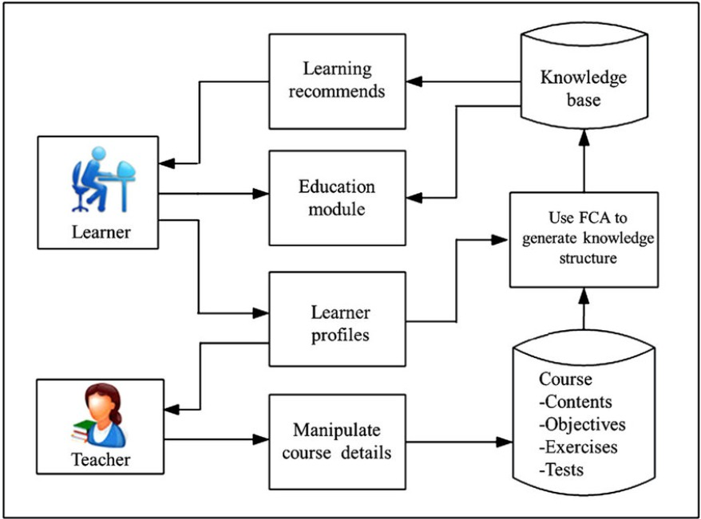
Fig 3.2: System Design Diagram
3.3 Conceptual Design
The conceptual design of Teach2Learn provides a high-level overview of the system and focuses on identifying key entities and their relationships. It abstracts technical complexities and presents a clear picture of how users and system components interact. This design phase helps stakeholders understand the system without delving into implementation details.
The primary entities in the system include Students, Tutors, Admin, Recommendation Engine, and Database. Students provide academic details and learning preferences, while tutors supply information regarding expertise, experience, and availability. These entities interact through the platform to facilitate effective learning connections.
The recommendation engine acts as the core conceptual component that processes user data and generates tutor suggestions. It uses stored information and feedback data to continuously improve recommendation quality. This feedback loop ensures adaptability and personalization within the system.
The conceptual design establishes clear boundaries between system components and defines data flow between entities. By representing relationships and interactions at a high level, this design ensures logical consistency, reduces ambiguity, and serves as a foundation for detailed logical and physical design phases.
3.4 Logical Design (Logical Tools / Logical Diagrams)
The logical design phase focuses on defining how the system functions internally by detailing data flow, process interactions, and system behaviour. It bridges the gap between conceptual design and physical implementation by providing a structured representation of system logic.
Logical tools such as Data Flow Diagrams (DFDs) are used to illustrate how data moves between different modules of the Teach2Learn system. These diagrams depict processes such as user registration, profile management, tutor recommendation, and feedback analysis. They help visualize system workflows and identify data dependencies.
In the logical design, the student module interacts with the recommendation module to request suitable tutors. The tutor module updates profile and availability information, which is stored in the database. The admin module oversees user management and system monitoring. Each interaction is logically defined to ensure accuracy and consistency.
This design phase helps validate functional requirements and ensures that all system components communicate effectively. Logical design also simplifies debugging, testing, and future enhancements by clearly defining system behavior and data handling mechanisms.
3.5 Database Design
The database design of Teach2Learn is a critical component that ensures efficient data storage, retrieval, and management. A relational database model is adopted to maintain structured and organized data. This design supports data consistency and integrity across the system.
The database includes multiple tables such as Student, Tutor, Admin, Feedback, and Recommendation History. Each table is designed with appropriate attributes to store relevant information. Primary keys uniquely identify records, while foreign keys establish relationships between tables.
Feedback data plays a crucial role in improving recommendation accuracy. Therefore, the database design ensures that feedback is properly linked to both students and tutors. This structured approach allows effective analysis of learning outcomes and system performance.
The database design also considers scalability and security. Proper indexing improves query performance, while access control mechanisms protect sensitive user data. This robust database structure supports the intelligent and data-driven nature of the Teach2Learn system.
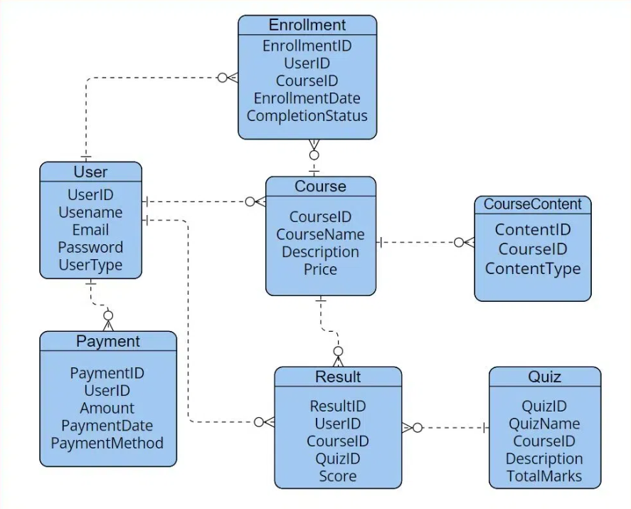
Fig 3.5: Database Design

CHAPTER 4:
Proposed System
4.1 Introduction to the Proposed System
The proposed system, Teach2Learn: An AI-Driven Personalized Tutor Recommendation System, is designed to simplify the process of finding suitable tutors for students by using Artificial Intelligence and Machine Learning techniques. Traditional tutor-finding systems often rely on manual search or static filtering methods, which may not always provide accurate or personalized results. The proposed system addresses these limitations by analyzing student preferences, academic requirements, tutor expertise, and feedback data to generate intelligent recommendations. By integrating AI algorithms into the platform, the system provides personalized tutor suggestions that better match individual learning needs.
The system is developed using modern web technologies to ensure accessibility and usability. The frontend of the system is implemented using HTML, CSS, and JavaScript, which provides an interactive and user-friendly interface for students, tutors, and administrators. The backend of the system is built using Python with the Flask framework, which manages user authentication, data processing, and communication between the frontend and the database. This architecture ensures that the system remains lightweight, efficient, and scalable.
A key component of the proposed system is the AI-based recommendation engine developed using Machine Learning libraries such as Scikit-learn and Deep Learning frameworks like TensorFlow/Keras. The recommendation model analyzes patterns in user data such as tutor ratings, student preferences, subjects, and learning history to generate accurate tutor recommendations. As the system collects more feedback and interaction data, the model can improve its prediction accuracy over time.
Overall, the proposed system aims to create a smarter and more efficient learning environment where students can easily discover qualified tutors, tutors can connect with learners who need their expertise, and administrators can manage the platform effectively. By combining Artificial Intelligence with modern web development technologies, Teach2Learn provides an intelligent and scalable solution for personalized education support.

4.2 System Architecture / Block Diagram
The system architecture of Teach2Learn is designed using a three-tier architecture, which includes the presentation layer, application layer, and data layer. This architecture ensures that the system remains modular, scalable, and easy to maintain. Each layer performs specific tasks that contribute to the overall functioning of the tutor recommendation platform.
The presentation layer represents the user interface of the system. It is developed using HTML, CSS, and JavaScript, which provide the visual components and interaction mechanisms required for users to access the system. Students can register, search for tutors, and view recommendations through the interface, while tutors can create profiles and manage their teaching details. The admin interface allows administrators to manage users, monitor system activity, and maintain platform data.
The application layer is responsible for processing requests, executing system logic, and communicating between the user interface and the database. This layer is implemented using Python with the Flask web framework, which handles server-side operations such as user authentication, session management, recommendation generation, and data validation. When a student searches for a tutor or requests recommendations, the application layer processes the request and sends it to the AI model for analysis.
The data layer stores all the system data required for the application to function effectively. The database is implemented using MySQL or SQLite, where information such as student profiles, tutor profiles, subject expertise, feedback, and ratings are stored. The AI recommendation model also uses this data to analyze patterns and generate personalized tutor suggestions. This structured architecture ensures efficient data handling, secure storage, and smooth system performance.
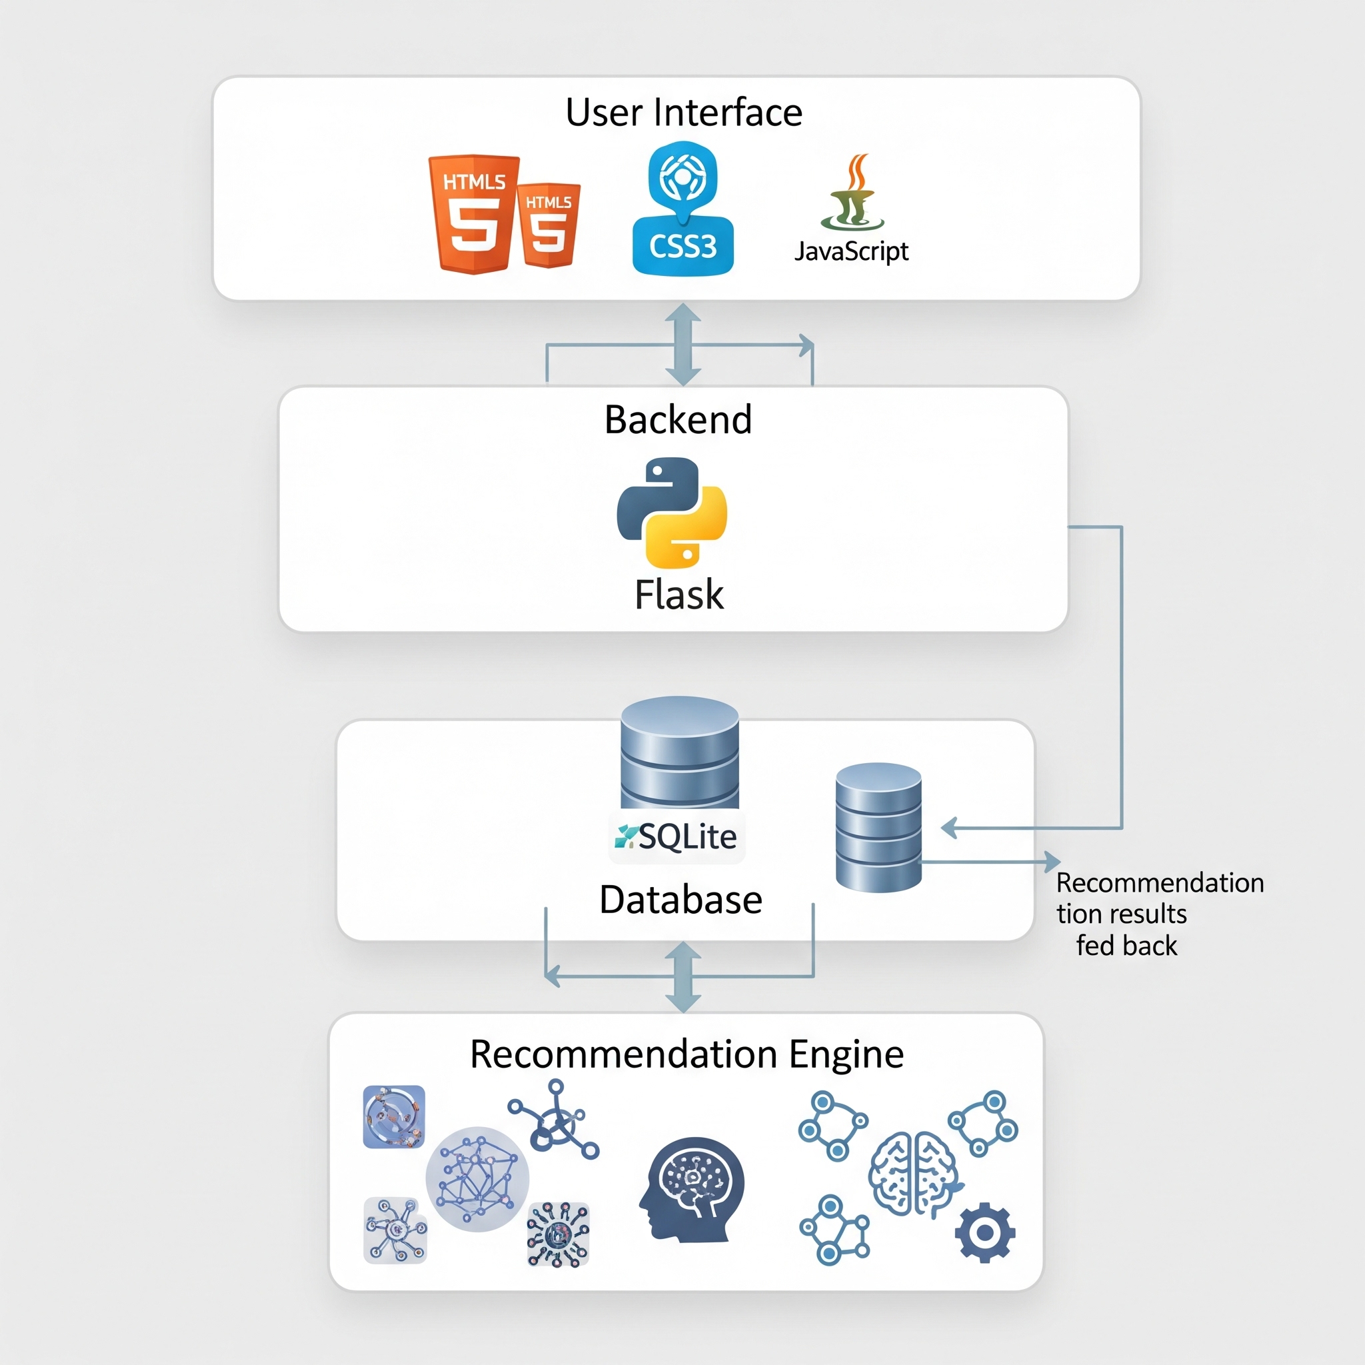

4.3 Algorithms Design
The Teach2Learn system uses Machine Learning algorithms and data analysis techniques to generate personalized tutor recommendations. The recommendation process is designed to analyze student requirements and tutor profiles to determine the most suitable matches. The algorithm considers several factors such as subject expertise, tutor ratings, student preferences, and feedback from previous sessions to ensure accurate results.
The recommendation algorithm begins by collecting and preprocessing user data. This includes information about student academic needs, preferred subjects, learning levels, and tutor ratings. The system uses data preprocessing techniques such as normalization and filtering to ensure that the data is clean and structured before being used for training the model. Once the data is prepared, Machine Learning models from Scikit-learn can be used to identify patterns between students and tutors.
In addition to traditional Machine Learning models, the system can also incorporate Deep Learning techniques using TensorFlow or Keras to improve recommendation accuracy. Deep learning models are capable of identifying complex relationships within the data and can learn from large datasets. As more users interact with the system and provide feedback, the model continuously updates its predictions to improve the quality of recommendations.
The final stage of the algorithm involves generating ranked tutor suggestions for students. The system evaluates tutor profiles based on calculated scores and displays the most relevant tutors to the student. This intelligent recommendation process ensures that students receive personalized tutor suggestions that match their academic needs and learning preferences.
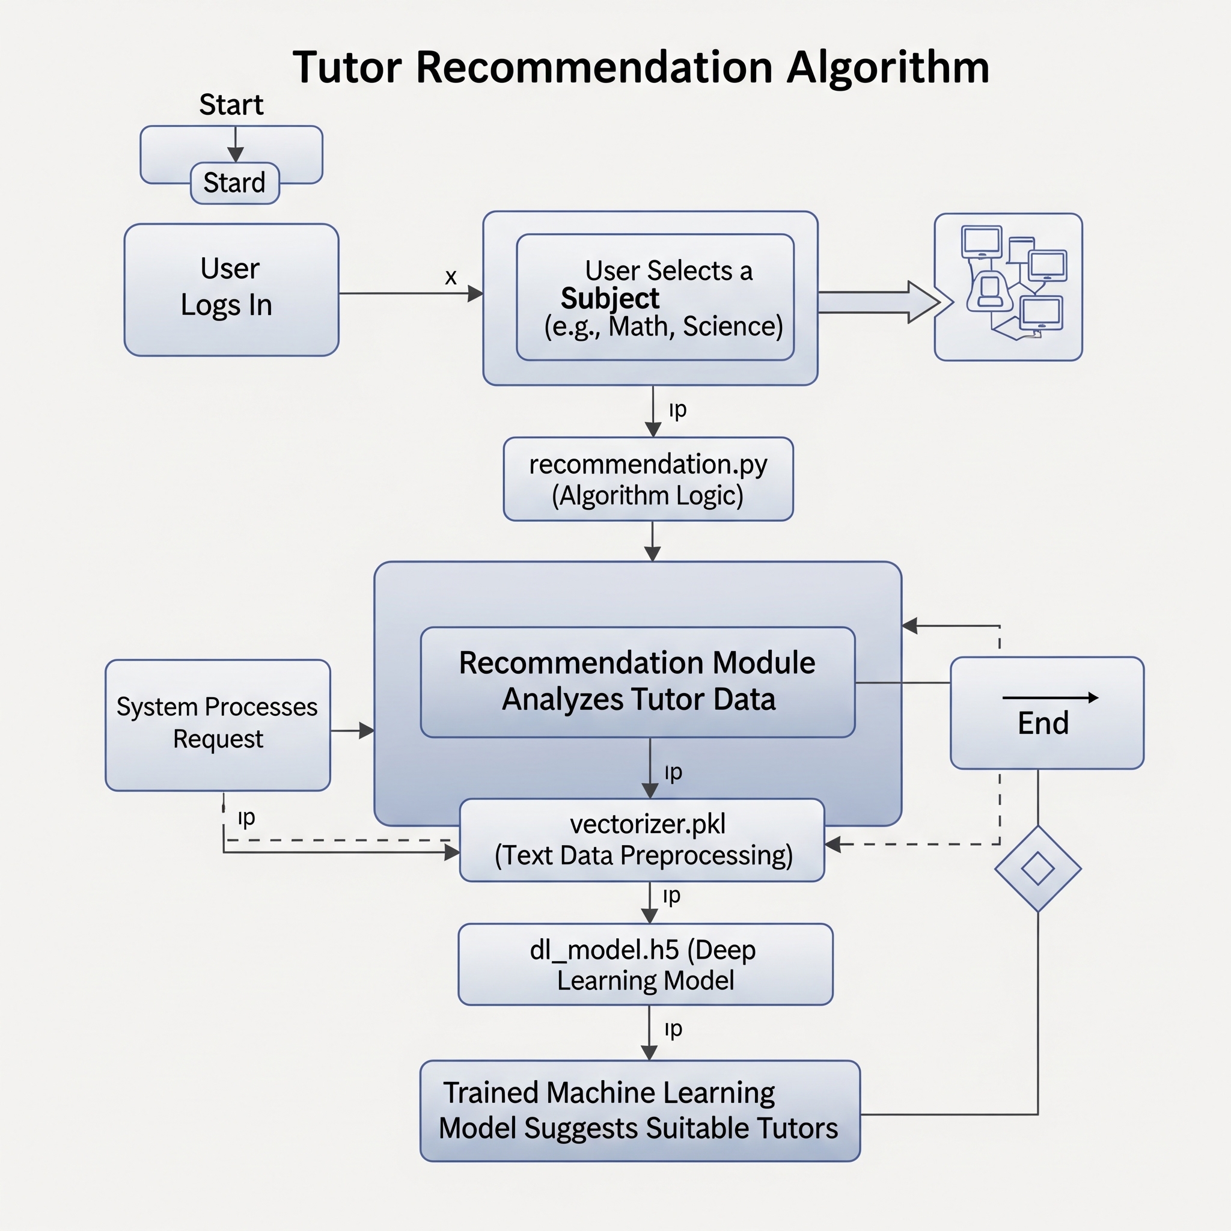

4.4 Modules and Functionalities with Outcomes
The Teach2Learn system is divided into several modules, each designed to perform specific tasks that contribute to the overall functionality of the platform. These modules ensure that the system remains organized, scalable, and easy to maintain while providing efficient services to students, tutors, and administrators.
The Student Module allows students to register, log in, and create personal learning profiles. Students can enter their academic details, subjects of interest, preferred learning methods, and availability. Based on this information, the AI recommendation system suggests suitable tutors. Students can also view tutor profiles, compare ratings, and select tutors that best match their learning requirements. The outcome of this module is an improved and personalized tutor discovery experience for students.
The Tutor Module enables tutors to register on the platform and create detailed profiles highlighting their expertise, qualifications, subjects taught, and teaching experience. Tutors can update their availability, manage their teaching sessions, and receive ratings and feedback from students. This module allows tutors to connect with students who require their specific skills and expertise, increasing opportunities for knowledge sharing and peer-to-peer learning.
The Admin Module provides administrative control over the entire platform. Administrators can manage user accounts, monitor system activities, maintain database records, and ensure that the platform operates smoothly. The admin can also review tutor profiles, verify authenticity, and remove invalid or inactive accounts to maintain system reliability.
Together, these modules work collaboratively to create a complete tutor recommendation ecosystem where students find suitable tutors efficiently, tutors connect with learners easily, and administrators ensure the smooth functioning of the system.
4.5 Advantages over Existing System
The proposed Teach2Learn system offers several advantages compared to traditional tutor-search platforms and manual tutor-finding methods. One of the most significant improvements is the integration of Artificial Intelligence, which allows the system to provide personalized tutor recommendations instead of relying on basic search filters. This helps students find tutors who better match their academic needs and learning preferences.
Another advantage of the system is its data-driven approach. The platform collects and analyzes various types of user data such as student preferences, tutor expertise, ratings, and feedback. By processing this information using Machine Learning algorithms, the system can generate more accurate and relevant recommendations. Over time, as more feedback is collected, the recommendation engine becomes smarter and more effective.
The system also provides a user-friendly interface developed using modern web technologies like HTML, CSS, and JavaScript. This ensures that students, tutors, and administrators can easily interact with the system without requiring advanced technical knowledge. The use of Flask for backend development ensures efficient communication between the user interface and the database while maintaining system performance.
Additionally, the proposed system supports scalability and future expansion. Since the platform is built using modular architecture and modern technologies, new features such as mobile integration, advanced analytics, or improved recommendation algorithms can be easily added in future versions. These advantages make Teach2Learn a more efficient and intelligent solution compared to existing tutor-finding systems.
4.6 Limitations
Although the Teach2Learn system provides many advantages, there are certain limitations that need to be considered during development and deployment. One limitation is the dependency on data quality. The accuracy of the AI recommendation system depends heavily on the quality and quantity of data available in the database. If there is insufficient user data or incomplete profiles, the system may not be able to generate highly accurate tutor recommendations.
Another limitation is related to initial training of the Machine Learning model. During the early stages of the platform, the AI model may have limited historical data to analyze, which can reduce recommendation accuracy. However, as more students and tutors interact with the platform and provide feedback, the system gradually improves its performance and becomes more reliable.
The system also requires continuous maintenance and updates to ensure optimal performance. Since the platform uses web technologies and Machine Learning models, regular monitoring is required to maintain system stability, update algorithms, and manage database growth. Without proper maintenance, system performance may decline over time.
Finally, the platform currently operates primarily as a web-based system, which may limit accessibility for users who prefer mobile applications. While the system is designed to support future enhancements such as mobile integration, the current version focuses on delivering a reliable web-based tutor recommendation platform. Despite these limitations, the system provides a strong foundation for intelligent tutor matching and can be improved further through future upgrades.
CHAPTER 5:
Implementation / Coding
5.1 Implementation Introduction
The implementation phase is a critical stage in the development of the Teach2Learn: An AI-Driven Personalized Tutor Recommendation System, as it transforms the conceptual design and system architecture into a fully functional software application. In this phase, the planned modules, algorithms, and database structures are converted into executable code using the selected programming languages and development frameworks. The objective of the implementation process is to ensure that all system components work together efficiently to provide a reliable and user-friendly tutor recommendation platform.
The Teach2Learn system is implemented as a web-based application using modern web technologies combined with Artificial Intelligence tools. The frontend of the application is developed using HTML, CSS, and JavaScript, which create the graphical user interface that allows users to interact with the system. These technologies are responsible for designing web pages, managing layout structures, applying visual styles, and enabling interactive features such as form validation and dynamic content display.
The backend of the system is developed using the Python programming language with the Flask web framework. Flask acts as the server-side framework that handles routing, user authentication, request processing, and communication with the database. It also integrates the Machine Learning model responsible for generating tutor recommendations based on user data. Flask is particularly suitable for this project because it is lightweight, flexible, and capable of integrating Artificial Intelligence models within web applications.
The database layer is implemented using MySQL or SQLite, which stores structured information such as student profiles, tutor details, subject expertise, ratings, and feedback data. This information is used by the system to perform operations such as retrieving tutor profiles and generating personalized tutor recommendations. In addition, the system integrates Machine Learning libraries such as Scikit-learn and Deep Learning frameworks like TensorFlow/Keras to build the recommendation engine. Through this implementation approach, the Teach2Learn platform successfully combines web development technologies with Artificial Intelligence techniques to create an intelligent and scalable tutor recommendation system.
5.2 Sample Coding
The Teach2Learn system is developed using Python and the Flask framework for backend functionality, while HTML, CSS, and JavaScript are used for frontend interface development. The following sample code snippets demonstrate some of the basic functionalities implemented in the system, such as creating a Flask application, handling user login, and generating tutor recommendations.
Sample Flask Application Setup
This code demonstrates how the Flask application is initialized and how routes are defined for different pages in the system.
from flask import Flask, render_template, request, redirect, url_for
import sqlite3
app = Flask(__name__)
@app.route('/')
def home():
return render_template('index.html')
@app.route('/login', methods=['GET','POST'])
def login():
if request.method == 'POST':
username = request.form['username']
password = request.form['password']
conn = sqlite3.connect('teach2learn.db')
cursor = conn.cursor()
cursor.execute("SELECT * FROM users WHERE username=? AND password=?", (username,password))
user = cursor.fetchone()
if user:
return redirect(url_for('dashboard'))
else:
return "Invalid login credentials"
return render_template('login.html')
if __name__ == '__main__':
app.run(debug=True)
Sample Tutor Recommendation Logic (Machine Learning)
The recommendation system can be implemented using Scikit-learn to analyze student preferences and tutor expertise.

from sklearn.metrics.pairwise import cosine_similarity
import pandas as pd
# Example tutor dataset
data = {
'Tutor': ['Tutor A', 'Tutor B', 'Tutor C'],
'Subject_Math': [1,0,1],
'Subject_Physics': [0,1,1],
'Rating': [4.5,4.0,4.8]
}
df = pd.DataFrame(data)
# Example student preference
student_pref = [[1,0,5]] # Math preference
similarity = cosine_similarity(student_pref, df[['Subject_Math','Subject_Physics','Rating']])
recommended_index = similarity.argmax()
print("Recommended Tutor:", df.iloc[recommended_index]['Tutor'])

Sample HTML Interface for Student Registration
<!DOCTYPE html>
<html>
<head>
<title>Student Registration</title>
</head>
<body>
<h2>Register as Student</h2>
<form method="POST" action="/register">
Name:<br>
<input type="text" name="name"><br>
Email:<br>
<input type="email" name="email"><br>
Subject Interested:<br>
<input type="text" name="subject"><br>
<input type="submit" value="Register">
</form>
</body>
</html>
These code snippets represent simplified examples of how the Teach2Learn system integrates web application development with AI-based recommendation logic. In the actual system implementation, additional modules, security mechanisms, and database operations are included to ensure efficient system performance.
5.3 Implementation Procedure & Steps
The implementation of the Teach2Learn system follows a structured development process to ensure that all components are properly designed, developed, and integrated. The implementation procedure involves several steps that guide the development of the system from initial setup to final deployment.
Step 1: Requirement Analysis
The first step in the implementation process involves analyzing the system requirements and identifying the features that need to be developed. This includes defining user roles such as students, tutors, and administrators, as well as determining the data required for generating tutor recommendations. The system requirements also include identifying the technologies and frameworks needed for development.
Step 2: Environment Setup
In this step, the development environment is prepared by installing the necessary software tools and libraries. Python is installed along with the Flask framework for backend development. Machine Learning libraries such as Scikit-learn, TensorFlow, and Keras are also installed for building the recommendation engine. Additionally, database systems such as MySQL or SQLite are configured to store system data.
Step 3: Database Design
The next step involves designing the database structure required for storing information about students, tutors, subjects, and feedback. Tables are created to store user registration details, tutor expertise, ratings, and recommendation data. Proper relationships between tables are established to ensure efficient data retrieval and management.
Step 4: Frontend Development
In this stage, the user interface of the system is developed using HTML, CSS, and JavaScript. Web pages are created for user registration, login, tutor profile viewing, recommendation results, and admin management. The design focuses on simplicity and usability so that users can easily navigate through the system.
Step 5: Backend Development
The backend functionality is developed using Python with Flask. This includes implementing user authentication, connecting the application with the database, processing user requests, and managing system modules. Flask routes are created to handle different operations such as login, registration, tutor search, and recommendation generation.
Step 6: Integration of AI Recommendation System
After implementing the basic system modules, the Machine Learning model is integrated into the application. The model analyzes student preferences, tutor expertise, and ratings to generate personalized tutor recommendations. The recommendation results are then displayed to students through the web interface.
Step 7: Testing and Debugging
Once all components are integrated, the system undergoes testing to identify and fix errors or performance issues. Different testing techniques such as functional testing and system testing are used to ensure that all modules work correctly and the recommendation system produces accurate results.
Step 8: Deployment and Maintenance
The final step involves deploying the system so that users can access it through a web browser. The system is monitored regularly to ensure smooth operation, and updates are applied when necessary to improve performance and add new features.

CHAPTER 6:
Testing
6.1 Introduction to Testing
Testing is an essential phase in the software development life cycle that ensures the developed system functions correctly and meets the specified requirements. It involves evaluating the software to identify errors, verify functionality, and ensure that the system performs reliably under different conditions. For the Teach2Learn: An AI-Driven Personalized Tutor Recommendation System, testing plays a crucial role in verifying that the tutor recommendation engine, user interface, database operations, and backend processes work together seamlessly.
The main objective of testing the Teach2Learn system is to ensure that all modules—including student registration, tutor profile management, recommendation generation, and administrative functions—operate without errors. Since the system integrates web technologies such as HTML, CSS, JavaScript, Python, and Flask, along with database systems like MySQL or SQLite, it is necessary to test both the frontend interface and backend functionality. Testing also ensures that data entered by users is properly stored, processed, and retrieved from the database.
Another important aspect of testing in this project is validating the Artificial Intelligence recommendation component. The Machine Learning model used in the system analyzes user preferences and tutor data to generate personalized recommendations. Testing helps verify that the recommendation engine produces relevant tutor suggestions based on the input provided by students. By evaluating the accuracy and efficiency of the recommendation system, developers can ensure that the AI model performs as expected.
Overall, the testing phase ensures that the Teach2Learn platform provides a stable, reliable, and efficient environment for students and tutors. By detecting and correcting issues before system deployment, testing improves software quality and enhances the overall user experience.
6.2 Types of Testing
Various types of testing are performed during the development of the Teach2Learn system to ensure that all system components operate correctly and meet the required performance standards. Each type of testing focuses on specific aspects of the application to identify potential issues and verify system functionality.
1. Unit Testing
Unit testing involves testing individual components or modules of the system to ensure they function correctly. In the Teach2Learn system, unit testing is performed on individual functions such as user authentication, database queries, tutor recommendation algorithms, and form validation processes. By testing each component separately, developers can detect errors at an early stage and ensure that each module performs its intended function correctly.
2. Integration Testing
Integration testing focuses on verifying the interaction between different modules of the system. Since the Teach2Learn platform includes multiple components such as the frontend interface, backend logic, database system, and AI recommendation engine, it is important to ensure that these components communicate effectively. Integration testing ensures that data flows correctly between modules and that system operations are executed without errors.
3. System Testing
System testing evaluates the entire application as a complete system. In this type of testing, the Teach2Learn platform is tested as a whole to ensure that all features work together correctly. This includes verifying user registration, tutor profile management, recommendation generation, and administrative operations. System testing helps confirm that the software meets the specified functional and non-functional requirements.
4. Functional Testing
Functional testing ensures that the system performs according to its defined functional requirements. For example, the system must allow students to register, log in, search for tutors, and receive personalized recommendations. Similarly, tutors must be able to create profiles and update their teaching information. Functional testing verifies that each of these features works correctly and produces the expected results.
5. User Interface Testing
User Interface (UI) testing focuses on evaluating the visual components and usability of the application. Since the Teach2Learn platform uses HTML, CSS, and JavaScript to create the user interface, UI testing ensures that web pages load correctly, forms function properly, and navigation between pages is smooth. This type of testing helps ensure that users can interact with the platform easily without confusion.
6. Performance Testing
Performance testing evaluates how the system behaves under different workloads and usage conditions. It ensures that the application remains stable and responsive even when multiple users access the system simultaneously. This type of testing is particularly important for web-based systems where server performance and database response time can affect user experience.
6.3 Test Cases and Test Reports
Test cases are structured procedures used to verify whether specific features of the system function as expected. Each test case includes information such as the test scenario, input data, expected output, and actual output. By executing test cases, developers can identify issues in the system and confirm whether the application meets the specified requirements. Test reports document the results of these tests and provide evidence that the system has been properly evaluated.
Below are some sample test cases for the Teach2Learn system:
Test Case ID | Test Scenario | Input | Expected Output | Actual Output | Result
TC01 | Student Registration | Valid student details | Student account created successfully | Account created | Pass
TC02 | Student Login | Correct username and password | User logged in and redirected to dashboard | Login successful | Pass
TC03 | Student Login | Incorrect password | Error message displayed | Error message shown | Pass
TC04 | Tutor Profile Creation | Valid tutor information | Tutor profile stored in database | Profile created | Pass
TC05 | Tutor Recommendation | Student selects subject preference | System displays recommended tutors | Tutors displayed | Pass
TC06 | Feedback Submission | Student submits tutor rating | Feedback stored in database | Feedback recorded | Pass
TC07 | Admin User Management | Admin removes inactive user | User account removed | Account removed | Pass

The test report summarizes the results of all executed test cases. In the Teach2Learn project, most test cases successfully passed, indicating that the system functions according to the specified requirements. The testing process also helped identify minor issues related to form validation and database connectivity, which were corrected during the debugging stage.
Through systematic testing and analysis of test reports, the Teach2Learn system was verified to be reliable, functional, and capable of providing personalized tutor recommendations effectively. Proper testing ensures that users experience a stable and efficient learning platform.

CHAPTER 7:
Results / Output Screens
7.1 Output Screens
The output screens of the Teach2Learn: An AI-Driven Personalized Tutor Recommendation System represent the visual interface through which users interact with the system and obtain results from the tutor recommendation process. These screens are developed using HTML, CSS, and JavaScript for the frontend, while the backend functionality is handled using Python with the Flask framework. The output screens play an important role in presenting system functionality clearly and enabling users to perform operations such as registration, login, tutor searching, and viewing recommendations.
The primary objective of the output screens is to provide a user-friendly and interactive interface that allows students, tutors, and administrators to use the system efficiently. Each screen is designed to ensure that users can easily navigate through different system modules without requiring advanced technical knowledge. The layout of the pages is structured in a simple and organized manner so that users can quickly access the features they need.
One of the key output screens in the Teach2Learn system is the Student Registration and Login Screen, which allows users to create accounts and securely access the system. After successful login, users are redirected to their respective dashboards where they can manage their profiles and access system functionalities. These screens ensure that user authentication is properly handled and that sensitive user data remains secure.
Another important output screen is the Tutor Recommendation Screen, where the Artificial Intelligence model analyzes student preferences and displays suitable tutors based on subject expertise, ratings, and experience. This screen presents recommendation results in an organized format, allowing students to review tutor profiles and select the most appropriate tutor for their learning needs. The output screens also include features for feedback submission, tutor profile management, and administrative control, ensuring that the entire system operates smoothly and efficiently.

7.2 Screen Reports
Screen reports provide a detailed explanation of the various output screens generated by the Teach2Learn system during its operation. These reports help demonstrate how the system functions in real-time and how users interact with different modules. Each screen represents a specific function of the application and contributes to the overall workflow of the tutor recommendation system.
The Home Page Screen is the first interface displayed when users access the Teach2Learn platform. This page provides a brief introduction to the system and presents options for student registration, tutor registration, and user login. The purpose of this screen is to guide users toward accessing the appropriate features of the system.
The User Registration Screen allows students and tutors to create their accounts by entering details such as name, email address, subject preferences, and teaching expertise. The system validates the entered data and stores it in the database. This screen ensures that only registered users can access the system features.
The Login Screen provides a secure authentication mechanism for users. By entering their registered username and password, users can access their personalized dashboards. The backend system verifies the credentials using the database and grants access only if the information is valid. This helps maintain system security and protect user information.
The Tutor Recommendation Screen displays personalized tutor suggestions generated by the Machine Learning model. Based on the student’s learning preferences, subject requirements, and tutor ratings, the system recommends the most suitable tutors. The recommended tutors are displayed with relevant information such as subject expertise, experience level, and ratings, enabling students to make informed decisions.
The Feedback and Rating Screen allows students to provide feedback about tutors after completing learning sessions. This feedback is stored in the system database and is used by the AI recommendation model to improve the accuracy of future recommendations. This feature ensures continuous improvement in the recommendation system and enhances the quality of tutor suggestions.
The Admin Dashboard Screen is designed for administrative users who manage the overall system. The administrator can view registered users, manage tutor profiles, monitor system activity, and ensure that the platform operates smoothly. This screen plays an important role in maintaining the integrity and functionality of the system.
Through these output screens and screen reports, the Teach2Learn platform demonstrates how Artificial Intelligence can be effectively integrated into an educational platform to provide personalized tutor recommendations. The well-designed interface and efficient backend processing ensure that users experience a smooth and reliable learning environment.

CHAPTER 8:
CONCLUSION AND FUTURE ENHANCEMENTS
8.1 Conclusion
The Teach2Learn: An AI-Driven Personalized Tutor Recommendation System was developed with the objective of creating an intelligent platform that helps students easily find suitable tutors based on their academic needs and learning preferences. Traditional tutor-search methods often require significant time and effort, and they may not always lead to the most suitable match between students and tutors. The Teach2Learn system addresses this problem by integrating Artificial Intelligence and Machine Learning techniques to provide personalized tutor recommendations.
The system successfully combines modern web development technologies such as HTML, CSS, and JavaScript for the frontend, with Python and Flask for backend processing. The database management system, implemented using MySQL or SQLite, efficiently stores and manages information related to students, tutors, subjects, and feedback. By integrating these technologies, the system provides a structured and interactive platform where students can register, search for tutors, receive AI-based recommendations, and provide feedback after learning sessions.
Another key achievement of the Teach2Learn system is the implementation of a data-driven recommendation mechanism. The system analyzes user data such as subject preferences, tutor expertise, ratings, and feedback to generate personalized recommendations. Machine Learning techniques implemented using Scikit-learn and Deep Learning frameworks like TensorFlow/Keras enable the system to continuously improve recommendation accuracy. As more users interact with the platform, the system becomes more intelligent and capable of suggesting better tutor matches.
Overall, the Teach2Learn project demonstrates how Artificial Intelligence can be effectively applied in the education sector to improve the process of tutor discovery and peer-to-peer learning. The system provides a simple, reliable, and scalable platform that benefits students, tutors, and administrators. By combining user-friendly interfaces with intelligent recommendation algorithms, the project contributes to the development of modern educational technology solutions that enhance learning experiences.

8.2 Future Enhancements
Although the Teach2Learn system successfully implements the core functionality of an AI-based tutor recommendation platform, there are several opportunities for further improvements and feature enhancements. Future developments can focus on expanding the capabilities of the system, improving user experience, and integrating additional technologies to make the platform more efficient and versatile.
One possible enhancement is the development of a mobile application version of the Teach2Learn platform. Currently, the system is designed as a web-based application; however, creating a mobile app using technologies such as Flutter or React Native would allow users to access the platform more conveniently from smartphones and tablets. Mobile integration would increase accessibility and make the platform more user-friendly for students and tutors.
Another important enhancement involves improving the Artificial Intelligence recommendation model. Advanced Machine Learning and Deep Learning techniques could be implemented to analyze additional factors such as learning behavior, session history, performance improvement, and user engagement patterns. These improvements would help the system generate even more accurate and personalized tutor recommendations.
The system could also be enhanced by introducing real-time communication features, such as chat and video conferencing between students and tutors. This would allow users to conduct live tutoring sessions directly through the platform, eliminating the need for external communication tools. Integrating such features would significantly improve the effectiveness of the learning process.
Additional features such as automated scheduling, payment integration, and advanced analytics dashboards could also be incorporated in future versions of the system. Automated scheduling would allow students to book tutoring sessions easily, while payment integration would support secure transactions for paid tutoring services. Analytics dashboards could provide insights into tutor performance, student progress, and overall system usage.
In conclusion, the Teach2Learn platform has significant potential for future growth and development. By incorporating new technologies and expanding its features, the system can evolve into a comprehensive intelligent learning platform that supports personalized education, improves tutor-student interaction, and enhances the overall learning experience.

CHAPTER 9:
BIBLIOGRAPHY
9.1 Books Referred
The following books were referred to during the development and documentation of the Teach2Learn system. These books provided fundamental knowledge related to software engineering, machine learning, web development, and database management.
[1] R. S. Pressman and B. R. Maxim, Software Engineering: A Practitioner’s Approach, 8th ed., New York: McGraw-Hill Education, 2015.
[2] I. Goodfellow, Y. Bengio, and A. Courville, Deep Learning, Cambridge, MA: MIT Press, 2016.
[3] T. Mitchell, Machine Learning, New York: McGraw-Hill, 1997.
[4] S. Russell and P. Norvig, Artificial Intelligence: A Modern Approach, 3rd ed., Upper Saddle River, NJ: Pearson Education, 2010.
[5] P. Barry and D. Griffiths, Head First Python, 2nd ed., Sebastopol, CA: O’Reilly Media, 2016.
9.2 Websites Visited
The following online resources and websites were used to understand technologies, frameworks, and implementation techniques related to Artificial Intelligence, Machine Learning, and web application development.
[6] Python Software Foundation, “Python Documentation.” [Online]. Available: https://www.python.org
[7] Flask Documentation, “Flask Web Framework.” [Online]. Available: https://flask.palletsprojects.com
[8] TensorFlow Documentation, “TensorFlow Machine Learning Framework.” [Online]. Available: https://www.tensorflow.org
[9] Scikit-learn Developers, “Scikit-learn Machine Learning Library.” [Online]. Available: https://scikit-learn.org
[10] W3Schools, “Web Development Tutorials.” [Online]. Available: https://www.w3schools.com
[11] Stack Overflow, “Programming Community Discussions.” [Online]. Available: https://stackoverflow.com
9.3 References
The following research papers and technical references were studied to understand recommendation systems, artificial intelligence techniques, and personalized learning systems.
[12] J. B. Schafer, D. Frankowski, J. Herlocker, and S. Sen, “Collaborative Filtering Recommender Systems,” in The Adaptive Web, Berlin, Germany: Springer, 2007, pp. 291–324.
[13] P. Resnick and H. R. Varian, “Recommender Systems,” Communications of the ACM, vol. 40, no. 3, pp. 56–58, Mar. 1997.
[14] X. Su and T. M. Khoshgoftaar, “A Survey of Collaborative Filtering Techniques,” Advances in Artificial Intelligence, vol. 2009, pp. 1–19, 2009.
[15] F. Ricci, L. Rokach, and B. Shapira, Recommender Systems Handbook, New York: Springer, 2011.

