**Print sum and average of elements of an Array**

using System;

using System.Collections.Generic;

using System.Linq;

using System.Text;

using System.Threading.Tasks;

namespace sum_and_avg

{

class Program

{

static void Main(string[] args)

{

int sum = 0;

double avg = 0.0;

Console.WriteLine("Enter the size of the array");

int n = Convert.ToInt32(Console.ReadLine());

Console.WriteLine("Enter Elements");

for (int i = 1; i <= n; i++)

{

int e = Convert.ToInt32(Console.ReadLine());

sum += e;

}

avg = sum / n;

Console.WriteLine("The sum of elements is : {0} The Average of elements is : {1}", sum, avg);

}

}

}

**WAP to display sum of 3 by 3 matrices**

using System;

using System.Collections.Generic;

using System.Linq;

using System.Text;

using System.Threading.Tasks;

namespace sum_of_matrices

{

class Program

{

static void Main(string[] args)

{

int i, j, n;

int[,] arr1 = new int[50, 50];

int[,] arr2 = new int[50, 50];

Console.WriteLine("Enter the size of an array");

n = Convert.ToInt32(Console.ReadLine());

Console.WriteLine("Enter elements into first matrix");

for (i = 0; i < n; i++)

{

for (j = 0; j < n; j++)

{

arr1[i, j] = Convert.ToInt32(Console.ReadLine());

}

}

Console.WriteLine("Enter elements into second matrix");

for (i = 0; i < n; i++)

{

for (j = 0; j < n; j++)

{

arr2[i, j] = Convert.ToInt32(Console.ReadLine());

}

}

Console.WriteLine("The First matrix is : ");

for (i = 0; i < n; i++)

{

Console.Write("\n ");

for (j = 0; j < n; j++)

{

Console.Write("{0}\t", arr1[i, j]);

}

}

Console.WriteLine("The Second matrix is : ");

for (i = 0; i < n; i++)

{

Console.WriteLine(" ");

for (j = 0; j < n; j++)

{

Console.Write("{0}\t", arr2[i, j]);

}

}

Console.WriteLine("The Addition of two matrices : ");

for (i = 0; i < n; i++)

{

Console.WriteLine(" ");

for (j = 0; j < n; j++)

{

Console.Write("{0}\t", arr1[i, j] + arr2[i, j]);

}

}

Console.WriteLine(" ");

}

}

}

WAP to find the eligibility of admission for a professional course based on the following criteria:

Marks in Maths >=65

Marks in Phy >=55

Marks in Chem>=50

Total in all three subject >=180

or

Total in Math and Phy>=140

Test Data :

Input the marks obtained in Physics :65

Input the marks obtained in Chemistry :51

Input the marks obtained in Mathematics :72

Expected Output :

The candidate is eligible for admission.

using System;

using System.Collections.Generic;

using System.Linq;

using System.Text;

using System.Threading.Tasks;

namespace EAdmission

{

class Program

{

static void Main(string[] args)

{

int phy, maths, chem;

Console.WriteLine("Input the marks obtained in physics :");

phy = Convert.ToInt32(Console.ReadLine());

Console.WriteLine("Input the marks obtained in chemistry :");

chem = Convert.ToInt32(Console.ReadLine());

Console.WriteLine("Input the marks obtained in Mathematics :");

maths = Convert.ToInt32(Console.ReadLine());

Console.Write("Total marks of Maths,Physics and Chemistry :{0}\n", +(maths + phy + chem));

Console.Write("Total marks of Maths and Physics :{0}\n", +(maths + phy));

if (maths >= 65 || phy >= 55 || chem >= 50 || (maths + phy + chem) >= 180 || (maths + phy) >= 140)

{

Console.WriteLine("The candidate is eligible for admission.");

}

else

{

Console.WriteLine("The candidate is not eligible for admission.");

}

}

}

}

**WAP to find the maximum element of an integer Array**

using System;

using System.Collections.Generic;

using System.Linq;

using System.Text;

using System.Threading.Tasks;

namespace FMaxElement

{

class Program

{

static void Main(string[] args)

{

int i, n;

int max = 0;

Console.WriteLine("Enter the size :");

n = Convert.ToInt32(Console.ReadLine());

int[] arr1 = new int[n];

Console.WriteLine("Enter the elements:");

for (i = 0; i < n; i++)

{

arr1[i] = Convert.ToInt32(Console.ReadLine());

}

max = arr1[0];

for (i = 1; i <n; i++)

{

if (arr1[i] > max)

{

max = arr1[i];

}

}

Console.Write("Maximum element is: {0}\n", max);

}

}

}

**WAP to print column wise sum of elements of 2 D Array**

using System;

using System.Collections.Generic;

using System.Linq;

using System.Text;

using System.Threading.Tasks;

namespace ColSum

{

class Program

{

static void Main(string[] args)

{

int n = 2, m = 2, sum = 0;

int[,] arr1 = new int[m, n];

Console.WriteLine("Enter the elements:");

for (int i = 0; i < 2; ++i)

{

for (int j = 0; j < 2; ++j)

{

arr1[i, j] = Convert.ToInt32(Console.ReadLine());

}

}

Console.WriteLine("Elements in the matrix are : "); for (int i = 0; i < 2; ++i)

{

Console.WriteLine();

for (int j = 0; j < 2; ++j)

{

Console.Write("{0}\t", +arr1[i, j]);

}

}

Console.WriteLine();

for (int i = 0; i < 2; ++i)

{

for (int j = 0; j <1; ++j)

{

sum = sum + arr1[i, j];

}

}

Console.WriteLine("First column sum " + sum);

sum = 0;

for (int i = 0; i < 2; ++i)

{

for (int j = 1; j < 2; ++j)

{

sum = sum + arr1[i, j];

}

}

Console.WriteLine("Second column sum " + sum);

}

}

}

**WAP to print row wise sum of elements of 2 D Array**

using System;

using System.Collections.Generic;

using System.Linq;

using System.Text;

using System.Threading.Tasks;

namespace Rowsum

{

class Program

{

static void Main(string[] args)

{

int n = 2, m = 2, sum = 0;

int[,] arr1 = new int[m, n];

Console.WriteLine("Enter the elements:");

for (int i = 0; i < 2; ++i)

{

for (int j = 0; j < 2; ++j)

{

arr1[i, j] = Convert.ToInt32(Console.ReadLine());

}

}

Console.WriteLine("Elements in the matrix are : "); for (int i = 0; i < 2; ++i)

{

Console.WriteLine();

for (int j = 0; j < 2; ++j)

{

Console.Write("{0}\t", +arr1[i, j]);

}

}

Console.WriteLine();

for (int i = 0; i < 1; ++i)

{

for (int j = 0; j < 2; ++j)

{

sum = sum + arr1[i, j];

}

}

Console.WriteLine("First row sum " + sum);

sum = 0;

for (int i = 1; i < 2; ++i)

{

for (int j = 0; j < 2; ++j)

{

sum = sum + arr1[i, j];

}

}

Console.WriteLine("Second row sum " + sum);

}

}

}

**An abstract class has a construtor which prints "This is constructor of abstract class", an abstract method named 'a_method' and a non-abstract method which prints "This is a normal method of abstract class". A class 'SubClass' inherits the abstract class and has a method named 'a_method' which prints "This is abstract method". Now create an object of 'SubClass' and call the abstract method and the non-abstract method. (Analyse the result)**

using System;

using System.Collections.Generic;

using System.Linq;

using System.Text;

using System.Threading.Tasks;

namespace ACConstructor

{

abstract class A

{

protected A()

{

Console.WriteLine("This is Constructor of abstract class");

}

public void Method()

{

Console.WriteLine("This is a normal method of abstract class");

}

public abstract void a_method();

}

class Subclass : A

{

public override void a_method()

{

Console.WriteLine("This is abstract method");

}

}

class Program

{

static void Main(string[] args)

{

Subclass sc = new Subclass();

sc.Method();

sc.a_method();

}

}

}

**Create an abstract class 'Animals' with two abstract methods 'cats' and 'dogs'. Now create a class 'Cats' with a method 'cats' which prints "Cats meow" and a class 'Dogs' with a method 'dogs' which prints "Dogs bark", both inheriting the class 'Animals'. Now create an object for each of the subclasses and call their respective methods.**

using System;

using System.Collections.Generic;

using System.Linq;

using System.Text;

using System.Threading.Tasks;

namespace AbstractClass

{

abstract class Animal

{

public abstract void animalSound();

}

class Cat : Animal

{

public override void animalSound()

{

Console.WriteLine("The cat says: meow meow");

}

}

class Dog : Animal

{

public override void animalSound()

{

Console.WriteLine("The dog says: bark bark");

}

}

class Program

{

static void Main(string[] args)

{

Cat myCat = new Cat();

myCat.animalSound();

Dog myDog = new Dog();

myDog.animalSound();

}

}

}

**Write a program in C# Sharp to calculate and print the Electricity bill of a given customer. The customer id., name and unit consumed by the user should be taken from the keyboard and display the total amount to pay to the customer. The charge are as follow :**

**Unit Charge/unit**

**upto 199 @1.20**

**200 and above but less than 400 @1.50**

**400 and above but less than 600 @1.80**

**600 and above @2.00**

**If bill exceeds Rs. 400 then a surcharge of 15% will be charged and the minimum bill should be of Rs. 100/-**

**Test Data :**

**1001**

**James**

**800**

**Expected Output :**

**Customer IDNO :1001**

**Customer Name :James**

**unit Consumed :800**

**Amount Charges @Rs. 2.00 per unit : 1600.00**

**Surchage Amount : 240.00**

**Net Amount Paid By the Customer : 1840.00**

using System;

using System.Collections.Generic;

using System.Linq;

using System.Text;

using System.Threading.Tasks;

namespace ElectricityBill

{

class Program

{

static void Main(string[] args)

{

int custid, conunit;

double charge, surcha = 0, amt, netchr;

string name;

Console.WriteLine("Customer IDNO:");

custid = Convert.ToInt32(Console.ReadLine());

Console.WriteLine("Customer Name:");

name = Console.ReadLine();

Console.WriteLine("Unit Consumed :");

conunit = Convert.ToInt32(Console.ReadLine());

if (conunit < 200)

charge = 1.20;

else if (conunit >= 200 && conunit < 400)

charge = 1.50;

else if (conunit >= 400 && conunit < 600)

charge = 1.80;

else

charge = 2.00;

amt = conunit * charge;

if (amt > 300)

surcha = amt * 15 / 100.0;

netchr = amt + surcha;

if (netchr < 100)

netchr = 100;

Console.Write("\nElectricity Bill\n");

Console.Write("Customer IDNO :{0}\n", custid);

Console.Write("Customer Name :{0}\n", name);

Console.Write("unit Consumed :{0}\n", conunit);

Console.Write("Amount Charges @Rs. {0} per unit :{1}\n", charge, amt);

Console.Write("Surchage Amount :{0}\n", surcha);

Console.Write("Net Amount Paid By the Customer :{0}\n", netchr);

}

}

}

**Write a program to insert elements in an integer array. ELements should be in order**

using System;

using System.Collections.Generic;

using System.Linq;

using System.Text;

using System.Threading.Tasks;

namespace InsertArray

{

class Program

{

static void Main(string[] args)

{

int i = 0, pos = 0, item = 0, n;

int[] arr = new int[30];

Console.WriteLine("Enter the size: ");

n = Convert.ToInt32(Console.ReadLine());

Console.WriteLine("Enter the elements");

for (i = 0; i < n; i++)

{

arr[i] = Convert.ToInt32(Console.ReadLine());

}

Console.WriteLine("Enter the position to insert:");

pos = Convert.ToInt32(Console.ReadLine());

Console.WriteLine("Enter the new item:");

item = Convert.ToInt32(Console.ReadLine());

for (i = n; i >= pos; i--)

{

arr[i] = arr[i - 1];

}

arr[pos - 1] = item;

Console.WriteLine("Array after insertion:");

for (i = 0; i < n + 1; i++)

{

Console.WriteLine(" " + arr[i]);

}

Console.WriteLine();

}

}

}

**Write a program to delete elements from an integer array.**

using System;

using System.Collections.Generic;

using System.Linq;

using System.Text;

using System.Threading.Tasks;

namespace DeletionArray

{

class Program

{

static void Main(string[] args)

{

int i = 0, pos = 0, n;

int[] arr = new int[30];

Console.WriteLine("Enter the size: ");

n = Convert.ToInt32(Console.ReadLine());

Console.WriteLine("Enter the elements");

for (i = 0; i < n; i++)

{

arr[i] = Convert.ToInt32(Console.ReadLine());

}

Console.WriteLine("Enter the position to delete:");

pos = Convert.ToInt32(Console.ReadLine());

for (i = pos - 1; i < n; i++)

{

arr[i] = arr[i + 1];

}

Console.WriteLine("Array after deletion:");

for (i = 0; i < n-1 ; i++)

{

Console.WriteLine(" " + arr[i]);

}

Console.WriteLine();

}

}

}

**Replace number of white spaces to 1 in a sentence**

**Input : This is my book**

**Output : This is my book**

using System;

using System.Collections.Generic;

using System.Linq;

using System.Text;

using System.Threading.Tasks;

namespace WhiteSpaces

{

class Program

{

static void Main(string[] args)

{

string text;

Console.WriteLine("Enter the text : ");

text = Console.ReadLine();

while (text.IndexOf(" ") != -1)

{

text = text.Replace(" ", " ");

}

Console.WriteLine(text);

}

}

}

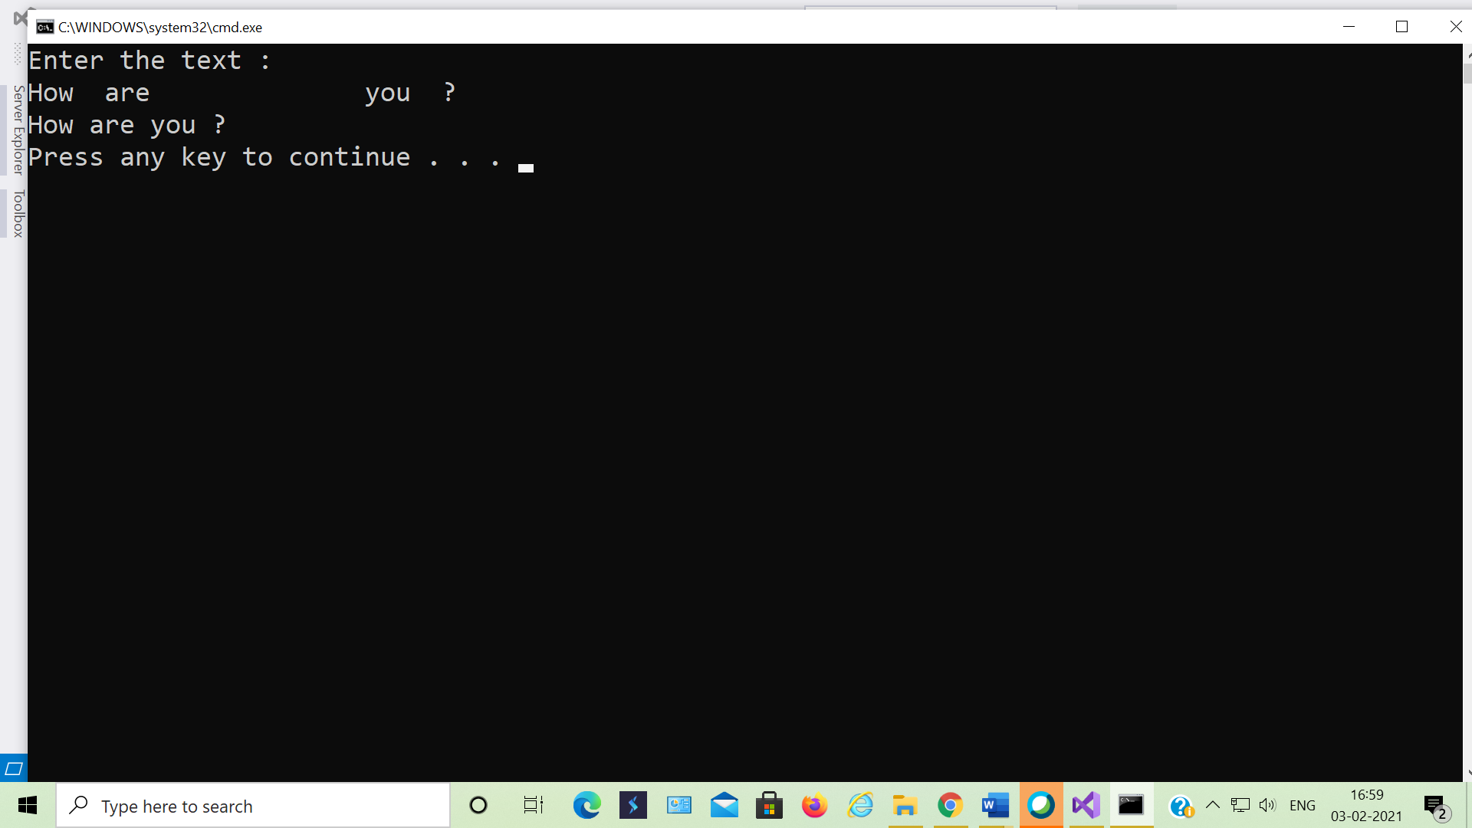

**We have to calculate the percentage of marks obtained in three subjects (each out of 100) by student A and in four subjects (each out of 100) by student B. Create an abstract class 'Marks' with an abstract method 'getPercentage'. It is inherited by two other classes 'A' and 'B' each having a method with the same name which returns the percentage of the students. The constructor of student A takes the marks in three subjects as its parameters and the marks in four subjects as its parameters for student B. Create an object for eac of the two classes and print the percentage of marks for both the students.**

using System;

using System.Collections.Generic;

using System.Linq;

using System.Text;

using System.Threading.Tasks;

namespace Percentageofmarks

{

public abstract class Marks

{

public double res;

public abstract void getPercentage();

}

class A : Marks

{

private float sub1, sub2, sub3;

public A(float s1, float s2, float s3)

{

sub1 = s1;

sub2 = s2;

sub3 = s3;

}

public override void getPercentage()

{

res = (sub1 + sub2 + sub3) / 300.0 * 100;

Console.WriteLine("Student A avg marks is:" + res);

}

}

class B : Marks

{

private float sub1, sub2, sub3, sub4;

public B(float s1, float s2, float s3, float s4)

{

sub1 = s1;

sub2 = s2;

sub3 = s3;

sub4 = s4;

}

public override void getPercentage()

{

res = (sub1 + sub2 + sub3 + sub4) / 400.0 * 100;

Console.WriteLine("Student B avg marks is:" + res);

}

}

class Program

{

public static void Main(String[] args)

{

A a = new A(59,63,79);

B b = new B(86,65,40,87);

a.getPercentage();

b.getPercentage();

}

}

}

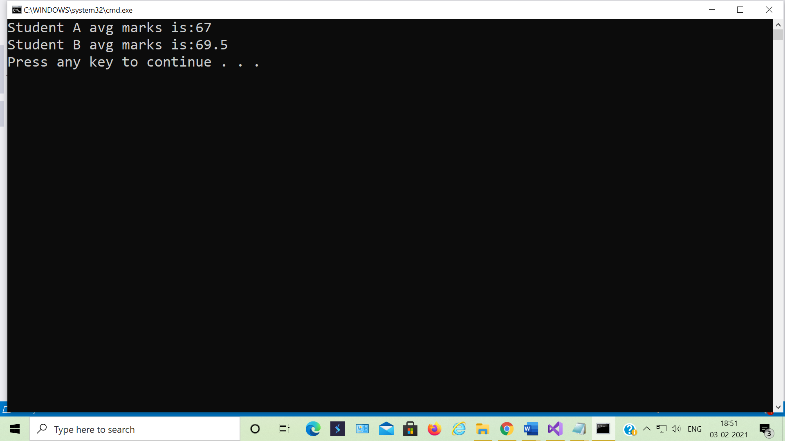

**Create a class named 'Member' having the following members:**

**Data members**

**1 - Name**

**2 - Age**

**3 - Phone number**

**4 - Address**

**5 - Salary**

**It also has a method named 'printSalary' which prints the salary of the members.**

**Two classes 'Employee' and 'Manager' inherits the 'Member' class. The 'Employee' and 'Manager' classes have data members 'specialization' and 'department' respectively. Now, assign name, age, phone number, address and salary to an employee and a manager by making an object of both of these classes and print the same.**

**Telephone numbers are strings of digit characters, they are not integers.**

**Consider for example:**

**Expressing a telephone number in a different base would render it meaningless**

**Adding or multiplying two telephone numbers together, or any math operation on a phone number, is meaningless. The result is not another telephone number (except by conicidence)**

**Telephone numbers are intended to be entered "as-is" into a connected device.**

**Telephone numbers may have leading zeroes.**

**Manipulations of telephone numbers, such as adding an area code, are String operations.**

**Storing the string version of the telephone number makes this clear and unambiguous.**

**Convert.ToInt16 > -65356 to 65356**

**0909898765**

**91-98877665**

**string Phonenum;**

using System;

using System.Collections.Generic;

using System.Linq;

using System.Text;

using System.Threading.Tasks;

namespace Inheritance

{

class Member

{

string name;

int age;

string address;

int salary;

string phone_no;

public virtual void GetDetails()

{

Console.WriteLine("Enter name:");

name = Console.ReadLine();

Console.WriteLine("Enter age:");

age = Convert.ToInt32(Console.ReadLine());

Console.WriteLine("Enter address:");

address = Console.ReadLine();

Console.WriteLine("Enter salary:");

salary = Convert.ToInt32(Console.ReadLine());

Console.WriteLine("Enter phone number:");

phone_no = Console.ReadLine();

if (phone_no == @"^(\+[0-9])$")

{ }

}

public virtual void DisplayDetails()

{

Console.WriteLine("name is:" + name);

Console.WriteLine("age is:" + age);

Console.WriteLine("address is:" + address);

Console.WriteLine("salary is:" + salary);

Console.WriteLine("phone number is is:" + phone_no);

}

public void printSalary()

{

Console.WriteLine("salary is" + salary);

}

}

class Manager : Member

{

string specialization;

string department;

public override void GetDetails()

{

base.GetDetails();

Console.WriteLine("Manager details:");

Console.WriteLine("Enter specialization of member");

specialization = Console.ReadLine();

Console.WriteLine("Enter department of member");

department = Console.ReadLine();

}

public override void DisplayDetails()

{

Console.WriteLine("Manager details is");

base.DisplayDetails();

Console.WriteLine("specialization is:" + specialization);

Console.WriteLine("department is:" + department);

}

}

class Employee : Member

{

string specialization;

string department;

public override void GetDetails()

{

base.GetDetails();

Console.WriteLine("employee details:");

Console.WriteLine("Enter specialization of member");

specialization = Console.ReadLine();

Console.WriteLine("Enter department of member");

department = Console.ReadLine();

}

public override void DisplayDetails()

{

Console.WriteLine("Employee details is");

base.DisplayDetails();

Console.WriteLine("specialization is:" + specialization);

Console.WriteLine("department is:" + department);

}

}

class Program

{

static void Main(string[] args)

{

Member m = new Member();

Manager ma = new Manager();

m = ma;

m.GetDetails();

m.DisplayDetails();

m.printSalary();

Employee e = new Employee();

m = e;

m.GetDetails();

m.DisplayDetails();

m.printSalary();

}

}

}

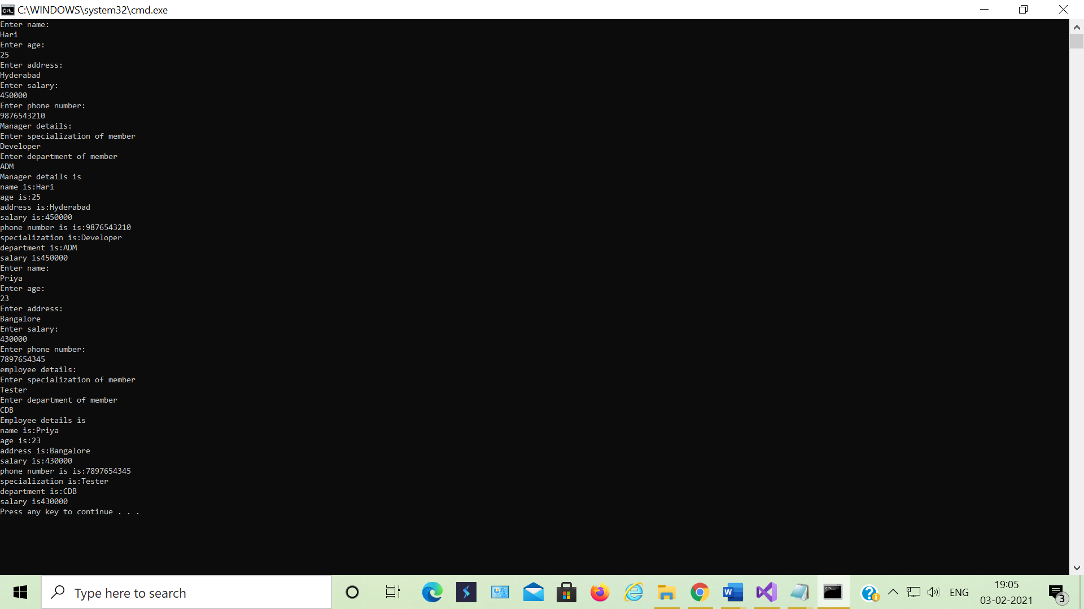

**Create a class Employee with following attributes**

**Empid**

**Name**

**dept**

**Manager**

**Basic Salary**

**Exp**

**Company Name**

**Company Address**

**Depending upon Exp, calculate Net Salary**

**if exp > 10 years , DA = 10% of basic, HRA = 8.5 % of basic , PF = 6200**

**if exp > 7 years and less than 10 years , DA = 7% of basic, HRA = 6.5 % of basic , PF = 4100**

**if exp > 5 years and less than 7 years, DA = 4.1% of basic, HRA = 3.8 % of basic , PF = 1800**

**if exp < 10 years , DA = 1.9% of basic, HRA = 2.0 % of basic , PF = 1200**

**Display the details in proper way**

**You are supposed to do it for some Employees, count is not known. Which loop you will use?**

**1. Understand how you will make this class and add data members**

**2. Create Methods accoringly:**

**a. We know name , dept and manager of Employee**

**b. We know employee id, name , department of Employee**

**c. We know all details about Employee**

**3. Print total number of Employees**

using System;

using System.Collections.Generic;

using System.Linq;

using System.Text;

using System.Threading.Tasks;

namespace NetSalary

{

public class Employee

{

public int Empid;

public string Name;

public string dept;

public string Manager;

public int BasicSalary;

public string CompanyName;

public string CompanyAddress;

public double DA;

public double HRA;

public int PF;

public double gs;

public double ns;

public void GetDetails()

{

Console.WriteLine("enter basic salary");

int BasicSalary = Convert.ToInt32(Console.ReadLine());

Console.WriteLine("enter exp value");

int Exp = Convert.ToByte(Console.ReadLine());

if (Exp > 10)

{

DA = 10 / 100 * BasicSalary;

HRA = 8.5 / 100 * BasicSalary;

PF = 6200;

ns = gs - PF;

}

if (Exp > 7 && Exp < 10)

{

DA = 7 / 100 * BasicSalary;

HRA = 6.5 / 100 * BasicSalary;

PF = 4100;

gs = BasicSalary - DA - HRA;

ns = gs - PF;

}

if (Exp > 5 && Exp < 7)

{

DA = 4.1 / 100 * BasicSalary;

HRA = 3.8 / 100 * BasicSalary;

PF = 1800;

gs = BasicSalary - DA - HRA;

ns = gs - PF;

}

if (Exp < 10)

{

DA = 1.9 / 100 * BasicSalary;

HRA = 2.0 / 100 * BasicSalary;

PF = 1200;

gs = BasicSalary - DA - HRA;

ns = gs - PF;

}

}

public void Display()

{

Console.WriteLine("da is " + DA);

Console.WriteLine("Hra is " + HRA);

Console.WriteLine("pf is " + PF);

Console.WriteLine("grass salary is " + gs);

Console.WriteLine("net salary is " + ns);

}

public void method1(string Name, string dept, string Manager)

{

Console.WriteLine("Name is " + Name);

Console.WriteLine("dept is " + dept);

Console.WriteLine("manager is " + Manager);

}

public void method2(string Name, string dept, int Empid)

{

Console.WriteLine("Name is " + Name);

Console.WriteLine("dept is " + dept);

Console.WriteLine("manager is " + Empid);

}

public void method3(string Name, string dept, int Empid, string Manager, string CompanyName, string CompanyAddress)

{

Console.WriteLine("Name is " + Name);

Console.WriteLine("dept is " + dept);

Console.WriteLine("manager is " + Empid);

Console.WriteLine("manager is " + Manager);

Console.WriteLine("manager is " + CompanyName);

Console.WriteLine("manager is " + CompanyAddress);

}

}

class Program

{

static void Main(string[] args)

{

Employee e = new Employee();

e.GetDetails();

e.Display();

e.method1("Hari", "CSE", "Priya");

e.method2("Hari", "CSE", 123456);

e.method3("Hari", "CSE", 123456, "Deep", "CTS", "Bangalore");

}

}

}

