MedScope


Project seminar report submitted in partial fulfillment of the requirement for the award of the
degree of
BACHELOR OF TECHNOLOGY

IN

COMPUTER SCIENCE AND ENGINEERING
Under the esteemed guidance of
G Santhoshi
Assistant Professor
By
M. Mounika(22R11A05W7)
K. Priyanka(22R11A05W4)
G. Bhavya Sree(22R11A05V9)


Department of Computer Science and Engineering Geethanjali College of Engineering and Technology (Autonomous)
Accredited by NAAC with A⁺ Grade: B.Tech. CSE, EEE, ECE accredited by NBA Sy. No: 33 & 34, Cheeryal (V), Keesara (M), Medchal District, Telangana – 501301
August – 2025

Geethanjali College of Engineering and Technology (Autonomous)
Accredited by NAAC with A⁺ Grade : B.Tech. CSE, EEE, ECE accredited by NBA Sy. No: 33 & 34, Cheeryal (V), Keesara (M), Medchal District, Telangana – 501301

Department of Computer Science and Engineering


Certificate
This is to certify that the B.Tech Project seminar report entitled “MedScope” is a bonafide work done by M.Mounika (22R11A05W7), K. Priyanka (22R11A05W4), and G. Bhavya Sree (22R11A05V9), in partial fulfillment of the requirement of the award for the degree of Bachelor of Technology in “Computer Science and Engineering” from Jawaharlal Nehru Technological University, Hyderabad during the year 2024-2025.
G Santhoshi HoD – CSE
Assistant Professor Dr.E. Ravindra
Professor

Internal Examiner(s):
1:
2:

Geethanjali College of Engineering and Technology (Autonomous)
Accredited by NAAC with A⁺ Grade : B.Tech. CSE, EEE, ECE accredited by NBA Sy. No: 33 & 34, Cheeryal (V), Keesara (M), Medchal District, Telangana – 501301

Department of Computer Science and Engineering


DECLARATION BY THE CANDIDATE
We, M Mounika, K Priyanka, G Bhavya Sree, bearing Roll Nos. 22R11A05W7, 22R11A05W4 and 22R11A05V9, hereby declare that the project seminar report entitled “MedScope” is done under the guidance of Mr./Ms Ms. G Santhoshi, Assistant Professor, Department of Computer Science and Engineering, Geethanjali College of Engineering and Technology, is submitted in partial fulfillment of the requirements for the award of the degree of Bachelor of Technology in Computer Science and Engineering.
This is a record of bonafide work carried out by us and the results embodied in this project have not been reproduced or copied from any source. The results embodied in this project report have not been submitted to any other University or Institute for the award of any other degree or diploma.
M.Mounika (22R11A05W7)
K.Priyanka (22R11A05W4)
G.Bhavya Sree (22R11A05V9)
Department of CSE, Geethanjali College of Engineering and Technology, Cheerya
ACKNOWLEDGEMENT
It is with profound gratitude and sincere appreciation that we extend my heartfelt thanks to all those who have played a significant role in the successful completion of this undergraduate project.
First and foremost, we express our deep sense of respect and gratitude to our Honourable Chairman, Mr. G. R. Ravinder Reddy, for his constant encouragement and for nurturing a culture of academic excellence and innovation within the institution.
We would also like to express my sincere thanks to Dr. S. Udaya Kumar, Director , for his visionary leadership and continued support, which have provided the ideal environment and motivation for academic pursuits such as this project.
Our heartfelt appreciation goes to Dr. K. Sagar, Principal, for his steadfast guidance, infrastructural support, and encouragement that have helped bring this project to successful fruition.
We are deeply grateful to Dr. E. Ravindra, Professor, Head of the Department- CSE, for his academic leadership, valuable feedback, and continuous support throughout the duration of this project.
We extend my sincere thanks to our Project Coordinators, Dr. G.Krishna Lava Kumar and Mr.Naseeruddin,, for their meticulous planning, timely evaluations, and constant coordination that ensured a smooth and structured project development process.
A special note of gratitude is reserved for our project guide, Ms. G Santhoshi , Assistant Professor,whose expert supervision, insightful suggestions, and dedicated mentorship have been instrumental in shaping the direction and outcome of this work.
Lastly,we are ever grateful to our parents and family for their unconditional love, encouragement, and moral support. Their faith in us has been my greatest strength throughout this journey.
With genuine appreciation, we acknowledge every individual who has, in one way or another, contributed to the successful completion of this project.

With warm regards,
M. Mounika (22R11A05W7)
K. Priyanka (22R11A05W4)
G. Bhavya Sree (22R11A05V9)
Department of Computer Science and Engineering Geethanjali College of Engineering and Technology
Table of Contents
Chapter | Title | Page No.
1 | Abstract | 1
2 | Introduction | 2
2.1 | Background | 2
2.2 | Motivation | 2
2.3 | Scope | 2
2.4 | Applications | 2
3 | Problem Identification | 3
3.1 | Problem Statement | 3
3.2 | Objectives | 3
3.3 | Existing System & Limitations | 3
3.4 | Proposed System & Benefits | 3
4 | Literature Review | 4
5 | Project Methodology | 5
5.1 | Overall Approach (Agile) | 5
5.2 | Architecture Diagram | 5
5.3 | Technology Stack | 6
6 | System Design | 7
6.1 | Problem Analysis | 7
6.2 | Design Diagrams | 7
6.2.1 | DFD | 7
6.2.2 | Use Case Diagram | 8
6.2.3 | ER Diagram | 8
6.2.4 | Class Diagram | 9
6.2.5 | Sequence Diagram | 9
6.3 | Module Identification | 10
7 | Proposed Work Plan | 11
8 | Conclusion | 12
9 | References | 13

List of Figures / Diagrams / Graphs / Screenshots

Figure No. | Title | Page No.
Figure 5.2.1 | Architecture Diagram | 5
Figure 6.2.1 | Data Flow Diagram (DFD) | 7
Figure 6.2.2 | Use Case Diagram | 8
Figure 6.2.3 | Entity–Relationship Diagram (ERD) | 8
Figure 6.2.4 | Class Diagram | 9
Figure 6.2.5 | Sequence Diagram | 9

List of Tables

Table No. | Title | Page No.
Table 4.1 | Literature Review Summary Table | 4
Table 7.1 | Proposed Work Plan (Phase-wise Tasks) | 11

List of Abbreviations

Abbreviation | Full Form
AI | Artificial Intelligence
DFD | Data Flow Diagram
ERD | Entity–Relationship Diagram
UI | User Interface
UX | User Experience
CSV | Comma-Separated Values
API | Application Programming Interface
HTML | HyperText Markup Language
CSS | Cascading Style Sheets
JS | JavaScript
CRUD | Create, Read, Update, Delete

1. ABSTRACT

Ensuring timely availability of essential medicines and preventing the circulation of expired drugs are continuing challenges, especially among local and mid-sized pharmacies that still depend on manual stock management. Customers often visit multiple medical stores to locate a required medicine, and due to urgency or lack of awareness, they frequently overlook expiry details. This increases the risk of consuming expired or soon-to-expire medicines.
The proposed Medicine Availability and Tracking System (MedScope) aims to address these challenges by providing a unified digital platform that connects pharmacies and customers. Pharmacies can upload their inventory details, including medicine name, quantity, and expiry dates, while the system intelligently categorizes medicines as Available, Expiring Soon, or Expired. Customers can search for medicines and view which nearby pharmacies stock them, supported through a map-based interface that enhances accessibility.
The system’s objectives include improving transparency, reducing the possibility of expired medicine circulation, and assisting pharmacies in maintaining organized digital records. Through real-time data handling and intuitive interfaces, the proposed solution enhances public safety and simplifies the process of locating medicines across different geographic locations.

2. INTRODUCTION

2.1 Background

Pharmacies play a critical role in the healthcare ecosystem by ensuring the availability of safe and effective medicines. However, traditional pharmacy management heavily relies on manual record-keeping, increasing the chances of expired stock circulation, stockouts, and inefficient customer service.

2.2 Motivation

Customers struggle to find medicines during peak hours, emergencies, or shortages.

Many pharmacies lack digital inventory systems to track expiry dates and stock levels.

There is no unified platform where users can check medicine availability across stores.

MedScope aims to fill these gaps through a central, easily accessible digital solution.

2.3 Scope

Tracks medicine availability at pharmacy level.

Classifies medicines based on expiry.

Provides a consumer-friendly search interface.

Displays nearby pharmacies using location mapping.

Supports inventory upload for pharmacies via CSV.

2.4 Applications

Pharmacy inventory management

Medicine search and availability checking

Safe dispensing practices

Public health monitoring of medicine supply
3. PROBLEM IDENTIFICATION
3.1 Problem Statement
To develop an intelligent and centralized web system that manages pharmacy medicine inventories, tracks expiry status, and assists users in locating available medicines.
3.2 Objectives
- To digitize medicine inventory management for pharmacies.
- To automatically classify medicines by expiry status.
- To provide users a platform to check availability instantly.
- To provide map-based results for locating nearest pharmacy.
- To ensure safe distribution and avoid expired medicine usage.
3.3 Existing System & Limitations
- Existing system refers to manual operations:
- Handwritten records introduce errors and are hard to update.
- No real-time inventory sharing across pharmacies.
- Customers must physically visit pharmacies.
- No automated system for expiry tracking
- Poor accessibility for rural/small pharmacies.
3.4 Proposed System & Benefits
- Proposed system provides
- A unified platform for uploading and managing pharmacy inventory.
- Automated expiry status classification.
- Real-time search and availability checking.
- Map view for locating nearest stocking pharmacy.
- Benefits include enhanced safety, efficient stock handling, improved transparency, and reduced manual effort.

4.LITERATURE REVIEW
Table 4.1
Author & Year | Title & Summary | Relevance to Project | Identified Gaps
Sharma et al. (2021) | Automated Pharmacy Inventory System: Discusses benefits of digital inventory platforms. | Supports digitizing pharmacy stock management. | Lacks geolocation & user-side access.
Li & Wong (2020) | Expiry Tracking in Healthcare: Importance of expiry classification. | Validates need for expiry categorization. | No multi-pharmacy support.
Ahmed (2022) | Location-based healthcare accessibility tools. | Encourages map-based pharmacy locating. | Not medicine-specific.
Rao et al. (2019) | Consumer behavior in medicine purchase. | Highlights difficulty in finding medicines. | No technological solution provided.
Patel (2021) | Stockouts & medicine supply chain. | Shows need for real-time inventory visibility. | Doesn’t involve local pharmacies.
Singh (2020) | Pharmacy digitization challenges. | Supports the need for simple digital tools. | Missing customer interface.
Das et al. (2022) | Public health risks of expired drugs. | Justifies expiry awareness module. | No prevention mechanism included.

5. PROJECT METHODOLOGY
5.1 Overall Approach – Agile Model
The system is developed using an Agile Iterative Approach:
- Requirements gathering
- UI design
- Backend module creation
- Integration
- Testing
- Enhancement based on feedback
5.2 Architecture Diagram
Figure 5.2.1
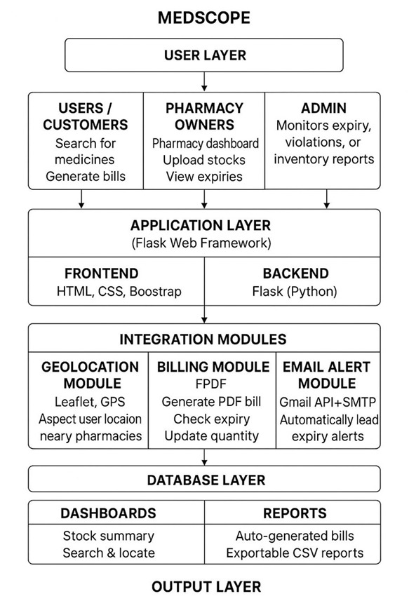
5.3 Technology Stack
- Frontend: HTML, CSS, JS, Bootstrap
- Backend: Python Flask
- Database: Firebase Firestore
- Libraries: Pandas, datetime, FPDF
- APIs: Google Maps / Leaflet
- Tools: VS Code, Git

6. SYSTEM DESIGN
6.1 Problem Analysis
Identified key challenges:
- No centralized system for medicine availability.
- Manual expiry tracking is error-prone.
- Customers face difficulty locating medicines.
- Pharmacies need a simple upload mechanism.
- Proposed solution addresses these with digital inventory, searching, expiry tracking, and maps.
6.2 Design Diagrams (DFD, Use Case, ER, Class, Sequence)

6.2.1 DFD
Figure 6.2.1
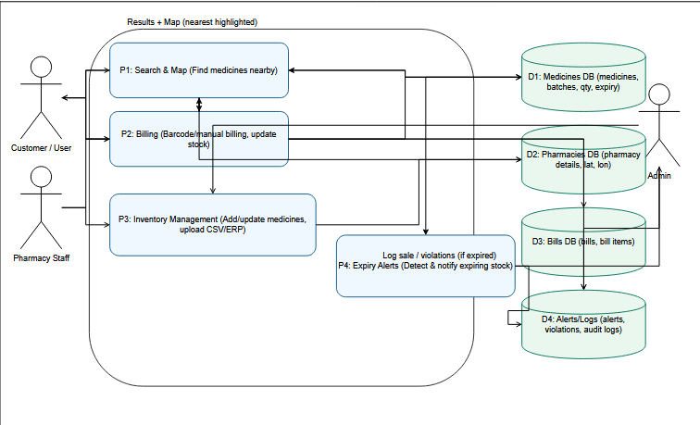

6.2.2 USE CASE
Figure 6.2.2
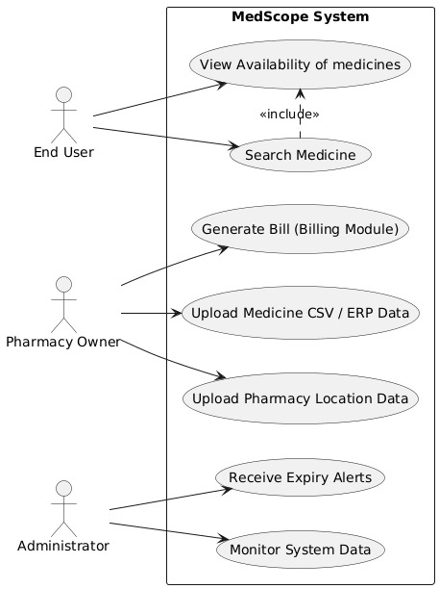
6.2.3 ENTITY RELATIONSHIP
Figure 6.2.3

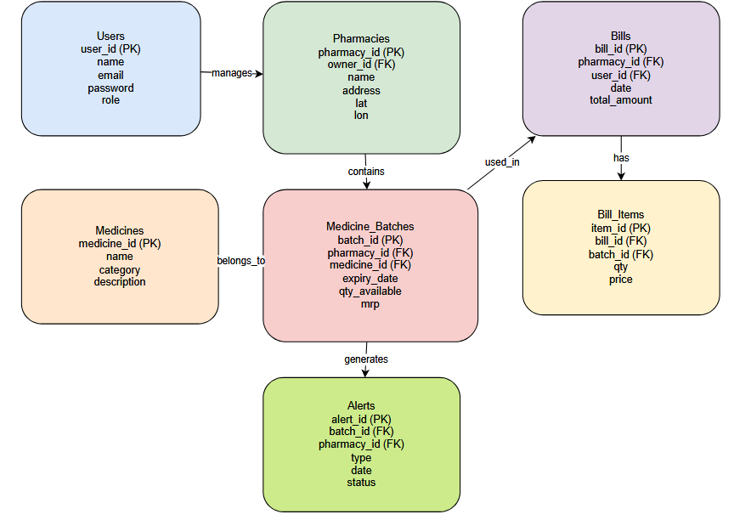
6.2.4 CLASS
Figure 6.2.4
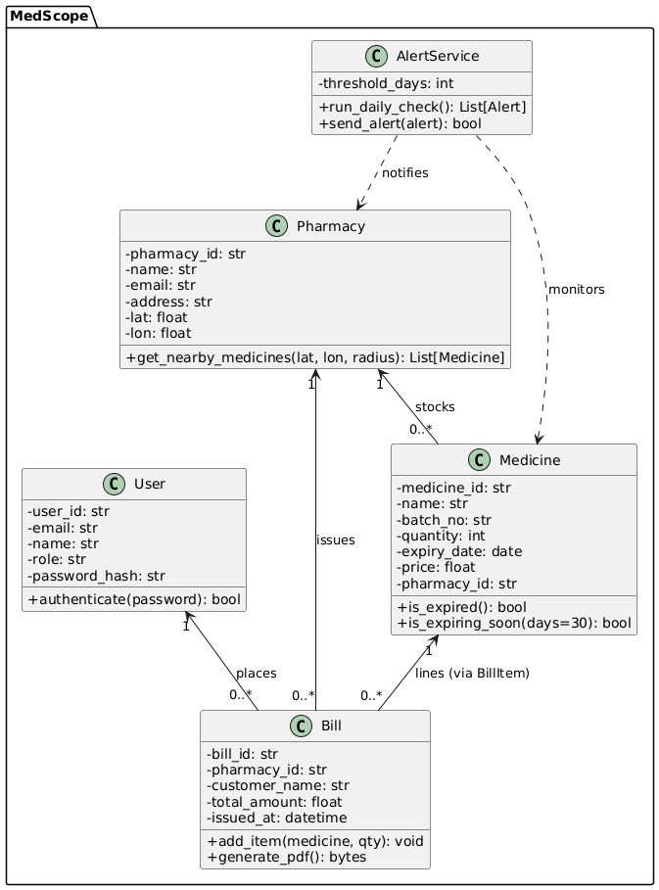
6.2.5 SEQUENCE
Figure 6.2.5
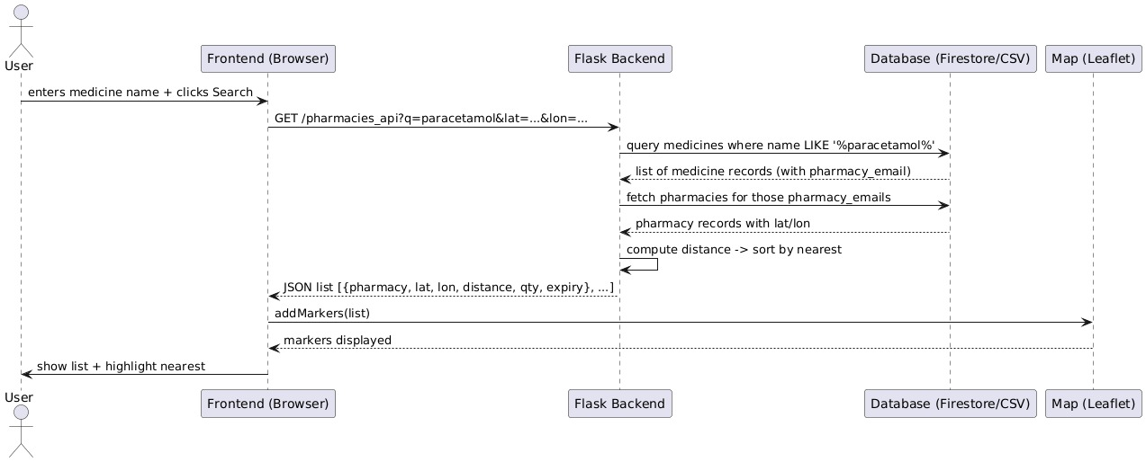
6.3 Module Identification
Modules:
- Pharmacy Inventory Upload Module
- Expiry Classification Module
- Medicine Search Module
- Pharmacy Locator Module
- Data Management Module

7. PROPOSED WORK PLAN
Table 7.1
Phase | Tasks | Deliverables
Phase 1 | Requirement analysis, literature review, initial UI/UX design | Synopsis, initial design diagrams
Phase 2 | Backend setup, database structure definition, basic medicine search module | Working prototype
Phase 3 | Map integration, medicine availability logic, expiry categorization module | Fully functional system
Phase 4 | Testing, debugging, performance improvements, documentation | Final report, screenshots

8. CONCLUSION
The Medicine Availability and Tracking System effectively bridges critical gaps in pharmacy accessibility, medicine availability verification, and patient safety by digitalizing the management of medicine inventories. The system’s primary contribution lies in providing a centralized, structured, and real-time platform that enables users to search, track, and verify the availability and expiry status of medicines across pharmacies. Throughout the semester, the project established a strong foundation through requirement analysis, literature survey, system modeling, UML diagrams, database structure planning, and preliminary prototype development. These steps collectively ensured that the system’s design aligns with real-world healthcare needs and industry workflows.
The study and implementation underscored the importance of reducing manual dependency, preventing medicine wastage due to expiry, and supporting timely patient access to essential drugs. By promoting transparency between pharmacies and consumers, the system helps address issues like medicine unavailability, counterfeit drug circulation, and delayed procurement. The system also demonstrates scalability for future integration with hospitals, medical suppliers, and government health platforms.

9. REFERENCES
- Sharma, K., & Verma, A. (2021). Automated Inventory Systems in Pharmacies. Journal of Health Informatics.
- Li, X., & Wong, T. (2020). Digital Management of Drug Expiry in Healthcare. International Journal of Medical Systems.
- Ahmed, R. (2022). Location-based Healthcare Systems. IEEE Access.
- Rao, S. (2019). Consumer Challenges in Medicine Availability. Pharma Journal.
- Patel, M. (2021). Drug Stockout Factors in Developing Regions. Journal of Pharma Logistics.
- Singh, P. (2020). Digital Transformation for Pharmacies. Healthcare IT Review.
- Das, S. (2022). Public Health Impact of Expired Medicines. Indian Journal of Pharmacology.

