**Exp 12: Implement Cursors**

create table cur(id integer, marks integer);

insert into cur (id, marks) values (1, 30), (2, 40), (3, 50), (5, 60), (6, 70);

DELIMITER //

create procedure cursor_marks(id1 int)

begin

declare m1 int;

declare cur1 cursor for select marks from cur where id = id1;

open cur1;

fetch cur1 into m1;

select m1;

close cur1;

end //

DELIMITER ;

call cursor_marks(2);

Output:

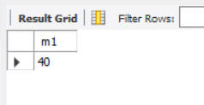

DELIMITER //

create procedure cur_max()

begin

declare m2 int;

declare cur2 cursor for select max(marks) from cur;

open cur2;

fetch cur2 into m2;

select m2;

close cur2;

end //

DELIMITER ;

call cur_max();

Output:

