**Exp No:7 Practice Queries using ANY, ALL, IN, EXISTS, UNION Operators**

**#ANY**

select BNAME from boats

where BID = any (select BID from reserves where day = '2018-01-27');

select * from reserves;

Output:

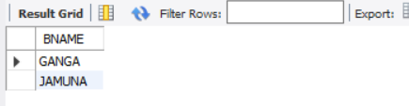

**#ALL**

select all BCOLOR from boats where True;

Output:

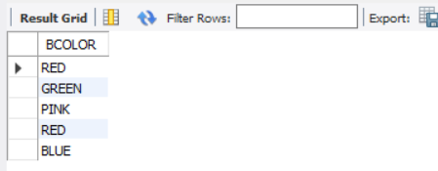

**#EXISTS**

select BNAME from boats

where exists

(select SNAME from sailors where boats.BID = sailors.SID

and RATING > 8);

Output:

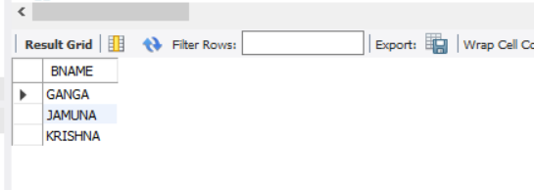

#IN

select * from boats

where BCOLOR in ('RED', 'GREEN');

Output:

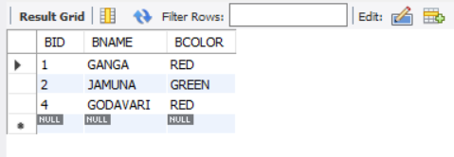

#UNION

select BNAME from boats

union

select SNAME from sailors;

Output:

