**Exp No 8: Practice Queries using Aggregate functions, Group By, Having Clause and Order by Clause.**

**#Aggregate Functions**

**#Count**

select count(roll_no) from marks

where DBMS > 22;

Output:

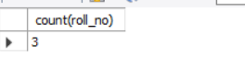

**#Average**

select avg(OS) from marks;

Output:

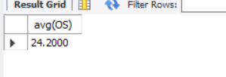

**#Sum**

select sum(BEFA) from marks;

Output:

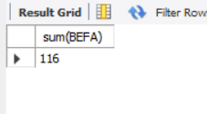

**#Min**

select min(DBMS) as lowestMarks from marks;

Output:

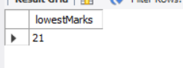

**#Max**

select max(DBMS) as HighestMarks from marks;

Output:

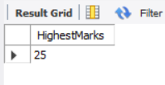

**#Group By**

select count(roll_no), BEFA from marks

group by BEFA;

Output:

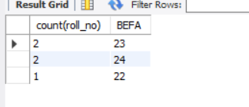

**#Having Clause**

select count(roll_no), OS from marks

group by OS

having count(roll_no) > 2;

Output:

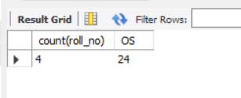

**#Order by Clause**

select roll_no, attendance from academic_details

order by attendance;

Output:

