SHOPEZ
E-COMMERCE APPLICATION
Prepared in partial fulfillment of [MERN Stack]
At
APSCHE Short-Term Virtual Internship Program
Under the guidance of
SmartBridge
Team Members
Vamsi Krishna Sinisetti
Allam Devi Mounika
Reddy Venkata Surya Chakra Mahalakshmi
Dhullipalla Radhika
Vijendra Kumar Mummidi

ACKNOWLEDGEMENT
I would like to express my heartfelt gratitude to all those who have contributed to the successful completion of the ShopEZ project. This opportunity has been an enriching and rewarding experience, and I am truly thankful for the support, guidance, and encouragement I have received along the way.
I extend my sincere regards to my supervisor and mentor for providing valuable insights, constant guidance, and unwavering support throughout the duration of this project. Their expertise and encouragement have been instrumental in shaping the direction of this work.
I would also like to thank SmartBridge and the APSCHE Short-Term Virtual Internship Program for fostering a collaborative and innovative environment. The knowledge sharing and feedback I received from my teammates significantly contributed to the development and success of this project.
In conclusion, I am grateful to have had the opportunity to work on this project, and I look forward to leveraging the skills and knowledge gained to contribute positively to future endeavours.
Thank You,
Sincerely,
Vamsi Krishna Sinisetti
Allam Devi Mounika
Reddy Venkata Surya Chakra Mahalakshmi
Dhullipalla Radhika
Vijendra Kumar Mummidi

ABSTRACT
ShopEZ is a full-stack e-commerce web application designed to give shoppers a fast, user-friendly platform for browsing products, managing a cart, and placing orders, while giving sellers a dedicated dashboard to manage inventory and track sales. Finding the perfect items is made simple through a searchable, category-filterable product catalog with detailed descriptions and clear pricing, backed by a secure checkout process that produces an instant order confirmation.
The application is built using the MERN stack — MongoDB, Express.js, React.js, and Node.js — with a fast, component-based React (Vite) frontend styled using Bootstrap, and a RESTful Express.js backend. Product and order data are persisted in MongoDB via Mongoose, and full CRUD (Create, Read, Update, Delete) operations are supported for products and orders. A role-based admin dashboard presents key metrics such as total products, total orders, pending orders, and total revenue, giving administrators an at-a-glance view of business performance.
The project follows a modular structure with separate directories for routes, controllers, models, and middleware on the backend, and components, pages, context, and services on the frontend, making the codebase maintainable and easy to extend. Role-based access control implemented using JWT (JSON Web Tokens) and bcrypt-based password encryption ensures secure access for regular users and administrators, and product images are handled through Multer-based file uploads.
This report documents the complete lifecycle of the project, including the methodology adopted, the system design and architecture, the implementation details for each module, the results obtained through functional and API-level testing, and the conclusions drawn, along with directions for future enhancement.

TABLE OF CONTENTS
1. Introduction
2. Methodology
3. System Design
4. Implementation
5. Results
6. Conclusion

1. INTRODUCTION

1.1 Background
Online shopping has become one of the most common ways people purchase goods, and the underlying platform's usability directly shapes how confidently a shopper browses, compares, and buys. As product catalogs grow, customers need fast search and filtering, clear product information, and a checkout process they can trust, while the businesses running the store need a simple way to keep inventory and orders under control without relying on spreadsheets or expensive third-party platforms.

1.2 Problem Statement
Small sellers and student projects often lack a simple, self-hosted system to list products, accept orders, and track fulfilment status without the cost and complexity of a full commercial e-commerce suite. There is a need for a lightweight web application that lets customers browse and purchase products through an intuitive interface, while giving an administrator complete control over the product catalog and order pipeline through a single dashboard.

1.3 Objectives
- To design and develop a full-stack web application for online product browsing and purchasing.
- To implement a searchable, filterable product catalog with detailed product pages.
- To build a persistent shopping cart and a secure checkout flow that generates real orders.
- To provide an admin dashboard summarizing products, orders, pending orders, and revenue.
- To implement complete CRUD functionality for products and order status management.
- To design a clean, responsive, and user-friendly interface.
- To implement secure, role-based access for customers and administrators.
- To structure the codebase in a modular and maintainable way.
- To version-control the project using Git and host it on GitHub.

1.4 Scope of the Project
The scope of this project covers the design, development, and local deployment of a web-based e-commerce platform. It includes user registration and login, product browsing with search and category filtering, product detail views, cart management, checkout and order placement, a profile page with order history, and an admin dashboard for product and order management. The scope also extends to product image uploads, though the application is intended as a demonstrable, project-scale platform rather than a production payment-processing system.

1.5 Organization of the Report
This report is organized into six chapters. Chapter 2 discusses the methodology and technology stack adopted for the project. Chapter 3 presents the system design, covering the overall design approach, data design, use cases, and interface design considerations. Chapter 4 details the implementation, including the project file structure and an explanation of how each module of the application was built. Chapter 5 presents the results and testing outcomes obtained from the completed application, supported by screenshots of the working system. Chapter 6 concludes the report and outlines directions for future work.

1.6 Significance of the Project
Beyond its immediate functionality, this project served as a practical exercise in building a complete, production-oriented e-commerce web application from the ground up. It required working across the full stack — from designing a data model that links users, products, and orders, to writing server-side business logic for stock management, to building a responsive and data-driven user interface, to implementing secure, role-based authentication. This end-to-end exposure mirrors the kind of work expected in real-world software development roles, where a developer is responsible not just for writing application code but also for how product and order data is validated, secured, and presented meaningfully to end users.

1.7 Existing Systems and Motivation
Several commercial platforms already offer full e-commerce capabilities, ranging from hosted storefront builders to enterprise-grade marketplaces. While these platforms are powerful, they are often designed for large organizations, come with recurring subscription or transaction fees, and require integration effort that may not be justified for a smaller seller, a student project, or an internal tool. Many of them also operate as closed, third-party services, meaning product and customer data is stored outside the organization's own infrastructure.
This project was motivated by the gap between these heavyweight commercial solutions and the simpler needs of an individual seller or a student project. By building a self-hosted application with a well-understood MERN technology stack, product and order data remains entirely under the owner's control, the system can be modified freely to fit specific needs, and there are no ongoing licensing costs. The trade-off is that certain advanced features — such as integrated payment gateways — are necessarily simpler than what a large commercial platform might offer, but as demonstrated in Chapter 5, this trade-off is reasonable for the scale the application is intended to handle.

2. METHODOLOGY

2.1 Development Approach
The project was developed using an iterative and incremental approach inspired by Agile principles. The application was broken down into functional modules — user authentication, product catalog, cart and checkout, order management, and the admin dashboard — each of which was designed, implemented, and tested independently before integration. This approach allowed early identification of issues and continuous refinement of the user interface and backend logic.
Work was carried out in short, focused cycles. Each cycle began with identifying a single piece of functionality, followed by building the minimum backend logic needed to support it, connecting that logic to a simple view, and then testing it manually before moving on to the next piece. This kept the codebase in a working state at almost every stage of development, rather than leaving large parts of the application unfinished until the very end.

2.2 Requirement Analysis
Before development began, the requirements of the system were separated into functional and non-functional categories. This helped clarify not only what the application needed to do, but also the quality standards it needed to meet.
Functional requirements included: allowing a user to register and log in securely; allowing products to be browsed, searched, and filtered by category; enabling items to be added to a persistent cart and checked out into a real order; presenting a profile page with order history; and allowing an administrator to add, edit, and delete products and update order status.
Non-functional requirements included: the interface should remain usable and readable on both desktop and mobile screen sizes; cart totals should update instantly, with no perceptible delay to the user; the codebase should be organized in a way that a new developer could understand and extend it without difficulty; and access to administrative functions should be enforced consistently and securely across every backend endpoint.

2.3 Technology Stack
Layer | Technology Used | Purpose
Frontend | React.js (Vite), Bootstrap 5 | Building a fast, component-driven, responsive user interface
Backend | Node.js, Express.js | Server-side logic and RESTful API routing
Database | MongoDB, Mongoose ODM | Persistent storage of users, products, and orders
Authentication | JWT (jsonwebtoken), bcryptjs | Secure, role-based authentication and password hashing
File Uploads | Multer | Handling product image uploads from the admin panel
HTTP Client | Axios | Communication between the React frontend and Express backend
Version Control | Git, GitHub | Source code management and collaboration
API Testing | Postman | Testing and validating REST API endpoints

2.4 Justification of Technology Choices
Node.js and Express.js were chosen for the backend because of their lightweight, non-blocking architecture, which is well suited to an application that needs to handle many short-lived requests, such as product searches and cart updates, without the overhead of a heavier framework. Express in particular offers a minimal, unopinionated routing layer that made it straightforward to keep routes, controllers, and models cleanly separated.
React.js, scaffolded with Vite, was selected for the frontend because its component-based architecture made it easy to build reusable product cards, cart views, and admin forms, while keeping the interface responsive to real-time changes in cart contents. Vite's fast development server and hot module reloading made the iterative build-test cycle significantly quicker than a traditional bundler setup.
MongoDB was chosen over a relational alternative because product and order data is naturally document-oriented — a single order can contain a variable number of line items, each with its own snapshot of product name, price, and image — and MongoDB's flexible schema accommodates this variability without requiring complex joins. Mongoose was layered on top to provide schema validation and a clean, model-based interface to the database.
JWT-based authentication combined with bcrypt password hashing was chosen because it requires no server-side session storage, scales cleanly across multiple backend instances, and is a well-established, secure pattern for enforcing role-based access control between regular users and administrators.

2.5 Development Tools
- Visual Studio Code — source code editor
- Node Package Manager (npm) — dependency management
- MongoDB Compass — local database design and querying
- Postman — API testing
- Git & GitHub — version control and repository hosting
- Google Chrome DevTools — UI testing and debugging

2.6 Testing Methodology
Testing was carried out continuously alongside development rather than as a separate phase at the end of the project. Each backend route was tested in isolation using Postman before its corresponding frontend view was built, which made it possible to confirm that the correct data was being returned and that authentication tokens were being issued and validated correctly before any UI code was written. Once views were connected, manual end-to-end testing was performed by using the application as a real customer and as an administrator would — registering, browsing products, adding items to the cart, checking out, and reviewing order history, and separately, logging in as an administrator to add products and update order status. Edge cases such as incomplete registration forms, unauthorized access attempts to admin-only routes, and out-of-stock scenarios were also tested to confirm that the application handled them gracefully.

2.7 Development Life Cycle
The project followed these stages: requirement analysis, system design (design approach and data design), implementation of backend routes and frontend views, integration of role-based authentication, testing of CRUD operations and order accuracy, and finally preparation of the deployment configuration. Each stage fed directly into the next, with lessons learned during implementation and testing occasionally looping back to refine the original design decisions — consistent with the iterative philosophy described at the start of this chapter.

3. SYSTEM DESIGN

3.1 Design Approach
The application follows a Model-View-Controller (MVC) inspired design, which is the natural pattern for Express.js applications paired with a React frontend. In this design, incoming requests from the browser are first received by the routing layer, which determines which piece of business logic should handle the request. The business logic itself lives in the controller layer, where tasks such as validating input, checking stock levels, and reading from or writing to the database take place. Once the controller has gathered or updated the necessary data, it returns a JSON response that the React frontend consumes and renders — keeping presentation entirely separate from business logic.
This separation also made the project easier to build incrementally. The routing and controller logic could be developed and tested using Postman before any of the React views existed, and the views could later be refined for appearance and responsiveness without needing to touch the underlying business logic or database queries.

3.2 Data Design
The application's data design is centered around three core collections: Users, Products, and Orders. The Users collection stores authentication credentials, contact details, and role information (USER or ADMIN). The Products collection stores each item's name, description, price, category, stock quantity, and image path. The Orders collection stores a snapshot of the products purchased — including name, image, and price at the time of purchase — along with the total amount, shipping address, and a status field that tracks the order's fulfilment stage.
Data integrity is maintained at the application layer: placing an order decrements the corresponding product's stock quantity at the same time the order document is created, so the stored stock level always reflects what has actually been sold rather than becoming stale or inconsistent.

3.3 Use Case Design
The system supports two broad categories of users: customers who browse products and place orders, and administrators who manage the product catalog and fulfil orders. The key interactions between these users and the system are summarized below.
Actor | Use Case
Visitor | Browse featured products on the home page and view the full catalog without logging in
Registered User | Register, log in, search/filter products, add items to cart, and place an order
Registered User | View and edit profile details and review personal order history
Administrator | View dashboard statistics (products, orders, pending orders, revenue)
Administrator | Add, edit, and delete products, including uploading a product image
Administrator | View all customer orders and update order status

3.4 UI Design Considerations
The interface was designed to be minimal, responsive, and accessible on both desktop and mobile devices using Bootstrap's grid system and utility classes. A card-based layout is used for product listings and dashboard statistics, and clearly labelled forms are used for registration, login, and product management, with a dedicated order summary panel used to communicate cart totals and shipping details during checkout.
Consistent spacing, a restrained colour palette anchored around a dark navy navigation bar and an orange accent colour, and clear typography were prioritized throughout so that both the shopping experience and the admin screens remain easy to scan at a glance, even as the number of products and orders grows over time.

3.5 Design Considerations for Reliability
A few additional design considerations were factored in to keep the application dependable in everyday use. Server-side validation ensures that a product cannot be saved without its required fields, and that an order cannot be placed with an empty product list, reducing the chance of incomplete or meaningless records reaching the database. Role-based middleware guards every admin-only route, preventing unauthorized access to product management or order status updates even if a request is crafted directly against the API. Multer-based upload handling isolates product images in a dedicated uploads directory, keeping binary file storage separate from the structured data in MongoDB.

3.6 Assumptions and Constraints
The design of the system rests on a small number of assumptions. It is assumed that the catalog will be managed by a single administrator role rather than requiring multiple seller accounts, and that checkout represents order placement rather than live payment capture, since integrating a production payment gateway was outside the scope of this project.
A number of constraints were also accepted as reasonable trade-offs for the scope of this project. The application does not currently integrate with a real payment provider or shipment tracking service; this was considered acceptable for a project-scale deployment but would need to be addressed before commercial use. These constraints are revisited in Chapter 6 as part of the discussion of future scope.

4. IMPLEMENTATION

4.1 Project File Structure
The project is organized into two top-level folders, client and server, so that the frontend and backend can be developed, run, and deployed independently. Within the server folder, the code is separated into controllers (business logic for authentication, products, and orders), routes (mapping URLs to controller functions), models (Mongoose schema definitions for User, Product, and Order), and middleware (JWT authentication, admin role checking, and Multer file uploads). Within the client folder, the React application is organized into components (reusable UI such as the navigation bar, product cards, and protected routes), context (global state for authentication and the cart), pages (one file per route, such as Home, Products, Cart, and the admin screens), and services (a centralized Axios wrapper for all API calls).
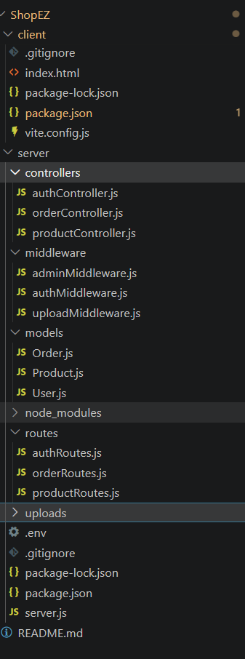 | 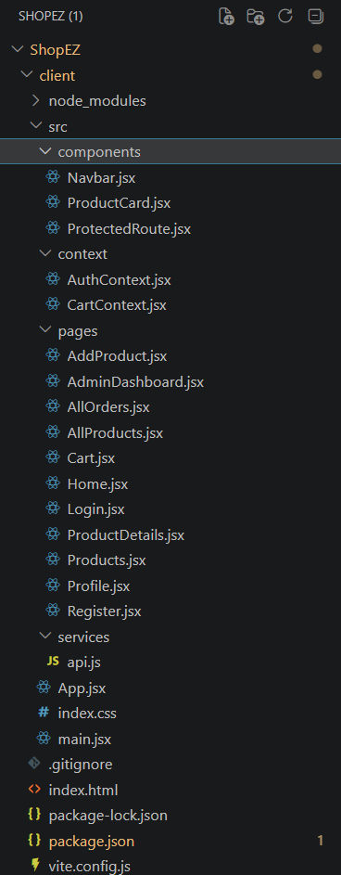
Server (left) and client (right) project file structure

4.2 Backend Implementation
The backend was built using Node.js with the Express.js framework. The main server file initializes the Express application, configures JSON body parsing and CORS, registers the API routes, and connects to MongoDB using Mongoose. It also loads environment variables such as the port number, database connection string, and JWT secret from a dedicated .env file, keeping sensitive information out of the source code.
The routing layer defines the application's endpoints: routes for user registration, login, and profile management; routes for listing, searching, adding, editing, and deleting products; and routes for placing orders, listing orders, and updating order status. Each route delegates the actual work to a corresponding function in the controller layer, keeping the routing definitions short and readable. A summary of the core API endpoints is given below.
Method | Endpoint | Access | Description
POST | /api/auth/register | Public | Register a new user account
POST | /api/auth/login | Public | Authenticate a user and issue a JWT
GET | /api/auth/profile | User | Fetch the logged-in user's profile and order history
PUT | /api/auth/profile | User | Update name, phone, address, or password
GET | /api/products | Public | List all products, with search and category filters
GET | /api/products/:id | Public | Fetch a single product's details
POST | /api/products/add | Admin | Add a new product, including image upload
PUT | /api/products/:id | Admin | Edit an existing product
DELETE | /api/products/:id | Admin | Delete a product
POST | /api/orders | User | Place a new order and decrement stock
GET | /api/orders | User/Admin | List the current user's orders, or all orders for admin
GET | /api/orders/:id | User/Admin | Fetch a single order's details
PUT | /api/orders/:id | Admin | Update an order's status

A representative excerpt from the order controller is shown below. It illustrates how an order is created and how the corresponding product's stock is decremented within the same request, keeping stock figures consistent with what has actually been purchased.
// server/controllers/orderController.js (excerpt)
exports.placeOrder = async (req, res) => {
const { products, shippingAddress } = req.body;
let totalAmount = 0;

for (const item of products) {
const product = await Product.findById(item.product);
if (!product || product.stock < item.quantity) {
return res.status(400).json({ message: "Insufficient stock" });
}
product.stock -= item.quantity;
totalAmount += product.price * item.quantity;
await product.save();
}

const order = await Order.create({
userId: req.user._id, products, totalAmount, shippingAddress,
});
res.status(201).json(order);
};

4.3 Product Catalog and Cart Module
Product browsing is handled by a dedicated controller that supports listing all products as well as filtering by name and category via query parameters, and fetching a single product's full details for the product detail page. On the frontend, the cart is managed through a dedicated CartContext that holds the list of items, their quantities, and derived totals, and persists the cart to local storage so that a customer's selections survive a page refresh. Adding a product from the catalog, updating its quantity in the cart, and removing it are all handled through this shared context so that the cart badge in the navigation bar, the cart page, and the checkout summary always stay in sync.

4.4 Checkout and Order Management Module
When a customer checks out, the cart contents and shipping address are submitted to the order endpoint, which validates the request, creates a new order document with a snapshot of each product's name, image, and price at the time of purchase, and decrements the corresponding stock quantity for each product. The newly created order is immediately visible in the customer's profile page under order history, and in the administrator's order management screen, both with a status of PENDING. Administrators can then progress each order through PROCESSING, SHIPPED, DELIVERED, or CANCELLED using a status dropdown, without needing direct database access.

4.5 Database Layer
The MongoDB database consists of three primary collections: Users, Products, and Orders. The Users collection stores hashed credentials, contact details, and role information. The Products collection stores name, description, price, category, stock quantity, and an image path populated by the Multer upload middleware. The Orders collection stores an embedded array of order line items (each referencing the originating product by ID while also snapshotting its name, image, and price), the order total, shipping address, and status. This schema is intentionally kept document-oriented, since an order's contents should remain historically accurate even if a referenced product's price or details change later.

4.6 Frontend Implementation
The frontend is built using React.js and Vite, with React Router managing navigation between the home, products, product detail, cart, login, register, profile, and admin pages. A shared Navbar component is included on every page, displaying the cart item count and switching between Login/Register and a Logout button depending on whether a user is authenticated, and showing an additional Admin Dashboard link for administrator accounts. AuthContext holds the logged-in user's details and JWT token, while ProtectedRoute wraps admin-only pages so that they redirect unauthenticated or non-admin users away automatically.
Styling is handled through Bootstrap combined with custom CSS that defines the overall layout, colour scheme, card styling, and responsive behaviour so that the interface adapts cleanly to smaller screens. Axios is used throughout the frontend via a centralized api.js service, which attaches the JWT token to authenticated requests and handles error responses consistently.
A representative excerpt from CartContext is shown below, illustrating how items are added to the cart and how the cart is persisted to local storage so it survives a page refresh.
// client/src/context/CartContext.jsx (excerpt)
const addToCart = (product, qty = 1) => {
setCart((prev) => {
const existing = prev.find((i) => i._id === product._id);
const updated = existing
? prev.map((i) => i._id === product._id
? { ...i, quantity: i.quantity + qty } : i)
: [...prev, { ...product, quantity: qty }];
localStorage.setItem("cart", JSON.stringify(updated));
return updated;
});
};

4.7 Role-Based Security Implementation
JWT (JSON Web Tokens) are issued upon successful login and are required for all subsequent authenticated requests. Passwords are hashed using bcryptjs before being stored, ensuring that plain-text credentials are never persisted. Express middleware (authMiddleware) verifies the JWT on every protected route, and a second layer of middleware (adminMiddleware) checks the user's role before allowing access to role-restricted functionality, such as adding products or updating order status. This ensures that administrative functions remain accessible only to authorized accounts throughout the user journey.

4.8 Git and GitHub Setup
The project was version-controlled using Git from the outset. A local Git repository was initialized in the project folder, all project files were staged and committed with descriptive commit messages, and the repository was then linked to a remote repository on GitHub and pushed to the main branch. This provides a complete history of changes and a central location from which the project can be cloned, reviewed, or deployed.

4.9 Challenges Faced During Implementation
A few practical challenges came up during implementation. Keeping stock quantities accurate at the moment of checkout was one of them: since multiple items can be purchased in a single order, stock had to be decremented for every line item atomically with order creation, otherwise a race condition could allow stock to go negative under concurrent checkouts. This was resolved by performing the stock update and order creation within the same controller function, with validation of available stock before the order is confirmed.
Another challenge was keeping the cart consistent across page reloads without a dedicated backend cart endpoint. This was addressed by persisting cart state to local storage from within CartContext, so the cart survives a refresh while still being fully re-validated (price and stock) against the server at checkout time.
Finally, implementing role-based access required care to ensure that every admin-only route was consistently protected, both in the Express backend and in the React frontend. This was addressed by centralizing role-checking logic into a single reusable adminMiddleware function on the backend and a single ProtectedRoute component on the frontend, so there was only one place in the codebase responsible for enforcing access control in each layer, reducing the risk of an unprotected route being introduced by accident.

5. RESULTS

5.1 Functional Outcomes
The application was successfully developed and tested locally. Customers are able to register, log in, browse and search the product catalog, add items to a persistent cart, and complete checkout, with each order immediately reflected in both the customer's profile and the administrator's order management screen. CRUD operations were verified across all core modules: products can be created, viewed, edited, and deleted from the admin panel, and order status can be updated through its full lifecycle.

5.2 Application Walkthrough
The screenshots below were captured from the running application and illustrate the core customer and administrator flows, from browsing the storefront through to fulfilling an order.
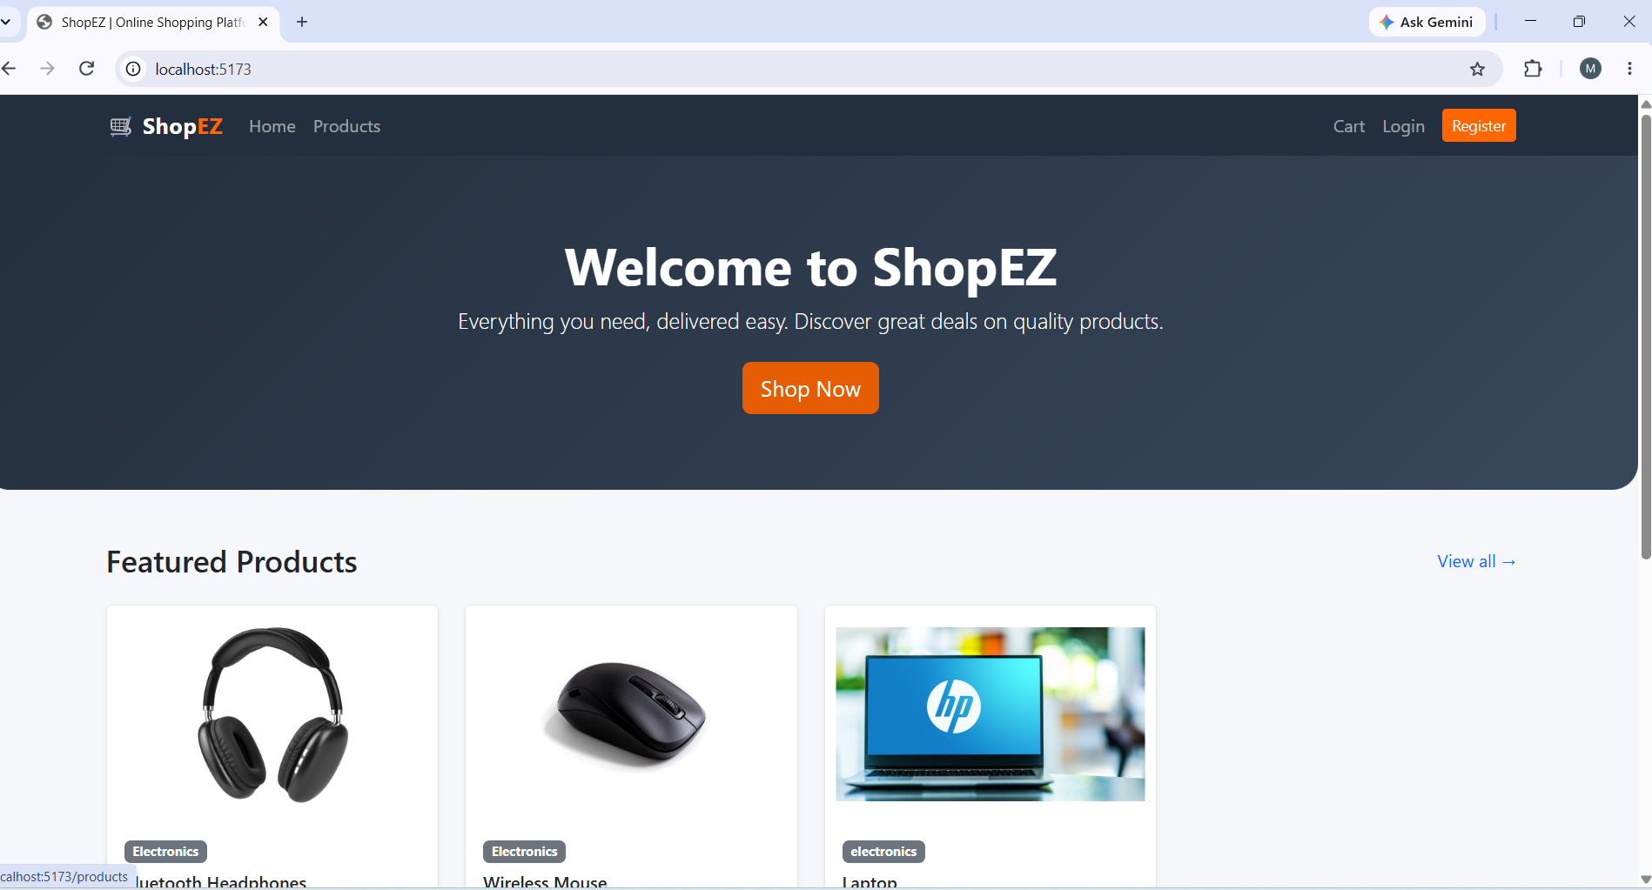
Landing Page: This is the landing page of the application.
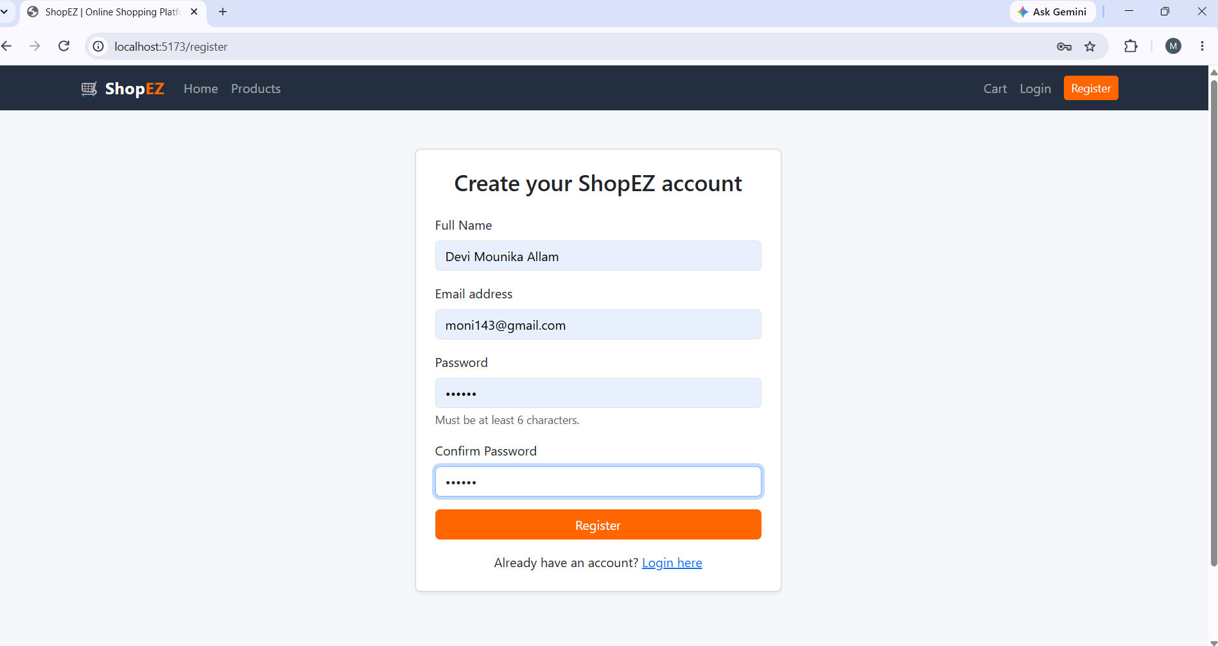
Authentication: This is the registration page where we need to register the application by entering the inputs.
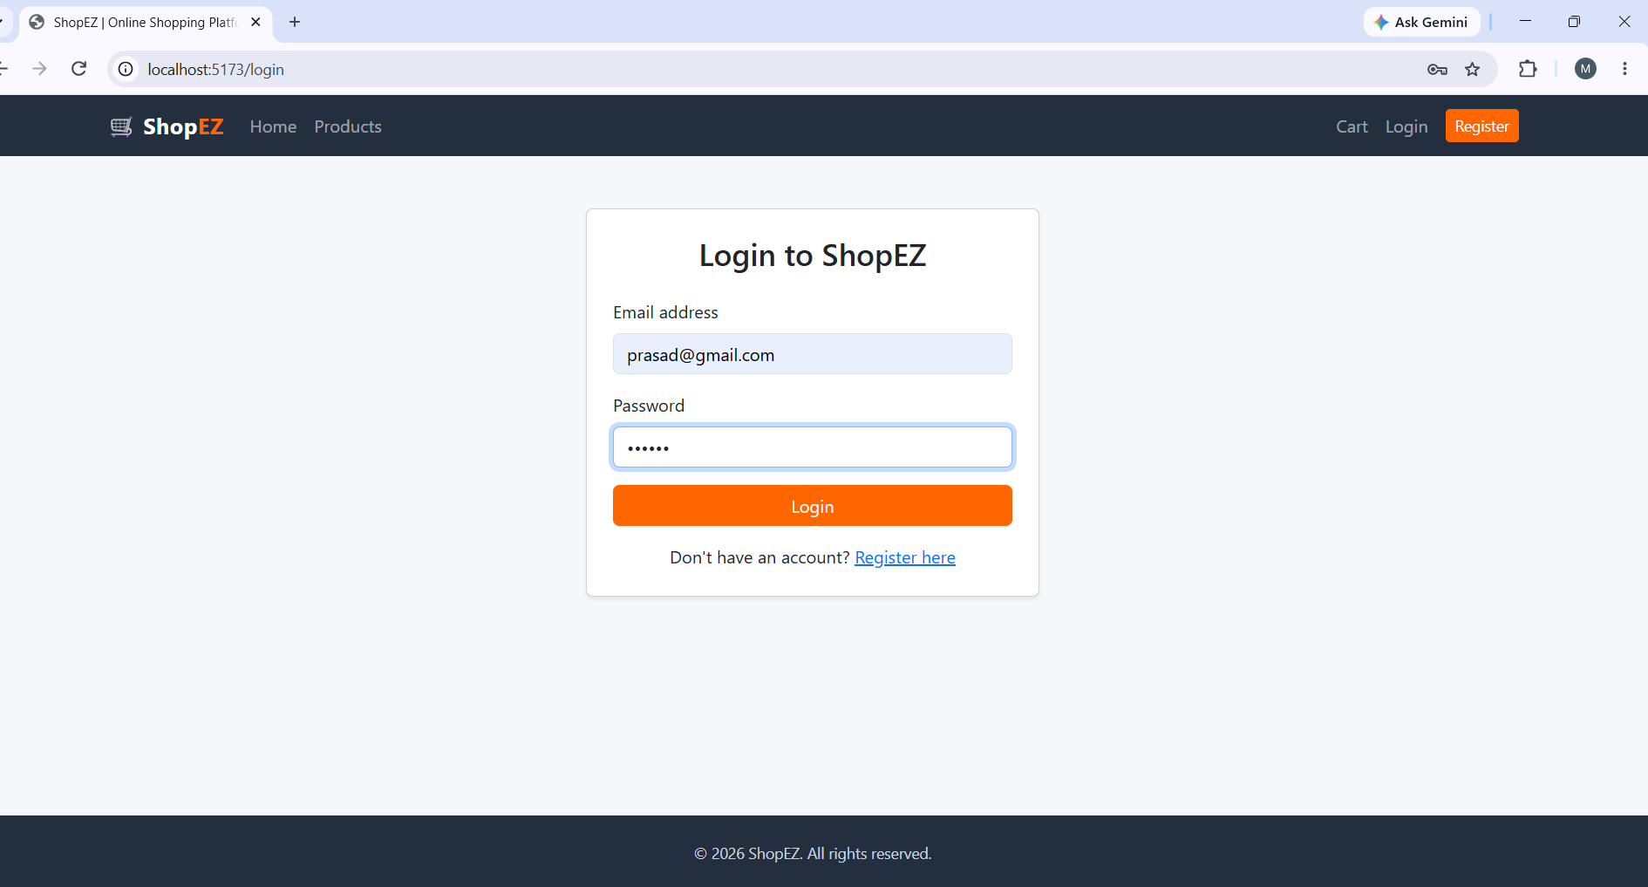
Login: This is the login page, where a registered user signs in to the application.
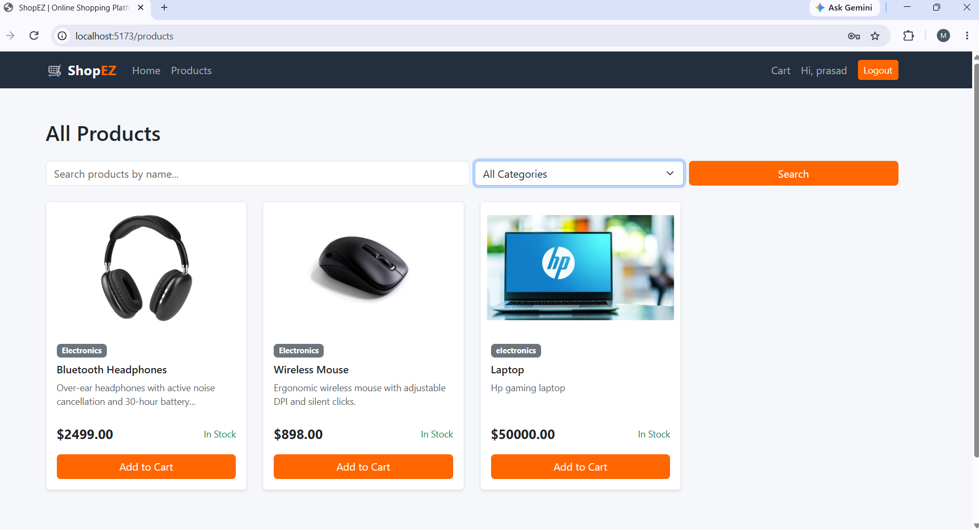
Products: This is the products page. It lists all the available products.
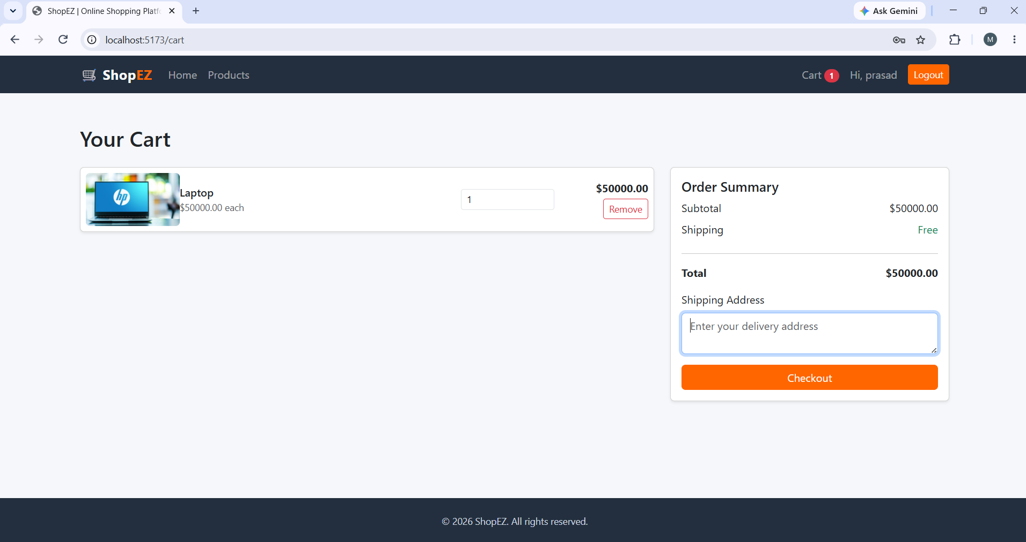
Cart: This is the cart page, where users can add products to the cart.
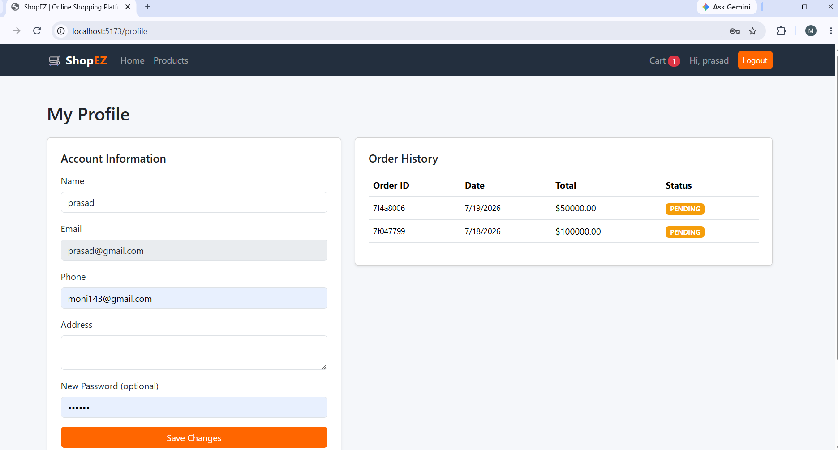
User Profile: This is the user profile page. It displays the users details and orders.
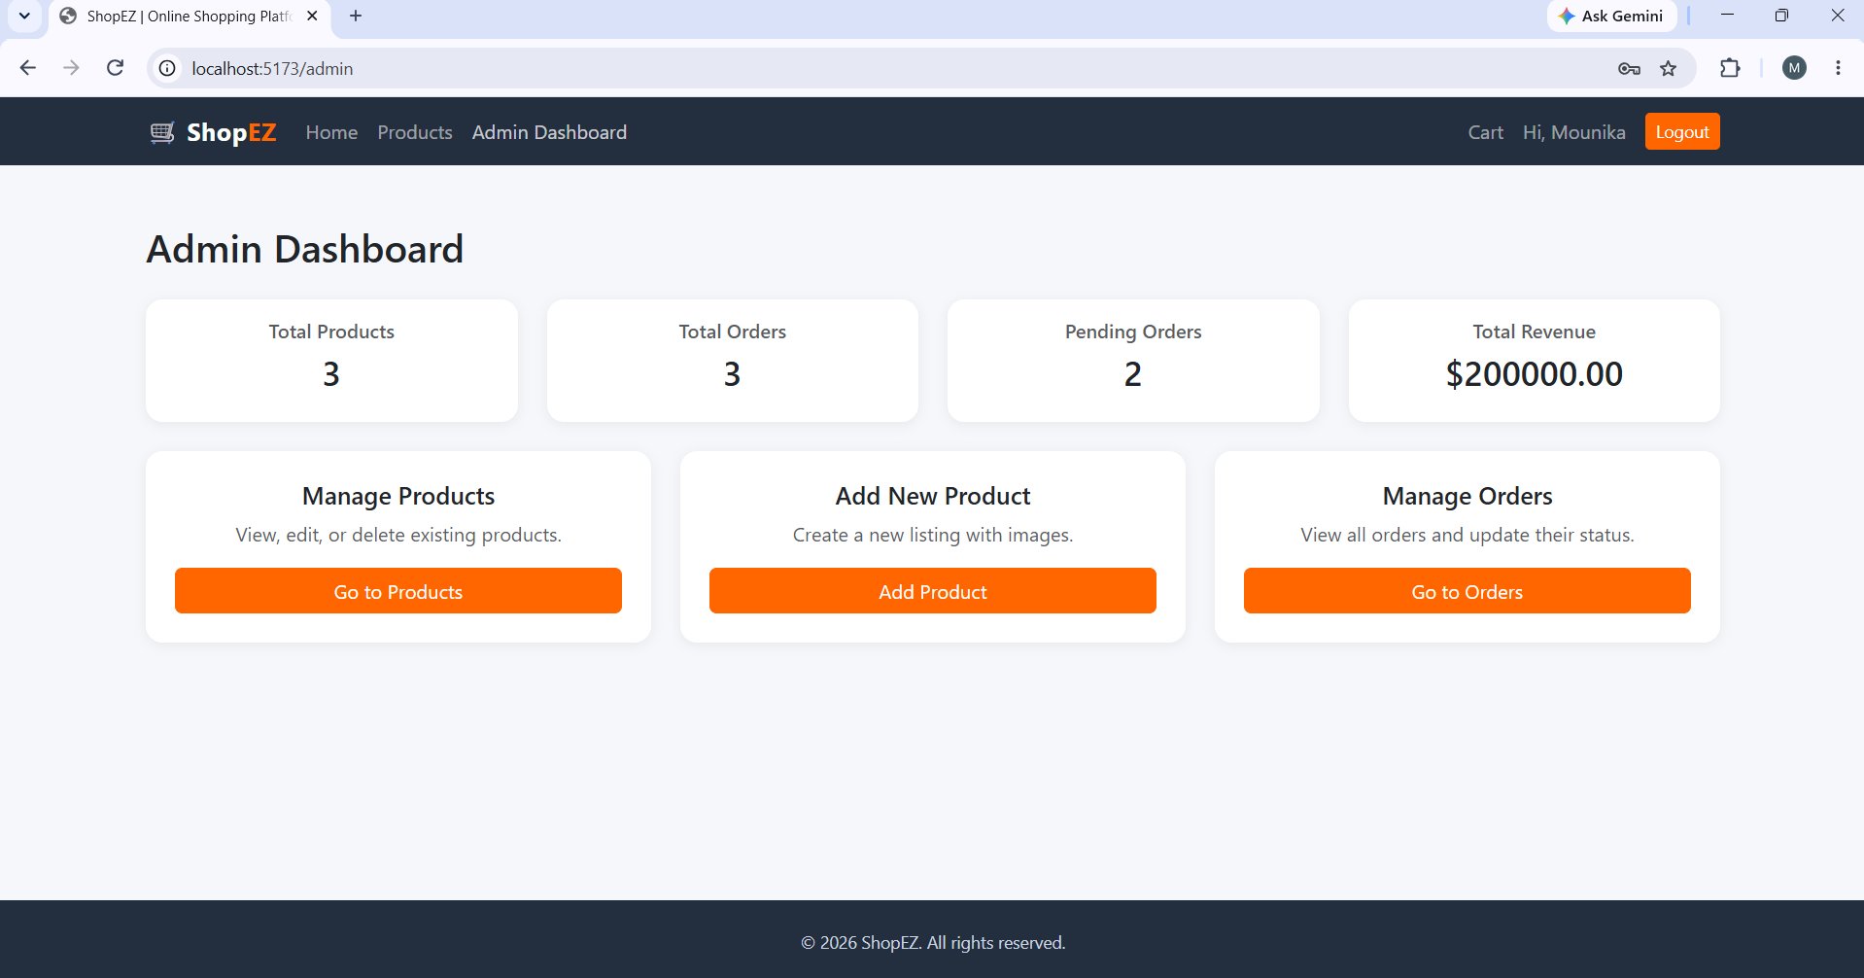
Admin Dashboard: This is the admin dashboard page.
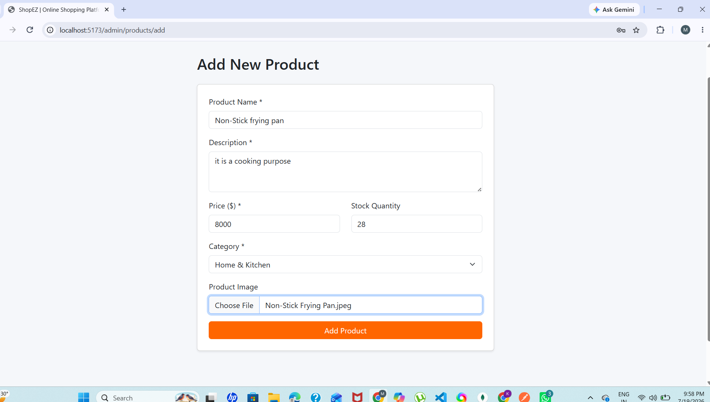
New Product Page: This is the new product page where admin can add new products.
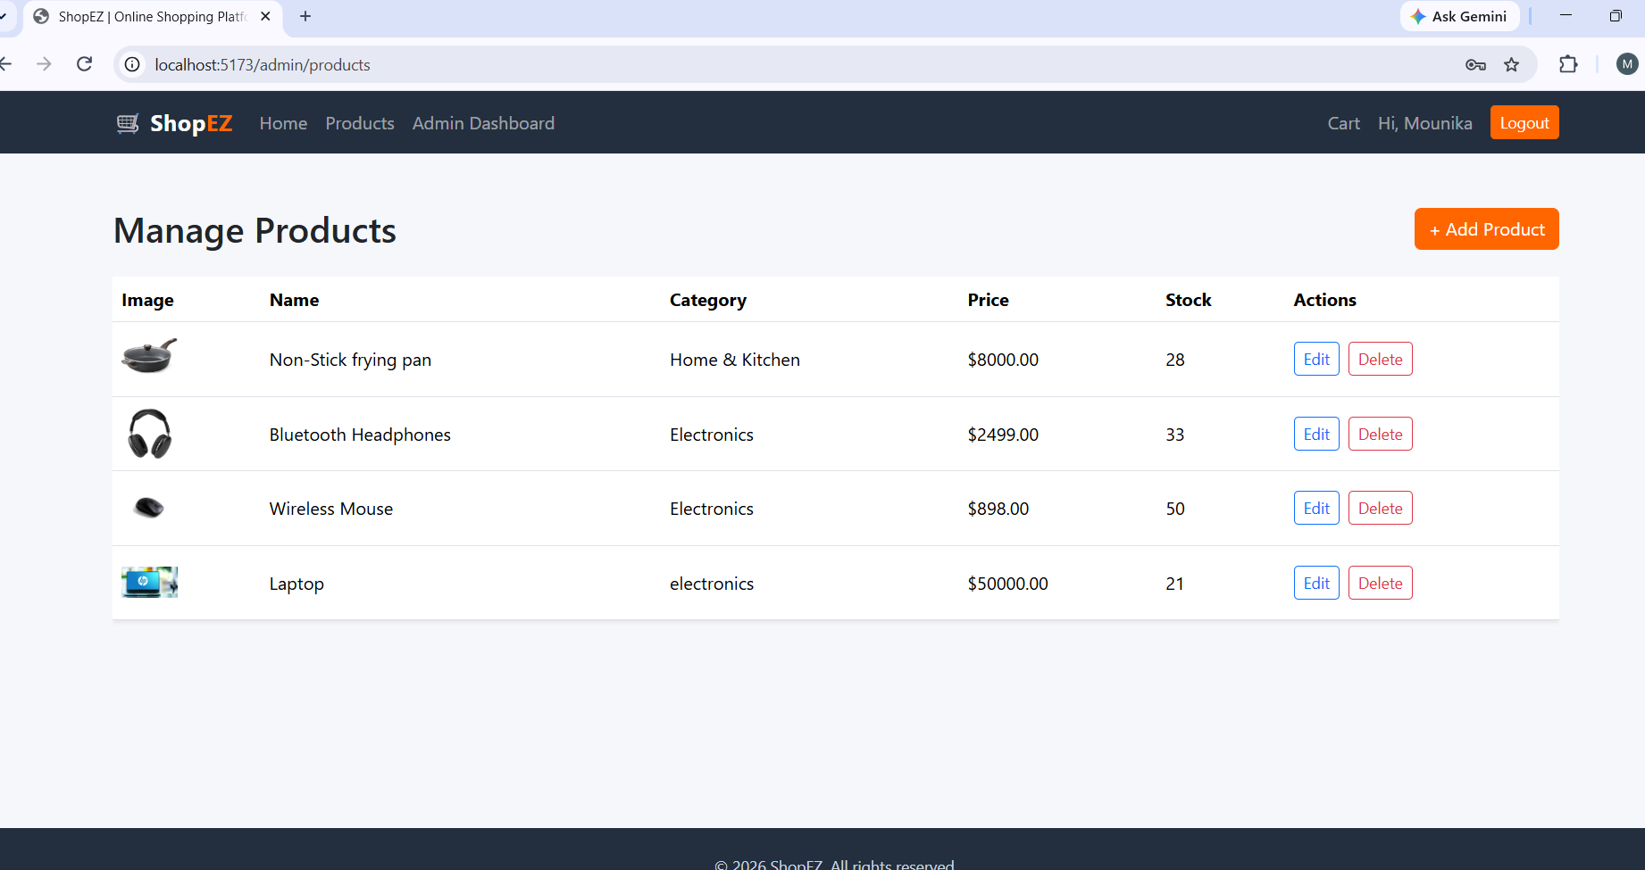
All Products: This is the all products page, where admins can display all the available products.
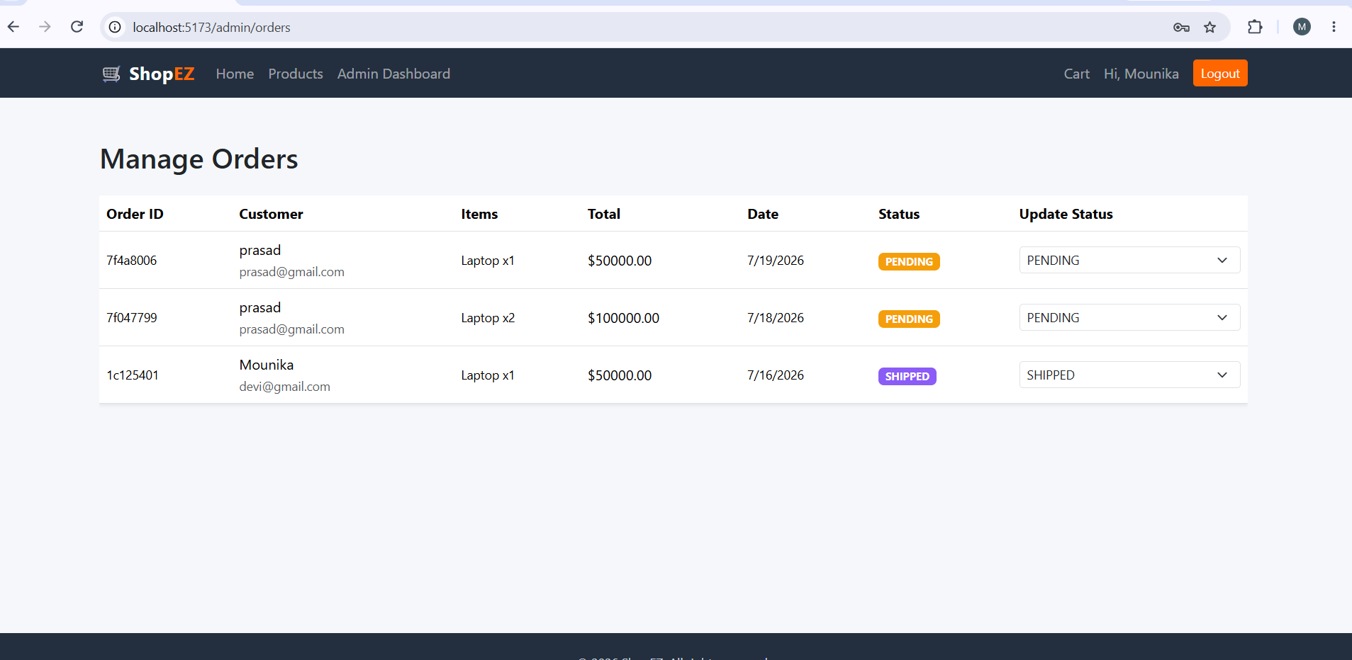
All Orders: This is all orders page, where admin can see all the orders that are placed.

5.3 API Testing
Each backend endpoint was independently verified using Postman before the corresponding frontend view was connected to it. The screenshot below shows a successful login request returning the user's profile details and a signed JWT, confirming that authentication and token issuance were working correctly.
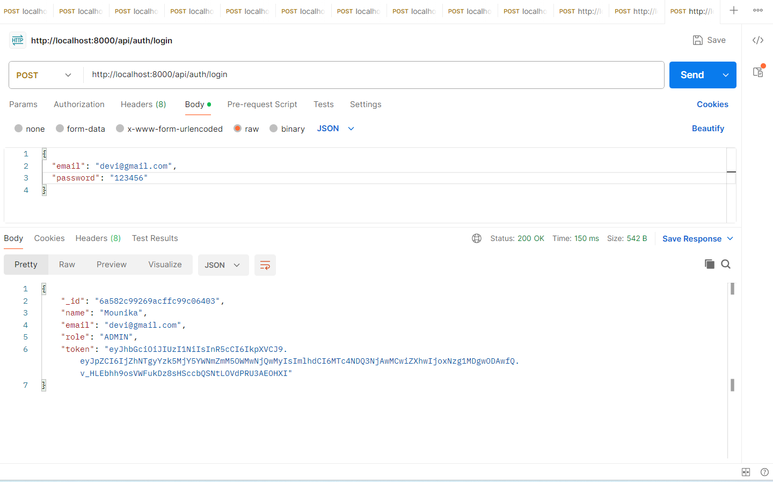
Postman test of the /api/auth/login endpoint returning a signed JWT

5.4 Test Case Summary
In addition to manual walkthrough testing, the core flows of the application were verified as discrete test cases. The table below summarizes the cases executed and their outcomes.
ID | Test Case | Expected Result | Result
TC-01 | Register with a new email | Account created, redirected to login | Pass
TC-02 | Register with an existing email | Registration blocked with a duplicate-email error | Pass
TC-03 | Login with correct credentials | JWT issued, navbar shows logged-in state | Pass
TC-04 | Login with incorrect password | Login rejected with an authentication error | Pass
TC-05 | Search products by name | Only matching products are displayed | Pass
TC-06 | Filter products by category | Only products in the selected category are shown | Pass
TC-07 | Add a product to the cart | Cart badge count increases, item appears in cart | Pass
TC-08 | Update quantity in the cart | Subtotal and total recalculate correctly | Pass
TC-09 | Checkout with a valid cart | Order created, stock decremented, cart cleared | Pass
TC-10 | Non-admin accesses /admin route | Access denied, redirected away | Pass
TC-11 | Admin adds a new product with image | Product appears in catalog and admin table | Pass
TC-12 | Admin updates an order's status | Updated status reflected for both admin and customer | Pass

5.5 Testing Outcomes
Each core feature of the application was manually tested. Registering a new account and logging in correctly issued a JWT and redirected to the home page with the navigation bar updated to reflect the logged-in state. Adding a product to the cart, updating its quantity, and removing it correctly updated the cart badge and order summary in real time. Completing checkout correctly created a new order, decremented the purchased product's stock, and immediately appeared in both the profile page's order history and the admin's order management screen with a PENDING status. Adding a product from the admin panel, including its image, correctly created a new listing that appeared in both the product catalog and the admin product table. Updating an order's status from the admin dropdown was correctly reflected on refresh. The responsive layout was also verified by resizing the browser window, confirming that the navigation, product cards, and dashboard cards adapted correctly to smaller screens. Role-based access was verified by attempting to reach the /admin routes as a regular, non-admin user, confirming that unauthorized access was correctly prevented. All of these checks passed without issues.

6. CONCLUSION

6.1 Conclusion
ShopEZ successfully demonstrates how a full-stack MERN web application can be used to deliver a complete, self-contained online shopping experience for both customers and administrators. By combining React.js, Node.js, Express.js, and MongoDB within a clean, modular structure, the project delivers a responsive storefront with search and category filtering, a persistent cart, and a real checkout flow, alongside a functional admin dashboard offering complete CRUD management of products and orders. The project further demonstrates good software engineering practice through the use of JWT-based role security, bcrypt password encryption, Multer-based file uploads, and Git for version control.

6.2 Known Issues / Limitations
A few limitations of the current implementation are worth noting for anyone extending the project. The cart is persisted in the browser's local storage rather than the database, so it does not carry over when a customer switches devices or browsers, and is cleared if browser data is cleared. Checkout does not integrate a real payment gateway; placing an order records the order and reduces stock but does not process an actual payment. There is a single administrator role rather than distinct seller accounts, so the platform currently suits one store rather than a multi-vendor marketplace. The product catalog does not yet support pagination, so very large catalogs would need this to remain fast to browse. Product images are stored on the local server's file system via Multer rather than a cloud object store, which is adequate for a project-scale deployment but would need to change before a multi-instance production deployment. Finally, the project does not yet include an automated test suite, so regressions are currently caught through manual testing rather than continuous integration.

6.3 Future Enhancements
- Integrate a real payment gateway (such as Razorpay or Stripe) for live payment capture.
- Add product reviews and star ratings to support customer decision-making.
- Introduce order tracking with shipment status notifications via email or SMS.
- Add pagination and more advanced filtering (price range, ratings) to the product catalog.
- Support multiple sellers with per-seller inventory and order dashboards.
- Add wishlist functionality and personalized product recommendations.
- Move product image storage to a cloud object store (such as AWS S3 or Cloudinary) for scalability.
- Persist the cart to the database so it syncs across a customer's devices.
- Add automated unit and integration tests to strengthen ongoing development.

