# Amazon Employees:

|  |  |  |  |
| --- | --- | --- | --- |
| STATE | LOCATION | AVG RATING(out of 5) | No.of Reviews |
| Uttar Pradesh | NoidaLucknowAgraKanpurGhaziabadAllahabadKanpur Nagar | 4.04.14.24.23.74.52.4 | 5591331919161510 |
| Maharashtra | PuneMumbaiNagpur | 4.24.24.1 | 97828333 |
| Haryana | GurgaonFaridabad | 4.14.7 | 30717 |
| Telangana | HyderabadShamshabad | 4.14.4 | 24114 |
| Karnataka | Bengalore | 4.0 | 316 |
| Tamil Nadu | ChennaiCoimbatore | 4.24.2 | 220278 |
| West Bengal | KolkataUluberia | 4.14.7 | 25210 |

# We seek top talent from all industries and a range of backgrounds to join our offices and operations centers around the world. People who succeed at Amazon have something in common—they are customer-centric, they are leaders and they are innovators.

**Employee Benefits:**

Along with average hourly pay of over $20.50, Amazon offers a range of great benefits that support employees and eligible family members, including domestic partners and their children. These comprehensive benefits begin on day one and include health care coverage, paid parental leave, ways to save for the future, paid college tuition, and other resources to improve health and well-being.

**Financial success**

We help our employees build successful futures for themselves through competitive pay.

Our average hourly wage is over $20.50 per hour—more than double the federal minimum wage—for full time, part time, and seasonal employees and contractors. In addition to fair pay, employees have opportunities to own Amazon stock, participate in 401(k) plans with company match, and enroll in paid life and accident insurance. Financial counseling and estate planning services are also available, plus paid short-term and long-term disability if needed.

**Employee health**

Taking care of our employees’ health and wellness is a priority. That’s why we offer medical, dental, and vision coverage to all our regular full-time employees, regardless of their level, tenure, or position.

When employees want to take time away from work, they are afforded ample paid time and paid holidays, in addition to other leave and medical accommodation options that are available for mental and physical health concerns.

**Parental leave**

Amazon supports employees throughout all stages of their lives.

We celebrate the growth of all our employees’ families through a variety of benefits. We offer up to 20 weeks of paid leave to birthing mothers and six weeks for parents who adopt. Our Leave Share program allows employees to give six weeks of paid parental leave to a spouse or partner who isn’t eligible for parental leave from their employer. Plus, our Ramp Back program offers birth parents eight consecutive weeks of flexibility and partial work hours as they readjust to work schedules as new parents.

**safety at Amazon:**

The safety of our employees is our top priority, and we wanted to share an update on our programs and progress. We have made, and continue to make, significant investments to ensure our workspaces are safe and improve safety outcomes for our employees. From 2019-2022, we invested $1 billion in safety projects and initiatives (unrelated to COVID-19) across Amazon, and in 2023 alone we have committed $550 million to our safety efforts. We also offer our roughly 750,000 employees in the United States a starting average wage of $19 per hour (well above the federal minimum wage of $7.25) and comprehensive benefits. These benefits include health care from day one; up to 20 weeks paid parental leave; 401(k) with a 50% company match; free skills and career advancement training; and our Career Choice program, which prepays tuition for continuing education courses, high school diplomas, GEDs, bachelor’s degrees, and English as a Second Language certifications. We’ve also committed $1.2 billion to provide 300,000 employees with access to education and skills training programs—including college tuition for front-line employees—through 2025 as part of Amazon’s Upskilling 2025 pledge. Taking care of our employees, providing a clean and safe place to work, and making continuous safety improvements are paramount priorities for us.

As described in our Safety Report, during the 2019–2022 period we reduced our recordable incident rate (RIR) by 23%, and we reduced our lost time incident rate (LTIR)—which focuses on more significant injuries that require an employee to miss at least one day of work—by 69% in the United States. These large safety gains occurred despite the surge in demand resulting from COVID-19, which resulted in us creating an additional 400,000 new American jobs and launching hundreds of new facilities so we could deliver an unprecedented number of essential goods to people across the country. We have more work to do, but we’re confident that our ongoing investment and innovation will continue to achieve results.

Our safety outcomes

As discussed in our recent Safety Report, we’re pleased that our recordable incident rate (RIR) dropped by 23% from the beginning of 2019 to the end of 2022; and, our lost time incident rate (LTIR) dropped by 69% in the United States. Focusing specifically on the 2021 to 2022 period, our RIR improved by 10% and our LITR improved by 28%. These significant safety gains demonstrate the efficacy of our safety initiatives and continued innovation. The charts below show the reductions in RIR and LTIR year by year:

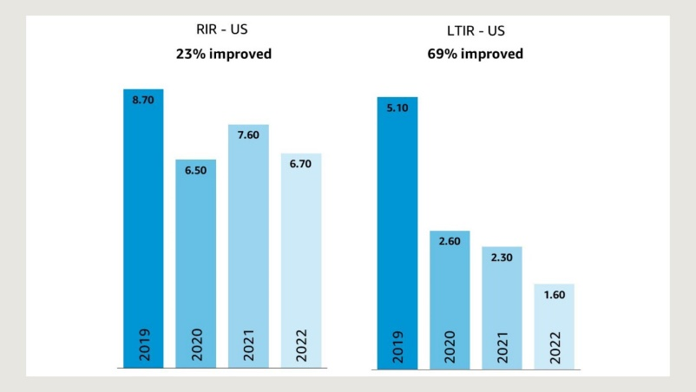

The three main metrics used to measure safety in the U.S. are RIR (Recordable Injury Rate), DART (Days Away, Restricted, or Transferred) and LTIR (Lost Time Incident Rate).

Amazon is committed to continually evaluating and improving work processes to reduce the risk of injury. This includes redesigning workstations and introducing new technologies, such as robotics, to relieve strain on employees and improve safety outcomes.