2/8/25:
1.course schedule:
There are a total of numCourses courses you have to take, labeled from 0 to numCourses - 1. You are given an array prerequisites where prerequisites[i] = [a_{i}, b_{i}] indicates that you must take course b_{i} first if you want to take course a_{i}.
- For example, the pair [0, 1], indicates that to take course 0 you have to first take course 1.
Return true if you can finish all courses. Otherwise, return false.

Example 1:
Input: numCourses = 2, prerequisites = [[1,0]]
Output: true
Explanation: There are a total of 2 courses to take.
To take course 1 you should have finished course 0. So it is possible.
Example 2:
Input: numCourses = 2, prerequisites = [[1,0],[0,1]]
Output: false
Explanation: There are a total of 2 courses to take.
To take course 1 you should have finished course 0, and to take course 0 you should also have finished course 1. So it is impossible.
class Solution {
public boolean canFinish(int numCourses, int[][] prerequisites) {
List<Integer>[] arr=new ArrayList[numCourses];
for (int i = 0; i < numCourses; i++) {
arr[i] = new ArrayList<>();
}

for(int i=0;i<prerequisites.length;i++){
arr[prerequisites[i][1]].add(prerequisites[i][0]);
}
// for(int i=0;i<arr.length;i++){
// System.out.println(arr[i]);
// }
boolean bool=iscycle(numCourses,arr);
//System.out.println(bool);
if(bool) return !bool;
boolean[] vis=new boolean[numCourses];
Stack<Integer> st=new Stack<>();
for(int i=0;i<numCourses;i++){
if(!vis[i]){
dfs2(arr,vis,st,i);
}
}
Collections.reverse(st);
System.out.println(st);
return !bool;
}
public boolean iscycle(int n,List<Integer>[] arr){
boolean[] visited=new boolean[n];
boolean[] pathvis=new boolean[n];
for(int i=0;i<n;i++){
if(!visited[i]){
if(dfs(arr,visited,pathvis,i)){
return true;
}
}
}
return false;
}
public boolean dfs(List<Integer>[] arr,boolean[] visited,boolean[] pathvis,int node){
visited[node]=true;
pathvis[node]=true;
for(int i=0;i<arr[node].size();i++){
if(!visited[arr[node].get(i)]){
if(dfs(arr,visited,pathvis,arr[node].get(i))) return true;
}
else if(pathvis[arr[node].get(i)]) return true;
}
pathvis[node]=false;
return false;
}
public void dfs2(List<Integer>[] arr,boolean[] vis,Stack st,int node){
vis[node]=true;
for(int i=0;i<arr[node].size();i++){
if(!vis[arr[node].get(i)]){
dfs2(arr,vis,st,arr[node].get(i));
}
}
st.push(node);
}
}
2.minimum height trees:
A tree is an undirected graph in which any two vertices are connected by exactly one path. In other words, any connected graph without simple cycles is a tree.
Given a tree of n nodes labelled from 0 to n - 1, and an array of n - 1 edges where edges[i] = [a_{i}, b_{i}] indicates that there is an undirected edge between the two nodes a_{i} and b_{i} in the tree, you can choose any node of the tree as the root. When you select a node x as the root, the result tree has height h. Among all possible rooted trees, those with minimum height (i.e. min(h)) are called minimum height trees (MHTs).
Return a list of all MHTs' root labels. You can return the answer in any order.
The height of a rooted tree is the number of edges on the longest downward path between the root and a leaf.

Example 1:
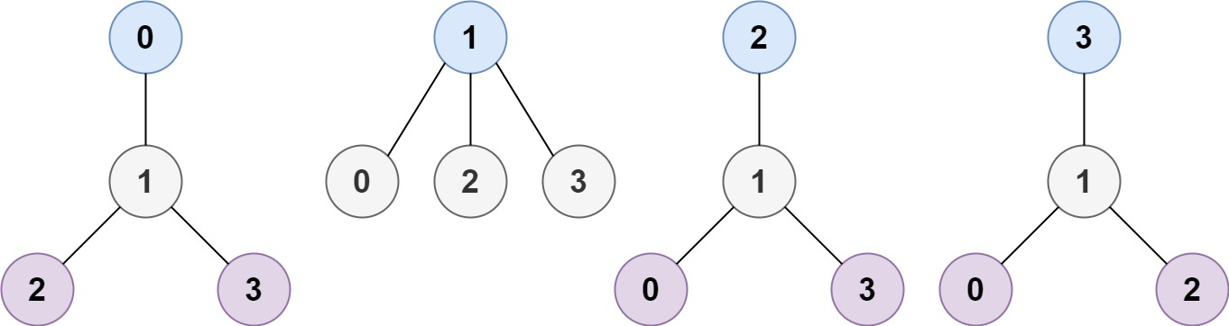
Input: n = 4, edges = [[1,0],[1,2],[1,3]]
Output: [1]
Explanation: As shown, the height of the tree is 1 when the root is the node with label 1 which is the only MHT.
Example 2:
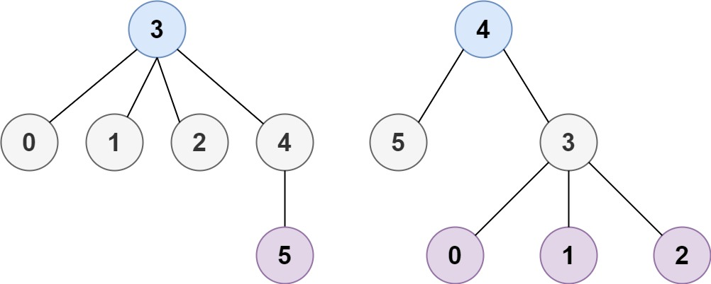
Input: n = 6, edges = [[3,0],[3,1],[3,2],[3,4],[5,4]]
Output: [3,4]
class Solution {
public List<Integer> findMinHeightTrees(int n, int[][] edges) {
List<Integer>[] arr=new ArrayList[n];
if(n==1) return Collections.singletonList(0);
int[] deg=new int[n];
for(int i=0;i<n;i++){
arr[i]=new ArrayList<>();
}
for(int i=0;i<edges.length;i++){
deg[edges[i][0]]++;
deg[edges[i][1]]++;
arr[edges[i][0]].add(edges[i][1]);
arr[edges[i][1]].add(edges[i][0]);
}
List<Integer> q=new ArrayList<>();
for(int i=0;i<n;i++){
if(deg[i]==1) q.add(i);
}
int processed=0;
while(n-processed>2){
int size=q.size();
processed+=size;
for(int i=0;i<size;i++){
int leaf=q.remove(0);
for(int j=0;j<arr[leaf].size();j++){
deg[arr[leaf].get(j)]--;
if(deg[arr[leaf].get(j)]==1) q.add(arr[leaf].get(j));
}
}
}
return q;
}
}
3/8/25:
1.island perimeter:
You are given row x col grid representing a map where grid[i][j] = 1 represents land and grid[i][j] = 0 represents water.
Grid cells are connected horizontally/vertically (not diagonally). The grid is completely surrounded by water, and there is exactly one island (i.e., one or more connected land cells).
The island doesn't have "lakes", meaning the water inside isn't connected to the water around the island. One cell is a square with side length 1. The grid is rectangular, width and height don't exceed 100. Determine the perimeter of the island.

Example 1:
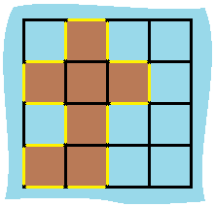
Input: grid = [[0,1,0,0],[1,1,1,0],[0,1,0,0],[1,1,0,0]]
Output: 16
Explanation: The perimeter is the 16 yellow stripes in the image above.
Example 2:
Input: grid = [[1]]
Output: 4
Example 3:
Input: grid = [[1,0]]
Output: 4
class Solution {
public int islandPerimeter(int[][] grid) {
int count=0;
for(int i=0;i<grid.length;i++){
for(int j=0;j<grid[0].length;j++){
if(grid[i][j]==1){
if(i-1<0 || grid[i-1][j]==0){
//System.out.println(i+"rowleft "+j);
count++;
}
if(i+1>=grid.length || grid[i+1][j]==0){
//System.out.println(i+"rowright "+j);
count++;
}
if(j-1<0 || grid[i][j-1]==0){
//System.out.println(i+"colleft "+j);
count++;
}
if(j+1>=grid[0].length || grid[i][j+1]==0){
//System.out.println(i+"colright "+j);
count++;
}
}
}
}
return count;
}
}
2.palindrome partitioning:
Given a string s, partition s such that every substring of the partition is a palindrome. Return all possible palindrome partitioning of s.

Example 1:
Input: s = "aab"
Output: [["a","a","b"],["aa","b"]]
Example 2:
Input: s = "a"
Output: [["a"]]
Slidingwindow I tried 1st not poss because want to have all poss aaa-> [a,a,a],[aa,a],[a,aa]
Method1-just backtracking-o(n*2^n)
class Solution {
public List<List<String>> partition(String s) {
List<List<String>> res = new ArrayList<>();
backtrack(s, 0, new ArrayList<>(), res);
return res;
}

private void backtrack(String s, int start, List<String> curr, List<List<String>> res) {
if (start == s.length()) {
res.add(new ArrayList<>(curr));
return;
}

for (int end = start + 1; end <= s.length(); end++) {
String sub = s.substring(start, end);
if (isPalindrome(sub)) {
curr.add(sub);
backtrack(s, end, curr, res);
curr.remove(curr.size() - 1); // backtrack
}
}
}

private boolean isPalindrome(String str) {
int left = 0, right = str.length() - 1;
while (left < right) {
if (str.charAt(left++) != str.charAt(right--)) return false;
}
return true;
}
}

Method-2: dp+backtrack-> no need palindrome func:
class Solution {
public List<List<String>> partition(String s) {
int n = s.length();
boolean[][] dp = new boolean[n][n];

// Fill DP table
for (int len = 1; len <= n; len++) {
for (int start = 0; start <= n - len; start++) {
int end = start + len - 1;
if (s.charAt(start) == s.charAt(end)) {
if (len <= 2) {
dp[start][end] = true;
} else {
dp[start][end] = dp[start + 1][end - 1];
}
}
}
}

List<List<String>> result = new ArrayList<>();
backtrack(s, 0, dp, new ArrayList<>(), result);
return result;
}

private void backtrack(String s, int start, boolean[][] dp, List<String> curr, List<List<String>> result) {
if (start == s.length()) {
result.add(new ArrayList<>(curr));
return;
}

for (int end = start; end < s.length(); end++) {
if (dp[start][end]) {
curr.add(s.substring(start, end + 1));
backtrack(s, end + 1, dp, curr, result);
curr.remove(curr.size() - 1); // backtrack
}
}
}
}
7/8/25
1.Bitmask+dp:
1.subset:
Given an integer array nums of unique elements, return all possible subsets (the power set).
The solution set must not contain duplicate subsets. Return the solution in any order.

Example 1:
Input: nums = [1,2,3]
Output: [[],[1],[2],[1,2],[3],[1,3],[2,3],[1,2,3]]
Example 2:
Input: nums = [0]
Output: [[],[0]]

class Solution {
public List<List<Integer>> subsets(int[] nums) {
int n=nums.length;
List<List<Integer>> arr=new ArrayList<>();
for(int i=0;i<(1<<n);i++){
List<Integer> lst=new ArrayList<>();
for(int j=0;j<n;j++){
if((i & (1<<j))!=0){
lst.add(nums[j]);
}
}
arr.add(lst);
}
return arr;
}
}
2.binary watch: A binary watch has 4 LEDs on the top to represent the hours (0-11), and 6 LEDs on the bottom to represent the minutes (0-59). Each LED represents a zero or one, with the least significant bit on the right.
- For example, the below binary watch reads "4:51".

Given an integer turnedOn which represents the number of LEDs that are currently on (ignoring the PM), return all possible times the watch could represent. You may return the answer in any order.
The hour must not contain a leading zero.
- For example, "01:00" is not valid. It should be "1:00".
The minute must consist of two digits and may contain a leading zero.
- For example, "10:2" is not valid. It should be "10:02".

Example 1:
Input: turnedOn = 1
Output: ["0:01","0:02","0:04","0:08","0:16","0:32","1:00","2:00","4:00","8:00"]
Example 2:
Input: turnedOn = 9
Output: []
class Solution {
public List<String> readBinaryWatch(int turnedOn) {
List<String> lst=new ArrayList<>();
if(turnedOn>8 || turnedOn<0) return lst;
int x=turnedOn;
for(int i=0;i<(1<<4);i++){
int count=0;
turnedOn=x;

for(int j=0;j<4;j++){
if((i&1<<j)!=0) count++;
}
if(count>turnedOn || i>11) continue;
turnedOn-=count;

for(int j=0;j<(1<<6);j++){
int count2=0;
for(int k=0;k<6;k++){
if((j&1<<k)!=0)count2++;
}
if(count2!=turnedOn || j>59) continue;

int hr=i;
int min=j;
String s=Integer.toString(i);
s+=":";
if(j<10){
s+="0";
}
s+=Integer.toString(j);
lst.add(s);
}
}
return lst;
}
}
3.beautiful arrangement:
Suppose you have n integers labeled 1 through n. A permutation of those n integers perm (1-indexed) is considered a beautiful arrangement if for every i (1 <= i <= n), either of the following is true:
- perm[i] is divisible by i.
- i is divisible by perm[i].
Given an integer n, return the number of the beautiful arrangements that you can construct.

Example 1:
Input: n = 2
Output: 2
Explanation:
The first beautiful arrangement is [1,2]:
- perm[1] = 1 is divisible by i = 1
- perm[2] = 2 is divisible by i = 2
The second beautiful arrangement is [2,1]:
- perm[1] = 2 is divisible by i = 1
- i = 2 is divisible by perm[2] = 1
Example 2:
Input: n = 1
Output: 1
class Solution {
int count=0;
public int countArrangement(int n) {
boolean[] vis=new boolean[n+1];
backtrack(1,n,vis);
return count;
}
public void backtrack(int pos,int n,boolean[] vis){
if(pos>n){
count++;
return;
}
for(int i=1;i<=n;i++){
if(!vis[i] && (pos%i==0 || i%pos==0)){
vis[i]=true;
backtrack(pos+1,n,vis);
vis[i]=false;
}
}
}
}
13/8/25:
1.distinct subsequence:
Given two strings s and t, return the number of distinct subsequences of s which equals t.
The test cases are generated so that the answer fits on a 32-bit signed integer.

Example 1:
Input: s = "rabbbit", t = "rabbit"
Output: 3
Explanation:
As shown below, there are 3 ways you can generate "rabbit" from s.
rabbbit
rabbbit
rabbbit
Example 2:
Input: s = "babgbag", t = "bag"
Output: 5
Explanation:
As shown below, there are 5 ways you can generate "bag" from s.
babgbag
babgbag
babgbag
babgbag
babgbag
class Solution {
public int numDistinct(String s, String t) {
int n1=s.length();
int n2=t.length();
int[][] dp=new int[n2+1][n1+1];
//empty sequence is subsequence once
for(int i=0;i<=n1;i++){
dp[0][i]=1;
}
for(int i=1;i<=n2;i++){
for(int j=1;j<=n1;j++){
if(s.charAt(j-1)==t.charAt(i-1)){
dp[i][j]=dp[i-1][j-1]+dp[i][j-1];
//all ways including that and excluding that
}
else{
dp[i][j]=dp[i][j-1];
}
}
}
return dp[n2][n1];
}
}
2.number of unique good subsequence:
You are given a binary string binary. A subsequence of binary is considered good if it is not empty and has no leading zeros (with the exception of "0").
Find the number of unique good subsequences of binary.
- For example, if binary = "001", then all the good subsequences are ["0", "0", "1"], so the unique good subsequences are "0" and "1". Note that subsequences "00", "01", and "001" are not good because they have leading zeros.
Return the number of unique good subsequences of binary. Since the answer may be very large, return it modulo 10⁹ + 7.
A subsequence is a sequence that can be derived from another sequence by deleting some or no elements without changing the order of the remaining elements.

Example 1:
Input: binary = "001"
Output: 2
Explanation: The good subsequences of binary are ["0", "0", "1"].
The unique good subsequences are "0" and "1".
Example 2:
Input: binary = "11"
Output: 2
Explanation: The good subsequences of binary are ["1", "1", "11"].
The unique good subsequences are "1" and "11".
Example 3:
Input: binary = "101"
Output: 5
Explanation: The good subsequences of binary are ["1", "0", "1", "10", "11", "101"].
The unique good subsequences are "0", "1", "10", "11", and "101".

Constraints:
- 1 <= binary.length <= 10⁵
- binary consists of only '0's and '1's.
- class Solution {
- public int numberOfUniqueGoodSubsequences(String binary) {
- int n=binary.length();
- int limit=1000000007;
- long end0=0;
- long end1=0;
- boolean haszero=false;
- for(Character ch:binary.toCharArray()){
- if(ch=='0'){
- end0=(end1+end0)%limit;
- haszero=true;
- }
- else{
- end1=(end1+end0+1)%limit;
- }
- }
- return (int)((end1+end0+(haszero?1:0))%limit);
- }
- }

14/8/25:
1.distinct subsequence-ii:
Given a string s, return the number of distinct non-empty subsequences of s. Since the answer may be very large, return it modulo 10⁹ + 7.
A subsequence of a string is a new string that is formed from the original string by deleting some (can be none) of the characters without disturbing the relative positions of the remaining characters. (i.e., "ace" is a subsequence of "abcde" while "aec" is not.

Example 1:
Input: s = "abc"
Output: 7
Explanation: The 7 distinct subsequences are "a", "b", "c", "ab", "ac", "bc", and "abc".
Example 2:
Input: s = "aba"
Output: 6
Explanation: The 6 distinct subsequences are "a", "b", "ab", "aa", "ba", and "aba".
Example 3:
Input: s = "aaa"
Output: 3
Explanation: The 3 distinct subsequences are "a", "aa" and "aaa".

Constraints:
- 1 <= s.length <= 2000
- s consists of lowercase English letters.
- class Solution {
- public int distinctSubseqII(String s) {
- int limit=1000000007;
- int n=s.length();
- int[] dp=new int[n+1];
- //initially considering empty too as asubsequence
- dp[0]=1;
- //dp[i]=no of unique sequence upto index i
- int[] lastidx=new int[26];
- Arrays.fill(lastidx,-1);
- for(int i=0;i<n;i++){
- int x=s.charAt(i)-'a';
- dp[i+1]=dp[i]*2%limit;
- if(lastidx[x]>=0){
- dp[i+1]-=dp[lastidx[x]];
- }
- dp[i+1]%=limit;
- lastidx[x]=i;
- }

- //remove empty sequence
- dp[n]--;
- if(dp[n]<0) dp[n]+=limit;
- return dp[n];

- }
- }

