Java's Primitive Data Types
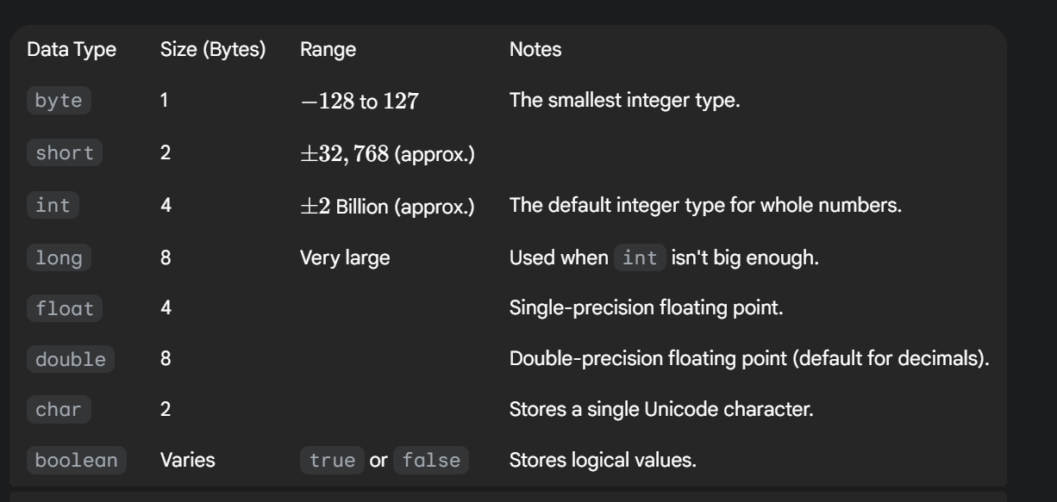
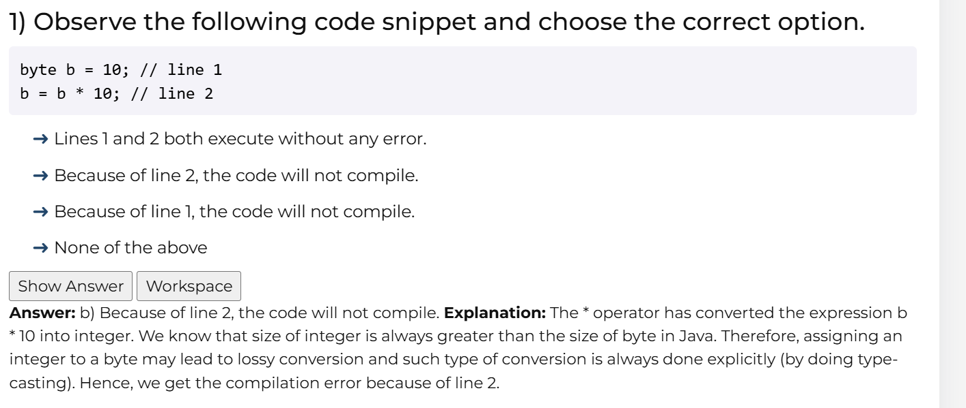
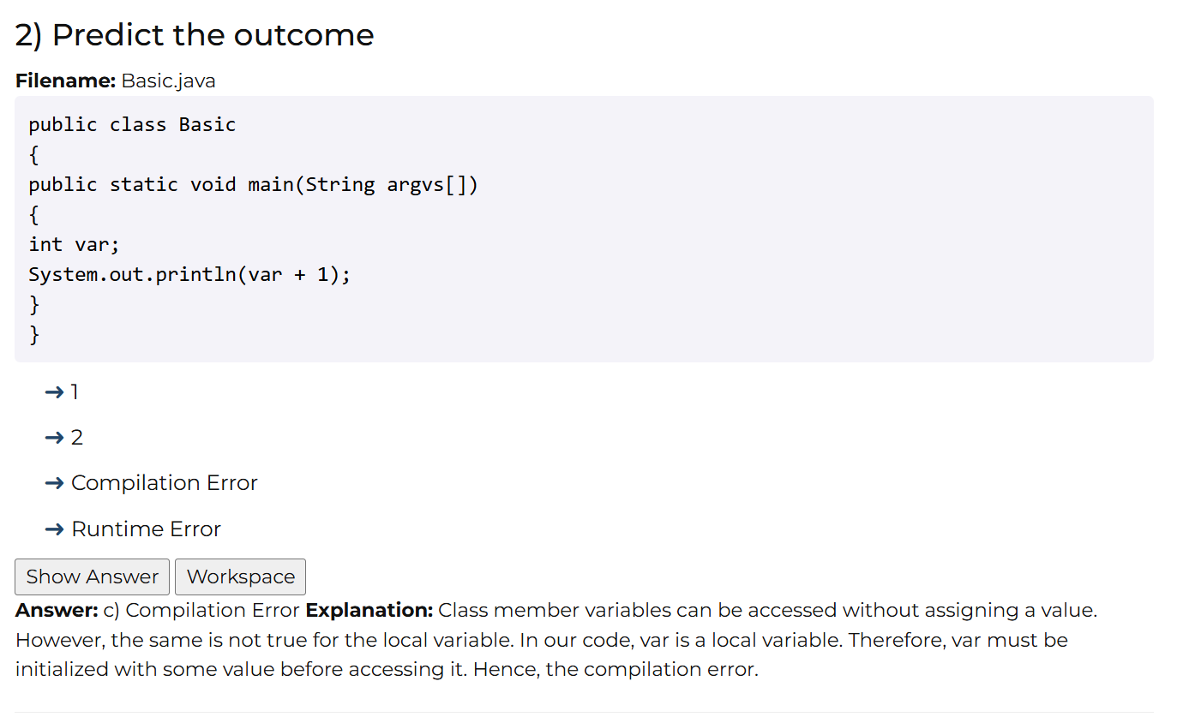
static or instance variable get default value but local var need to be initialized
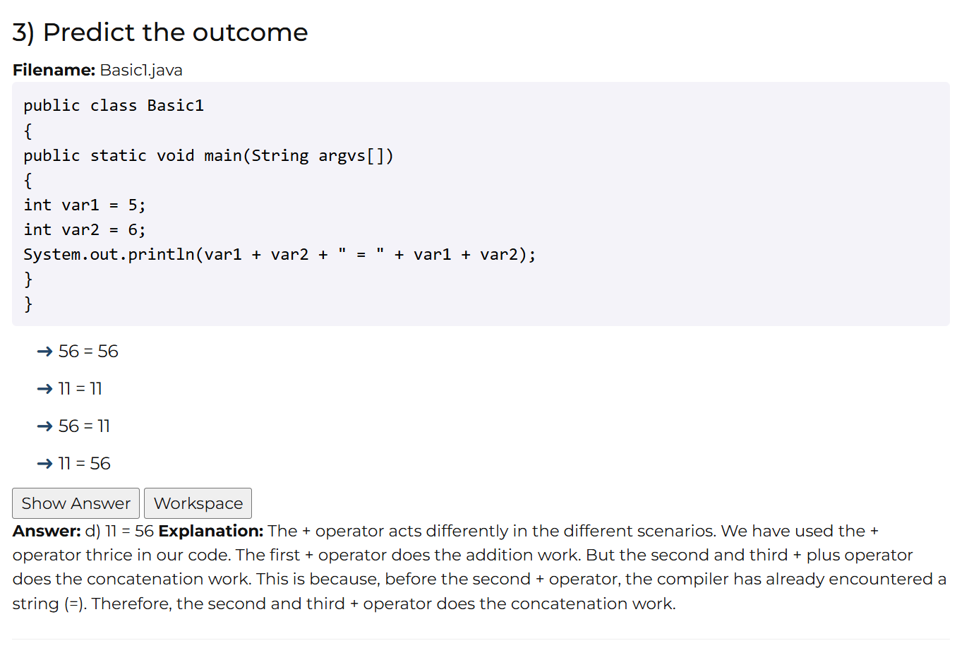
The predicted outcome is: 11 = 56

Explanation: Operator Precedence and String Concatenation 🔗
This outcome is a classic example of how operator precedence and string concatenation work in Java, especially when mixing arithmetic operations (+) and strings (" = ").
Java evaluates the expression var1 + var2 + " = " + var1 + var2 strictly from left-to-right:
1. Left-to-Right Evaluation
- var1 + var2
  - Since both var1 (5) and var2 (6) are integers, the + operator performs arithmetic addition.
  - Result: 5+6=11.
  - The expression is now: 11 + " = " + var1 + var2
- 11 + " = "
  - The expression now involves an integer (11) and a String (" = ").
  - When the + operator is used with at least one String operand, it performs string concatenation (joining text).
  - Result: "11="
  - The expression is now: "11 = " + var1 + var2
- "11 = " + var1
  - The result is a String, so concatenation continues. var1 (5) is converted to the string "5".
  - Result: "11=5"
  - The expression is now: "11 = 5" + var2
- "11 = 5" + var2
  - Concatenation continues. var2 (6) is converted to the string "6".
  - Final Result: "11=56"

