17/7/25:
1.maximum length of valid subsequence -II:
You are given an integer array nums and a positive integer k.
A subsequence sub of nums with length x is called valid if it satisfies:
- (sub[0] + sub[1]) % k == (sub[1] + sub[2]) % k == ... == (sub[x - 2] + sub[x - 1]) % k.
Return the length of the longest valid subsequence of nums.

Example 1:
Input: nums = [1,2,3,4,5], k = 2
Output: 5
Explanation:
The longest valid subsequence is [1, 2, 3, 4, 5].
Example 2:
Input: nums = [1,4,2,3,1,4], k = 3
Output: 4
Explanation:
The longest valid subsequence is [1, 4, 1, 4].
class Solution {
public int maximumLength(int[] nums, int k) {
int[][] dp=new int[k][k];
int maxi=0;
//alternative remainder can be lead to valid subsequence
//1,0,1,0
//0,0,0,0
//2,0,2,0
for(int i=0;i<nums.length;i++){
int n=nums[i]%k;
//j-> previous numsbers remainder it can be anything from 0 to k-1
for(int j=0;j<k;j++){
dp[j][n]=dp[n][j]+1;
maxi=Math.max(maxi,dp[j][n]);
}
}
return maxi;
}
}
2.permutation:
class Solution {
private static List<List<Integer>> fin=new ArrayList<>();
public List<List<Integer>> permute(int[] nums) {
fin=new ArrayList<>();
boolean[] bool=new boolean[nums.length];
backtrack(nums,new ArrayList<>(),bool);
return fin;
}
public void backtrack(int[] nums,List<Integer> res,boolean[] bool){
if(res.size()==nums.length){
fin.add(new ArrayList<>(res));
return;
}
for(int i=0;i<nums.length;i++){
if(bool[i]) continue;
res.add(nums[i]);
bool[i]=true;
backtrack(nums,res,bool);
res.remove(res.size()-1);
bool[i]=false;
}
}
}
3.pathsum:
/**
* Definition for a binary tree node.
* public class TreeNode {
* int val;
* TreeNode left;
* TreeNode right;
* TreeNode() {}
* TreeNode(int val) { this.val = val; }
* TreeNode(int val, TreeNode left, TreeNode right) {
* this.val = val;
* this.left = left;
* this.right = right;
* }
* }
*/
class Solution {
private static boolean bool=false;
public boolean hasPathSum(TreeNode root, int targetSum) {
bool=false;
sum(root,0,targetSum);
return bool;
}
public void sum(TreeNode root,int sum,int tar){
if (root==null) return;
sum+=root.val;
if(root.left==null && root.right==null){
if(sum==tar) bool=true;

}
else{
sum(root.right,sum,tar);
sum(root.left,sum,tar);
}
sum-=root.val;
}
}
4.zigzag level order travelsal:
Given the root of a binary tree, return the zigzag level order traversal of its nodes' values. (i.e., from left to right, then right to left for the next level and alternate between).

Example 1:
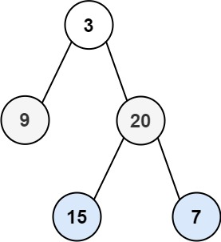
Input: root = [3,9,20,null,null,15,7]
Output: [[3],[20,9],[15,7]]
Example 2:
Input: root = [1]
Output: [[1]]
Example 3:
Input: root = []
Output: []

/**
* Definition for a binary tree node.
* public class TreeNode {
* int val;
* TreeNode left;
* TreeNode right;
* TreeNode() {}
* TreeNode(int val) { this.val = val; }
* TreeNode(int val, TreeNode left, TreeNode right) {
* this.val = val;
* this.left = left;
* this.right = right;
* }
* }
*/
class Solution {
public List<List<Integer>> zigzagLevelOrder(TreeNode root) {
Queue<TreeNode> q=new LinkedList<>();
if(root==null) return new ArrayList<>();
q.add(root);
List<List<Integer>> fin=new ArrayList<>();
int level=0;
while(!q.isEmpty()){
List<Integer> res=new ArrayList<>();
int size=q.size();
for(int i=0;i<size;i++){
TreeNode x=q.poll();
if(x.left!=null) q.add(x.left);
if(x.right!=null) q.add(x.right);
res.add(x.val);
}
if(level%2!=0){
Collections.reverse(res);
}
fin.add(res);
level++;
}
return fin;
}

}
Method2: using recursion:
class Solution {
public List<List<Integer>> zigzagLevelOrder(TreeNode root) {
List<List<Integer>> result = new ArrayList<>();
int height = getHeight(root);

for (int level = 0; level < height; level++) {
List<Integer> currentLevel = new ArrayList<>();
collectLevel(root, level, level % 2 == 0, currentLevel);
result.add(currentLevel);
}

return result;
}

// Helper to calculate height of tree
private int getHeight(TreeNode node) {
if (node == null) return 0;
return 1 + Math.max(getHeight(node.left), getHeight(node.right));
}

// Collect nodes at a given level in zigzag order
private void collectLevel(TreeNode node, int level, boolean leftToRight, List<Integer> currentLevel) {
if (node == null) return;

if (level == 0) {
currentLevel.add(node.val);
} else {
if (leftToRight) {
collectLevel(node.left, level - 1, leftToRight, currentLevel);
collectLevel(node.right, level - 1, leftToRight, currentLevel);
} else {
collectLevel(node.right, level - 1, leftToRight, currentLevel);
collectLevel(node.left, level - 1, leftToRight, currentLevel);
}
}
}
}

18/7/25:
1.decode ways:
You have intercepted a secret message encoded as a string of numbers. The message is decoded via the following mapping:
"1" -> 'A'
"2" -> 'B'
...
"25" -> 'Y'
"26" -> 'Z'
However, while decoding the message, you realize that there are many different ways you can decode the message because some codes are contained in other codes ("2" and "5" vs "25").
For example, "11106" can be decoded into:
- "AAJF" with the grouping (1, 1, 10, 6)
- "KJF" with the grouping (11, 10, 6)
- The grouping (1, 11, 06) is invalid because "06" is not a valid code (only "6" is valid).
Note: there may be strings that are impossible to decode.
Given a string s containing only digits, return the number of ways to decode it. If the entire string cannot be decoded in any valid way, return 0.
The test cases are generated so that the answer fits in a 32-bit integer.

Example 1:
Input: s = "12"
Output: 2
Explanation:
"12" could be decoded as "AB" (1 2) or "L" (12).
Example 2:
Input: s = "226"
Output: 3
Explanation:
"226" could be decoded as "BZ" (2 26), "VF" (22 6), or "BBF" (2 2 6).
Example 3:
Input: s = "06"
Output: 0
Explanation:
"06" cannot be mapped to "F" because of the leading zero ("6" is different from "06"). In this case, the string is not a valid encoding, so return 0.
class Solution {
public int numDecodings(String s) {
if (s == null || s.length() == 0) return 0;

int n = s.length();
int[] dp = new int[n + 1];
dp[0] = 1; // base case: empty string has 1 way to decode

// First character decoding
dp[1] = s.charAt(0) != '0' ? 1 : 0;

for (int i = 2; i <= n; i++) {
// Check if single digit decode is valid
int oneDigit = Integer.parseInt(s.substring(i - 1, i));
if (oneDigit >= 1 && oneDigit <= 9) {
dp[i] += dp[i - 1];
}

// Check if two digit decode is valid
int twoDigits = Integer.parseInt(s.substring(i - 2, i));
if (twoDigits >= 10 && twoDigits <= 26) {
dp[i] += dp[i - 2];
}
}
return dp[n];
}
}
2.count number of texts:
Alice is texting Bob using her phone. The mapping of digits to letters is shown in the figure below.
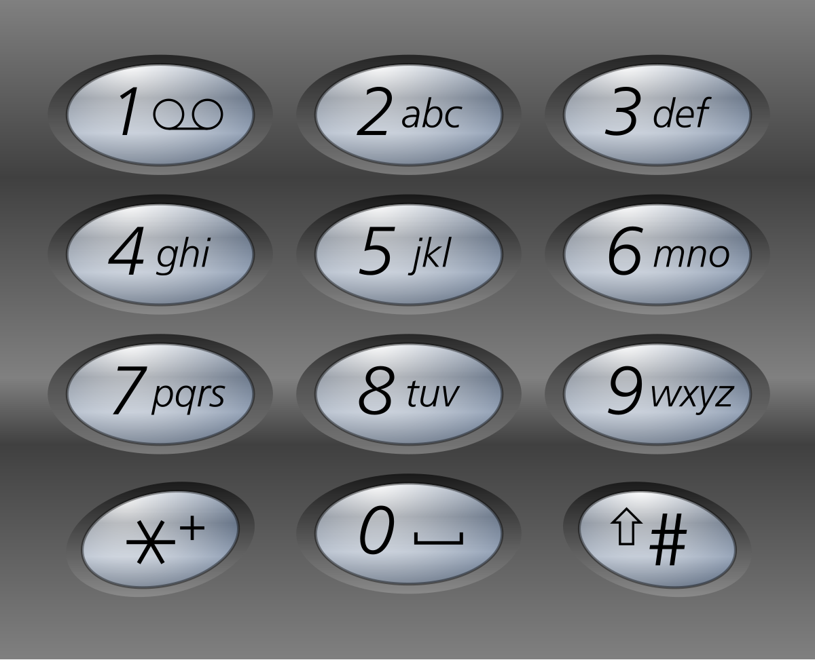
In order to add a letter, Alice has to press the key of the corresponding digit i times, where i is the position of the letter in the key.
- For example, to add the letter 's', Alice has to press '7' four times. Similarly, to add the letter 'k', Alice has to press '5' twice.
- Note that the digits '0' and '1' do not map to any letters, so Alice does not use them.
However, due to an error in transmission, Bob did not receive Alice's text message but received a string of pressed keys instead.
- For example, when Alice sent the message "bob", Bob received the string "2266622".
Given a string pressedKeys representing the string received by Bob, return the total number of possible text messages Alice could have sent.
Since the answer may be very large, return it modulo 10⁹ + 7.

Example 1:
Input: pressedKeys = "22233"
Output: 8
Explanation:
The possible text messages Alice could have sent are:
"aaadd", "abdd", "badd", "cdd", "aaae", "abe", "bae", and "ce".
Since there are 8 possible messages, we return 8.
Example 2:
Input: pressedKeys = "222222222222222222222222222222222222"
Output: 82876089
Explanation:
There are 2082876103 possible text messages Alice could have sent.
Since we need to return the answer modulo 10⁹ + 7, we return 2082876103 % (10⁹ + 7) = 82876089.
class Solution {
static final int MOD = 1_000_000_007;

public int countTexts(String pressedKeys) {
int n = pressedKeys.length();
int[] dp = new int[n + 1];
dp[0] = 1; // base case: empty string

for (int i = 1; i <= n; i++) {
char digit = pressedKeys.charAt(i - 1);
int maxLen = (digit == '7' || digit == '9') ? 4 : 3;

// Use your line here:
for (int j = 1; j <= maxLen; j++) {
if (i - j < 0) break;

if (pressedKeys.charAt(i - j) == digit) {
dp[i] = (dp[i] + dp[i - j]) % MOD;
} else {
break;
}
}
}

return dp[n];
}
}
Core concept:
for (int i = 1; i <= n; i++) {
for (int j = 1; j <= maxGroup; j++) {
if (i - j >= 0 && isValid(s.substring(i - j, i))) {
dp[i] += dp[i - j];
} else {
break;
}
}
}
19/7/25:
1.remove subfolders from file system:
Given a list of folders folder, return the folders after removing all sub-folders in those folders. You may return the answer in any order.
If a folder[i] is located within another folder[j], it is called a sub-folder of it. A sub-folder of folder[j] must start with folder[j], followed by a "/". For example, "/a/b" is a sub-folder of "/a", but "/b" is not a sub-folder of "/a/b/c".
The format of a path is one or more concatenated strings of the form: '/' followed by one or more lowercase English letters.
- For example, "/leetcode" and "/leetcode/problems" are valid paths while an empty string and "/" are not.

Example 1:
Input: folder = ["/a","/a/b","/c/d","/c/d/e","/c/f"]
Output: ["/a","/c/d","/c/f"]
Explanation: Folders "/a/b" is a subfolder of "/a" and "/c/d/e" is inside of folder "/c/d" in our filesystem.
Example 2:
Input: folder = ["/a","/a/b/c","/a/b/d"]
Output: ["/a"]
Explanation: Folders "/a/b/c" and "/a/b/d" will be removed because they are subfolders of "/a".
Example 3:
Input: folder = ["/a/b/c","/a/b/ca","/a/b/d"]
Output: ["/a/b/c","/a/b/ca","/a/b/d"]
Method-1:
Arrays.sort(folder);
List<String> arr=new ArrayList<>();
arr.add(folder[0]);
for(int i=1;i<folder.length;i++){
String prev=arr.get(arr.size()-1);
prev+='/';
if(!folder[i].startsWith(prev)){
arr.add(folder[i]);
}
}
return arr;
method2:
// List<String> arr=new ArrayList<>();
// List<String> parent=new ArrayList<>(Arrays.asList(folder));
// for(int i=0;i<folder.length;i++){
// String tocheck=folder[i];
// boolean bool=false;
// while(!tocheck.isEmpty()){
// int pos=tocheck.lastIndexOf('/');
// if(pos==-1) break;
// tocheck=tocheck.substring(0,pos);
// if(parent.contains(tocheck)){
// bool=true;
// break;
// }
// }
// if(!bool){
// arr.add(folder[i]);
// }
// }
// return arr;
2.house robber -||:
You are a professional robber planning to rob houses along a street. Each house has a certain amount of money stashed. All houses at this place are arranged in a circle. That means the first house is the neighbor of the last one. Meanwhile, adjacent houses have a security system connected, and it will automatically contact the police if two adjacent houses were broken into on the same night.
Given an integer array nums representing the amount of money of each house, return the maximum amount of money you can rob tonight without alerting the police.

Example 1:
Input: nums = [2,3,2]
Output: 3
Explanation: You cannot rob house 1 (money = 2) and then rob house 3 (money = 2), because they are adjacent houses.
Example 2:
Input: nums = [1,2,3,1]
Output: 4
Explanation: Rob house 1 (money = 1) and then rob house 3 (money = 3).
Total amount you can rob = 1 + 3 = 4.
Example 3:
Input: nums = [1,2,3]
Output: 3
class Solution {
public int rob(int[] nums) {
int n=nums.length;
if(n<=3){
int maxi=0;
for(int i=0;i<n;i++){
maxi=Math.max(nums[i],maxi);
}
return maxi;
}
int[] dp1=new int[n-1];
int[] dp2=new int[n];
dp1[0]=nums[0];
dp1[1]=Math.max(nums[0],nums[1]);
for(int i=2;i<n-1;i++){
dp1[i]=Math.max(dp1[i-1],dp1[i-2]+nums[i]);
}
dp2[1]=nums[1];
dp2[2]=Math.max(dp2[1],nums[2]);
for(int i=3;i<n;i++){
dp2[i]=Math.max(dp2[i-1],dp2[i-2]+nums[i]);
}
return Math.max(dp1[n-2],dp2[n-1]);
}
}
1.unique paths
There is a robot on an m x n grid. The robot is initially located at the top-left corner (i.e., grid[0][0]). The robot tries to move to the bottom-right corner (i.e., grid[m - 1][n - 1]). The robot can only move either down or right at any point in time.
Given the two integers m and n, return the number of possible unique paths that the robot can take to reach the bottom-right corner.
The test cases are generated so that the answer will be less than or equal to 2 * 10⁹.

Example 1:
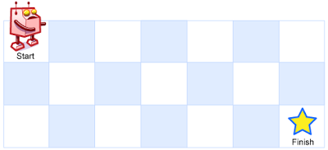
Input: m = 3, n = 7
Output: 28
Example 2:
Input: m = 3, n = 2
Output: 3
Explanation: From the top-left corner, there are a total of 3 ways to reach the bottom-right corner:
1. Right -> Down -> Down
2. Down -> Down -> Right
3. Down -> Right -> Down
class Solution {
public int uniquePaths(int m, int n) {
int[][] dp = new int[m][n];

// Fill first row and column with 1s
for (int i = 0; i < m; i++) dp[i][0] = 1;
for (int j = 0; j < n; j++) dp[0][j] = 1;

// Fill the rest
for (int i = 1; i < m; i++) {
for (int j = 1; j < n; j++) {
dp[i][j] = dp[i - 1][j] + dp[i][j - 1];
}
}

return dp[m - 1][n - 1];
}
}

22/7/25:
1.maximum erase value:
You are given an array of positive integers nums and want to erase a subarray containing unique elements. The score you get by erasing the subarray is equal to the sum of its elements.
Return the maximum score you can get by erasing exactly one subarray.
An array b is called to be a subarray of a if it forms a contiguous subsequence of a, that is, if it is equal to a[l],a[l+1],...,a[r] for some (l,r).

Example 1:
Input: nums = [4,2,4,5,6]
Output: 17
Explanation: The optimal subarray here is [2,4,5,6].
Example 2:
Input: nums = [5,2,1,2,5,2,1,2,5]
Output: 8
Explanation: The optimal subarray here is [5,2,1] or [1,2,5].
class Solution {
public int maximumUniqueSubarray(int[] nums) {
HashMap<Integer,Integer> hm=new HashMap<>();
int p1=0;
int sum=0;
int maxi=0;
for(int i=0;i<nums.length;i++){
hm.put(nums[i],hm.getOrDefault(nums[i],0)+1);
sum+=nums[i];
while(hm.get(nums[i])>1 && p1<nums.length){
sum-=nums[p1];
hm.put(nums[p1],hm.get(nums[p1])-1);
p1++;

}
maxi=Math.max(sum,maxi);
//System.out.println(maxi);
}
return maxi;
}
}
2.invert binary tree:
Given the root of a binary tree, invert the tree, and return its root.

Example 1:
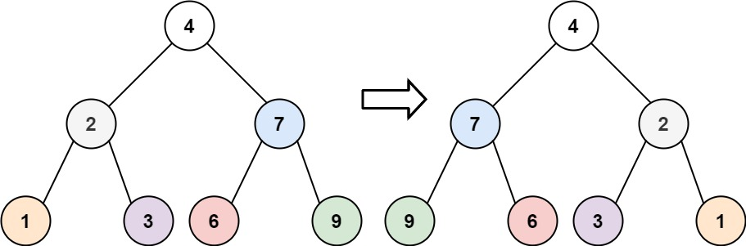
Input: root = [4,2,7,1,3,6,9]
Output: [4,7,2,9,6,3,1]
Example 2:
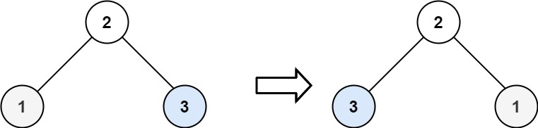
Input: root = [2,1,3]
Output: [2,3,1]
Example 3:
Input: root = []
Output: []
/**
* Definition for a binary tree node.
* public class TreeNode {
* int val;
* TreeNode left;
* TreeNode right;
* TreeNode() {}
* TreeNode(int val) { this.val = val; }
* TreeNode(int val, TreeNode left, TreeNode right) {
* this.val = val;
* this.left = left;
* this.right = right;
* }
* }
*/
class Solution {
public TreeNode invertTree(TreeNode root) {
root=recur(root);
return root;
}
public TreeNode recur(TreeNode root){
if(root==null) return root;
if(root.right!=null && root.left!=null) {
TreeNode temp=root.left;
root.left=recur(root.right);

root.right=recur(temp);
}
else if(root.right==null && root.left!=null) {
root.right=root.left;
root.left=null;
recur(root.right);
}
else if(root.left==null && root.right!=null){
root.left=root.right;
root.right=null;
recur(root.left);
}
return root;
}
}
3.snake and ladder:
You are given an n x n integer matrix board where the cells are labeled from 1 to n² in a Boustrophedon style starting from the bottom left of the board (i.e. board[n - 1][0]) and alternating direction each row.
You start on square 1 of the board. In each move, starting from square curr, do the following:
- Choose a destination square next with a label in the range [curr + 1, min(curr + 6, n²)].
  - This choice simulates the result of a standard 6-sided die roll: i.e., there are always at most 6 destinations, regardless of the size of the board.
- If next has a snake or ladder, you must move to the destination of that snake or ladder. Otherwise, you move to next.
- The game ends when you reach the square n².
A board square on row r and column c has a snake or ladder if board[r][c] != -1. The destination of that snake or ladder is board[r][c]. Squares 1 and n² are not the starting points of any snake or ladder.
Note that you only take a snake or ladder at most once per dice roll. If the destination to a snake or ladder is the start of another snake or ladder, you do not follow the subsequent snake or ladder.
- For example, suppose the board is [[-1,4],[-1,3]], and on the first move, your destination square is 2. You follow the ladder to square 3, but do not follow the subsequent ladder to 4.
Return the least number of dice rolls required to reach the square n². If it is not possible to reach the square, return -1.

Example 1:
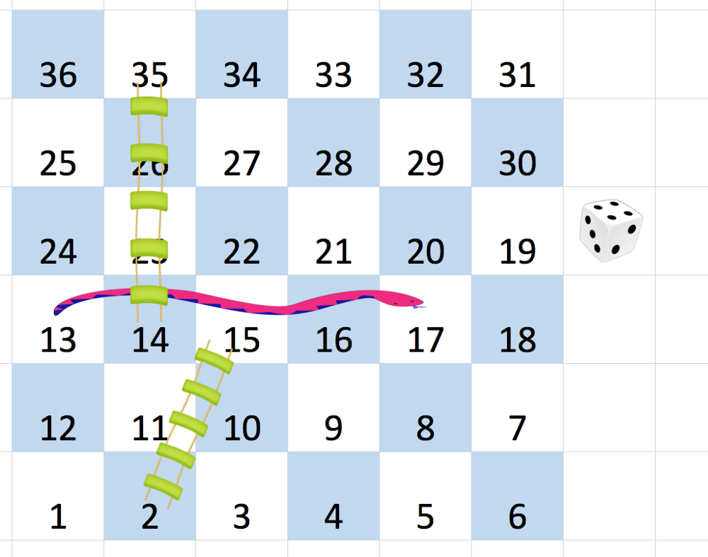
Input: board = [[-1,-1,-1,-1,-1,-1],[-1,-1,-1,-1,-1,-1],[-1,-1,-1,-1,-1,-1],[-1,35,-1,-1,13,-1],[-1,-1,-1,-1,-1,-1],[-1,15,-1,-1,-1,-1]]
Output: 4
Explanation:
In the beginning, you start at square 1 (at row 5, column 0).
You decide to move to square 2 and must take the ladder to square 15.
You then decide to move to square 17 and must take the snake to square 13.
You then decide to move to square 14 and must take the ladder to square 35.
You then decide to move to square 36, ending the game.
This is the lowest possible number of moves to reach the last square, so return 4.
Example 2:
Input: board = [[-1,-1],[-1,3]]
Output: 1
class Solution {
public int snakesAndLadders(int[][] board) {
int n=board.length;
for(int i=0;i<n/2;i++){
int[] temp=board[i];
board[i]=board[n-i-1];
board[n-i-1]=temp;
}
int step=0;
boolean[] vis=new boolean[n*n+1];
vis[1]=true;
Queue<Integer> q=new LinkedList<>();
q.add(1);
while(!q.isEmpty()){
int size=q.size();
for(int i=0;i<size;i++){
int cur=q.poll();
if(cur==(n*n)) return step;
for(int dice=1;dice<=6;dice++){
int next=cur+dice;
if(next>n*n) continue;
int[] coord=coordinates(next,n);
int x=coord[0];
int y=coord[1];
if(board[x][y]!=-1) next=board[x][y];

if(!vis[next]){
vis[next]=true;
q.add(next);
}

}

}
step++;
}
return -1;
}
public int[] coordinates(int next,int n){
int[] coord=new int[2];
coord[0]=(next-1)/n;
coord[1]=(next-1)%n;
if(coord[0]%2==1){
coord[1]=n-coord[1]-1;
}
return coord;
}
}
23/7/25:
1.check if every row and col contains all number:
An n x n matrix is valid if every row and every column contains all the integers from 1 to n (inclusive).
Given an n x n integer matrix matrix, return true if the matrix is valid. Otherwise, return false.

Example 1:
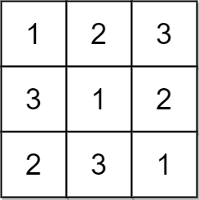
Input: matrix = [[1,2,3],[3,1,2],[2,3,1]]
Output: true
Explanation: In this case, n = 3, and every row and column contains the numbers 1, 2, and 3.
Hence, we return true.
Example 2:
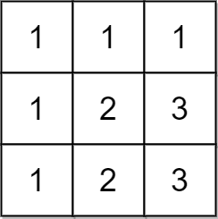
Input: matrix = [[1,1,1],[1,2,3],[1,2,3]]
Output: false
Explanation: In this case, n = 3, but the first row and the first column do not contain the numbers 2 or 3.
Hence, we return false.
class Solution {
public boolean checkValid(int[][] matrix) {
HashSet<Integer> row=new HashSet<>();
HashSet<Integer> col=new HashSet<>();
int n=matrix.length;
for(int i=0;i<matrix.length;i++){
row=new HashSet<>();
col=new HashSet<>();

for(int j=0;j<matrix.length;j++){
row.add(matrix[i][j]);
col.add(matrix[j][i]);
}
if(row.size()!=n) return false;
if(col.size()!=n) return false;
}
return true;
}
}
2.valid sudukko:
Determine if a 9 x 9 Sudoku board is valid. Only the filled cells need to be validated according to the following rules:
- Each row must contain the digits 1-9 without repetition.
- Each column must contain the digits 1-9 without repetition.
- Each of the nine 3 x 3 sub-boxes of the grid must contain the digits 1-9 without repetition.
Note:
- A Sudoku board (partially filled) could be valid but is not necessarily solvable.
- Only the filled cells need to be validated according to the mentioned rules.

Example 1:
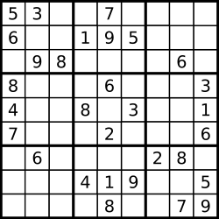
Input: board =
[["5","3",".",".","7",".",".",".","."]
,["6",".",".","1","9","5",".",".","."]
,[".","9","8",".",".",".",".","6","."]
,["8",".",".",".","6",".",".",".","3"]
,["4",".",".","8",".","3",".",".","1"]
,["7",".",".",".","2",".",".",".","6"]
,[".","6",".",".",".",".","2","8","."]
,[".",".",".","4","1","9",".",".","5"]
,[".",".",".",".","8",".",".","7","9"]]
Output: true
Example 2:
Input: board =
[["8","3",".",".","7",".",".",".","."]
,["6",".",".","1","9","5",".",".","."]
,[".","9","8",".",".",".",".","6","."]
,["8",".",".",".","6",".",".",".","3"]
,["4",".",".","8",".","3",".",".","1"]
,["7",".",".",".","2",".",".",".","6"]
,[".","6",".",".",".",".","2","8","."]
,[".",".",".","4","1","9",".",".","5"]
,[".",".",".",".","8",".",".","7","9"]]
Output: false
Explanation: Same as Example 1, except with the 5 in the top left corner being modified to 8. Since there are two 8's in the top left 3x3 sub-box, it is invalid.

class Solution {
public boolean isValidSudoku(char[][] board) {
Set<String> seen = new HashSet<>();

for (int i = 0; i < 9; ++i) {
for (int j = 0; j < 9; ++j) {
char current = board[i][j];
if (current != '.') {
if (!seen.add(current + " in row " + i) ||
!seen.add(current + " in col " + j) ||
!seen.add(current + " in box " + i/3 + "-" + j/3)) {
return false;
}
}
}
}
return true;
}
}

24.7.25:
1.different ways to add paranthesis:
Given a string expression of numbers and operators, return all possible results from computing all the different possible ways to group numbers and operators. You may return the answer in any order.
The test cases are generated such that the output values fit in a 32-bit integer and the number of different results does not exceed 10⁴.

Example 1:
Input: expression = "2-1-1"
Output: [0,2]
Explanation:
((2-1)-1) = 0
(2-(1-1)) = 2
Example 2:
Input: expression = "2*3-4*5"
Output: [-34,-14,-10,-10,10]
Explanation:
(2*(3-(4*5))) = -34
((2*3)-(4*5)) = -14
((2*(3-4))*5) = -10
(2*((3-4)*5)) = -10
(((2*3)-4)*5) = 10
Why used integer list instead of int is want allposs result:
class Solution {
// ❌ Don't use static or global list for this — we can handle it recursively
// private static List<Integer> fin = new ArrayList<>();

public List<Integer> diffWaysToCompute(String expression) {
return recur(expression); // ✅ return the result directly
}

// ✅ Now returns a list of all possible results
public List<Integer> recur(String exp) {
List<Integer> fin = new ArrayList<>();

// ✅ Check if expression is fully numeric (base case)
boolean isDigit = true;
for (int i = 0; i < exp.length(); i++) {
if (!Character.isDigit(exp.charAt(i))) {
isDigit = false;
break;
}
}
if (isDigit) {
fin.add(Integer.parseInt(exp));
return fin;
}

// ✅ Go through the string and split at each operator
for (int i = 0; i < exp.length(); i++) {
char c = exp.charAt(i);
if (!Character.isDigit(c)) {
// 🔥 ERROR FIXED: You were returning early inside the loop,
// which skipped other valid splits

List<Integer> left = recur(exp.substring(0, i));
List<Integer> right = recur(exp.substring(i + 1));

for (int l : left) {
for (int r : right) {
if (c == '+') {
fin.add(l + r);
} else if (c == '-') {
fin.add(l - r);
} else if (c == '*') {
fin.add(l * r);
}
}
}
}
}

return fin;
}
}

24/7/25:
1.gas station:
There are n gas stations along a circular route, where the amount of gas at the i^{th} station is gas[i].
You have a car with an unlimited gas tank and it costs cost[i] of gas to travel from the i^{th} station to its next (i + 1)^{th} station. You begin the journey with an empty tank at one of the gas stations.
Given two integer arrays gas and cost, return the starting gas station's index if you can travel around the circuit once in the clockwise direction, otherwise return -1. If there exists a solution, it is guaranteed to be unique.

Example 1:
Input: gas = [1,2,3,4,5], cost = [3,4,5,1,2]
Output: 3
Explanation:
Start at station 3 (index 3) and fill up with 4 unit of gas. Your tank = 0 + 4 = 4
Travel to station 4. Your tank = 4 - 1 + 5 = 8
Travel to station 0. Your tank = 8 - 2 + 1 = 7
Travel to station 1. Your tank = 7 - 3 + 2 = 6
Travel to station 2. Your tank = 6 - 4 + 3 = 5
Travel to station 3. The cost is 5. Your gas is just enough to travel back to station 3.
Therefore, return 3 as the starting index.
Example 2:
Input: gas = [2,3,4], cost = [3,4,3]
Output: -1
Explanation:
You can't start at station 0 or 1, as there is not enough gas to travel to the next station.
Let's start at station 2 and fill up with 4 unit of gas. Your tank = 0 + 4 = 4
Travel to station 0. Your tank = 4 - 3 + 2 = 3
Travel to station 1. Your tank = 3 - 3 + 3 = 3
You cannot travel back to station 2, as it requires 4 unit of gas but you only have 3.
Therefore, you can't travel around the circuit once no matter where you start.

class Solution {
public int canCompleteCircuit(int[] gas, int[] cost) {
int n=gas.length;
int st=0;
if(n==1 && gas[0]>=cost[0]) return 0;
else if(n==1 && gas[0]<cost[0]) return -1;
for(int i=0;i<n;i++){
if(gas[i]<=cost[i]) continue;
int index=(i+1)%n;
int sum=0;
sum+=gas[i];
boolean bool=false;
while(true){
if(index!=0)sum=sum-cost[index-1];
else if(index==0) sum=sum-cost[n-1];
//System.out.println(sum);
if(sum<0){
break;
}
else if(sum>=0){
sum+=gas[index];
}
if(sum>=0 && index==(i+1)%n && bool){
return i;
}

//System.out.println(" "+index);
bool=true;
index=(index+1)%n;
}
}
return -1;
}
}

