Context:
- Bidirectional bfs-open the lock(leetcode-752)
- Bfs+minheap-trapping rain waterII (leetcode-407)
- maximum number of points from grid queriy(leetcode-2503)
- dynamic programming-palindrome string (leetcode-1312)
- 5.dfs+memorization (leetcode-329)
- Pacific atlantic water flow-dfs(bidirectional) (leetcode-417)
- Swim in raising water-leetcode778
- 0/1 knapsack
- 2 best non-overlapping events(leetcode2054)-dp
- Cycle detection in undirected graph
- simultaneous bfs+bitmask+dp(leetcode-847)-shortest path visiting all nodes
- calculate money in leetcode bank(leetcode-1716)-math

Oct2:
1.open the lock:-bfs
You have a lock in front of you with 4 circular wheels. Each wheel has 10 slots: '0', '1', '2', '3', '4', '5', '6', '7', '8', '9'. The wheels can rotate freely and wrap around: for example we can turn '9' to be '0', or '0' to be '9'. Each move consists of turning one wheel one slot.
The lock initially starts at '0000', a string representing the state of the 4 wheels.
You are given a list of deadends dead ends, meaning if the lock displays any of these codes, the wheels of the lock will stop turning and you will be unable to open it.
Given a target representing the value of the wheels that will unlock the lock, return the minimum total number of turns required to open the lock, or -1 if it is impossible.

Example 1:
Input: deadends = ["0201","0101","0102","1212","2002"], target = "0202"
Output: 6
Explanation:
A sequence of valid moves would be "0000" -> "1000" -> "1100" -> "1200" -> "1201" -> "1202" -> "0202".
Note that a sequence like "0000" -> "0001" -> "0002" -> "0102" -> "0202" would be invalid,
because the wheels of the lock become stuck after the display becomes the dead end "0102".
Example 2:
Input: deadends = ["8888"], target = "0009"
Output: 1
Explanation: We can turn the last wheel in reverse to move from "0000" -> "0009".
Example 3:
Input: deadends = ["8887","8889","8878","8898","8788","8988","7888","9888"], target = "8888"
Output: -1
Explanation: We cannot reach the target without getting stuck.

Constraints:
- 1 <= deadends.length <= 500
- deadends[i].length == 4
- target.length == 4
- target will not be in the list deadends.
- target and deadends[i] consist of digits only.
I tried backtracking-dfs but didn’t work:
class Solution {
boolean found;
int minSteps = Integer.MAX_VALUE;

public int openLock(String[] deadends, String target) {
Set<String> dead = new HashSet<>(Arrays.asList(deadends));
Set<String> vis = new HashSet<>();
found = false;

backtrack("0000", target, dead, vis, 0);

return found ? minSteps : -1;
}

private void backtrack(String cur, String target, Set<String> dead, Set<String> vis, int steps) {
// base cases
if (dead.contains(cur) || vis.contains(cur)) return;
if (cur.equals(target)) {
found = true;
minSteps = Math.min(minSteps, steps);
return;
}

vis.add(cur);

// try rotating each wheel
for (int i = 0; i < 4; i++) {
char[] arr = cur.toCharArray();

// rotate forward
arr[i] = (arr[i] == '9') ? '0' : (char)(arr[i] + 1);
backtrack(new String(arr), target, dead, vis, steps + 1);

// rotate backward
arr = cur.toCharArray(); // reset
arr[i] = (arr[i] == '0') ? '9' : (char)(arr[i] - 1);
backtrack(new String(arr), target, dead, vis, steps + 1);
}
}
}

Bfs:
class Solution {
public int openLock(String[] deadends, String target) {
//let's try bfs now
Queue<String> q=new LinkedList<>();
HashSet<String> vis=new HashSet<>();
List<String> dead=Arrays.asList(deadends);
if (dead.contains("0000")) return -1;
q.add("0000");
int steps=0;
while(!q.isEmpty()){
int size = q.size();
for (int i = 0; i < size; i++) {
String cur = q.poll();
if (cur.equals(target)) return steps;

for (String nei : nei(cur)) {
if (!dead.contains(nei) && !vis.contains(nei)) {
q.add(nei);
vis.add(nei);
}
}
}
steps++;
}
return -1;
}
public List<String> nei(String cur){
List<String> lst=new ArrayList<>();
char[] arr=cur.toCharArray();
for(int i=0;i<4;i++){
char c=arr[i];
//forward
arr[i]=(c=='9')?'0':(char)(c+1);
lst.add(new String(arr));
//backward
arr[i]=(c=='0')?'9':(char)(c-1);
lst.add(new String(arr));
arr[i]=c;

}
return lst;
}
}

Time Limit Exceeded
47 / 48 testcases passed
Last Executed Input
Use Testcase
deadends =
["1000","9000","0100","0900","0010","0090","0001","0009"]
target =
"8888"

Solution:
Solution: Bidirectional BFS
Instead of searching only from "0000" to "8888", we search from both ends:
- One queue starts at "0000".
- One queue starts at "8888".
- At each step, expand the smaller frontier.
- When the two frontiers meet → shortest path found.
This reduces complexity from O(N) to about O(N/2).
How Bidirectional BFS Works
- Initialize two sets:
  - begin = {"0000"} (start side)
  - end = {target} (end side)
- Always expand the smaller set first:
  - If begin.size() > end.size(), swap them.
  - This keeps the branching factor low (fewer neighbors explored).
- Expand all neighbors of the current frontier (begin).
  - If any neighbor is already in the other frontier (end), we found a meeting point → shortest path found.
- Update steps after each level expansion.

📝 Key Point
The reason this works:
- In an unweighted graph, BFS guarantees shortest path.
- By expanding from both directions, the two waves meet in the middle.
- So instead of exploring N states, we explore about 2 * √N.
- For N = 10000, this reduces from ~10k → ~200 steps worst case.
- class Solution {
- public int openLock(String[] deadends, String target) {
- Set<String> dead = new HashSet<>(Arrays.asList(deadends));
- if (dead.contains("0000")) return -1;
- if (target.equals("0000")) return 0;

- Set<String> begin = new HashSet<>();
- Set<String> end = new HashSet<>();
- Set<String> vis = new HashSet<>();

- begin.add("0000");
- end.add(target);
- int steps = 0;

- while (!begin.isEmpty() && !end.isEmpty()) {
- // always expand the smaller set
- if (begin.size() > end.size()) {
- Set<String> temp = begin;
- begin = end;
- end = temp;
- }

- Set<String> next = new HashSet<>();
- for (String cur : begin) {
- if (dead.contains(cur)) continue;
- if (end.contains(cur)) return steps;

- vis.add(cur);

- for (String nei : neighbors(cur)) {
- if (!vis.contains(nei) && !dead.contains(nei)) {
- next.add(nei);
- }
- }
- }
- begin = next;
- steps++;
- }
- return -1;
- }

- private List<String> neighbors(String cur) {
- List<String> lst = new ArrayList<>();
- char[] arr = cur.toCharArray();
- for (int i = 0; i < 4; i++) {
- char c = arr[i];

- // forward
- arr[i] = (c == '9') ? '0' : (char)(c + 1);
- lst.add(new String(arr));

- // backward
- arr[i] = (c == '0') ? '9' : (char)(c - 1);
- lst.add(new String(arr));

- arr[i] = c; // restore
- }
- return lst;
- }
- }

Oct3:
Trapping rain water-II
Given an m x n integer matrix heightMap representing the height of each unit cell in a 2D elevation map, return the volume of water it can trap after raining.

Example 1:
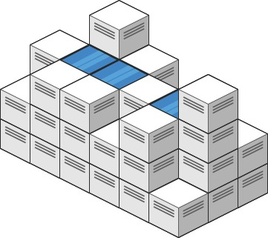
Input: heightMap = [[1,4,3,1,3,2],[3,2,1,3,2,4],[2,3,3,2,3,1]]
Output: 4
Explanation: After the rain, water is trapped between the blocks.
We have two small ponds 1 and 3 units trapped.
The total volume of water trapped is 4.
Example 2:

Input: heightMap = [[3,3,3,3,3],[3,2,2,2,3],[3,2,1,2,3],[3,2,2,2,3],[3,3,3,3,3]]
Output: 10

Constraints:
- m == heightMap.length
- n == heightMap[i].length
- 1 <= m, n <= 200
- 0 <= heightMap[i][j] <= 2 * 10⁴
- class Solution {
- public int trapRainWater(int[][] heightMap) {
- int m=heightMap.length;
- int n=heightMap[0].length;
- boolean[][] vis=new boolean[m][n];
- PriorityQueue<int[]> pq=new PriorityQueue<>((a, b) -> a[0] - b[0]);
- int count=0;
- for(int i=0;i<n;i++){
- pq.add(new int[]{heightMap[0][i],0,i});
- pq.add(new int[]{heightMap[m-1][i],m-1,i});
- vis[0][i] = true;
- vis[m-1][i] = true;
- }
- for(int i=1;i<m-1;i++){
- pq.add(new int[]{heightMap[i][0],i,0});
- pq.add(new int[]{heightMap[i][n-1],i,n-1});
- vis[i][0] = true;
- vis[i][n-1] = true;
- }
- while(!pq.isEmpty()){
- int[] cell=pq.poll();
- int row=cell[1];
- int col=cell[2];
- int val=cell[0];
- //if(vis[row][col]) continue;
- vis[row][col]=true;
- List<int[]> nei=func(cell,heightMap,vis);
- // Collections.sort(nei,(a,b)->{
- // if(a[0]<b[0]) return -1;
- // else return 1;
- // })
- for(int[] arr:nei){
- if(arr[0]<val){
- count+=(val-arr[0]);
- pq.add(new int[]{val,arr[1],arr[2]});

- }
- else{
- pq.add(new int[]{arr[0],arr[1],arr[2]});
- }
- }
- }
- return count;
- }
- public List<int[]> func(int[] cell, int[][] arr, boolean[][] vis) {
- int row = cell[1];
- int col = cell[2];
- int m = arr.length;
- int n = arr[0].length;
- List<int[]> lst = new ArrayList<>();

- int[][] dirs = {{1,0},{-1,0},{0,1},{0,-1}};
- for (int[] d : dirs) {
- int nr = row + d[0];
- int nc = col + d[1];
- if (nr >= 0 && nr < m && nc >= 0 && nc < n && !vis[nr][nc]) {
- vis[nr][nc]=true;
- lst.add(new int[]{arr[nr][nc], nr, nc});
- }
- }

- return lst;
- }
- }
- • After poll (marking visited)= simpler logic, but wastes queue operations.
- • When add = avoids duplicates, more efficient.
2.maximum number of points from grid quries:
You are given an m x n integer matrix grid and an array queries of size k.
Find an array answer of size k such that for each integer queries[i] you start in the top left cell of the matrix and repeat the following process:
- If queries[i] is strictly greater than the value of the current cell that you are in, then you get one point if it is your first time visiting this cell, and you can move to any adjacent cell in all 4 directions: up, down, left, and right.
- Otherwise, you do not get any points, and you end this process.
After the process, answer[i] is the maximum number of points you can get. Note that for each query you are allowed to visit the same cell multiple times.
Return the resulting array answer.

Example 1:
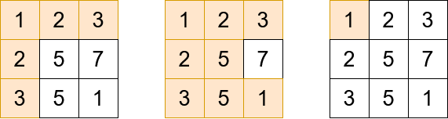
Input: grid = [[1,2,3],[2,5,7],[3,5,1]], queries = [5,6,2]
Output: [5,8,1]
Explanation: The diagrams above show which cells we visit to get points for each query.
Example 2:
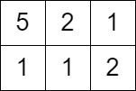
Input: grid = [[5,2,1],[1,1,2]], queries = [3]
Output: [0]
Explanation: We can not get any points because the value of the top left cell is already greater than or equal to 3.

Constraints:
- m == grid.length
- n == grid[i].length
- 2 <= m, n <= 1000
- 4 <= m * n <= 10⁵
- k == queries.length
- 1 <= k <= 10⁴
- 1 <= grid[i][j], queries[i] <= 10⁶

class Solution {
public int[] maxPoints(int[][] grid, int[] queries) {
int m = grid.length;
int n = grid[0].length;
int k = queries.length;

int[][] qarr = new int[k][2];
for (int i = 0; i < k; i++) {
qarr[i][0] = queries[i];
qarr[i][1] = i;
}
Arrays.sort(qarr, (a, b) -> a[0] - b[0]);

int[] ans = new int[k];
boolean[][] vis = new boolean[m][n];

// Priority queue: always expand smallest value first
PriorityQueue<int[]> pq = new PriorityQueue<>((a, b) -> a[0] - b[0]);

pq.add(new int[]{grid[0][0], 0, 0});
vis[0][0] = true;

int[][] dir = {{1,0},{-1,0},{0,1},{0,-1}};
int count = 0;

for (int j = 0; j < k; j++) {
int val = qarr[j][0];

while (!pq.isEmpty() && pq.peek()[0] < val) {
int[] cell = pq.poll();
count++;
int r = cell[1];
int c = cell[2];

for (int[] d : dir) {
int nr = r + d[0], nc = c + d[1];
if (nr >= 0 && nr < m && nc >= 0 && nc < n && !vis[nr][nc]) {
pq.add(new int[]{grid[nr][nc], nr, nc});
vis[nr][nc] = true;
}
}
}
ans[qarr[j][1]] = count;
}
return ans;
}
}
Oct4:
1,minimum insertion steps to make string palindrome
Given a string s. In one step you can insert any character at any index of the string.
Return the minimum number of steps to make s palindrome.
A Palindrome String is one that reads the same backward as well as forward.

Example 1:
Input: s = "zzazz"
Output: 0
Explanation: The string "zzazz" is already palindrome we do not need any insertions.
Example 2:
Input: s = "mbadm"
Output: 2
Explanation: String can be "mbdadbm" or "mdbabdm".
Example 3:
Input: s = "leetcode"
Output: 5
Explanation: Inserting 5 characters the string becomes "leetcodocteel".

Constraints:
- 1 <= s.length <= 500
- s consists of lowercase English letters.
- class Solution {
- public int minInsertions(String s) {
- int n=s.length();
- String rev = new StringBuilder(s).reverse().toString();
- return n-lcs(s,rev);

- }
- public int lcs(String s1,String s2){
- int n=s1.length();
- int[][] dp=new int[n+1][n+1];
- //dp[i][j]-> longest common substring present fron s1[0...i] and s2[0...j]
- dp[0][0]=0;
- //empty string has 0 common;
- for(int i=1;i<=n;i++){
- for(int j=1;j<=n;j++){
- if(s1.charAt(i-1)==s2.charAt(j-1)){
- dp[i][j]=1+dp[i-1][j-1];
- }
- else{
- dp[i][j]=Math.max(dp[i][j-1],dp[i-1][j]);
- }
- }
- }
- return dp[n][n];
- }
- }

2.longest increasing path in matrix:
Given an m x n integers matrix, return the length of the longest increasing path in matrix.
From each cell, you can either move in four directions: left, right, up, or down. You may not move diagonally or move outside the boundary (i.e., wrap-around is not allowed).

Example 1:
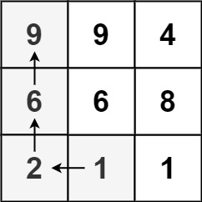
Input: matrix = [[9,9,4],[6,6,8],[2,1,1]]
Output: 4
Explanation: The longest increasing path is [1, 2, 6, 9].
Example 2:
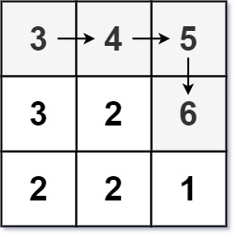
Input: matrix = [[3,4,5],[3,2,6],[2,2,1]]
Output: 4
Explanation: The longest increasing path is [3, 4, 5, 6]. Moving diagonally is not allowed.
Example 3:
Input: matrix = [[1]]
Output: 1

Constraints:
- m == matrix.length
- n == matrix[i].length
- 1 <= m, n <= 200
- 0 <= matrix[i][j] <= 2³¹ - 1
- class Solution {
- public int longestIncreasingPath(int[][] matrix) {
- int m = matrix.length;
- int n = matrix[0].length;
- int[][] dp = new int[m][n]; // memoization table
- int maxLen = 0;

- for (int i = 0; i < m; i++) {
- for (int j = 0; j < n; j++) {
- maxLen = Math.max(maxLen, dfs(matrix, i, j, dp, -1));
- }
- }
- return maxLen;
- }

- public int dfs(int[][] matrix, int row, int col, int[][] dp, int prev) {
- int m = matrix.length, n = matrix[0].length;

- // boundary or not increasing
- if (row < 0 || col < 0 || row >= m || col >= n || matrix[row][col] <= prev)
- return 0;

- // already computed
- if (dp[row][col] != 0)
- return dp[row][col];

- int val = matrix[row][col];

- int up = dfs(matrix, row - 1, col, dp, val);
- int down = dfs(matrix, row + 1, col, dp, val);
- int left = dfs(matrix, row, col - 1, dp, val);
- int right = dfs(matrix, row, col + 1, dp, val);

- dp[row][col] = 1 + Math.max(Math.max(up, down), Math.max(left, right));
- return dp[row][col];
- }
- }

Oct 5:
1.pacific Atlantic water flow:
There is an m x n rectangular island that borders both the Pacific Ocean and Atlantic Ocean. The Pacific Ocean touches the island's left and top edges, and the Atlantic Ocean touches the island's right and bottom edges.
The island is partitioned into a grid of square cells. You are given an m x n integer matrix heights where heights[r][c] represents the height above sea level of the cell at coordinate (r, c).
The island receives a lot of rain, and the rain water can flow to neighboring cells directly north, south, east, and west if the neighboring cell's height is less than or equal to the current cell's height. Water can flow from any cell adjacent to an ocean into the ocean.
Return a 2D list of grid coordinates result where result[i] = [r_{i}, c_{i}] denotes that rain water can flow from cell (r_{i}, c_{i}) to both the Pacific and Atlantic oceans.

Example 1:
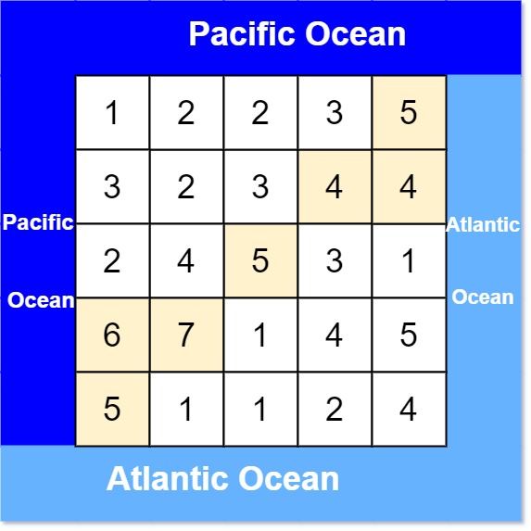
Input: heights = [[1,2,2,3,5],[3,2,3,4,4],[2,4,5,3,1],[6,7,1,4,5],[5,1,1,2,4]]
Output: [[0,4],[1,3],[1,4],[2,2],[3,0],[3,1],[4,0]]
Explanation: The following cells can flow to the Pacific and Atlantic oceans, as shown below:
[0,4]: [0,4] -> Pacific Ocean
[0,4] -> Atlantic Ocean
[1,3]: [1,3] -> [0,3] -> Pacific Ocean
[1,3] -> [1,4] -> Atlantic Ocean
[1,4]: [1,4] -> [1,3] -> [0,3] -> Pacific Ocean
[1,4] -> Atlantic Ocean
[2,2]: [2,2] -> [1,2] -> [0,2] -> Pacific Ocean
[2,2] -> [2,3] -> [2,4] -> Atlantic Ocean
[3,0]: [3,0] -> Pacific Ocean
[3,0] -> [4,0] -> Atlantic Ocean
[3,1]: [3,1] -> [3,0] -> Pacific Ocean
[3,1] -> [4,1] -> Atlantic Ocean
[4,0]: [4,0] -> Pacific Ocean
[4,0] -> Atlantic Ocean
Note that there are other possible paths for these cells to flow to the Pacific and Atlantic oceans.
Example 2:
Input: heights = [[1]]
Output: [[0,0]]
Explanation: The water can flow from the only cell to the Pacific and Atlantic oceans.

Constraints:
- m == heights.length
- n == heights[r].length
- 1 <= m, n <= 200
- 0 <= heights[r][c] <= 10⁵
- class Solution {
- public List<List<Integer>> pacificAtlantic(int[][] heights) {
- int m = heights.length, n = heights[0].length;
- boolean[][] pac = new boolean[m][n];
- boolean[][] atl = new boolean[m][n];

- // DFS from Pacific and Atlantic borders
- for (int i = 0; i < m; i++) {
- dfs(heights, pac, i, 0, heights[i][0]);
- dfs(heights, atl, i, n - 1, heights[i][n - 1]);
- }
- for (int j = 0; j < n; j++) {
- dfs(heights, pac, 0, j, heights[0][j]);
- dfs(heights, atl, m - 1, j, heights[m - 1][j]);
- }

- List<List<Integer>> res = new ArrayList<>();
- for (int i = 0; i < m; i++) {
- for (int j = 0; j < n; j++) {
- if (pac[i][j] && atl[i][j]) {
- res.add(Arrays.asList(i, j));
- }
- }
- }
- return res;
- }

- private void dfs(int[][] h, boolean[][] vis, int r, int c, int prev) {
- int m = h.length, n = h[0].length;
- if (r < 0 || c < 0 || r >= m || c >= n || vis[r][c] || h[r][c] < prev) return;
- vis[r][c] = true;
- dfs(h, vis, r + 1, c, h[r][c]);
- dfs(h, vis, r - 1, c, h[r][c]);
- dfs(h, vis, r, c + 1, h[r][c]);
- dfs(h, vis, r, c - 1, h[r][c]);
- }
- }

Oct6:
1.swim in raising water: bfs+priority(dijistra like min path)
You are given an n x n integer matrix grid where each value grid[i][j] represents the elevation at that point (i, j).
It starts raining, and water gradually rises over time. At time t, the water level is t, meaning any cell with elevation less than equal to t is submerged or reachable.
You can swim from a square to another 4-directionally adjacent square if and only if the elevation of both squares individually are at most t. You can swim infinite distances in zero time. Of course, you must stay within the boundaries of the grid during your swim.
Return the minimum time until you can reach the bottom right square (n - 1, n - 1) if you start at the top left square (0, 0).

Example 1:
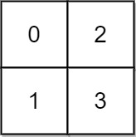
Input: grid = [[0,2],[1,3]]
Output: 3
Explanation:
At time 0, you are in grid location (0, 0).
You cannot go anywhere else because 4-directionally adjacent neighbors have a higher elevation than t = 0.
You cannot reach point (1, 1) until time 3.
When the depth of water is 3, we can swim anywhere inside the grid.
Example 2:
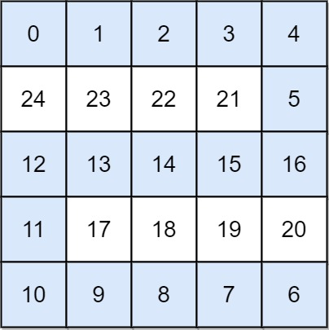
Input: grid = [[0,1,2,3,4],[24,23,22,21,5],[12,13,14,15,16],[11,17,18,19,20],[10,9,8,7,6]]
Output: 16
Explanation: The final route is shown.
We need to wait until time 16 so that (0, 0) and (4, 4) are connected.

Constraints:
- n == grid.length
- n == grid[i].length
- 1 <= n <= 50
- 0 <= grid[i][j] < n²
- Each value grid[i][j] is unique.
- import java.util.*;

- class Solution {
- public int swimInWater(int[][] grid) {
- int n = grid.length;
- int[][] dirs = {{1,0},{-1,0},{0,1},{0,-1}};
- boolean[][] vis = new boolean[n][n];
- PriorityQueue<int[]> pq = new PriorityQueue<>((a,b) -> a[0]-b[0]);
- pq.offer(new int[]{grid[0][0], 0, 0});
- vis[0][0] = true;
- int res = 0;

- while (!pq.isEmpty()) {
- int[] cur = pq.poll();
- res = Math.max(res, cur[0]);
- int r = cur[1], c = cur[2];
- if (r == n - 1 && c == n - 1) return res;
- for (int[] d : dirs) {
- int nr = r + d[0], nc = c + d[1];
- if (nr >= 0 && nc >= 0 && nr < n && nc < n && !vis[nr][nc]) {
- vis[nr][nc] = true;
- pq.offer(new int[]{grid[nr][nc], nr, nc});
- }
- }
- }
- return -1;
- }
- }

Oct7:
1.treeaure hunter’s knapsack:
A treasure hunter is exploring an ancient cave filled with valuable artifacts.
Each artifact has a specific weight and value.
The hunter has a knapsack that can carry at most a certain weight W.
Your task is to find the maximum total value of artifacts the hunter can carry without exceeding the knapsack's weight capacity.
Each artifact can either be picked once or not picked at all (you cannot break or partially pick an item).
Input Format
- The first line contains two integers n and W — the number of artifacts and the maximum weight the knapsack can carry.
- The second line contains n space-separated integers representing the weights of the artifacts.
- The third line contains n space-separated integers representing the values of the artifacts.
Constraints
- 1 <= n <= 100
- 1 <= W <= 10^4
- 1 <= weight[i], value[i] <= 10^4
Output Format
Output a single integer — the maximum total value the hunter can collect.
Sample Input 0
4 8
2 3 4 5
3 4 5 6
Sample Output 0
10
Explanation 0
The hunter can pick artifacts with weights 3 and 5 (total weight 8) and values 4 and 6, total value 10.
Sample Input 1
3 50
10 20 30
60 100 120
Sample Output 1
220

import java.io.*;
import java.util.*;

public class Solution {

public static void main(String[] args) {
Scanner in=new Scanner(System.in);
int n=in.nextInt();
int w=in.nextInt();
in.nextLine();
int[] weight=new int[n];
int[] value=new int[n];
for(int i=0;i<n;i++){
weight[i]=in.nextInt();

}
in.nextLine();
for(int i=0;i<n;i++){
value[i]=in.nextInt();
}
int[][] dp=new int[n+1][w+1];
//dp[i][j]-> max profit we can get if included 1st i items within capacity of j
//base case dp[i][0]=0 and dp[0][j]=0
for(int i=1;i<=n;i++){
for(int j=1;j<=w;j++){
//choose ith item if ith item weight is less than or equal to capacity limit j
if(weight[i-1]<=j){
dp[i][j]=Math.max(
dp[i-1][j],//not taking ith item
value[i-1]+dp[i-1][j-weight[i-1]]);// taking ith item
}
else dp[i][j]=dp[i-1][j];
}
}
System.out.println(dp[n][w]);
}
}
Oct8:
- 2best non overlapping events:
You are given a 0-indexed 2D integer array of events where events[i] = [startTime_{i}, endTime_{i}, value_{i}]. The i^{th} event starts at startTime_{i} and ends at endTime_{i}, and if you attend this event, you will receive a value of value_{i}. You can choose at most two non-overlapping events to attend such that the sum of their values is maximized.
Return this maximum sum.
Note that the start time and end time is inclusive: that is, you cannot attend two events where one of them starts and the other ends at the same time. More specifically, if you attend an event with end time t, the next event must start at or after t + 1.

Example 1:
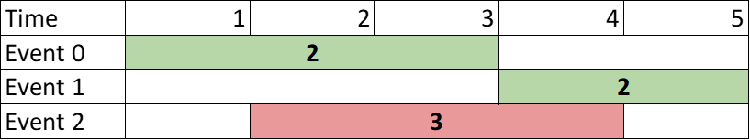
Input: events = [[1,3,2],[4,5,2],[2,4,3]]
Output: 4
Explanation: Choose the green events, 0 and 1 for a sum of 2 + 2 = 4.
Example 2:
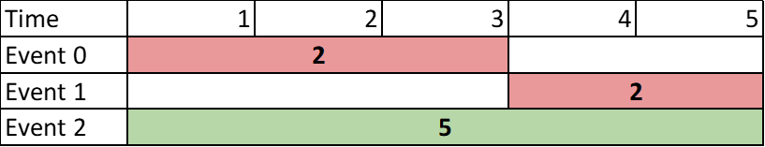
Input: events = [[1,3,2],[4,5,2],[1,5,5]]
Output: 5
Explanation: Choose event 2 for a sum of 5.
Example 3:
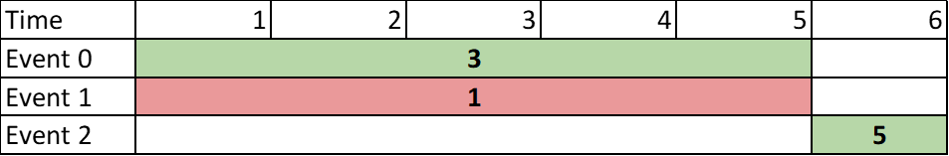
Input: events = [[1,5,3],[1,5,1],[6,6,5]]
Output: 8
Explanation: Choose events 0 and 2 for a sum of 3 + 5 = 8.

Constraints:
- 2 <= events.length <= 10⁵
- events[i].length == 3
- 1 <= startTime_{i} <= endTime_{i} <= 10⁹
- 1 <= value_{i} <= 10⁶

- class Solution {
- public int maxTwoEvents(int[][] events) {
- Arrays.sort(events,(a,b)->a[1]-b[1]);
- int n=events.length;
- int[] inter=new int[n+1];
- for(int i=1;i<=n;i++){
- inter[i]=binarySearch(events,events[i-1][0]);
- }
- int[][] dp=new int[3][n+1];
- //dp[k][i] k overlapping event that can be attented with o to i events present
- for(int k=1;k<3;k++){
- for(int i=1;i<=n;i++){
- dp[k][i]=Math.max(dp[k][i-1],events[i-1][2]+dp[k-1][inter[i]]);
- }
- }
- return dp[2][n];
- }
- public int binarySearch(int[][] arr,int start){
- int p1=0;
- int p2=arr.length-1;
- int index=0;
- while(p1<=p2){
- int mid=(p1+p2)/2;
- if(arr[mid][1]<start){
- index=mid+1;
- p1=mid+1;
- }
- else{
- p2=mid-1;
- }
- }
- return index;
- }
- }

2.successful pairs of spells and potions:
You are given two positive integer arrays spells and potions, of length n and m respectively, where spells[i] represents the strength of the i^{th} spell and potions[j] represents the strength of the j^{th} potion.
You are also given an integer success. A spell and potion pair is considered successful if the product of their strengths is at least success.
Return an integer array pairs of length n where pairs[i] is the number of potions that will form a successful pair with the i^{th} spell.

Example 1:
Input: spells = [5,1,3], potions = [1,2,3,4,5], success = 7
Output: [4,0,3]
Explanation:
- 0th spell: 5 * [1,2,3,4,5] = [5,10,15,20,25]. 4 pairs are successful.
- 1st spell: 1 * [1,2,3,4,5] = [1,2,3,4,5]. 0 pairs are successful.
- 2nd spell: 3 * [1,2,3,4,5] = [3,6,9,12,15]. 3 pairs are successful.
Thus, [4,0,3] is returned.
Example 2:
Input: spells = [3,1,2], potions = [8,5,8], success = 16
Output: [2,0,2]
Explanation:
- 0th spell: 3 * [8,5,8] = [24,15,24]. 2 pairs are successful.
- 1st spell: 1 * [8,5,8] = [8,5,8]. 0 pairs are successful.
- 2nd spell: 2 * [8,5,8] = [16,10,16]. 2 pairs are successful.
Thus, [2,0,2] is returned.

Constraints:
- n == spells.length
- m == potions.length
- 1 <= n, m <= 10⁵
- 1 <= spells[i], potions[i] <= 10⁵
- 1 <= success <= 10¹⁰
- class Solution {
- public int[] successfulPairs(int[] spells, int[] potions, long success) {

- int n=spells.length;
- int m=potions.length;
- Arrays.sort(potions);
- int[] ans=new int[n];
- for(int i=0;i<n;i++){
- int index=binarySearch(potions,spells[i],success);
- if(index!=-1)ans[i]=m-index;
- }
- return ans;
- }
- public int binarySearch(int[] potions,int cur,long fin){
- int p1=0;
- int p2=potions.length-1;
- int index=-1;
- while(p1<=p2){
- int mid=(p1+p2)/2;
- if((long)potions[mid]*cur>=fin){
- index=mid;
- p2=mid-1;
- }
- else if((long)potions[mid]*cur<fin){
- p1=mid+1;
- }

- }
- return index;
- }
- }
3.cycle detection in undirected graph:
class Solution {
public boolean isCycle(int V, ArrayList<ArrayList<Integer>> adj) {
boolean[] vis = new boolean[V];

for (int i = 0; i < V; i++) {
if (!vis[i]) {
if (bfs(i, adj, vis)) return true;
}
}
return false;
}

private boolean bfs(int start, ArrayList<ArrayList<Integer>> adj, boolean[] vis) {
Queue<int[]> q = new LinkedList<>(); // {node, parent}
q.add(new int[]{start, -1});
vis[start] = true;

while (!q.isEmpty()) {
int[] cur = q.poll();
int node = cur[0];
int parent = cur[1];

for (int neighbor : adj.get(node)) {
if (!vis[neighbor]) {
vis[neighbor] = true;
q.add(new int[]{neighbor, node});
}
else if (neighbor != parent) {
return true;
}
}
}
return false;
}
}
11.shortest path visiting all nodes
You have an undirected, connected graph of n nodes labeled from 0 to n - 1. You are given an array graph where graph[i] is a list of all the nodes connected with node i by an edge.
Return the length of the shortest path that visits every node. You may start and stop at any node, you may revisit nodes multiple times, and you may reuse edges.

Example 1:
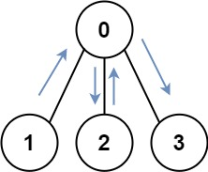
Input: graph = [[1,2,3],[0],[0],[0]]
Output: 4
Explanation: One possible path is [1,0,2,0,3]
Example 2:
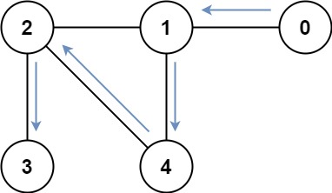
Input: graph = [[1],[0,2,4],[1,3,4],[2],[1,2]]
Output: 4
Explanation: One possible path is [0,1,4,2,3]

Constraints:
- n == graph.length
- 1 <= n <= 12
- 0 <= graph[i].length < n
- graph[i] does not contain i.
- If graph[a] contains b, then graph[b] contains a.
- The input graph is always connected.
- class Solution {
- public int shortestPathLength(int[][] graph) {
- //lead,mask
- //dp[lead][mask]-> current node and visited mask
- int n=graph.length;
- Queue<int[]> q=new LinkedList<>();
- int tot=1<<n;
- int[][] dp=new int[n][tot];
- for(int i=0;i<n;i++){
- Arrays.fill(dp[i],-1);
- }
- for(int i=0;i<n;i++){
- dp[i][1 << i] = 0;
- q.add(new int[]{i,(1<<i)});
- }
- while(!q.isEmpty()){
- int size=q.size();
- for(int i=0;i<size;i++){
- int[] temp=q.poll();
- int lead=temp[0];
- int mask=temp[1];
- if(mask==(1<<n)-1) return dp[lead][mask];
- for(int j=0;j<graph[lead].length;j++){
- int nlead=graph[lead][j];
- int nmask=mask|(1<<(nlead));
- if(dp[nlead][nmask]!=-1) continue;
- dp[nlead][nmask]=1+dp[lead][mask];
- q.add(new int[]{nlead,nmask});
- }
- }

- }
- return 0;
- }
- }

Oct25:
1.calculate money in leetcode bank:
Hercy wants to save money for his first car. He puts money in the Leetcode bank every day.
He starts by putting in $1 on Monday, the first day. Every day from Tuesday to Sunday, he will put in $1 more than the day before. On every subsequent Monday, he will put in $1 more than the previous Monday.
Given n, return the total amount of money he will have in the Leetcode bank at the end of the n^{th} day.

Example 1:
Input: n = 4
Output: 10
Explanation: After the 4th day, the total is 1 + 2 + 3 + 4 = 10.
Example 2:
Input: n = 10
Output: 37
Explanation: After the 10th day, the total is (1 + 2 + 3 + 4 + 5 + 6 + 7) + (2 + 3 + 4) = 37. Notice that on the 2nd Monday, Hercy only puts in $2.
Example 3:
Input: n = 20
Output: 96
Explanation: After the 20th day, the total is (1 + 2 + 3 + 4 + 5 + 6 + 7) + (2 + 3 + 4 + 5 + 6 + 7 + 8) + (3 + 4 + 5 + 6 + 7 + 8) = 96.

Constraints:
- 1 <= n <= 1000

class Solution {
public int totalMoney(int n) {
int x=n;
int i=0;
int sum=0;
while(x>=7){
sum+=(28+(7*i));
//System.out.println(sum+" in");
i++;
x-=7;
}
//ap a=i+1 d=1 sum=n/2 (2a+(n-1)d)
sum+=(x*(2*(i+1)+(x-1)))/2;
//System.out.println(sum);
return sum;
}
}

