1.merge sort
class MergeSort {
void merge(int[] arr, int l, int m, int r) {
int n1 = m - l + 1, n2 = r - m;
int[] L = new int[n1];
int[] R = new int[n2];

for (int i = 0; i < n1; i++) L[i] = arr[l + i];
for (int j = 0; j < n2; j++) R[j] = arr[m + 1 + j];

int i = 0, j = 0, k = l;
while (i < n1 && j < n2)
arr[k++] = (L[i] <= R[j]) ? L[i++] : R[j++];

while (i < n1) arr[k++] = L[i++];
while (j < n2) arr[k++] = R[j++];
}

void sort(int[] arr, int l, int r) {
if (l < r) {
int m = (l + r) / 2;
sort(arr, l, m);
sort(arr, m + 1, r);
merge(arr, l, m, r);
}
}
}
2.QUICK SORT:
import java.util.*;
class Main{
public static void main(String[] args){
Scanner in=new Scanner(System.in);
int n=in.nextInt();
in.nextLine();
String s=in.nextLine();
String[] str=s.split(" ");
String s2="";
for(int i=0;i<n;i++){
s2+=str[i];
}
char[] arr=s2.toCharArray();
//quicksort(arr,0,arr.length-1);
Arrays.sort(arr);
for(int i=0;i<n;i++){
System.out.print(arr[i]+" ");
}
}
public static void quicksort(char[] arr,int low,int high){
if(low<high){
int pivot=quick(arr,low,high);
quicksort(arr,low,pivot-1);
quicksort(arr,pivot+1,high);
}
}
public static int quick(char[] arr,int low,int high){
int i=low;
int j=high;
int pivot=low;
while(low<=high){
while(i<arr.length && arr[i]<=arr[pivot]){
i++;
}
while(j>=0 && arr[j]>arr[pivot]){
j--;
}
if(i<j){
char t=arr[i];
arr[i]=arr[j];
arr[j]=t;
}
}
char t=arr[j];
arr[j]=arr[pivot];
arr[pivot]=t;
return j;
}

}
Strassen multiplication:
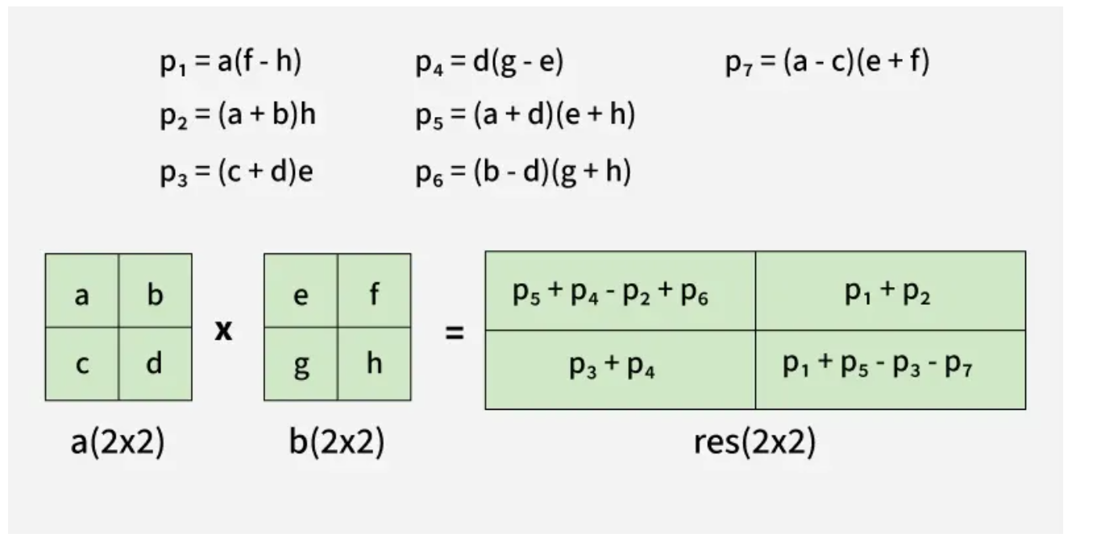
3.largest sum of 2 elements:
public class MaxTwoSum {

// Helper function to return the top two largest numbers in a subarray
static int[] findTwoLargest(int[] arr, int low, int high) {
// Base case: only one element
if (low == high) {
return new int[]{arr[low], Integer.MIN_VALUE};
}

// Base case: two elements
if (high - low == 1) {
int first = Math.max(arr[low], arr[high]);
int second = Math.min(arr[low], arr[high]);
return new int[]{first, second};
}

int mid = (low + high) / 2;

// Recurse on left and right halves
int[] left = findTwoLargest(arr, low, mid);
int[] right = findTwoLargest(arr, mid + 1, high);

// Combine step — find top 2 among 4 candidates
int[] combined = {left[0], left[1], right[0], right[1]};
int max1 = Integer.MIN_VALUE, max2 = Integer.MIN_VALUE;

for (int val : combined) {
if (val > max1) {
max2 = max1;
max1 = val;
} else if (val > max2) {
max2 = val;
}
}

return new int[]{max1, max2};
}

public static void main(String[] args) {
int[] arr = {5, 12, 9, 21, 7, 18};
int[] result = findTwoLargest(arr, 0, arr.length - 1);
int maxSum = result[0] + result[1];

System.out.println("Largest two elements: " + result[0] + ", " + result[1]);
System.out.println("Maximum sum = " + maxSum);
}
}
4.island perimeter:
class Solution {
public int islandPerimeter(int[][] grid) {
int rows = grid.length;
int cols = grid[0].length;
boolean[][] visited = new boolean[rows][cols];

for (int i = 0; i < rows; i++) {
for (int j = 0; j < cols; j++) {
if (grid[i][j] == 1) {
// start DFS from first land cell found
return dfs(grid, visited, i, j);
}
}
}
return 0; // no island
}

private int dfs(int[][] grid, boolean[][] visited, int r, int c) {
int rows = grid.length;
int cols = grid[0].length;

// out of bounds → contributes 1 edge
if (r < 0 || c < 0 || r >= rows || c >= cols)
return 1;

// water → contributes 1 edge
if (grid[r][c] == 0)
return 1;

// already visited land → no new perimeter
if (visited[r][c])
return 0;

visited[r][c] = true;

// explore 4 directions
int perimeter = 0;
perimeter += dfs(grid, visited, r - 1, c); // up
perimeter += dfs(grid, visited, r + 1, c); // down
perimeter += dfs(grid, visited, r, c - 1); // left
perimeter += dfs(grid, visited, r, c + 1); // right

return perimeter;
}
}
5.maximum area code:
class Solution {
public int maxAreaOfIsland(int[][] grid) {
int rows = grid.length;
int cols = grid[0].length;
boolean[][] visited = new boolean[rows][cols];
int maxArea = 0;

for (int i = 0; i < rows; i++) {
for (int j = 0; j < cols; j++) {
if (grid[i][j] == 1 && !visited[i][j]) {
int area = dfs(grid, visited, i, j);
maxArea = Math.max(maxArea, area);
}
}
}
return maxArea;
}

private int dfs(int[][] grid, boolean[][] visited, int r, int c) {
int rows = grid.length;
int cols = grid[0].length;

// out of bounds or water or already visited
if (r < 0 || c < 0 || r >= rows || c >= cols || grid[r][c] == 0 || visited[r][c])
return 0;

visited[r][c] = true;

// area = 1 (current cell) + all connected lands
int area = 1;
area += dfs(grid, visited, r - 1, c); // up
area += dfs(grid, visited, r + 1, c); // down
area += dfs(grid, visited, r, c - 1); // left
area += dfs(grid, visited, r, c + 1); // right

return area;
}
}
6.sudoku solver:
Write a program to solve a Sudoku puzzle by filling the empty cells.
A sudoku solution must satisfy all of the following rules:
- Each of the digits 1-9 must occur exactly once in each row.
- Each of the digits 1-9 must occur exactly once in each column.
- Each of the digits 1-9 must occur exactly once in each of the 9 3x3 sub-boxes of the grid.
The '.' character indicates empty cells.

Example 1:
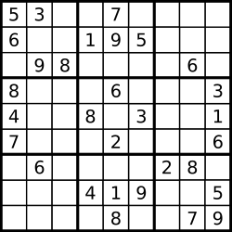
Input: board = [["5","3",".",".","7",".",".",".","."],["6",".",".","1","9","5",".",".","."],[".","9","8",".",".",".",".","6","."],["8",".",".",".","6",".",".",".","3"],["4",".",".","8",".","3",".",".","1"],["7",".",".",".","2",".",".",".","6"],[".","6",".",".",".",".","2","8","."],[".",".",".","4","1","9",".",".","5"],[".",".",".",".","8",".",".","7","9"]]
Output: [["5","3","4","6","7","8","9","1","2"],["6","7","2","1","9","5","3","4","8"],["1","9","8","3","4","2","5","6","7"],["8","5","9","7","6","1","4","2","3"],["4","2","6","8","5","3","7","9","1"],["7","1","3","9","2","4","8","5","6"],["9","6","1","5","3","7","2","8","4"],["2","8","7","4","1","9","6","3","5"],["3","4","5","2","8","6","1","7","9"]]
Explanation: The input board is shown above and the only valid solution is shown below:

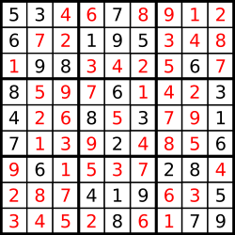

Constraints:
- board.length == 9
- board[i].length == 9
- board[i][j] is a digit or '.'.
- It is guaranteed that the input board has only one solution.

class Solution {
public void solveSudoku(char[][] board) {
solve(board);
}

private boolean solve(char[][] board) {
for (int row = 0; row < 9; row++) {
for (int col = 0; col < 9; col++) {
if (board[row][col] == '.') { // empty cell
for (char ch = '1'; ch <= '9'; ch++) {
if (isValid(board, row, col, ch)) {
board[row][col] = ch;

if (solve(board)) return true; // solved
else board[row][col] = '.'; // backtrack
}
}
return false; // no valid number fits
}
}
}
return true; // all cells filled
}

private boolean isValid(char[][] board, int row, int col, char ch) {
// check row
for (int i = 0; i < 9; i++) {
if (board[row][i] == ch) return false;
}

// check column
for (int i = 0; i < 9; i++) {
if (board[i][col] == ch) return false;
}

// check 3×3 sub-box separately
int startRow = 3 * (row / 3);
int startCol = 3 * (col / 3);
for (int r = 0; r < 3; r++) {
for (int c = 0; c < 3; c++) {
if (board[startRow + r][startCol + c] == ch)
return false;
}
}

return true;
}

}

7word ladder:
A transformation sequence from word beginWord to word endWord using a dictionary wordList is a sequence of words beginWord -> s₁ -> s₂ -> ... -> s_{k} such that:
- Every adjacent pair of words differs by a single letter.
- Every s_{i} for 1 <= i <= k is in wordList. Note that beginWord does not need to be in wordList.
- s_{k} == endWord
Given two words, beginWord and endWord, and a dictionary wordList, return the number of words in the shortest transformation sequence from beginWord to endWord, or 0 if no such sequence exists.

Example 1:
Input: beginWord = "hit", endWord = "cog", wordList = ["hot","dot","dog","lot","log","cog"]
Output: 5
Explanation: One shortest transformation sequence is "hit" -> "hot" -> "dot" -> "dog" -> cog", which is 5 words long.
Example 2:
Input: beginWord = "hit", endWord = "cog", wordList = ["hot","dot","dog","lot","log"]
Output: 0
Explanation: The endWord "cog" is not in wordList, therefore there is no valid transformation sequence.

Constraints:
- 1 <= beginWord.length <= 10
- endWord.length == beginWord.length
- 1 <= wordList.length <= 5000
- wordList[i].length == beginWord.length
- beginWord, endWord, and wordList[i] consist of lowercase English letters.
- beginWord != endWord
- All the words in wordList are unique.
- import java.util.*;
- //here efficient use of hashmap
- //hashmap->take role of vis + stores step of the string also
- class Solution {
- public int ladderLength(String beginWord, String endWord, List<String> wordList) {
- Set<String> dict = new HashSet<>(wordList);
- if (!dict.contains(endWord)) return 0;

- Queue<String> q = new LinkedList<>();
- q.offer(beginWord);
- Map<String,Integer> dist = new HashMap<>();
- dist.put(beginWord,1);

- while(!q.isEmpty()) {
- String word = q.poll();
- int steps = dist.get(word);
- if (word.equals(endWord)) return steps;

- char[] arr = word.toCharArray();
- for (int i = 0; i < arr.length; i++) {
- char old = arr[i];
- for (char c = 'a'; c <= 'z'; c++) {
- arr[i] = c;
- String next = new String(arr);
- if (dict.contains(next) && !dist.containsKey(next)) {
- dist.put(next, steps + 1);
- q.offer(next);
- }
- }
- arr[i] = old;
- }
- }
- return 0;
- }
- }
8.reverse pairs-merge sort:
Given an integer array nums, return the number of reverse pairs in the array.
A reverse pair is a pair (i, j) where:
- 0 <= i < j < nums.length and
- nums[i] > 2 * nums[j].

Example 1:
Input: nums = [1,3,2,3,1]
Output: 2
Explanation: The reverse pairs are:
(1, 4) --> nums[1] = 3, nums[4] = 1, 3 > 2 * 1
(3, 4) --> nums[3] = 3, nums[4] = 1, 3 > 2 * 1
Example 2:
Input: nums = [2,4,3,5,1]
Output: 3
Explanation: The reverse pairs are:
(1, 4) --> nums[1] = 4, nums[4] = 1, 4 > 2 * 1
(2, 4) --> nums[2] = 3, nums[4] = 1, 3 > 2 * 1
(3, 4) --> nums[3] = 5, nums[4] = 1, 5 > 2 * 1

Constraints:
- 1 <= nums.length <= 5 * 10⁴
- -2³¹ <= nums[i] <= 2³¹ - 1
- class Solution {
- public int reversePairs(int[] nums) {
- if (nums == null || nums.length == 0) return 0;
- return mergeSort(nums, 0, nums.length - 1);
- }

- private int mergeSort(int[] nums, int left, int right) {
- if (left >= right) return 0;

- int mid = left + (right - left) / 2;
- int count = mergeSort(nums, left, mid) + mergeSort(nums, mid + 1, right);

- // Count reverse pairs across halves
- int j = mid + 1;
- for (int i = left; i <= mid; i++) {
- while (j <= right && (long) nums[i] > 2L * nums[j]) {
- j++;
- }
- count += j - (mid + 1);
- }

- // Merge step
- merge(nums, left, mid, right);
- return count;
- }

- private void merge(int[] nums, int left, int mid, int right) {
- int[] temp = new int[right - left + 1];
- int i = left, j = mid + 1, k = 0;

- while (i <= mid && j <= right) {
- if (nums[i] <= nums[j]) temp[k++] = nums[i++];
- else temp[k++] = nums[j++];
- }
- while (i <= mid) temp[k++] = nums[i++];
- while (j <= right) temp[k++] = nums[j++];

- // Copy back
- System.arraycopy(temp, 0, nums, left, temp.length);
- }
- }

