**JavaScript-Task-4**

**1, Print odd numbers in an array :-**

**var arr = [1,2,3,4,5,6,7,8];**

**var oddArr = arr.filter(num => num%2 !== 0);**

**console.log(oddArr);**

**Console :-**

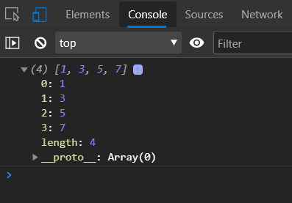

**2. Convert all the strings to title caps in a string array :-**

var arr = ["i am","a","LITTLE","tea","pot"];

arr = arr.map(word => word.toLowerCase());

arr = arr.map(word=>word.replace(word[0],word[0].toUpperCase()));

console.log(arr);

**Console :-**

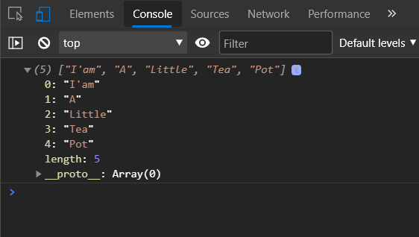

**3. Sum of all numbers in an array**

**var arr = [1,2,3,4,5,6,7,8];**

**var arrSum = arr.reduce((sum,num) => sum+=num,0);**

**console.log(arrSum);**

**Console :-**

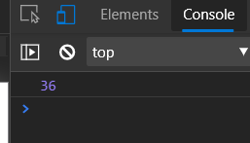

**4. Return all the prime numbers in an array**

**var arr = [1,2,3,4,5,6,7,8];**

**function isPrime(x){**

**if(x==2){return true}**

**else if(x%2==0 || x<2){return false}**

**else{**

**for(let i=3;i<x;i++){**

**if(x%i===0){return false}}**

**}return true;}**

**let primeArr = arr.filter(num => isPrime(num));**

**console.log(primeArr);**

**Console :-**

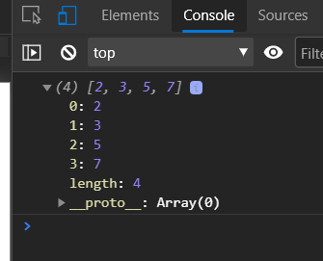

**5. Return all the palindromes in an array**

**let arr = ["cat", "bob", "mom", "call", "racecar"];**

**let palindromeArr = arr.filter(word => word == word.split("").reverse().join(""));**

**console.log(palindromeArr);**

**Console :-**

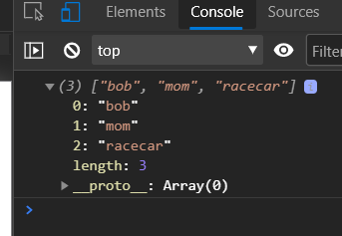

**6. Return median of two sorted arrays of same size**

let arr1 =[1,2,5,8,4];

let arr2 =[3,7,6,19,20];

function median(arr1,arr2){

let sortArr = arr1.concat(arr2).sort((a,b)=>a-b);

let result = (sortArr[sortArr.length/2]+sortArr[sortArr.length/2-1])/2;

return result;}

console.log(median(arr1,arr2));

Console :-

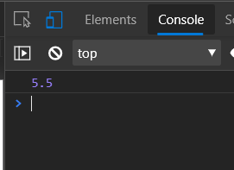

**7.Remove duplicates from an array**

**let arr = [1,2,3,2,4,2,5,5,4,3,1];**

**function removeDuplicates(arr){**

**arr = arr.sort();**

**for(let i=0;i<arr.length-1;i++){**

**if(arr[i]==arr[i+1]){**

**arr.splice(i,1);**

**i = i-1;**

**}**

**}return arr;**

**}**

**console.log(removeDuplicates(arr));**

**Console :-**

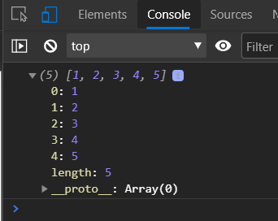

**8. Rotate an array by k times and return the rotated array**

**let arr = [1,2,3,4,5];**

**function rotateArray(arr,k){**

**let newarr = arr.splice(0,k%arr.length);**

**return arr.concat(newarr);**

**}**

**console.log(rotateArray(arr,3));**

**Console :-**

